Supplementary：analysis of RNA sequencing results
Figure 1. The genes of cryptorchidism mice with elevated mir210 were sequenced and enriched in the INHBB-Smad2/3 pathway.
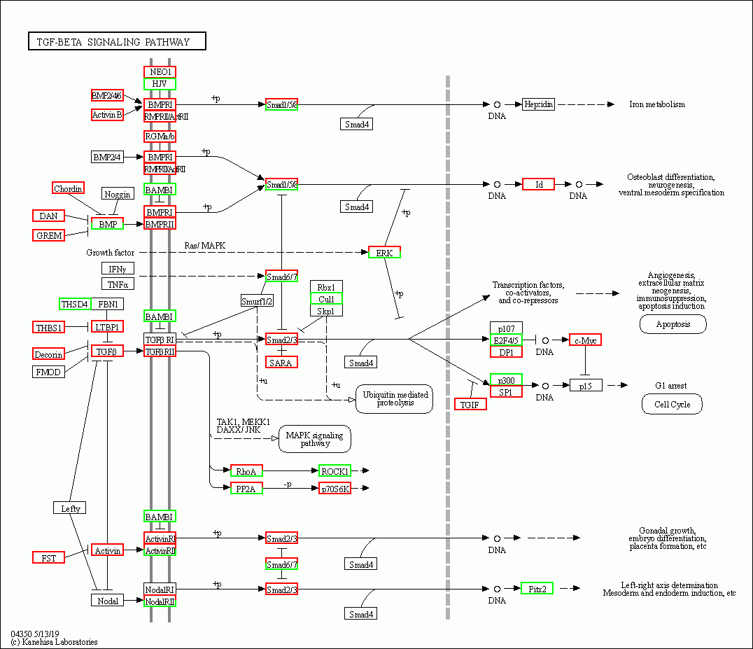
Figure 2. Expression of INHBB-SMAD2/3-casp3 pathway in testis of cryptorchidism mice
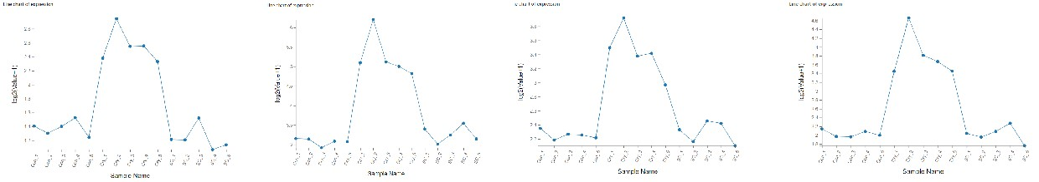
Casp3
Smad3
Smad2
INHBB

RNA-seq sequencing analysis in mice model of cryptorchidism and control group showed that the expression levels of INHBB,Smad2/3 and casp3 genes were significantly increased (p < 0.05).

