Targeting antimalarial metabolites from the actinomycetes associated with the red sea sponge Callyspongia siphonella using a metabolomic method
Noha M. Gamaleldin¹, Hebatallah S. Bahr², Natalie Millán-Aguiñaga³, Mahshid Danesh⁴, Eman M. Othman^{4,5}, Thomas Dandekar⁴, Hossam M. Hassan²,^{6*}, Usama Ramadan Abdelmohsen^{7,8*}
¹Department of Microbiology, Faculty of Pharmacy, the British University in Egypt (BUE), Cairo 11837, Egypt. noha.gamaleldin@bue.edu.eg
²Department of Pharmacognosy, Faculty of Pharmacy, Nahda University, Beni-Suef, Egypt.
³Universidad Autónoma de Baja California, Facultad de Ciencias Marinas. 22860 Ensenada, Baja California, México.
⁴Department of Bioinformatics, Biocenter, University of Würzburg, Am Hubland, 97074 Würzburg, Germany.
⁵ Department of Biochemistry, Faculty of Pharmacy, Minia University, 61519 Minia, Egypt.
⁶Department of Pharmacognosy, Faculty of Pharmacy, Beni-Suef University, Beni-Suef, Egypt.
⁷ Department of pharmacognosy, faculty of Pharmacy, Minia University, Minia, Egypt.
⁸ Department of pharmacognosy, faculty of Pharmacy, Deraya University, 61111 New Minia City, Minia, Egypt.
*Corresponding author: Hossam.mokhtar@nub.edu.eg (HMH), Usama.ramadan@mu.edu.eg (URA)

Abstract
Malaria is a persistent illness that is still a public health issue. On the other hand, marine organisms are considered a rich source of anti‑infective drugs and other medically significant compounds. Herein, we reported the isolation of the actinomycete associated with the Red Sea sponge Callyspongia siphonella. Using "one strain many compounds" (OSMAC) approach, a suitable strain was identified and then sub-cultured in three different media (M1, ISP2 and OLIGO). The extracts were evaluated for their in-vitro antimalarial activity against Plasmodium falciparum strain and subsequently analyzed by Liquid chromatography coupled with high-resolution mass spectrometry (LC-HR-MS). In addition, MetaboAnalyst 5.0 was used to statistically analyze the LC-MS data. Finally, Molecular docking was carried out for the dereplicated metabolites against lysyl-tRNA synthetase (PfKRS1). The phylogenetic study of the 16S rRNA sequence of the actinomycete isolate revealed its affiliation to Streptomyces genus. Antimalarial screening revealed that ISP2 media is the most active against Plasmodium falciparum strain. Based on LC-HRMS-based metabolomics and multivariate analyses, ISP2-S and M1-S are the optimal media for metabolites production. OPLS-DA suggested that quinone derivatives are abundant in the extracts with the highest antimalarial activity. Fifteen important compounds were identified where 8 of these metabolites were correlated to the observed antimalarial activity of the active extracts. According to molecular docking experiments, saframycin Y3 and juglomycin E showed the greatest binding energy scores (-6.2 and -5.13) to lysyl-tRNA synthetase (PfKRS1), respectively. Using metabolomics and molecular docking investigation, the quinones, saframycin Y3 (5) and juglomycin E (1) were identified as promising antimalarial therapeutic candidates. Our approach can be used as a first evaluation stage in natural product drug development, facilitating the separation of chosen metabolites, particularly biologically active ones.
Keywords: Callyspongia siphonella; Streptomyces; PCA; PLS-DA; antimalarial; metabolomics; quinones.

Figure (S1): LC/HRMS-negative mode total ion chromatogram of M1 solid extract (M1-S).
Figure (S2): LC/HRMS-positive mode total ion chromatogram of M1 solid extract (M1-S).
Figure (S3): LC/HRMS-positive mode total ion chromatogram of ISP2 solid extract (ISP2-S).
Figure (S4): LC/HRMS-negative mode total ion chromatogram of ISP2 solid extract (ISP2-S).
Figure (S5): LC/HRMS-negative mode total ion chromatogram of Oligo solid extract (Oligo-S).
Figure (S6): LC/HRMS-positive mode total ion chromatogram of Oligo solid extract (Oligo-S).
Figure (S7): LC/HRMS-negative mode total ion chromatogram of M1 liquid extract (M1-L).
Figure (S8): LC/HRMS-positive mode total ion chromatogram of the M1 liquid extract (M1-L).
Figure (S9): LC/HRMS-negative mode total ion chromatogram of ISP2 liquid extract (ISP2-L).
Figure (S10): LC/HRMS-positive mode total ion chromatogram of ISP2 liquid extract (ISP2-L).
Figure (S11): LC/HRMS-positive mode total ion chromatogram of Oligo liquid extract (Oligo-L).
Figure (S12): LC/HRMS-negative mode total ion chromatogram of Oligo liquid extract (Oligo-L).

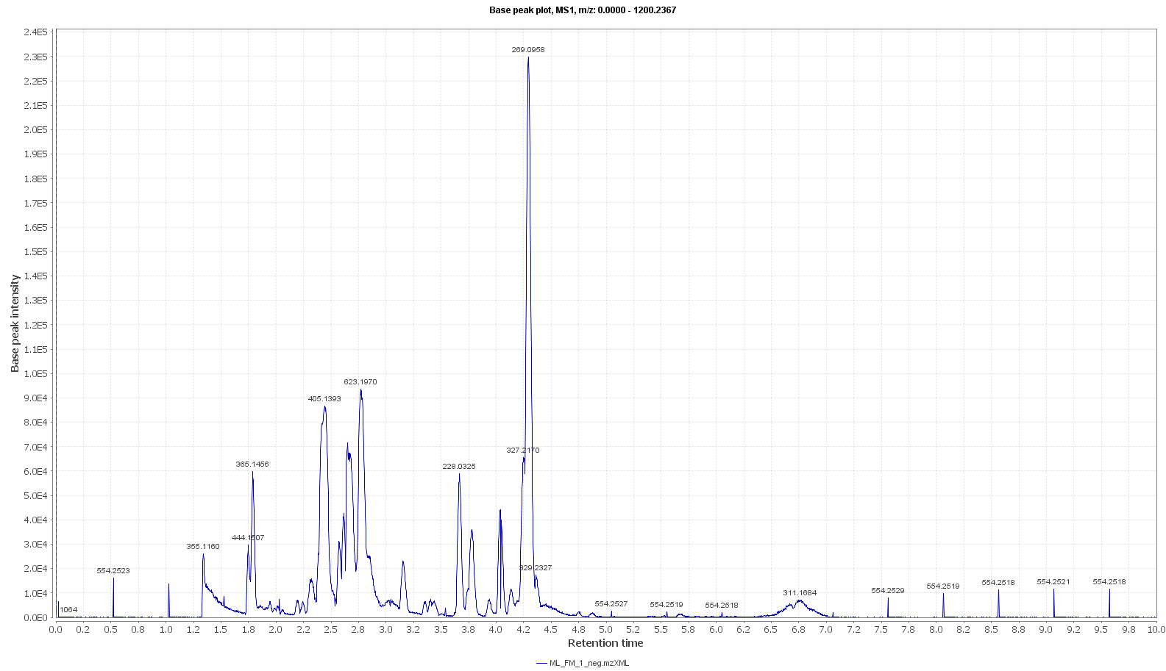
Figure (S1): LC/HRMS-negative mode total ion chromatogram of M1 solid extract (M1-S).

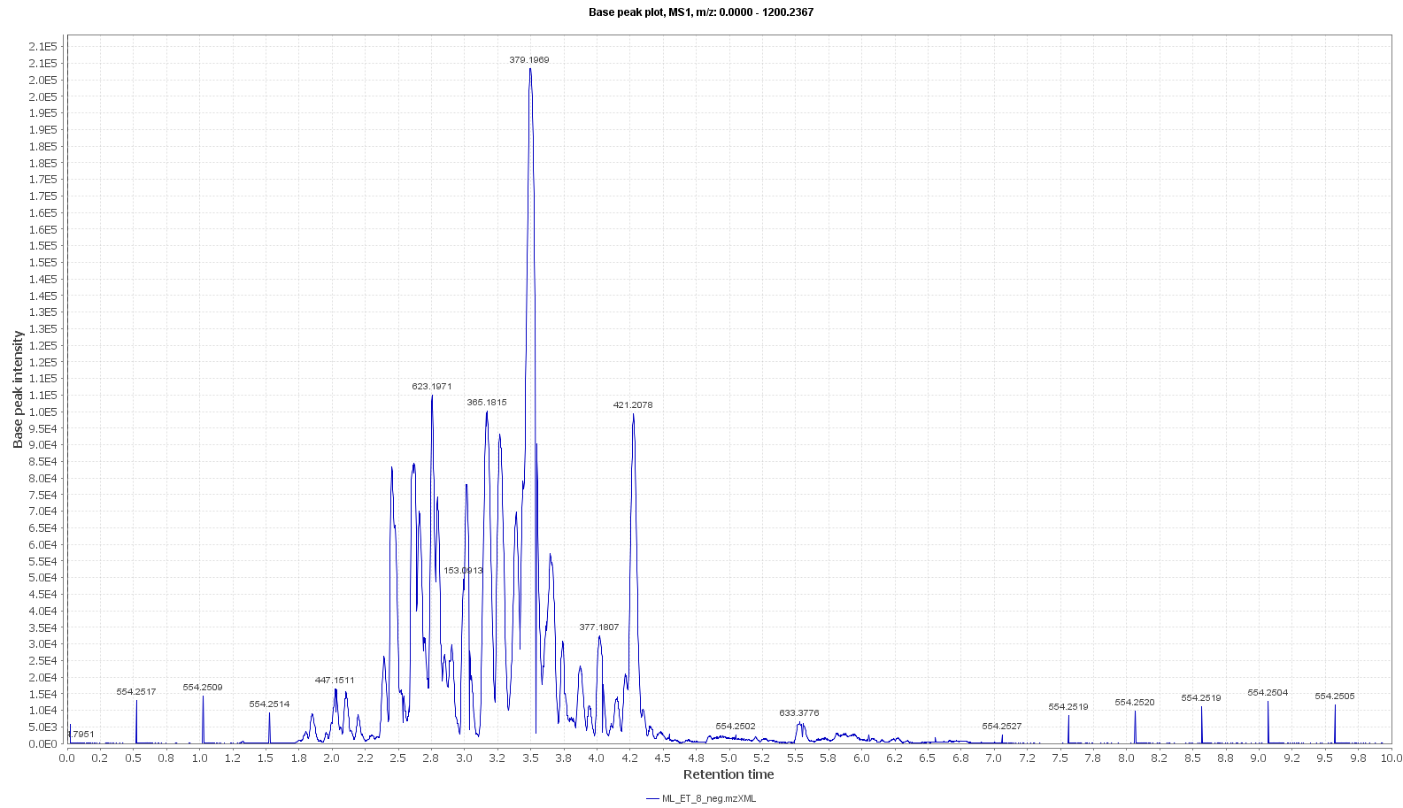
Figure (S2): LC/HRMS-positive mode total ion chromatogram of M1 solid extract (M1-S).

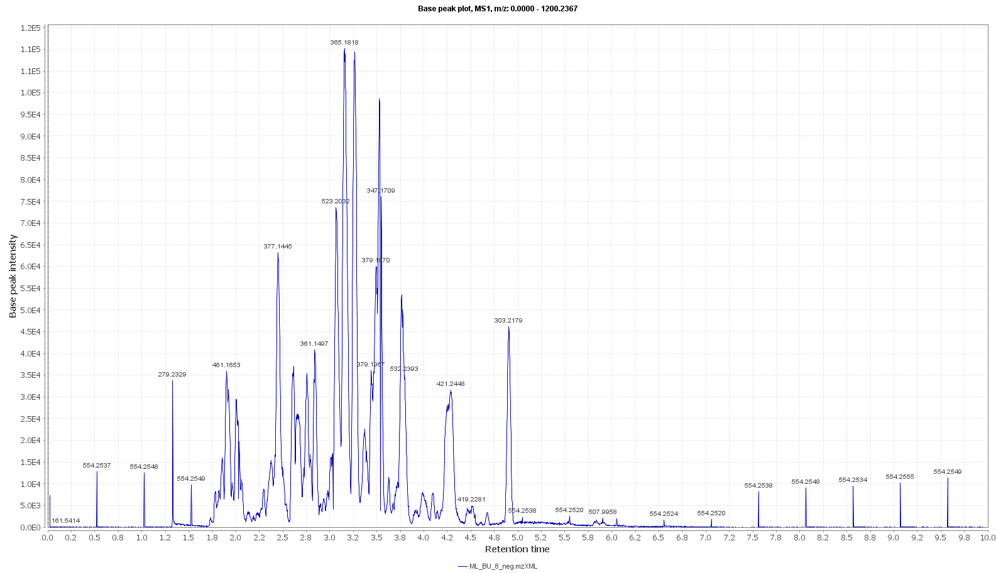
Figure (S3): LC/HRMS-positive mode total ion chromatogram of ISP2 solid extract (ISP2-S).

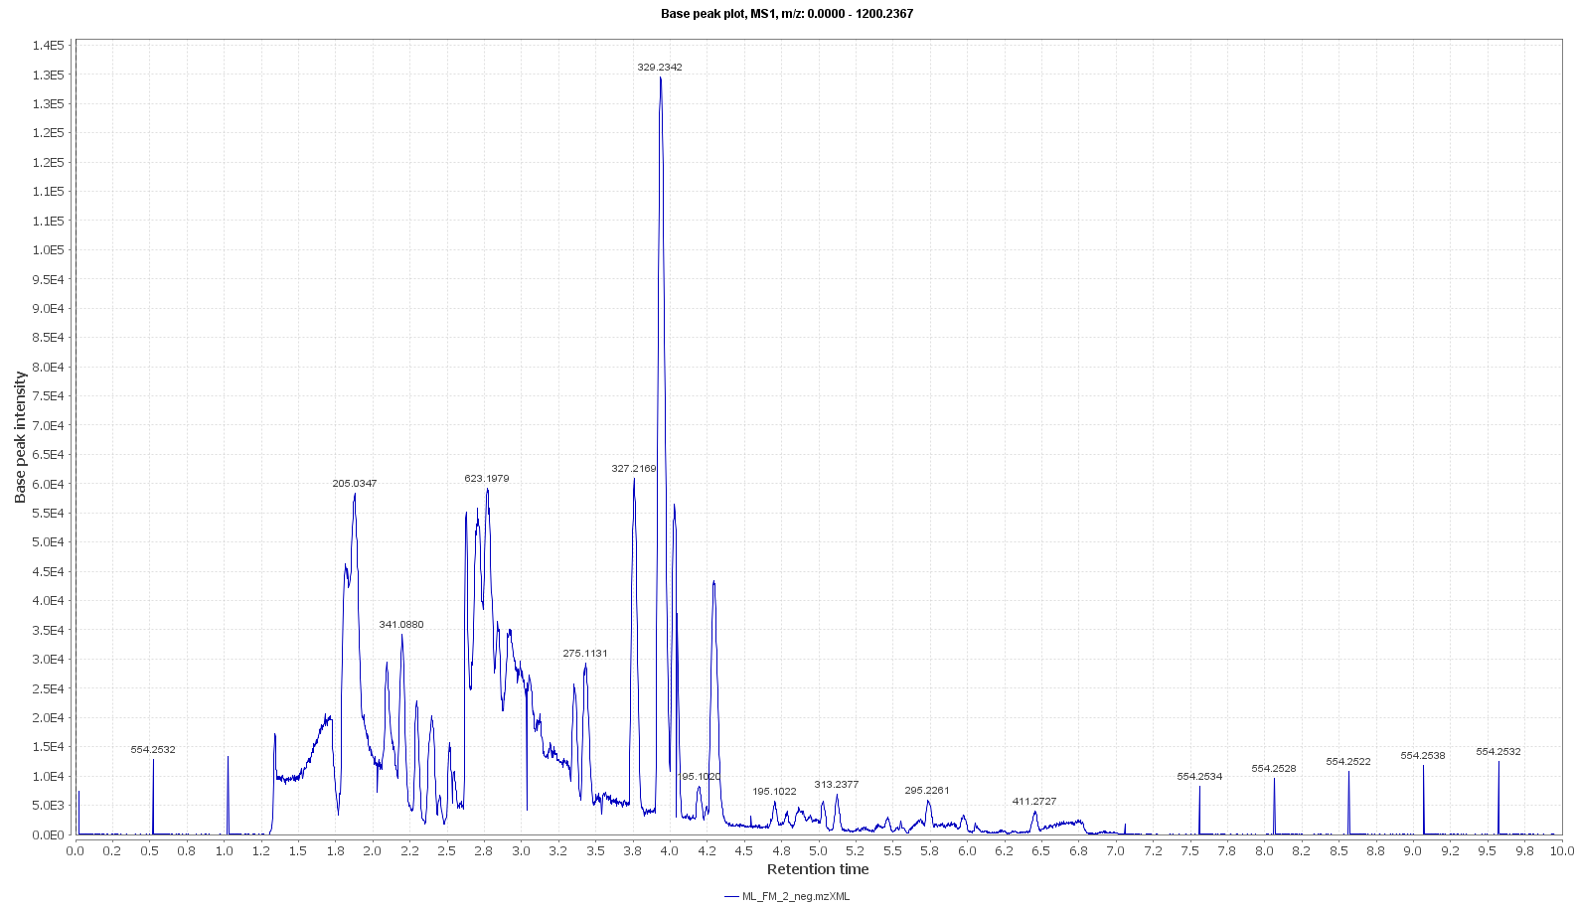
Figure (S4): LC/HRMS-negative mode total ion chromatogram of ISP2 solid extract (ISP2-S).
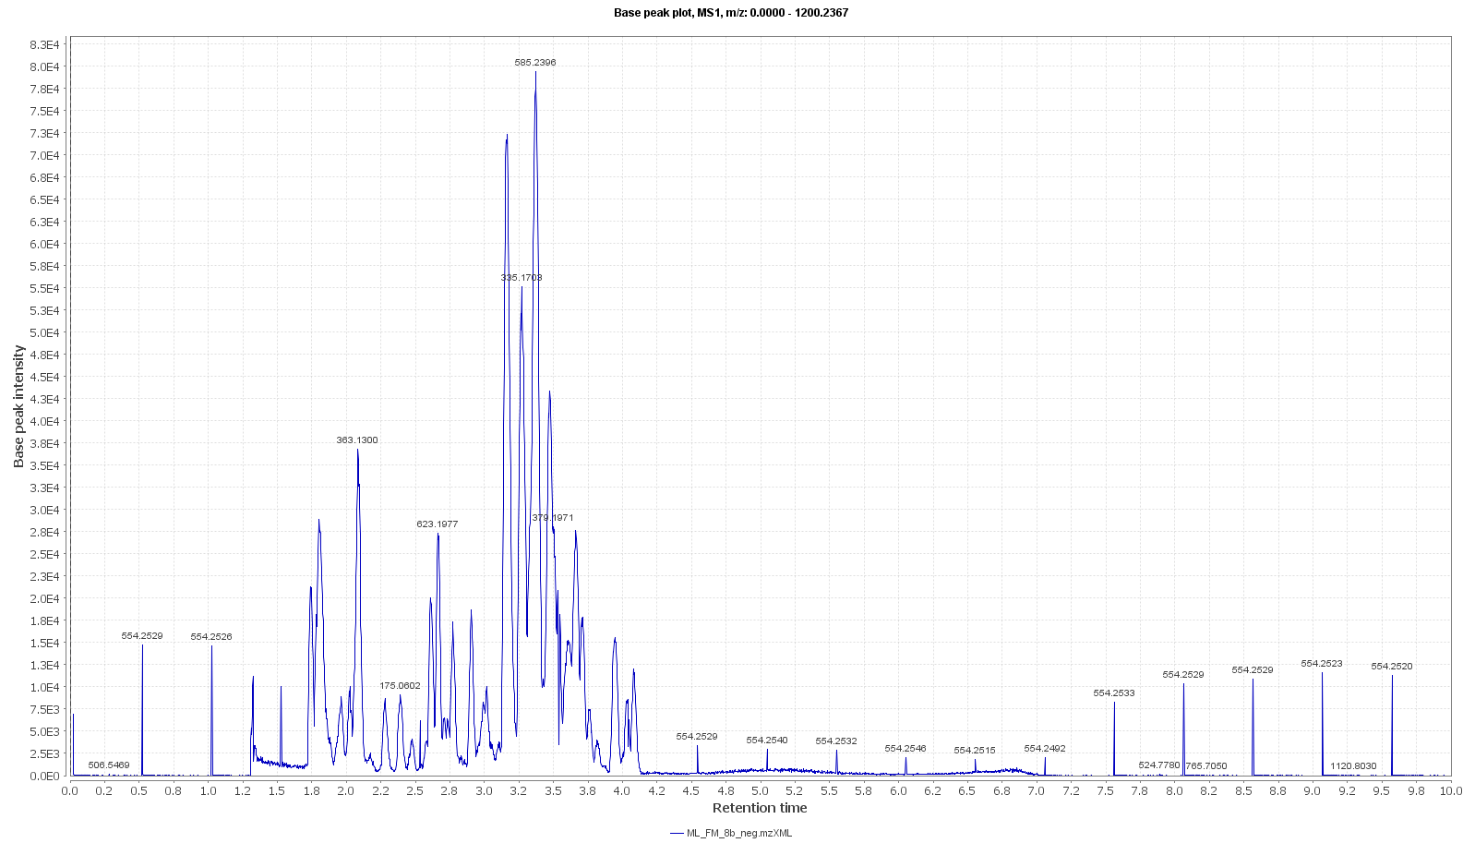
Figure (S5): LC/HRMS-negative mode total ion chromatogram of Oligo solid extract (Oligo-S).

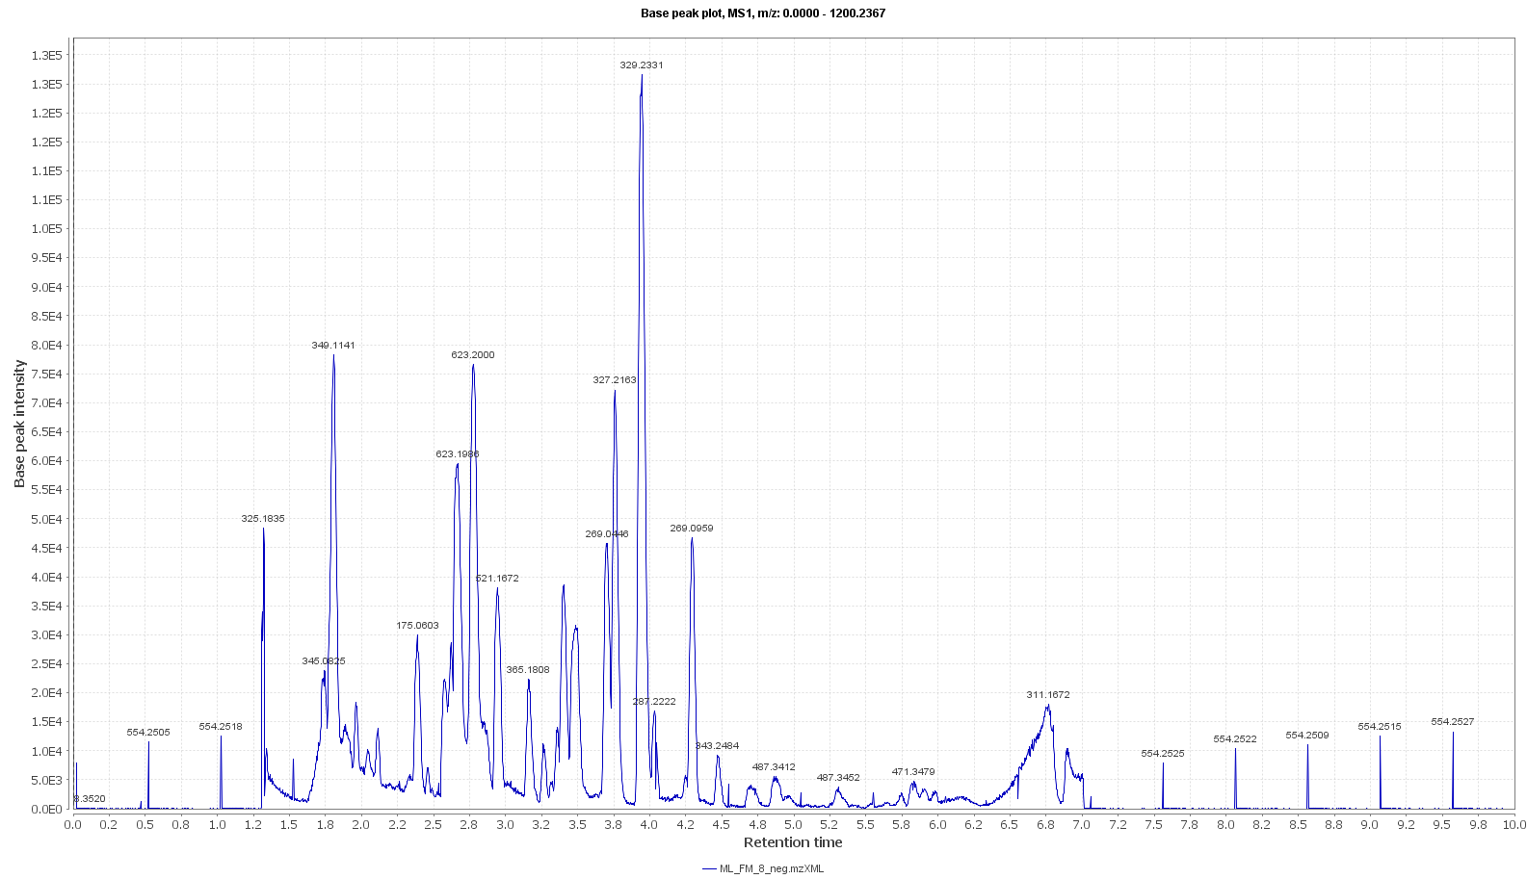
Figure (S6): LC/HRMS-positive mode total ion chromatogram of Oligo solid extract (Oligo-S).

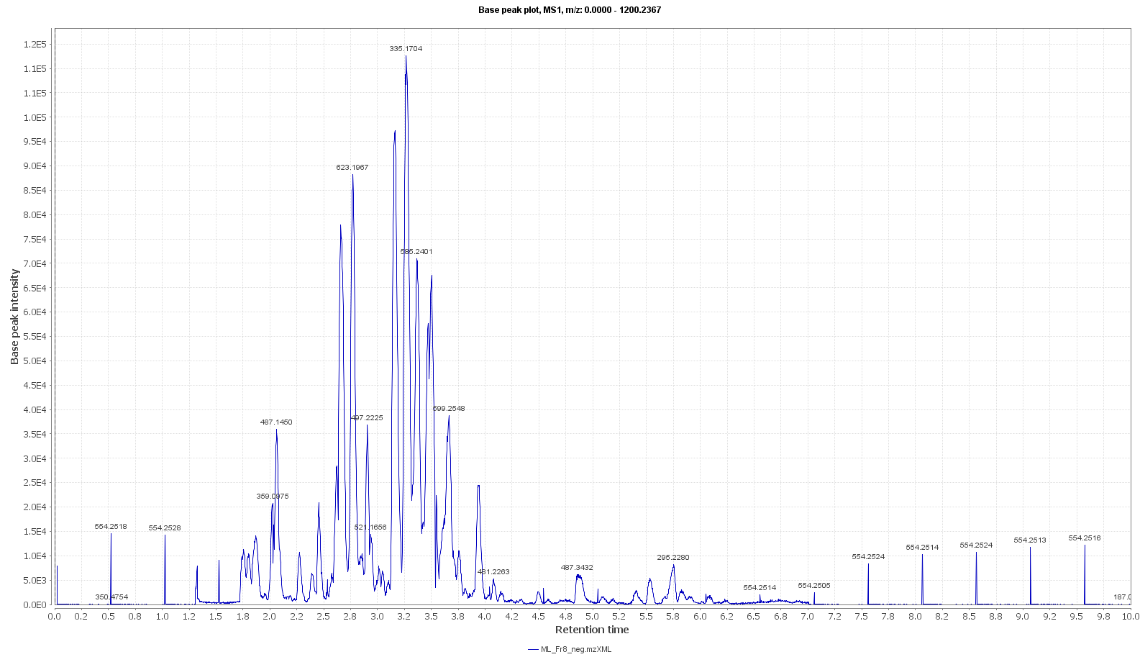
Figure (S7): LC/HRMS-negative mode total ion chromatogram of M1 liquid extract (M1-L).

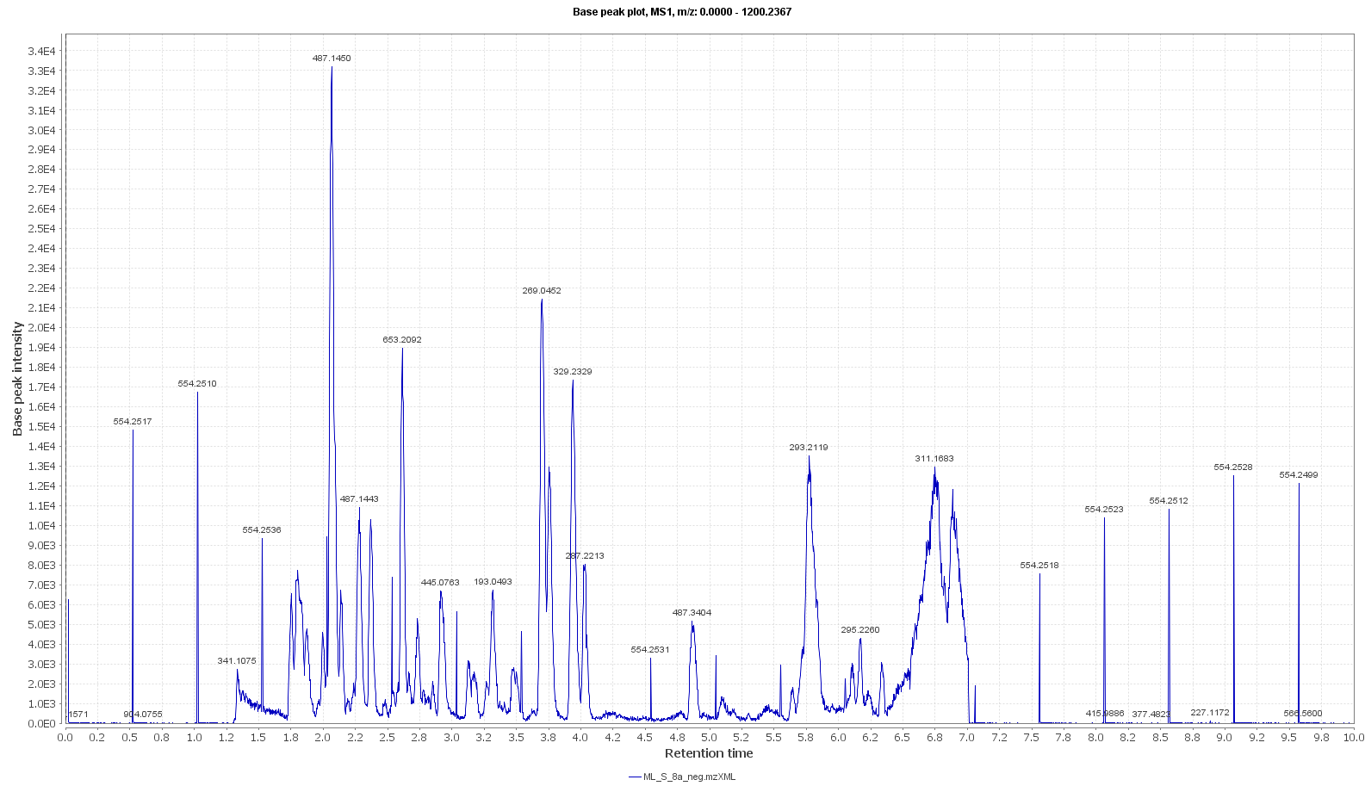
Figure (S8): LC/HRMS-positive mode total ion chromatogram of the M1 liquid extract (M1-L).

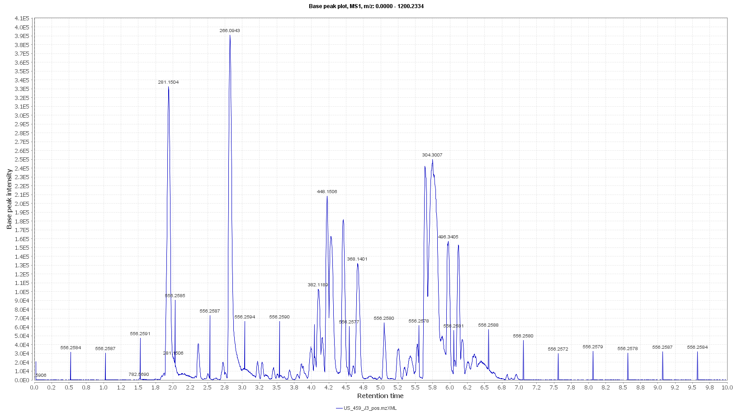
Figure (S9): LC/HRMS-negative mode total ion chromatogram of ISP2 liquid extract (ISP2-L).

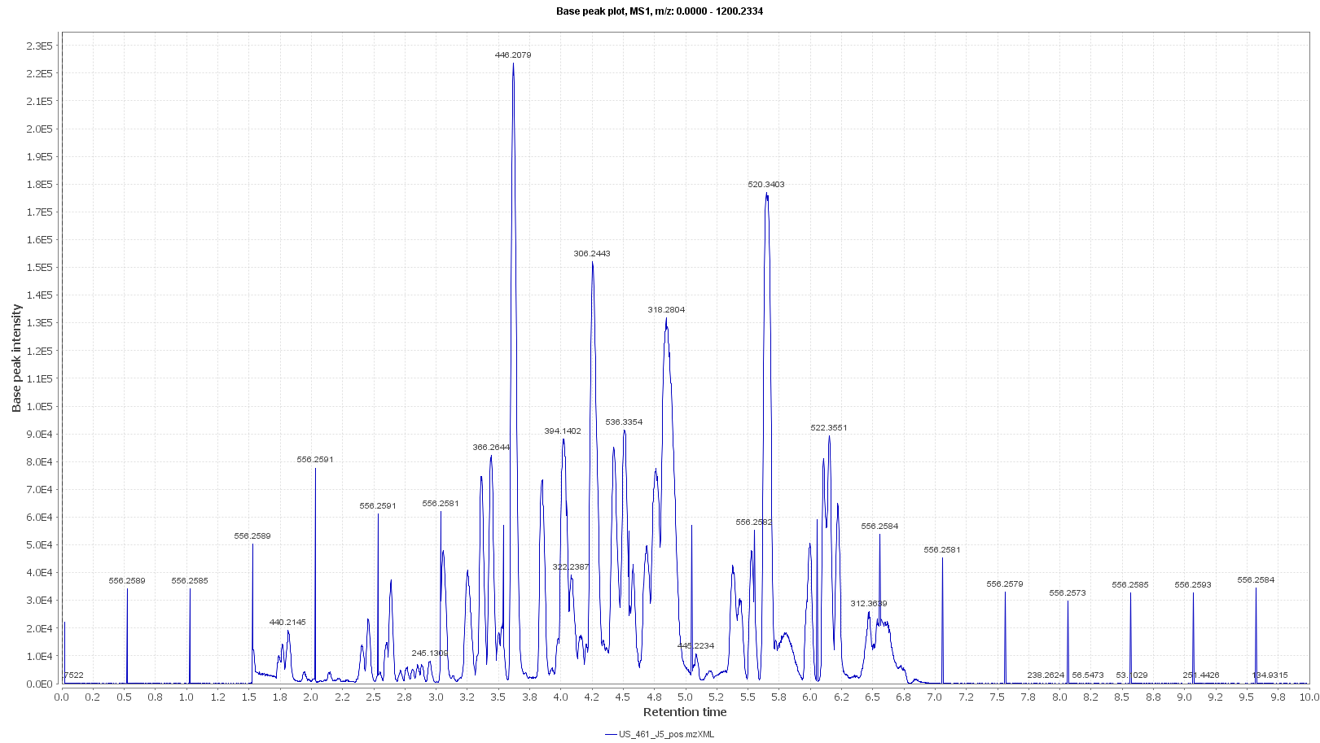
Figure (S10): LC/HRMS-positive mode total ion chromatogram of ISP2 liquid extract (ISP2-L).

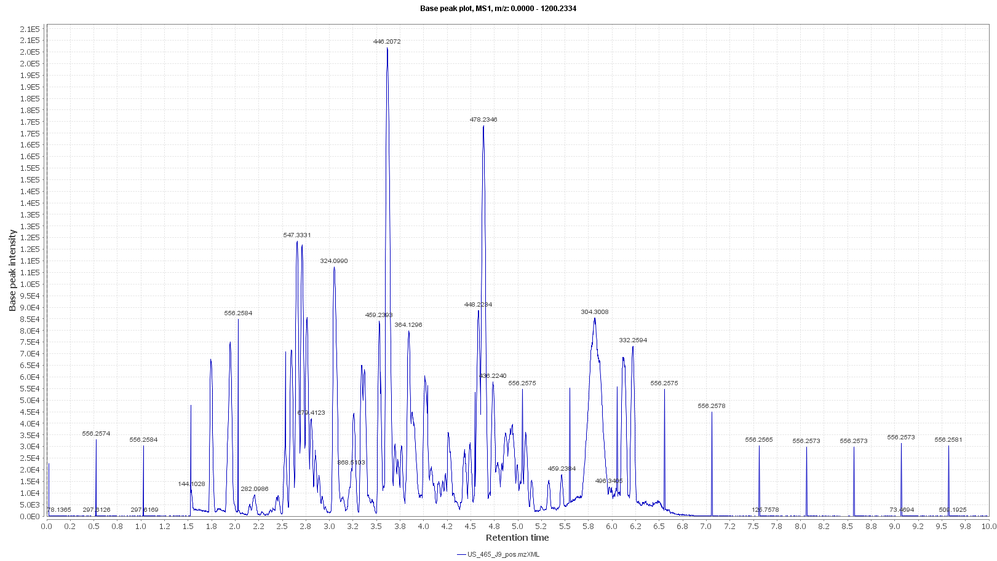

Figure (S11): LC/HRMS-positive mode total ion chromatogram of Oligo liquid extract (Oligo-L)

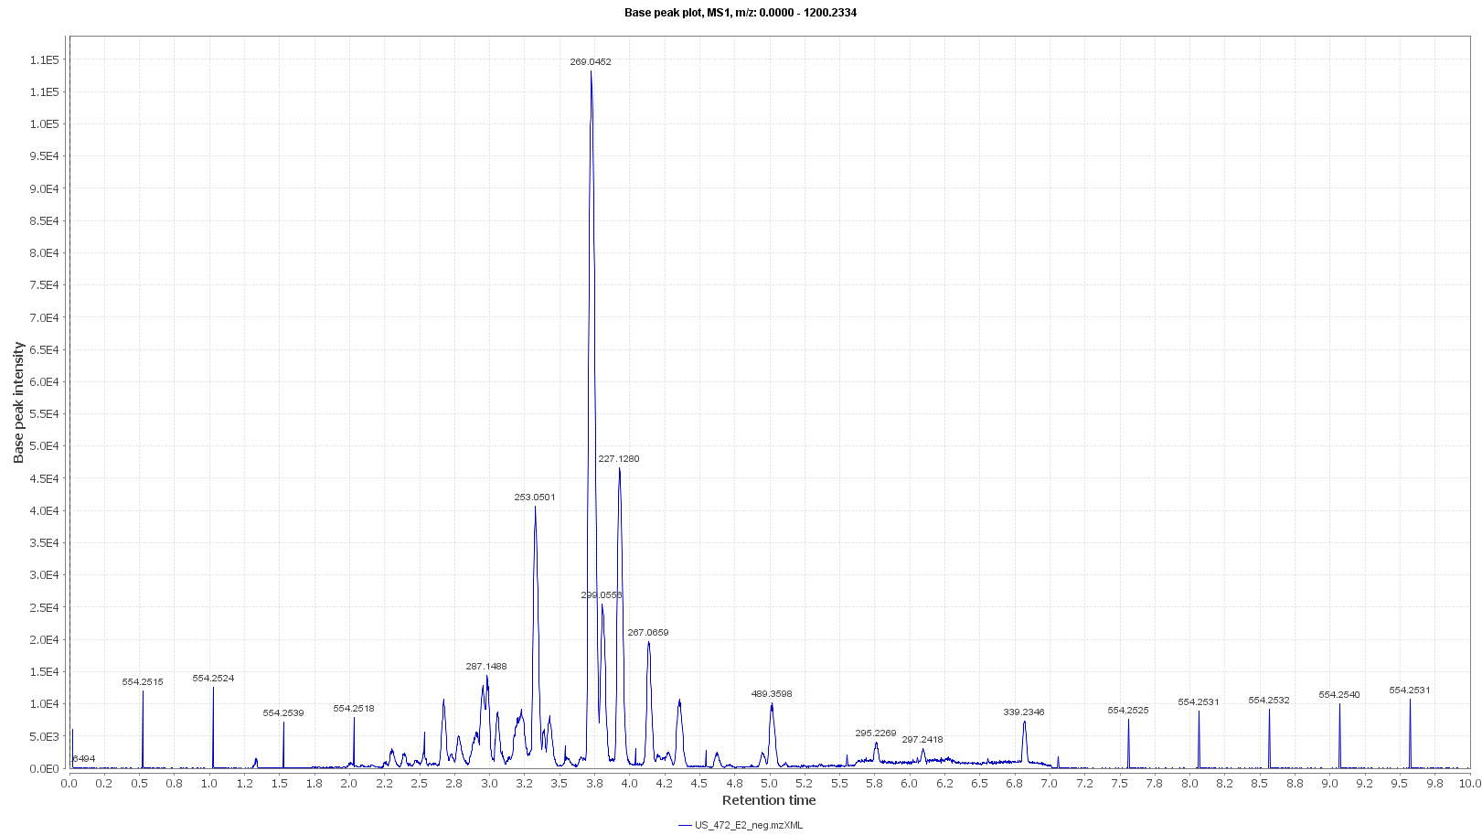

Figure (S12): LC/HRMS-negative mode total ion chromatogram of Oligo liquid extract (Oligo-L).

