PL02® alleviates joint Pain and Inflammation, and subchondral bone deterioration in the Monosodium iodoacetate-induced Osteoarthritis rat model

Prabhat Upadhyay^{1,2}, Diya Kalra², Aishwarya Shrikant Nilakhe², Vijay Aggrawal³, Sarika Gupta^{2*}

¹Wellman Center for Photomedicine, Massachusetts General Hospital, Harvard Medical School, Massachusetts USA
²Molecular Science Lab, National Institute of Immunology New Delhi India
³M/S Purobien Lifesciences, 53, EPIP-I, Jharmajri, Distt. Solan, Baddi, Himachal Pradesh, India

Short Title: PL02® Prevented Cartilage degeneration in Osteoarthritis

*Corresponding author
Dr Sarika Gupta (ORCID: 0000-0002-3054-0337)
Scientist
Molecular Science Lab
National Institute of Immunology
Department of Biotechnology
Govt of India, New Delhi- 110067
Email: sarika@nii.ac.in

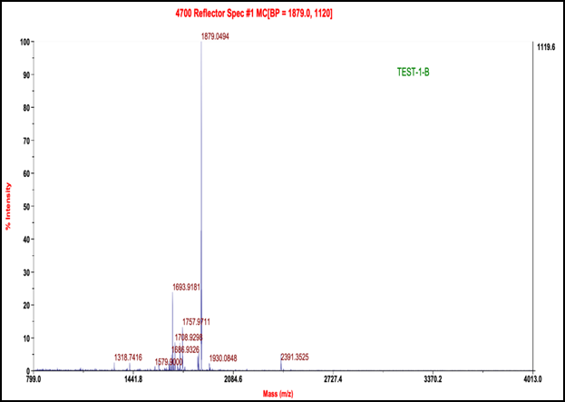

Figure S1: Image illustrated the MALDI-TOF mass spectrum collagen peptide to validate the molecular weight (~2 kDa)

Table S1: Behavioral responses and general appearance of Mice/Rat treated in the sub-acute toxicity study
Observation | Control | MIA | MIA + Indo | MIA + PL02
Change In Skin | No effect | No effect | No effect | No effect
Eye color change | No effect | No effect | No effect | No effect
Food intake | Normal | Normal | Normal | Normal
General physique | Normal | Normal | Normal | Normal
Diarrhea | Not present | Not present | Not present | Not present
Coma | Not present | Not present | Not present | Not present
Drowsiness | Not present | Not present | Not present | Not present
Breathing difficulty | Not observed | Not observed | Not observed | Not observed
Sedation | No effect | No effect | No effect | No effect
Tremor | Not present | Not present | Not present | Not present

B
A

Figure S2: PL02 showed no toxicity after 28 days of treatment in mice (A) Average body weight recorded on days 1, 3, 7,10, 14,21, and 28 (n=8) (B) Serum parameter (i) SGOT level measured from blood serum at day 14 and day 28 (n=6) (ii) SGPT measured from blood serum at day 14 and day 28 (n=6) (iii) ALP measured from blood serum at day 14 and day 18 (n=6) (iv) Urea measured from blood serum at day 14 and day 28 (n=6) (v) Creatinine measured from blood serum at day 14 and day 28 (n=6). Statistical analysis was performed using one-way ANOVA with the Bonferroni post hoc test. Data presented as means ± SEM. *P < 0.05, **P < 0.01 and ***P< 0.001
C
B
A
D

Figure S3: PL02 helps in reducing the pain and inflammation (A) Hot plate used to measure the Pain sensation on days 1, 3, 7, 10, 14, 21, and 28 (n=8) (B) Rota rod used to measure the joint pain through recorded the latency of fall time at days at day 1, 3, 7, 10, 14, 21 and 28 (n=8) (C) vernier caliper used to the measure the inflammation on knee joint at days 1, 3, 7, 10, 14, 21 and 28 (n=8) (D) Von Frey was performed for mechanical allodynia to measure the pain at day 1, 3, 7, 10, 14, 21 and 28 (n=8) Statistical analysis was performed using Two-way ANOVA with Bonferroni post hoc test. Data presented as means ± SEM. *P < 0.05, **P < 0.01 and ***P< 0.001

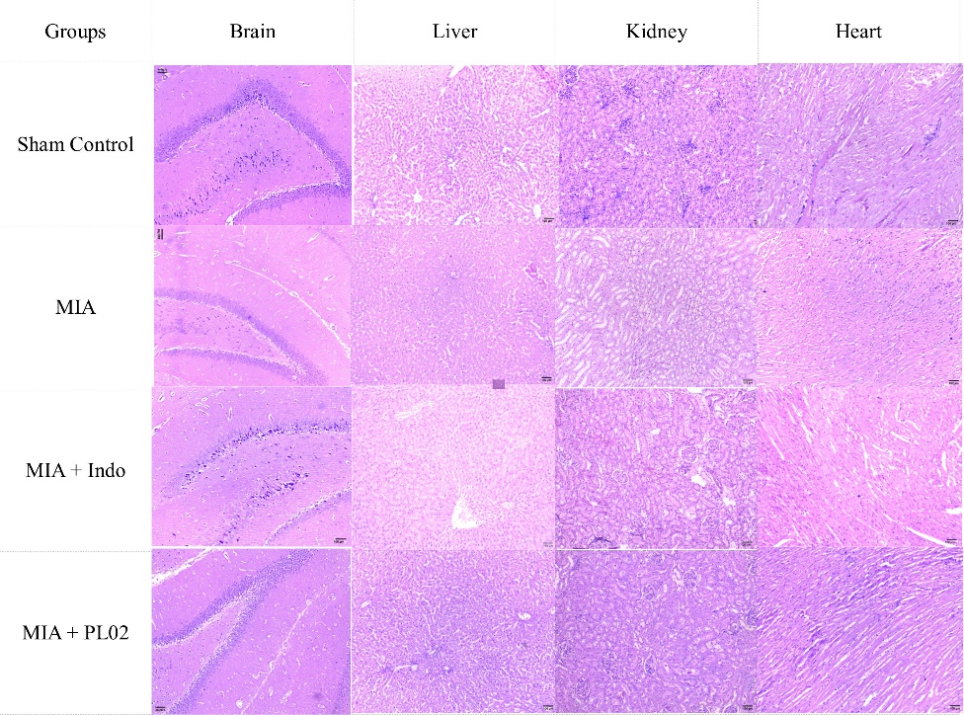
B
A
Figure S4: PL02 showed no toxicity after 28 days of treatment
(A) Serum parameter
(i) SGOT level measured from blood serum on day 14 and day 18 (n=6)
(ii) SGPT measured from blood serum on day 14 and day 28 (n=6)
(iii) ALP measured from blood serum on day 14 and day 28 (n=6)
(iv) Urea measured from blood serum on day 14 and day 28 (n=6)
(v) Creatinine measured from blood serum on day 14 and day 28 (n=6)
(B) H & E stain of the isolated vital organ after 28 days of treatment at 10 X (Brain, Liver Kidney & Heart) scale bar 100 µm

Statistical analysis was performed using Two-way ANOVA with the Bonferroni post hoc test. Data presented as means ± SEM. *P < 0.05, **P<0.01, ***P<0.001

Marker | Forward | Reverse | Product length (bp) | NCBI Reference Sequence
Aggrecan | ACAGACACCCCTACCCTTGC | ACAAGGGCTTGAGAGGCACT | 90 | XM_039101034.1
SOX-9 | CCTCGGGCATGAGTGAGGTG | TCCCAGCTTGCACGTCTGTT | 102 | NM_080403.2
MMP13 | CTGGTCTTCTGGCACACGCT | GAGTGGTCCAGACCGAGGGA | 154 | NM_133530.1
IL-1β | ACCTATGTCTTGCCCGTGGAG | GCAGGTCGTCATCATCCCAC | 110 | NM_031512.2
NF-κB p65 | GGATGACAGAGGCGTGTATAAG | CCTTCTCTCTGTCTGTGAGTTG | 114 | NM_001276711.2
IL-4 | GGCAACAAGGAACACCACGG | CGTGGACTCATTCACGGTGC | 190 | NM_201270.1
Bcl2 | TACCTGAACCGGCATCTGCAC | GCATGCTGGGGCCATATAGT | 82 | NM_016993.2
TNF-α | GCCCTGGTATGAGCCCATGT | CCAAAGTAGACCTGCCCGGA | 123 | NM_012675.3
CXCL-12 | CCTCAACACTCCAAACTGTGCC | ACGGAGGTCAGCCTTCCTCA | 178 | NM_022177.3
Ccl2 | GCAGGTCTCTGTCACGCTTC | AGCAGGTGAGTGGGGCATTA | 101 | NM_031530.1
TIMP 2 | CGGACTCCTAGAGACACGCT | TCTGCTCAGGAATTTGAAGGCAG | 70 | XM_039099407.1
NOS2 | CTTGGTGAGGGGACTGGACTTT | ACCAACTCTGCTGTTCTCCGT | 104 | NM_012611.3
Coll type II | CTCTGGCAAAGATGGCTCTAAT | GTCATGCTGTCTCAAGGTACTG | 244 | XM_006242308.4
Ptgs2/Cox2 | TCAAGGGAGTCTGGAACATTG | GCTTCCCAACTTTTGTAACCG | 139 | NM_017232.3
CGRP 1 | CCAGATCAAGAGTCACCGC | GGAGAACTTCAGAAAGCCCATG | 137 | NM_001033955.1
Beta Actin | CACTTTCTACAATGAGCTGCG | CTGGATGGCTACGTACATGG | 148 | NM_031144.3
GAPDH | GGTCGGTGTGAACGGATTT | TGGAAGATGGTGATGGGTTTC | 219 | NM_017008.4
Table S2: List of Primers with sequence used in Quantitative Real-time PCR analysis

