Supplemental Figures
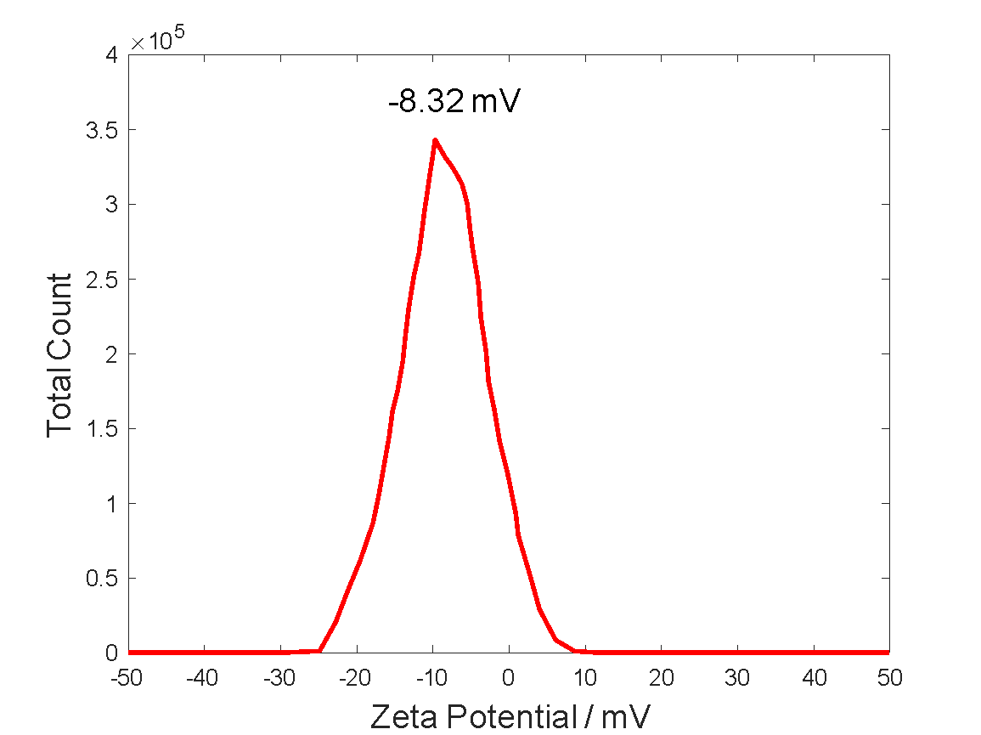
Figure S1: SN-CNPs have negative charges.
The zeta potential of SN-CNPs measured at 50 $μ$g mL⁻¹ indicates that they are negatively charged.

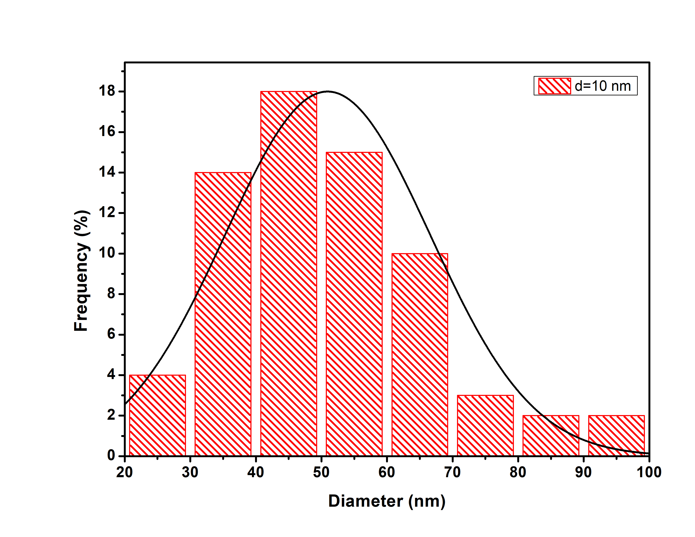
Figure S2: Size distribution of SN-CNPs.
Analysis of the TEM images of SN-CNPs measured at 100 $μ$g mL⁻¹ shows that the peak distribution for the diameter of the nanoparticles is around 50 nm.

(a) | (b)
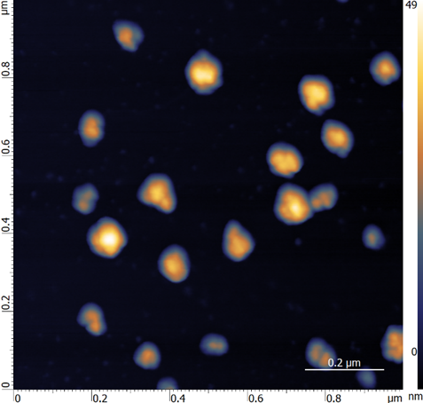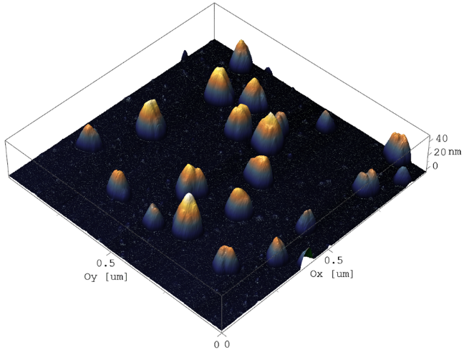

Figure S3: SN-CNPs form aggregates at high concentration.
2D (a) and 3D (b) AFM images of dried SN-CNPs on mica slide show sign of aggregation at 150 $μ$g mL⁻¹.

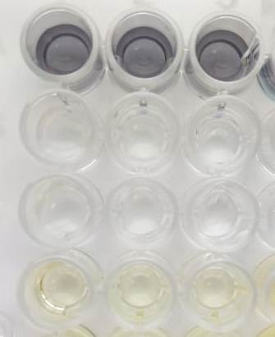
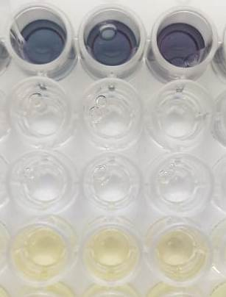
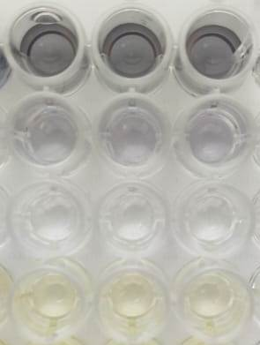

pH 4.7
pH 7.0
pH 8.8
N-CNP + NBT/BCIP
ALP + NBT/BCIP
NBT/BCIP control
BTSSCT control

Figure S4: Phosphatase assay for N–CNPs.
The results show that N-CNPs have low phosphatase activity, especially at pH values that differ from neutral.

(a) | (b)
(c)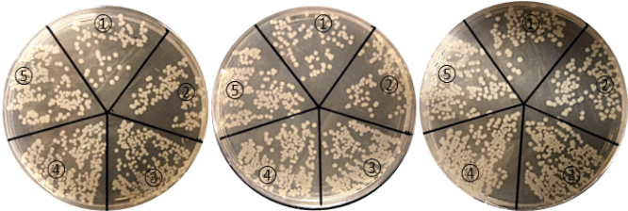 | (d)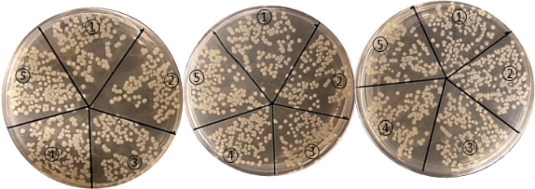
0 $μ$g mL⁻¹ (1); 10 $μ$g mL⁻¹ (2); 50 $μ$g mL⁻¹ (3); 100 $μ$g mL⁻¹ (4); 200 $μ$g mL⁻¹ (5) | 0 $μ$g mL⁻¹ (1); 10 $μ$g mL⁻¹ (2); 50 $μ$g mL⁻¹ (3); 100 $μ$g mL⁻¹ (4); 200 $μ$g mL⁻¹ (5)
(e)  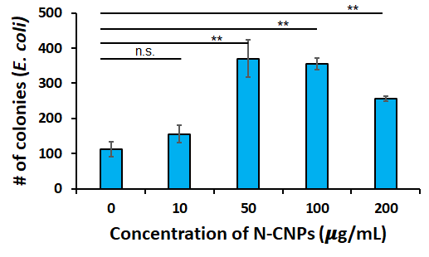 | (f)  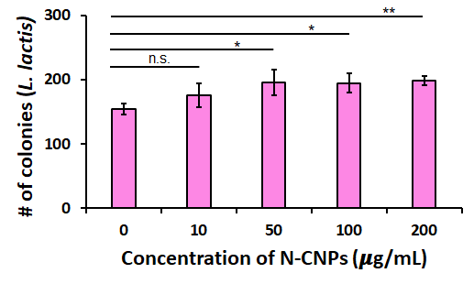

Figure S5: Antibacterial test for N-CNPs against E. coli (left column) and L. lactis (right column).
Antibacterial activity tests for N-CNPs against E. coli (a, c, e) and L. lactis (b, d, f) reveal that N-CNPs have significantly weaker antibacterial properties than SN-CNPs. N-CNPs do not inhibit bacterial growth at concentrations less than 200 $μ$g mL⁻¹, whereas SN-CNPs almost completely inhibit at this concentration.
(a) | (b)
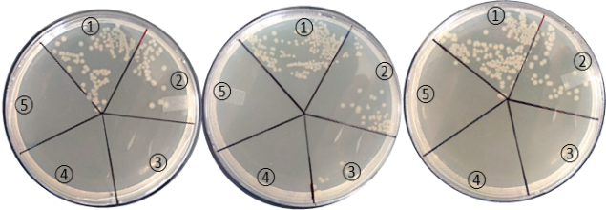  0 $μ$g mL⁻¹ (1); 13 $μ$g mL⁻¹ (2); 25 $μ$g mL⁻¹ (3); 50 $μ$g mL⁻¹ (4); 75 $μ$g mL⁻¹ (5) | 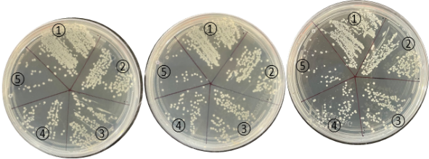  0 $μ$g mL⁻¹ (1); 50 $μ$g mL⁻¹ (2); 100 $μ$g mL⁻¹ (3); 150 $μ$g mL⁻¹ (4); 200 $μ$g mL⁻¹ (5)
Figure S6. SN-CNPs have antibacterial properties against both E. coli and L. Lactis.
Antibacterial activity tests of SN-CNPs at different concentrations against E. coli (a) and L. lactis (b) reveal that L. Lactis has much more tolerance or resistance to SN-CNPs than E. coli.

