Table 1 - Samples name, image of the object or of the point on the artwork from which the sample was taken, description of the sampled artwork/object and of the region where the samples were taken.
Sample name |  | Artwork/object  image | Description of the sampled artwork/object | Sampled region
ARTWORKS | A2 | 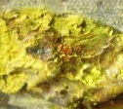 | Untitled- FPJM-29  Oil on canvas  1978 | Visibly degraded yellow paint, discoloured and chalky. Sample taken from a thick area of impasto.
ARTWORKS | A7 | 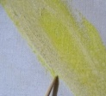 | Untitled- FPJM-54.1  Oil, acrylic and charcoal on canvas  1973 | Visibly degraded yellow paint, discoloured and powdery, with some whitish crusts on the surface.
ARTWORKS | A9 | 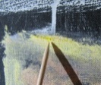 | Untitled- FPJM-53  Oil, acrylic and chalk on canvas  1974 | Visibly degraded yellow paint, discoloured and powdery, with some whitish crusts on the surface.
OIL PAINT TUBES | A3 | 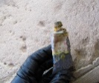 | Tube of yellow oil paint  Mir  Artist studio Son Boter | Yellow sample taken from the dry paint around the edge of the paint tube.
OIL PAINT TUBES | A5 | 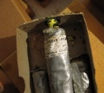 | Tube of Cadmium Yellow Lemon No.1  Lucien Lefebvre-Foinet  Artist studio Son Boter | Yellow sample taken from the inside of the paint tube (liquid).
OIL PAINT TUBES | A6 | 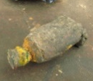 | Tube of yellow oil paint  Unknown brand, possibly Mir  Artist studio Taller Sert | Yellow sample taken from the dry paint around the edge of the paint tube.
ARTIST PALETTES | A1 | 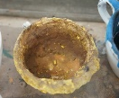 | Cup used for mixing paint  Artist studio Taller Sert | Visibly degraded yellow paint, discoloured and chalky.
ARTIST PALETTES | A4 | 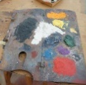 | Artist palette  Artist studio Taller Sert * | Yellow sample taken from the edge of the yellow paint on the palette.
ARTIST PALETTES | A12 | 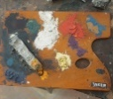 | Artist palette  Artist studio Taller Sert | Visibly degraded yellow paint, discoloured and chalky. Sample taken from the edge of the yellow paint on the palette.
* Inside a display case from 1986 to 2018, then removed and placed in the Taller Sert studio.

