Supplementary Materials: Anomalous interlayer exciton diffusion in WS₂/WSe₂ moiré heterostructure
Antonio Rossi*^{1,2,}†‡, Jonas Zipfel^{1,}†, Indrajit Maity*^{3,}†, Monica Lorenzon¹, Luca Francaviglia¹, Emma C. Regan⁴, Zuocheng Zhang⁴, Jacob H. Nie^{4,5}, Edward Barnard¹, Kenji Watanabe⁶, Takashi Taniguchi⁷, Eli Rotenberg², Feng Wang⁴, Johannes Lischner³, Archana Raja¹* and Alexander Weber-Bargioni¹*
1-The Molecular Foundry, Lawrence Berkeley National Laboratory, Berkeley, USA.
2-Advanced Light Source, Lawrence Berkeley National Laboratory, Berkeley, USA.
3-Imperial College London, South Kensington Campus, London, United Kingdom.
4-Department of Physics, University of California at Berkeley, Berkeley, CA, USA.
5-Department of Physics, University of California at Santa Barbara, Santa Barbara, CA, USA
6-Research Center for Functional Materials, National Institute for Materials Science, 1-1 Namiki, Tsukuba, Japan 8
7-International Center for Materials Nanoarchitectonics, National Institute for Materials Science, 1-1 Namiki, Tsukuba,Japan
†-These authors contributed equally
‡-Current affiliation: Center for Nanotechnology Innovation @ NEST, Instituto Italiano di Tecnologia, Pisa,Italy
*Corresponding authors: antonio.rossi@iit.it, i.maity@imperial.ac.uk, araja@lbl.gov, awb@lbl.gov,

Figure S1: Sample Characterization¹
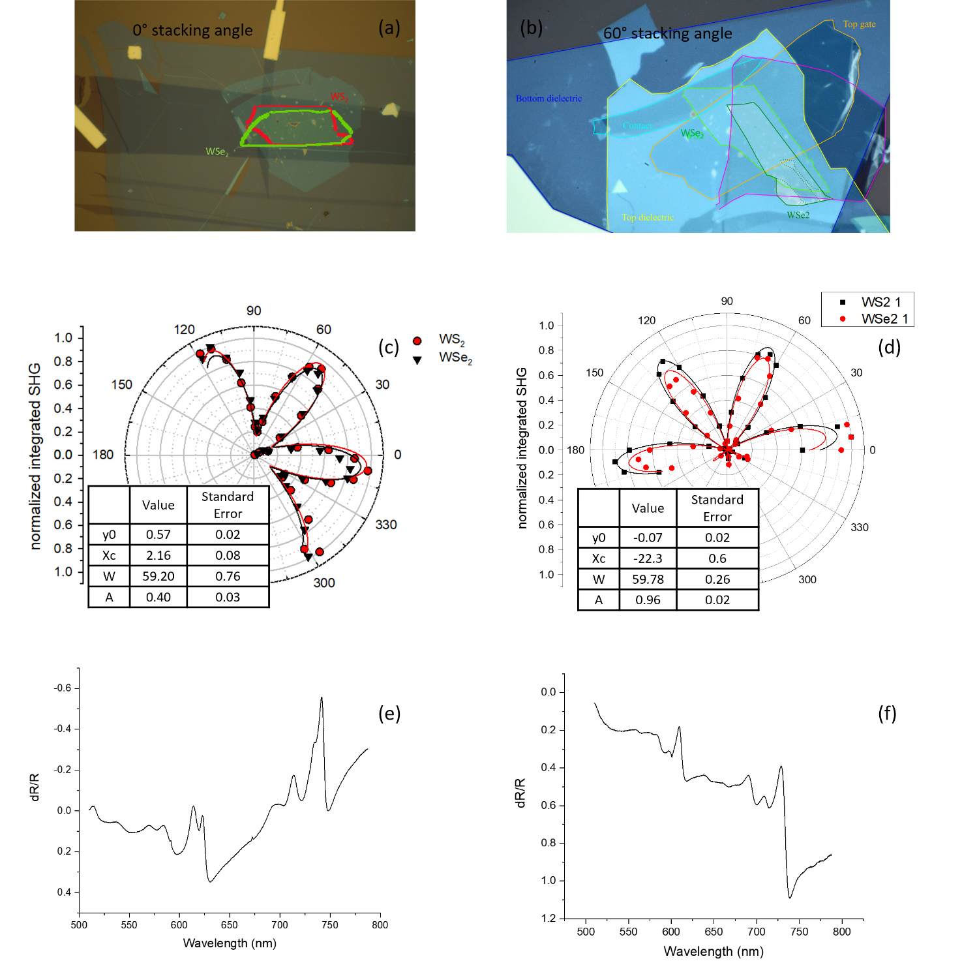
Figure S1. Optical image of the samples used for this work. (a) and (b) are images of the 0° and 60° stacking angle samples respectively. (c-d) Second Harmonic Generation (SHG) analysis confirming the relative orientation of WS2 and WSe2 monolayers to be 0° and 60 respectively. (e-f) Adsorption spectra for the two samples. The sample in panel (a) is the same sample used in Ref.1.
0°
60°
¹

Figure S2: PL spectrum multipeak fitting
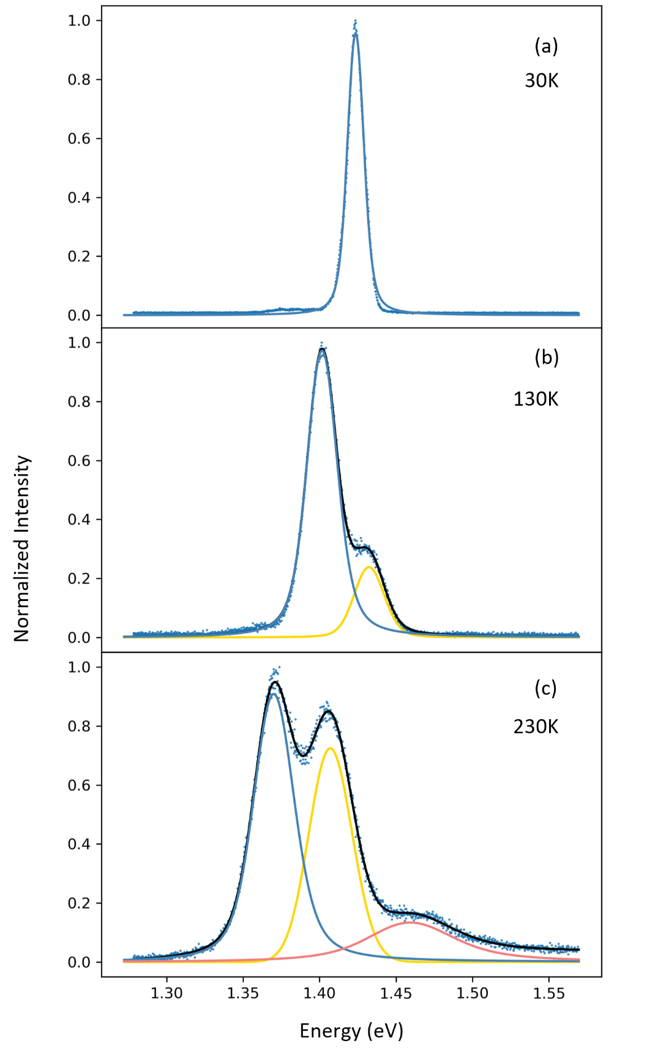
Figure S2. PL peak fitting for 0° sample at (a) 30 K, (b) 130K and (c) 230 K. The fitting is performed with one, two and three Voigt functions respectively.

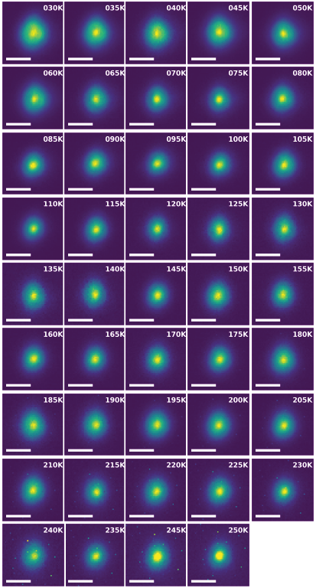
Figure S3: Diffusion Measurements
Figure S3. Spatially resolved PL emission from 0° stacking angle sample. Each image is taken at different temperatures, ranging from 30 K to 250 K.
Figure S4: Diffusion Measurements
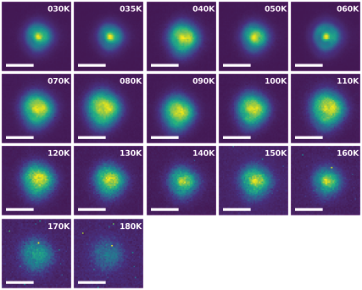
Figure S4. Spatially resolved PL emission from 0° stacking angle sample. Each image is taken at different temperatures, ranging from 30 K to 180 K

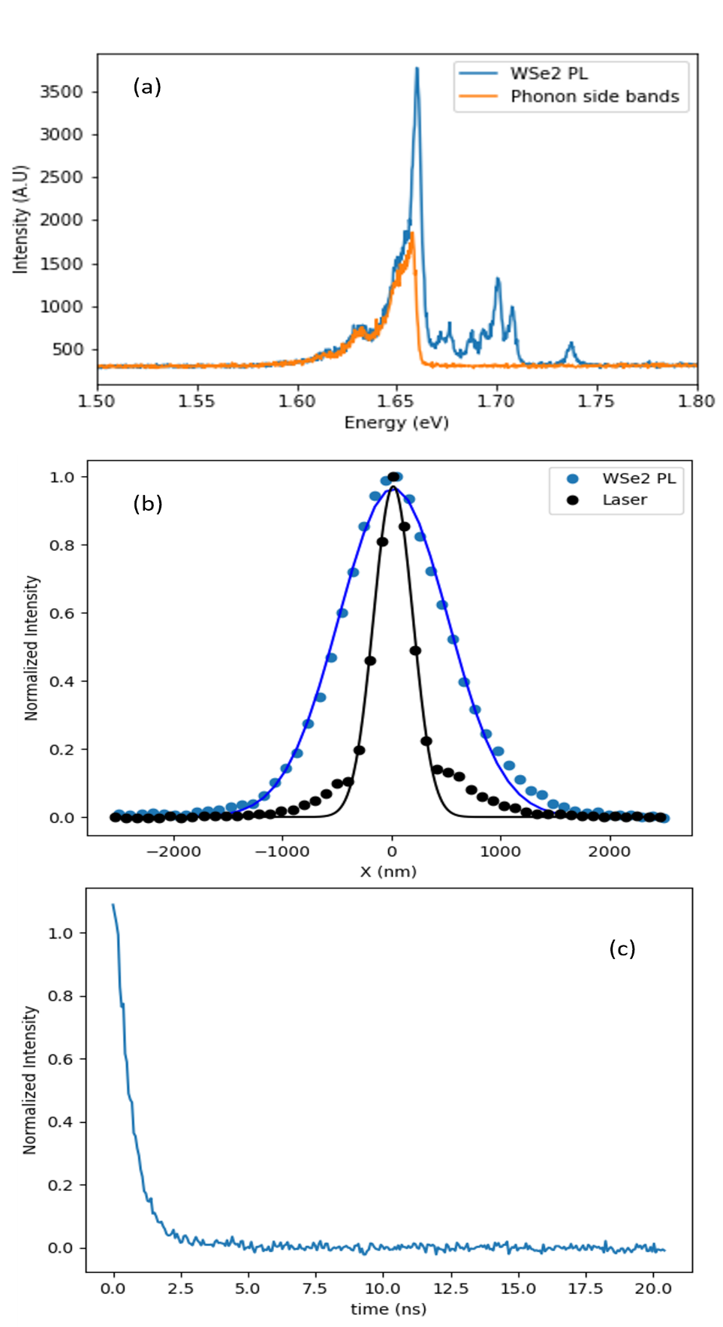
Figure S5: Exciton Diffusion single layer
L=466 nm
τ=0.8 ns
Figure S5. To estimate the exciton diffusivity at cryogenic temperature in monolayer we measure the dark exciton dynamic through their spectrally well separated phonon side-bands (PSB)². (a)PL spectra of WSe2 (blue) and PSB only (orange). Spatially(b) and (c) time resolved PL from PSB of isolated WSe₂ crystal The extracted diffusion length and lifetime are reported in the insets. The calculated Diffusivity is D = 1.35 cm²/s
²

Figures S6-S7-S8: Additional details on DFT Calculations
- Moiré potential using unit-cell calculations
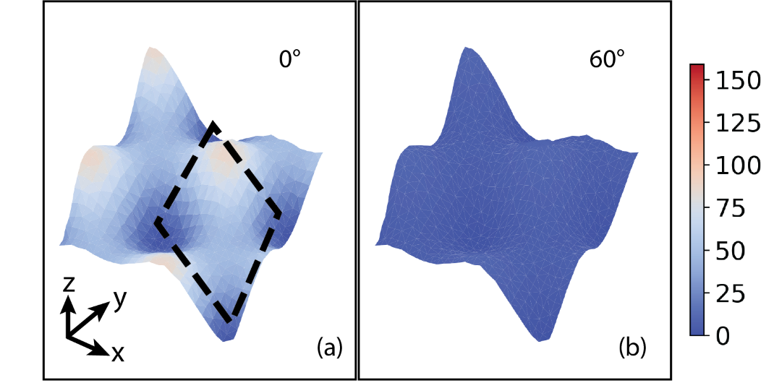
The unit-cell lattice-constants of the WS₂ and WSe₂ are 3.18 and 3.32 Å, respectively. The lattice mismatch (about 4%) gives rise to a moiré when WS₂ and WSe₂ are stacked together even without a twist angle. We extract the moiré potential using the approach discussed in the main text. We also strain both the layer (isotropic tensile strain for WS₂ and compressive strain for WSe₂) and set the unit-cell lattice to 3.25 Å. We find that the qualitative moiré potential differences between 0◦ and 60◦ stacking are similar to experiments (see Fig. S6). However, these unit-cell calculations that do not include atomic reconstructions hugely underestimate the moiré potential for exciton hopping (which were shown in the main text). All the calculations are performed with the Quantum ESPRESSO package³.
Figure S6. Moiré potential for the 0° and 60° alignment evaluated without atomic reconstruction.
- Moiré potential extraction from twisted bilayer
We develop a simple scheme to compute the moiré potential using large-scale DFT calculations by taking into account the full atomic reconstructions. In this approach, we explicitly consider the localization of the electronic wave functions and extract the local band gap for different high symmetry stacking regions. To illustrate this, we plot the electronic wave function |ψ_{Γ}|² for several bands near the band gap (see Fig. S 7). The valence bands are marked as V1, V2,... . V1 corresponds to Valence Band Maximum (VBM). Similarly, the conduction bands are marked as C1, C2,... . C1 corresponds to Conduction Band Minimum (CBM). The local band gap at the red diamond stacking is 0.775 eV and obtained from V2 and C1 bands. The local band gap at the orange diamond stacking is 0.843 eV and obtained from V1 and C4 bands. The local band gap at the green diamond stacking is 0.963 eV and obtained from V3 and C4 bands. Similarly, we obtain the local band-gaps for 0◦ twisted WS₂/WSe₂ heterobilayer.
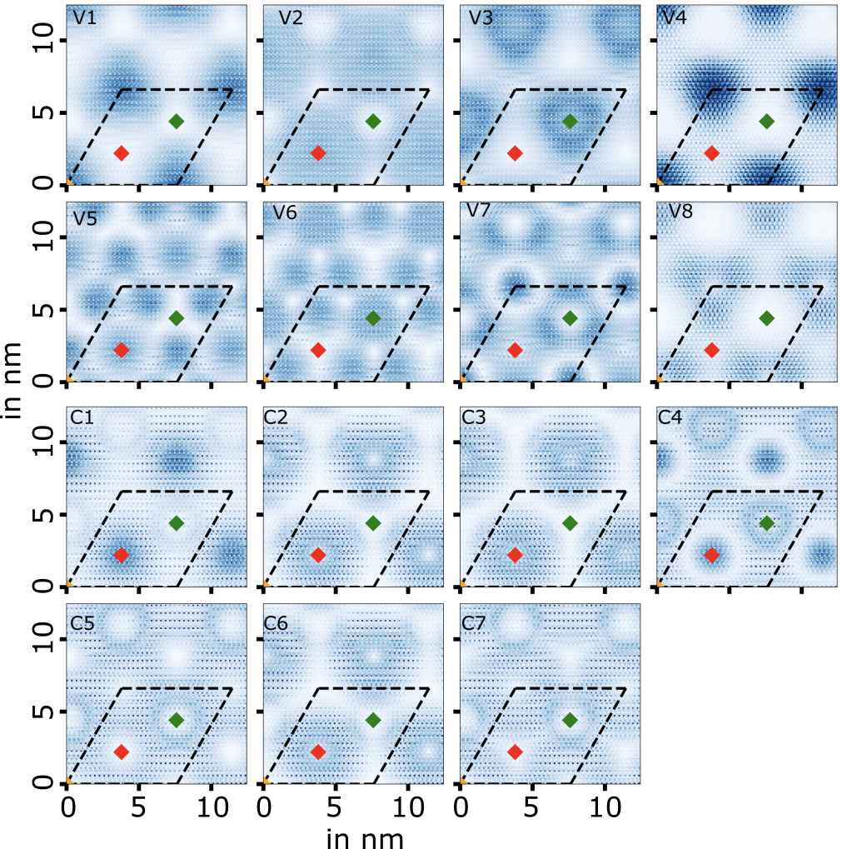
Figure S7. |ψ_{Γ}|² averaged in the out-of-plane directions for several bands of 60◦ twisted WS₂/WSe₂. The unit cell is marked with dashed lines and different high-symmetry stackings are marked with coloured diamonds.

- Moiré movements at different times
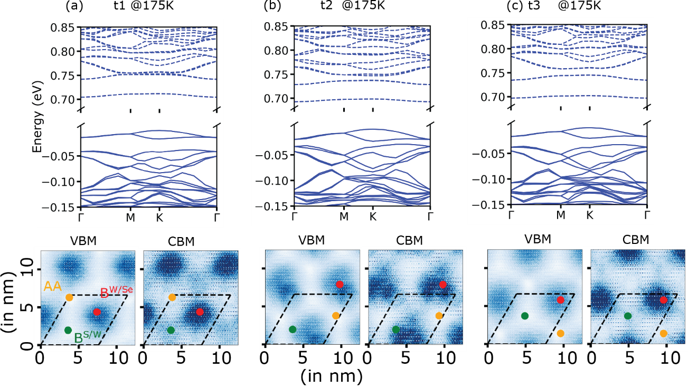
Figure S8. Electronic band-structures using density functional theory of the structures obtained from classical molecular dynamics simulations in the canonical ensemble at 175 K. The |ψ_{Γ}|2 averaged in the out-of-plane directions for the valence band maximum (VBM) and conduction band minimum (CBM) are shown in the bottom panel for the same structures. The center of different high-symmetry stackings in the moiré pattern is also marked.

Bibliography
1. Jin, C. et al. Identification of spin, valley and moiré quasi-angular momentum of interlayer excitons. Nat. Phys. 15, 1140–1144 (2019).
2. Rosati, R. et al. Temporal Evolution of Low-Temperature Phonon Sidebands in Transition Metal Dichalcogenides. ACS Photonics 7, 2756–2764 (2020).
3. Giannozzi, P. et al. QUANTUM ESPRESSO: a modular and open-source software project for quantum simulations of materials. J. Phys.: Condens. Matter 21, 395502 (2009).

