Bifunctional circular DNA amplifier transforms a classic CRISPR/Cas sensor into an ultrasensitive autocatalytic sensor
Fei Deng ^{a,b,}*, Rui Sang ^{a,b}, Yi Li ^{a,b,}*, Wei Deng ^{c}, Ewa M. Goldys ^{a,b,}*
ª Graduate School of Biomedical Engineering, Faculty of Engineering, University of New South Wales, Sydney 2052, Australia
^{b} ARC Centre of Excellence for Nanoscale Biophotonics, University of New South Wales, Sydney 2052, Australia
^{c} School of Biomedical Engineering, University of Technology Sydney, Sydney, NSW, 2007, Australia
* Correspondence: e.goldys@unsw.edu.au; yi.li6@unsw.edu.au; fei.deng@unsw.edu.au

List of abbreviations
DANCER | DNA amplifier enhanced CRISPR/Cas autocatalytic sensor
RNP | ribonucleoprotein
gRNA | guiding RNA or presenting the crRNA (CRISPR RNA), sgRNA (single guiding RNA)
target-C | target DNA for classic CRISPR/Cas12a sensor
gRNA-C | gRNA for classic CRISPR/Cas12a sensor
target-D | target DNA for DANCER
gRNA-D | gRNA for DANCER
ctDNA | circulating tumor DNA
gRNA-ct | gRNA for ctDNA detection sensor
ssDNA  dsDNA | single strand DNA  double strand DNA
c-DNA | Complementary DNA
Cir-ssDNA | circular single strand DNA
Cir-amplifier | a circular DNA comprising a dsDNA section and a ssDNA section which was created by a fluorescent labelled cDNA bound to a circular ssDNA
CRC-mouse | mice bearing with human colorectal cancer
LFA | Lateral flow assay
PCR | Polymerase Chain Reaction
RPA | Recombinase polymerase amplification
LAMP | Loop-mediated isothermal amplification
SERS | Surface-enhanced Raman spectroscopy
LOD | Limit of detection

Supplementary methods
Method S1. Materials
Chemicals and biological reagents: EnGen® Lba Cas12a (Cpf1) protein (New England Biolab), 10X NEB 2.1 buffer (New England Biolab), exonuclease VII (New England Biolab), SYBR Gold DNA dye (ThermoFisher), 10 bp DNA ladder (ThermoFisher), 6X DNA loading dye (ThermoFisher), copper sulfate (CuSO₄) (Sigma, 209198), Tris(2-carboxyethyl) phosphine (TCEP) (Sigma, C4706), tris(benzyltriazolylmethyl) amine (TBTA) (ChemSupply, T2993), streptavidin coated magnetic particles (Spherotech, SVM-08-10), DNase/RNase free water (ThermoFisher), phosphate buffered saline (PBS) (Sigma, 10 mM, pH=7.4), and HybriDetect – Universal Lateral Flow Assay Kit (Milenia biotec).
All DNA and RNA oligos are synthesized and modified by Sangon Bio-Tech Ltd.
Method S2. Investigation of the ssDNA linker length in Cir-amplifier.
To investigate the ssDNA linker length in Cir-amplifier, we conducted the following two step experiments. In the first step, the reaction mixture was prepared as follows: 1 µL 100 µM (100 pmol) of Cas12a protein was gently mixed with 5 µL 20 µM (100 pmol) of classic-gRNA in 3.6 mL 1X NEB 2.1 buffer. Then, 180 µL of 5 µM (0.9 nmol) of Cir-amplifier with different linker length were added and well mixed to form the reaction mixture. Afterwards, 10 µL 0.25 µM of the target-C ssDNA was added into 90 µL of the prepared CRISPR/Cas12a reaction mixture for activating trans-cleavage of Cas12a and cleaving Cir-amplifiers to linearized Cir-amplifiers. After one hour incubation at room temperature, the reaction mixture was collected for further use. To eliminate the influence of activated Cas12a RNPs from step 1, the reaction mixture was heated to 65 ℃ for 10 min to deactivate all the Cas12a RNPs from step 1. This ensures that only linearized Cir-amplifier will be the active trigger for downstream step 2 biosensing system.
In the second step, the reaction mixture was prepared as follows: 1 µL 100 µM (100 pmol) of Cas12a protein was gently mixed with 5 µL 20 µM (100 pmol) of amplifier-gRNA in 3.6 mL 1X NEB 2.1 buffer. Then, 6 µL of 100 µM (0.6 nmol) of pre-synthesized fluorescent quenched ssDNA reporters (Texas red-TTATT-BHQ2) were added and well mixed to form the reaction mixture. Subsequently, 10 µL of prepared reaction mixture from step 1 (25 nM) was added to 90 µL CRISPR/Cas12a reaction mixture prepared in step 2 and incubated for 120min. A SpectraMax iD5 multi-Mode Microplate Reader (Molecular Devices) was applied for the detection of fluorescence readout. The Ex/Em of Texas red-TTATT-BHQ2 reporter was 570/615 nm.
Method S3. The evaluation and biosensing application of two Cas12a RNP based autocatalysis biosensing system (DANCER-2)
The two Cas12a RNP based autocatalysis reaction mixture was prepared as follows: 1 µL 100 µM (100 pmol) of Cas12a protein was gently mixed with 5 µL 20 µM (100 pmol) of classic-gRNA to form the Cas12a RNP-1. In the meanwhile, 1 µL 100 µM (100 pmol) of Cas12a protein was gently mixed with 5 µL 20 µM (100 pmol) of D-gRNA to form the Cas12a RNP-2. Afterwards, the prepared Cas12a RNP-1 and Cas12a RNP-2 were mixed with 200 µL of 5 µM (1 nmol) of Cir-amplifiers in 5 mL 1X NEB 2.1 buffer to form the standard reaction mixture.
Afterwards, 10 µL of target-C ssDNA at different concentrations were added to 90 µL of the prepared reaction mixture for activating trans-cleavage of Cas12a and enabling the CRISPR/Cas biosensing reaction. A SpectraMax iD5 multi-Mode Microplate Reader (Molecular Devices) was applied for the detection of fluorescence readout.

Supplementary Note (Kinetics)
In order to understand the kinetics of the Cir-amplifier system discussed here, we extend and adapt the model outlined in Ref ¹, broadly following their notation to facilitate comparisons. In this approach Briggs-Haldane approximation is used.
We denote:
$U_{0}$ - initial concentration of supplied RNPs,
$\left[U\right]$- concentration of inactive Cas RNPs
$\left[E\right]$ - total concentration of activated RNPs which are not complexed with reaction intermediates,
[E_{T}] – total concentration of activated RNPs,
$\left[T\right]$ - concentration of targets,
${[S}_{cir}]$- concentration of Cir-amplifiers in their circular form
${[P}_{cir}]$ - concentration of linearised (cleaved) Cir-amplifiers
$\left[C_{cir}\right]$ - concentration of reaction intermediates – activated RNP and Cir-amplifier complexes (Cir-amplifiers in their circular, uncleaved form),
The species conservation conditions and their meaning are as follows:
$\left[E_{T}\right]=\left[E\right]+[C_{cir}]$ concentration of total activated RNPs = concentration of total activated uncomplexed RNPs + concentration of the reaction intermediates).
$U_{0}=\left[U\right]$+ [E_{T}] initial concentration of RNPs = sum of inactive and active RNPs
$\left[C_{cir}\right]+\left[S_{cir}\right]+\left[P_{cir}\right]=S_{cir0}$ Cir-amplifiers complexed with RNPs + uncleaved Cir-amplifiers in their circular form + cleaved (linearised) Cir-amplifiers = initial concentration of supplied Cir-amplifiers in their circular form.
The initial conditions are:
${[E}_{T}]\left(0\right)=0$ - initial concentrations of activated RNPs expressing no initial RNP activation,
$U_{0}$ - initial concentration of RNPs,
$S_{cir0}$- initial concentration of Cir-amplifiers in their circular form,
$P_{cir0}$ = 0 - initial concentration of linearised (cleaved) Cir-amplifiers,
We also denote:
$C_{cir0}$ - a constant describing the concentration of the reaction intermediate for RNPs with uncleaved Cir-amplifiers according to the Briggs-Haldane approximation.
The reactions describing the activation of the RNPs can be modelled as:
$U+T+P_{cir} ↔E_{T}$ with bimolecular association and dissociation rate constants $k_{on}, k_{off}$
The rate equation for RNP activation is:
$\frac{d{[E}_{T}]}{dt}= k_{on}\left[U\right](\left[T\right]+\left[P_{cir}\right])- k_{off}\left[E_{T}\right]$ /1/
The catalytic reaction of Cir-amplifier cleavage (linearisation) is modelled as:
$${{(k}_{f}{,k}_{r}) (k}_{cat})$$
$E+S_{cir} ↔ C_{cir} → E+P_{cir}$ /4/
Here, ${(k}_{f}{,k}_{r})$ are bimolecular association and dissociation rate constants for the reaction between activated RNP and Cir-amplifier in circular form, while $k_{cat}$is the cleavage rate of Cir-amplifier.
The Cir-amplifier system is described by the following system of nonlinear differential equations:
The “catalysis” equation is:
$\frac{d\left[E\right]}{dt}= - k_{f}\left[E\right]\left[S_{cir}\right]+{(k}_{r}+k_{cat)}\left[C_{cir}\right]$ /6/
The “substrate” equation is, correspondingly:
$\frac{d\left[S_{cir}\right]}{dt}= - k_{f}\left[E\right]\left[S_{cir}\right]+ k_{r}\left[C_{cir}\right]$ /8/
The “intermediate” equation describing how the reaction intermediates are formed is given by:
$\frac{d\left[C_{cir}\right]}{dt}= k_{f}\left[E\right]\left[S_{cir}\right]- {(k}_{r}+k_{cat})\left[C_{cir}\right]$ /10/
The “product” equation is:
$\frac{d\left[P_{cir}\right]}{dt}= k_{cat}\left[C_{cir}\right]$ /12/
These equations, together with species conservation conditions and initial conditions, allow to predict all relevant concentrations in this problem.
In the below the cleaved reporter rate $\frac{d\left[P_{cir}\right]}{dt}$ is referred to as the “experimental observable”.
Result 1: The experimental observable reflects the concentration of activated RNPs in the Briggs-Haldane approximation.
Derivation:
We first apply the standard approximation (Briggs -Haldane) to the Cir-amplifier. This approximation says that the concentration of reaction intermediates is constant ($\left[C_{cir}\right]=$ const)
From Equation /10/ we then get
$$\frac{d\left[C_{cir}\right]}{dt}=0= k_{f}\left[E\right]\left[S_{cir}\right]- {(k}_{r}+k_{cat})\left[C_{cir}\right]$$
Hence
$$k_{f}\left[E\right]\left[S_{cir}\right]= {(k}_{r}+k_{cat})\left[C_{cir}\right]$$
This leads to the Michaelis-Menten equation, in the following way. We substitute in the above equation
$$\left[E\right]= \left[E_{T}\right]-\left[C_{cir}\right]$$
$$k_{f}(\left[E_{T}\right]-\left[C_{cir}\right])\left[S_{cir}\right]= {(k}_{r}+k_{cat})\left[C_{cir}\right]$$
This gives
$\left[C_{cir}\right]= \frac{k_{f}\left[E_{T}\right]\left(\left[S_{cir}\right]\right)}{{(k}_{r}+ k_{cat}+ k_{f}\left(\left[S_{cir}\right]\right)}$=

Hence from Equation /16/ the rate $\frac{d(\left[P_{cir}\right])}{dt}$can be expressed as:
$$\frac{d(\left[P_{cir}\right])}{dt}= k_{cat}(\left[C_{cir}\right])= \frac{k_{cat}k_{f}\left[E_{T}\right]\left(\left[S_{cir}\right]\right)}{{(k}_{r}+ k_{cat}+ k_{f}\left(\left[S_{cir}\right]\right)}$$
which can be expressed using the Michaelis-Menten constant $K_{M}=\frac{{(k}_{r}+ k_{cat})}{k_{f}}$ as
$\frac{d(\left[P_{cir}\right])}{dt}= \frac{k_{cat}\left[E_{T}\right][S_{cir}]}{K_{M}+ {[S}_{cir}]}$
which is very similar to a standard Michaelis-Menten equation except that $\left[E_{T}\right]$ varies over the course of the reaction.
Result 2: When the RNPs and Cir-amplifiers are sufficiently abundant and do not get depleted, the experimental observable increase approximately exponentially.
Derivation: The condition that Cir-amplifiers are sufficiently abundant means that $\left[S_{cir}\right]= S_{cir0}$, and we are also assuming here that $S_{cir0} ≫\left[T\right].$ Sufficiently abundant RNPs means that $\left[U_{cir}\right]$ can be approximated by $U_{cir0}$.We will assume that $S_{cir0}$and $\left[E\right]$ are comparable and that the Briggs-Haldane approximation is also applicable to Cir-amplifier, so $\left[C_{cir}\right]=$ const.

$\frac{d(\left[P_{cir}\right])}{dt}= \frac{k_{cat}\left[E_{T}\right][S_{cir}]}{K_{M}+ {[S}_{cir}]}$=$\frac{k_{cat}\left[E_{T}\right]S_{cir0}}{K_{M}+ S_{cir0}}$=

Hence, in order to evaluate the experimental observable, we need to evaluate $\left[E_{T}\right].$
The relevant activation equation in our approximation where we have many more Cir-amplifiers than targets is derived from Equation /1/ as:
$\frac{d\left[E_{T}\right]}{dt}= k_{on}U_{cir0}\left[P_{cir}\right]{ - k}_{off}\left[E_{T}\right]$ /19/
Combining Equation /12/ with Equation /10/ where $\frac{d\left[C_{cir}\right]}{dt}=0$ we get in our regime and after the application of Briggs-Haldane approximation:
$\frac{d\left[P_{cir}\right]}{dt}=$ ${{k_{cat}k}_{f}\left[E\right]S_{cir0}}/{\left(k_{r}+k_{cat} \right)}=\frac{{k_{cat}k}_{f} S_{cir0}}{\left(k_{r}+k_{cat} \right)}*(\left[E_{T}\right]- C_{cir0})$ /20/
Equations /19/ and /20/ have the form:
$\frac{d\left[E_{T}\right]}{dt}= p\left[P_{cir}\right]-k_{off}\left[E_{T}\right]$ /21/
$\frac{d\left[P_{cir}\right]}{dt}=q(\left[E_{T}\right]$-$C_{cir0})$ /22/
where ${p= k}_{on} U_{cir0}$ and
$$q= {{k_{cat}k}_{f}S_{cir0}}/{\left(k_{r}+k_{cat} \right)}$$

From Equations /21/ and /22/ we get:

$\frac{d^{2}\left[E_{T}\right]}{{dt}^{2}}+k_{off}\frac{d\left[E_{T}\right]}{dt}-pq\left[E_{T}\right]+pqC_{cir0}=0$ /23/
The solution of Equation /23/ is a sum of a general solution of a homogeneous equation and a specific solution of an inhomogeneous equation. We can guess that specific solution by noticing that a constant $E_{s}$can satisfy the inhomogeneous equation as long as:
$-pqE_{s}+pqC_{cir0}=0$
so
$E_{s}=C_{cir0}$
Consequently,
$\left[E_{T}\right]=A\exp{{(λ}_{1}}t)+B \exp{{(λ}_{2}}t)+C_{cir0}$ /24/
where $λ_{1}=\frac{-k_{off}+ \sqrt{{k_{off}}^{2}+4pq}}{2}$ and $λ_{2}=\frac{-k_{off}- \sqrt{{k_{off}}^{2}+4pq}}{2}$ and $A,B$ are constants obtained from the initial conditions ( $\left[E_{T}\right]\left(0\right)=0$, and $\frac{d\left[E_{T}\right]}{dt}\left(0\right)=0$).
We can use Equation /18/ to express the experimental observable:

$$\frac{d\left[P_{cir}\right]}{dt}= \frac{k_{cat}\left[E_{T}\right]{[S}_{cir}]}{K_{M}+[S_{cir}]}=$$
$= \frac{k_{cat}{[S}_{cir}]}{(K_{M}+\left[S_{cir}\right])} * \left(A\exp{{(λ}_{1}}t)+B \exp{{(λ}_{2}}t)+C_{cir0}\right)$ /25/

Hence at increasing times under the above experimental conditions we should observe the fluorescence rates increasing approximately exponentially. The fluorescence signal is proportional to the integral of fluorescence rate. Exponentially increasing rate produces a signal exponentially increasing with time.
At increasing times, the solution is dominated by the term $\exp{{(λ}_{1}}t) .$The exponent $λ_{1}$ can be experimentally controlled via $pq$, which is a product of various molecular constants and $S_{cir0}U_{cir0}$. Correspondingly, to maximise the reaction rate in the reaction mixture, the concentration of enzyme and substrate should be maximised, while making sure that the substrate is not depleted.

Supplementary Figures
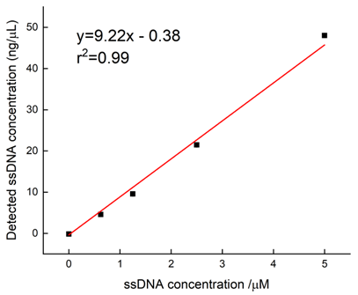
Figure S1. Standard calibration curve for the calculation of Cir-ssDNA concentration using Nanodrop (ThermoFisher) (Method 1).

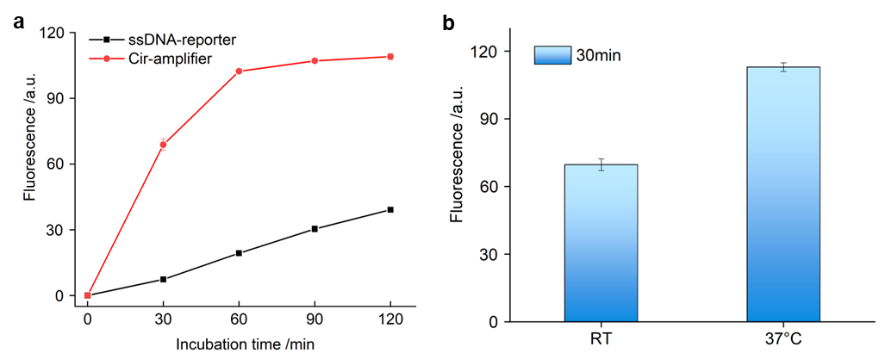
Figure S2. Evaluation of Cir-amplifier as fluorescent reporters in a classic CRISPR/Cas12a biosensing system (Method 2). (a) Comparison of the biosensing performance of Cir-amplifier and ssDNA reporter in a classic CRISPR/Cas12a biosensing system; (b) Comparison of the biosensing performance of Cir-amplifier at RT and 37℃.

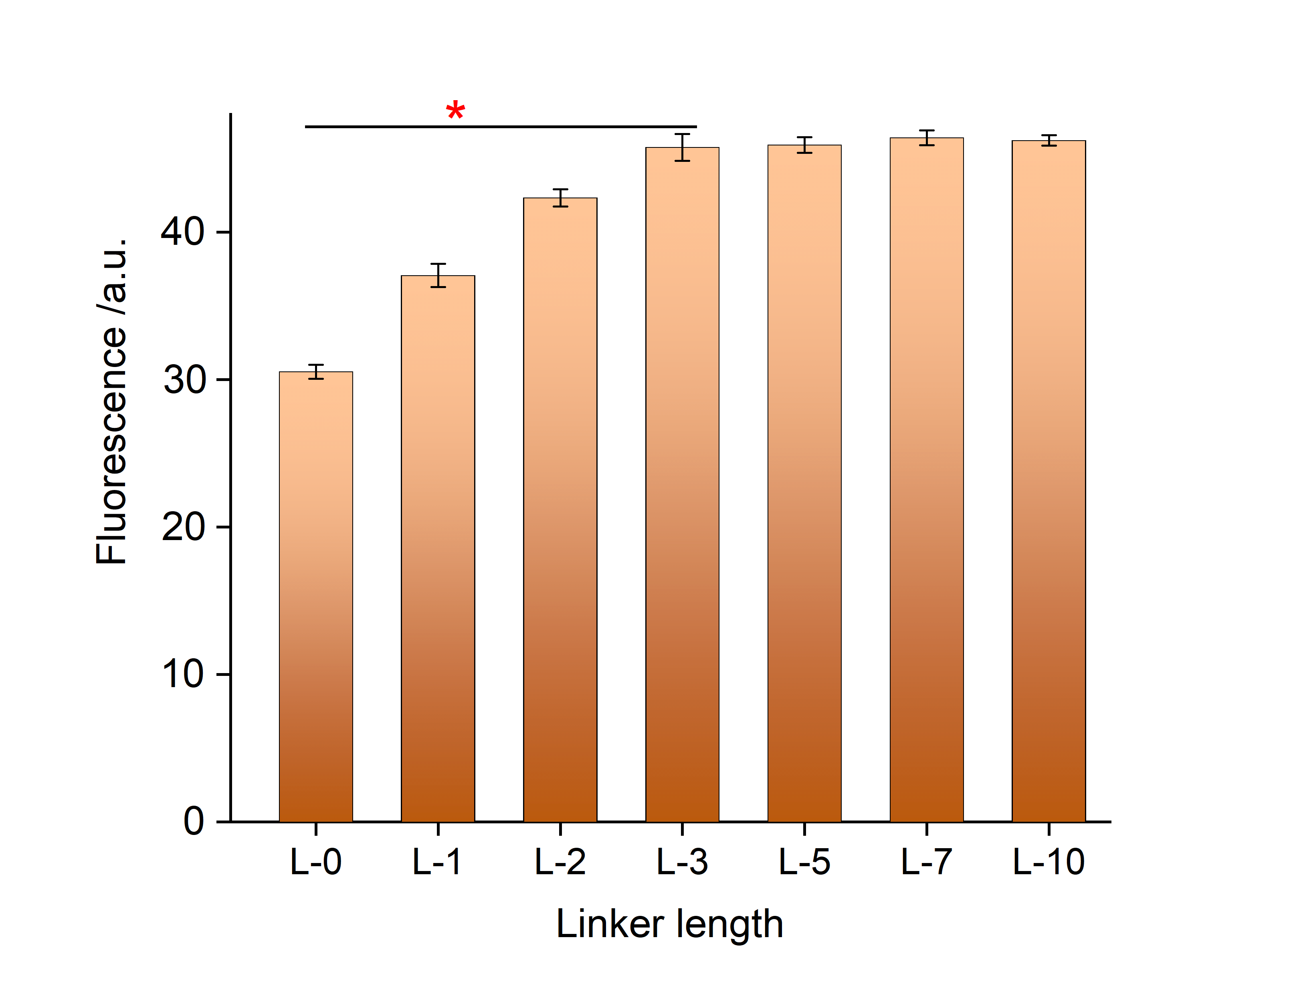
Figure S3. Investigation of the ssDNA linker length in the Cir-amplifier (Method S2).

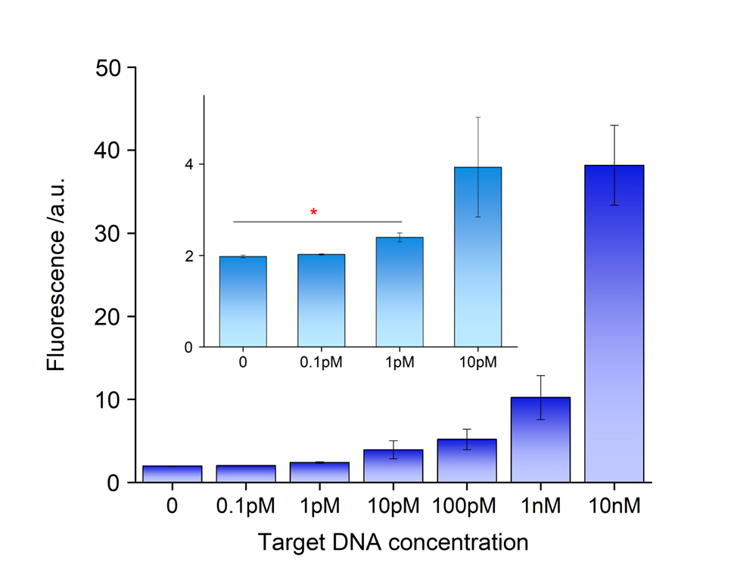
Figure S4. The calibration curve of a classic CRISPR/Cas12a biosensing system (Method 2).

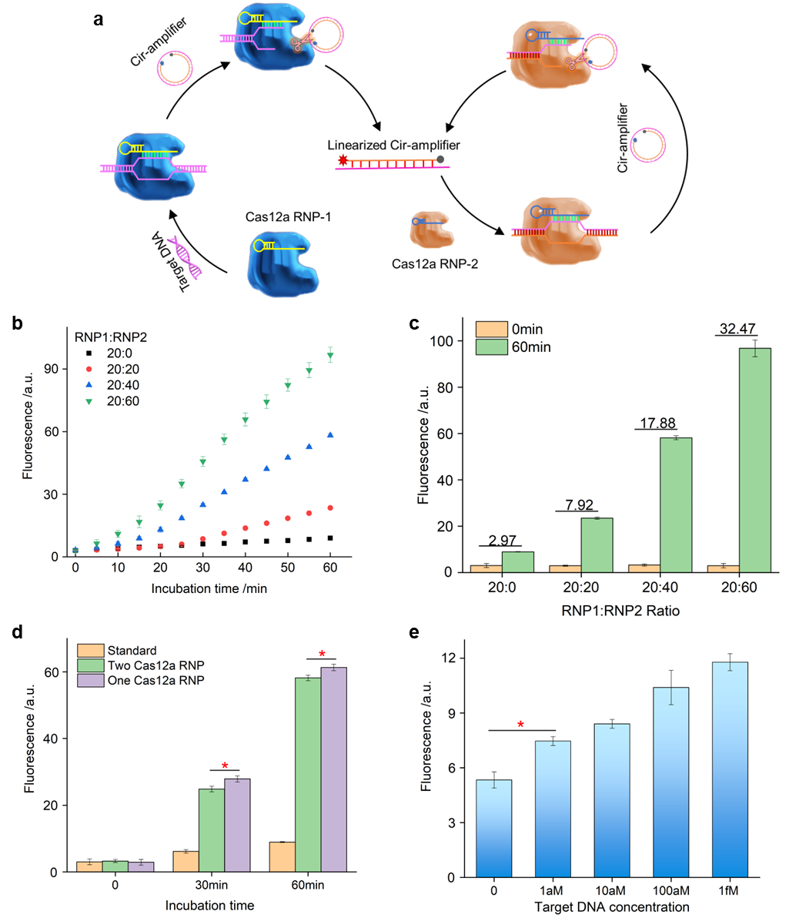
Figure S5. The development of Cir-amplifier assisted autocatalysis biosensing system using two different types of Cas12a RNPs (DANCER-2) (Method S3). (a) The schematic for the development of DANCER-2; (b) The investigation of Cas12a RNP1 and RNP2 ratio (Cir-amplifier 200 nM, and 1 pM target-C); (c) The amplified signals of Cas12a RNP1-RNP2 biosensing system (Cir-amplifier 200 nM, and 1 pM target-C); (d) The comparison of DANCER-2 (two Cas12a RNPs) and DANCER (One Cas12a RNP); (e) The limit of detection of DANCER-2.

Supplementary Tables
Table S1. DNA and RNA oligos used in Fig. 2 & Fig. S1.
Name | Oligo type | Sequence 5’-3’ | Modification
Cir-ssDNA-19nt | ssDNA | T CTA /iBio-dT/GT GCT ATG TCT AAA | 5’-Azide (N3); 3’-CHCH

Table S2. DNA and RNA oligos used in Fig. 3 & Fig. S2.
Name | Oligo type | Sequence 5’-3’ | Modification
18nt cDNA | ssDNA | TTT AGA CAT AGC ACA TAG | 5’-Texa Red; 3’-BHQ2
Cir-ssDNA-18nt (L-0) | ssDNA | CTA /iBio-dT/GT GCT ATG TCT AAA | 5’-Azide (N3); 3’-CHCH
Cir-ssDNA-19nt (L-1) | ssDNA | T CTA /iBio-dT/GT GCT ATG TCT AAA | 5’-Azide (N3); 3’-CHCH
Cir-ssDNA-21nt (L-3) | ssDNA | TTT CTA /iBio-dT/GT GCT ATG TCT AAA | 5’-Azide (N3); 3’-CHCH
Cir-ssDNA-23nt (L-5) | ssDNA | TT TTT CTA /iBio-dT/GT GCT ATG TCT AAA | 5’-Azide (N3); 3’-CHCH
Cir-ssDNA-25nt (L-7) | ssDNA | T TTT TTT CTA /iBio-dT/GT GCT ATG TCT AAA | 5’-Azide (N3); 3’-CHCH
target-C | ssDNA | GAA GAC ACC CTA CCA ACC CCC CCC | N/A
gRNA-C | ssRNA | UAA UUU CUA CUA AGU GUA GAU GGG GGG GGU UGG UAG GGU GUC | N/A
ssDNA reporter | ssDNA | TTATT | 5’-Texa Red; 3’-BHQ2

Table S3. DNA and RNA oligos used in Fig. 4b.
Name | Oligo type | Sequence 5’-3’ | Modification
25nt cDNA | ssDNA | TTT AGA CAT AGC ACA TAG ACT GAG A | N/A
Cir-ssDNA-28nt | ssDNA | TTT TCT CAG TCT A/iBio-dT/G TGC TAT GTC TAA A | 5’-Azide (N3); 3’-CHCH
21nt cDNA | ssDNA | TTT AGA CAT AGC ACA TAG ACT | N/A
Cir-ssDNA-24nt | ssDNA | TTT AGT CTA /iBio-dT/GT GCT ATG TCT AAA | 5’-Azide (N3); 3’-CHCH
18nt cDNA | ssDNA | TTT AGA CAT AGC ACA TAG | N/A
Cir-ssDNA-21nt | ssDNA | TTT CTA /iBio-dT/GT GCT ATG TCT AAA | 5’-Azide (N3); 3’-CHCH
15nt cDNA | ssDNA | TTT AGA CAT AGC ACA | N/A
Cir-ssDNA-18nt | ssDNA | TTT /iBio-dT/GT GCT ATG TCT AAA | 5’-Azide (N3); 3’-CHCH
target-D | ssDNA | TCT CAG TCT ATG TGC TAT GTC | N/A
gRNA-D | ssRNA | UAA UUU CUA CUA AGU GUA GAU GAC AUA GCA CAU AGA CUG AGA | N/A
ssDNA reporter | ssDNA | TTATT | 5’-Texa Red; 3’-BHQ2

Table S4. DNA and RNA oligos used in Fig. 4c & Fig. S3.
Name | Oligo type | Sequence 5’-3’ | Modification
18nt cDNA | ssDNA | TTT AGA CAT AGC ACA TAG | N/A
Cir-ssDNA-18nt (L-0) | ssDNA | CTA /iBio-dT/GT GCT ATG TCT AAA | 5’-Azide (N3); 3’-CHCH
Cir-ssDNA-19nt (L-1) | ssDNA | T CTA /iBio-dT/GT GCT ATG TCT AAA | 5’-Azide (N3); 3’-CHCH
Cir-ssDNA-20nt (L-2) | ssDNA | TT CTA /iBio-dT/GT GCT ATG TCT AAA | 5’-Azide (N3); 3’-CHCH
Cir-ssDNA-21nt (L-3) | ssDNA | TTT CTA /iBio-dT/GT GCT ATG TCT AAA | 5’-Azide (N3); 3’-CHCH
Cir-ssDNA-23nt (L-5) | ssDNA | TT TTT CTA /iBio-dT/GT GCT ATG TCT AAA | 5’-Azide (N3); 3’-CHCH
Cir-ssDNA-25nt (L-7) | ssDNA | T TTT TTT CTA /iBio-dT/GT GCT ATG TCT AAA | 5’-Azide (N3); 3’-CHCH
Cir-ssDNA-28nt (L-10) | ssDNA | T TTT TTT TTT CTA /iBio-dT/GT GCT ATG TCT AAA | 5’-Azide (N3); 3’-CHCH

Table S5. DNA and RNA oligos used in Fig. 5 & Fig. S5
Name | Oligo type | Sequence 5’-3’ | Modification
target-D | ssDNA | TCT CAG TCT ATG TGC TAT GTC | N/A
gRNA-D | ssRNA | UAA UUU CUA CUA AGU GUA GAU GAC AUA GCA CAU AGA CUG AGA | N/A
18nt cDNA | ssDNA | TTT AGA CAT AGC ACA TAG | 5’-Texa Red; 3’-BHQ2
Cir-ssDNA-21nt | ssDNA | TTT CTA /iBio-dT/GT GCT ATG TCT AAA | 5’-Azide (N3); 3’-CHCH
target-C | ssDNA | GAA GAC ACC CTA CCA ACC CCC CCC | N/A
gRNA-C | ssRNA | UAA UUU CUA CUA AGU GUA GAU GGG GGG GGU UGG UAG GGU GUC | N/A
ssDNA reporter | ssDNA | TTATT | 5’-Texa Red; 3’-BHQ2

Table S6. DNA and RNA oligos used in Fig. 6
Name | Oligo type | Sequence 5’-3’ | Modification
ctDNA² | ssDNA | CTC AGT GAT TTT AGA GAG AGG AT | N/A
gRNA-ct | ssRNA | UAA UUU CUA CUA AGU GUA GAU CCU CUC UCU AAA AUC ACU GAG | N/A
Cir-ssDNA | ssDNA | TTT A/iBio-dT/T TTA GAG AGA GGT AAA | 5’-Azide (N3); 3’-CHCH
cDNA | ssDNA | TTT ACC TCT CTC TAA AAT | 5’-Texa Red; 3’-BHQ2
cDNA-extend | ssDNA | TTT ACC TCT CTC TAA AAT CCC CC | 5’-FAM; 3’-Biotin
ssDNA reporter | ssDNA | TTATT | 5’-Texa Red; 3’-BHQ2

References:
1 Ramachandran, A. & Santiago, J. G. CRISPR enzyme kinetics for molecular diagnostics. Analytical chemistry 93, 7456-7464 (2021).
2 Zhou, M. et al. Spherical nucleic acid reporter-based cascade CRISPR/Cas12a amplifier for stable and sensitive biosensing of circulating tumor DNA. Chemical Communications 58, 4508-4511 (2022).

