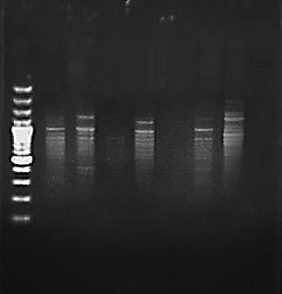

Figure S1: PCR amplified product showing different banding pattern in grape cultivars with primers (GTG)5

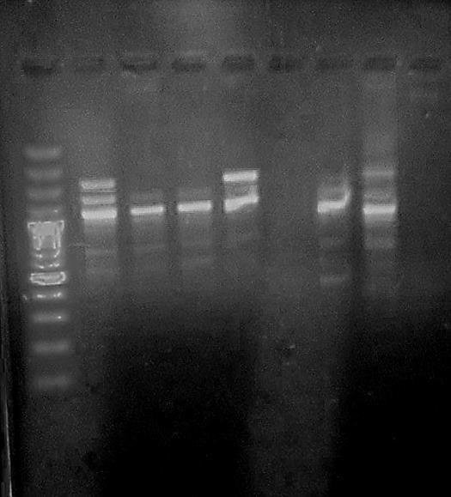

Figure S2: PCR amplified product showing different banding pattern in grape cultivars with primers (GACA)4

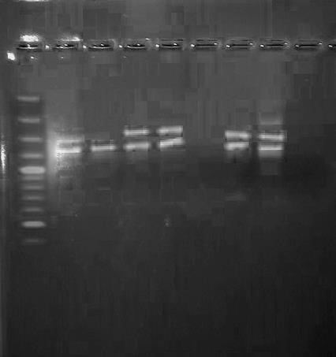

Figure S3: PCR amplified product showing different banding pattern in grape cultivars with primers (CAA)5

