Supplementary file:
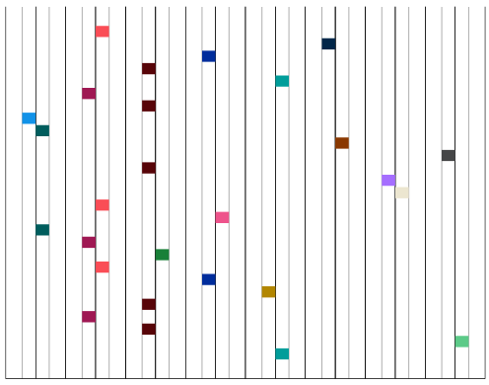
1 2 3 4 5 6 7 8 9 10 11 12 13 14 15 16

Figure S1: Major cities chosen for Oral Health Monitoring Survey in Tamil Nadu, India

1; Chennai, 2; Salem & Madurai, 3; Nagappattinam, Chengalpattu & Virudhunagar, 4; Dharmapuri, Tiruvannamalai & Trichy, 5; Thanjavur, Thenkasi, Ramnad, Erode & Tiruvarur, 6; Kallakurichi, 7; Tiruvallur & Sivagangai, 8; Coimbatore, 9; Theni, 10; Pudukottai & Thiruthani, 11; Namakkal, 12; Perambalur, 13; Tirunelveli, 14; Mayiladuthurai, 15; Krishnagiri, 16; Cuddalore.

Table S1: Frequency of Oral hygiene practice in Tamil Nadu, India
Characteristics | Frequency  YES | N (%)
Oral hygiene practice
Tooth Clean Material  1. Tooth Brush  2. Neem Stick  3. Finger  4. Tooth Powder  5. All | 270  11  8  10  1 | 90  3.6  2.6  3.3  0.3
Mouth wash | 147 | 49
Time duration of tooth clean  a).1minutes  b). 2minutes  c). 3minutes | 54  172  74 | 18  57.3  24.7

