Supporting Information
for

Methyl Oleate Alkylated Tetralin with Dual-Functional Groups as Base Oil with PAO to Improve the Performance of Lithium-Based Grease
Qiong Tang, Zhiping Zhao, Ting Li, Leizhen Ge, Hong Xu, Lei Liu* and Jinxiang Dong
College of Chemical Engineering and Technology, Taiyuan University of Technology, Taiyuan, Shanxi,030024, China

* Corresponding author: Lei Liu, E-mail: liulei@tyut.edu.cn

1 Mass spectrum of MOAT
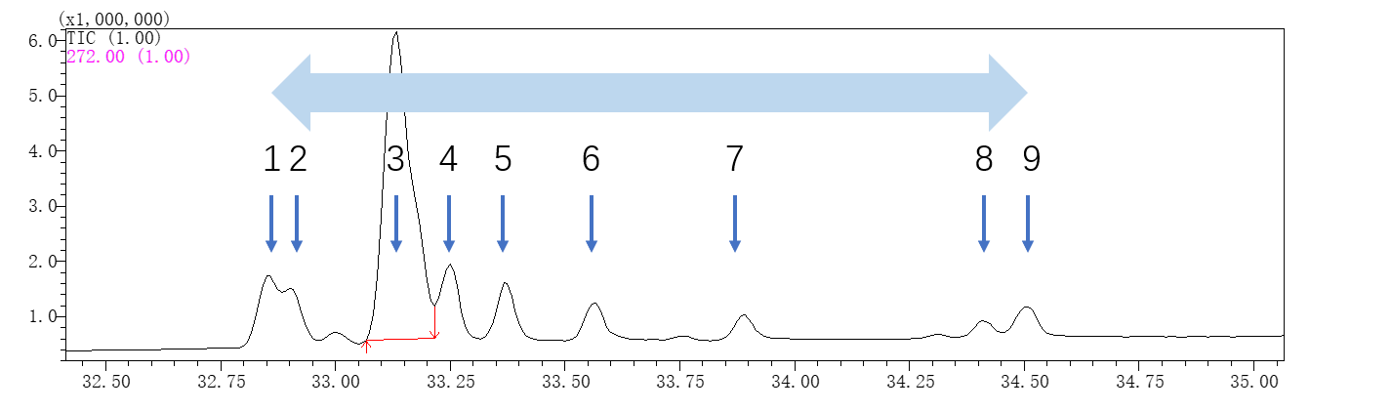
Peak-1
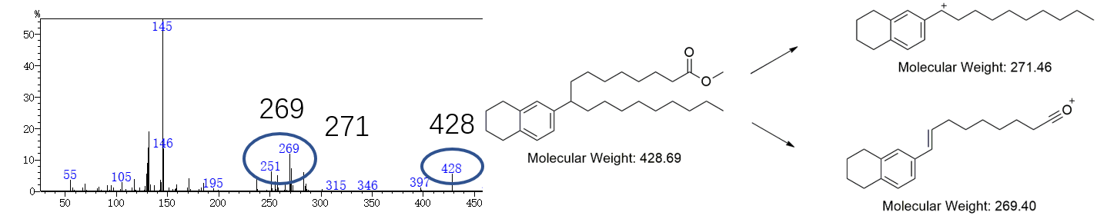
Peak-2
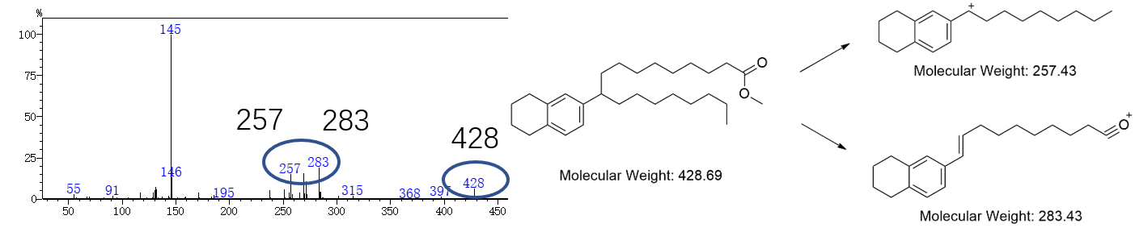
Peak-3
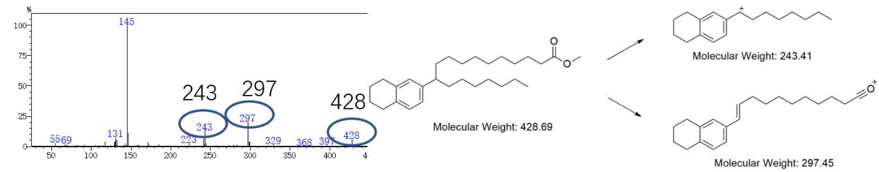
Peak-4
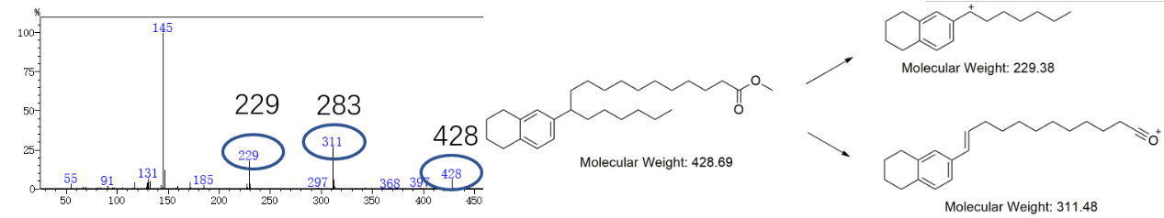
Peak-5
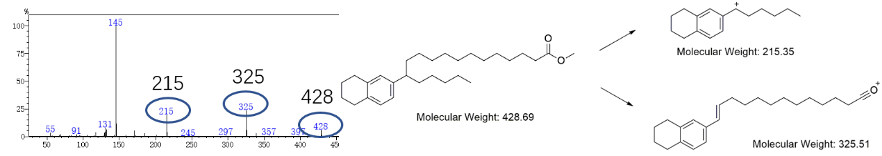
Peak-6
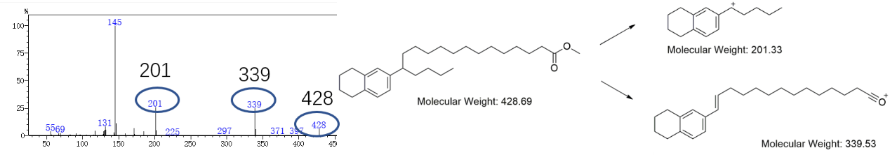
Peak-7
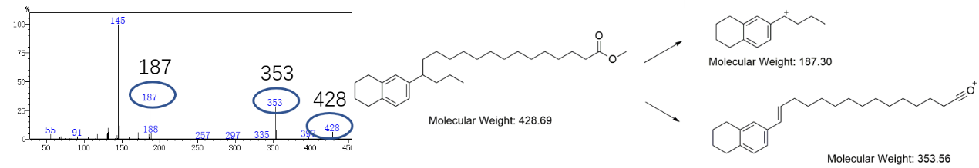
Peak-8
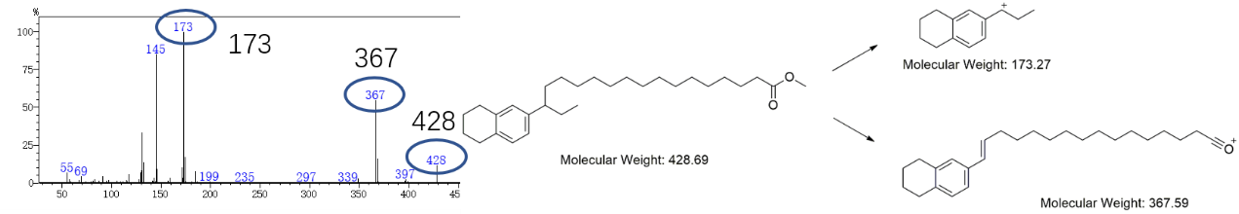
Peak-9
