TABLES RELATED FILES
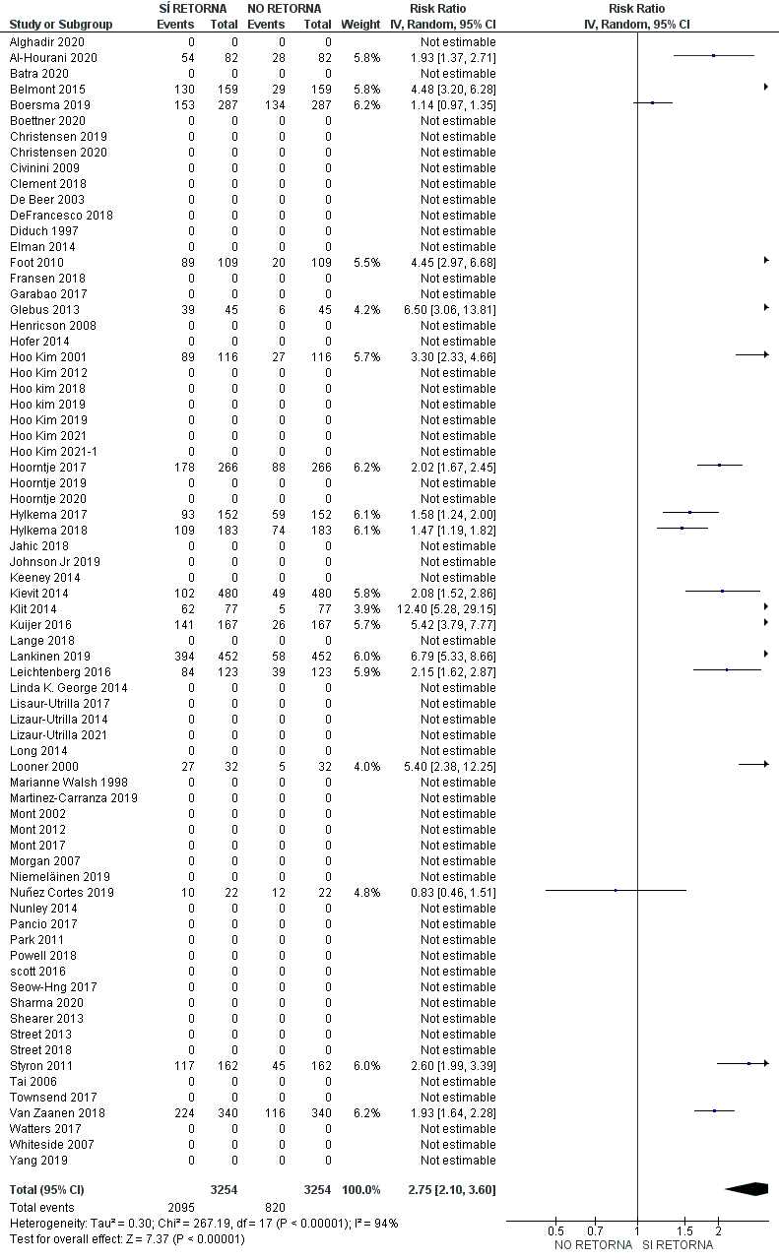
1. Forest Plot return to work activities
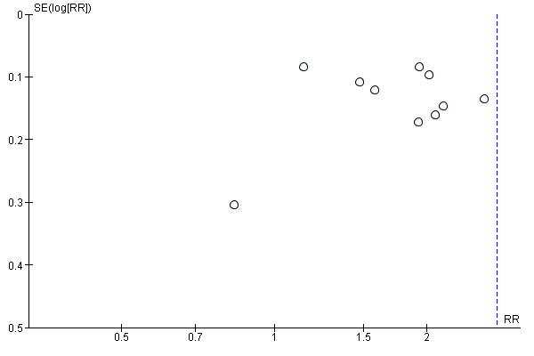
2. Funnel Plot return to work activities
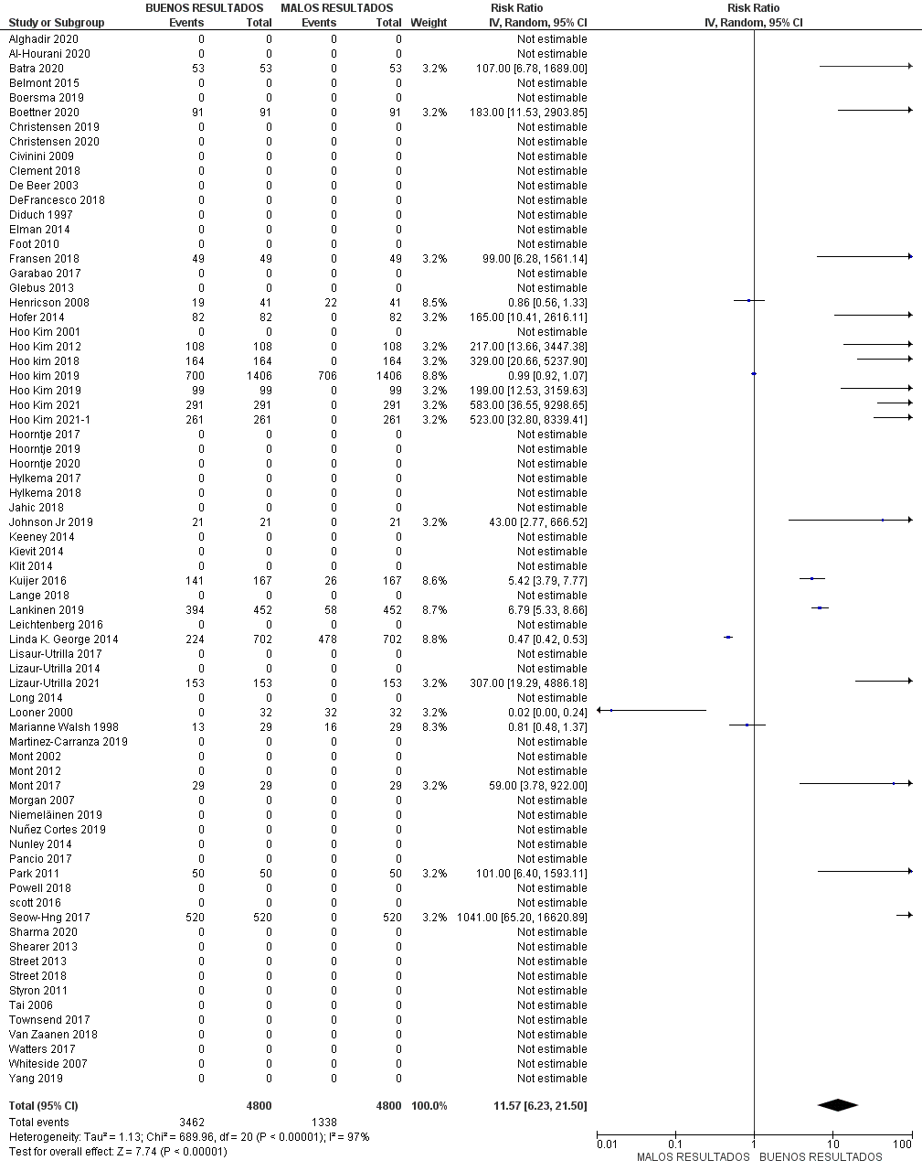
3. Forest Plot Joint Mobility Arcs
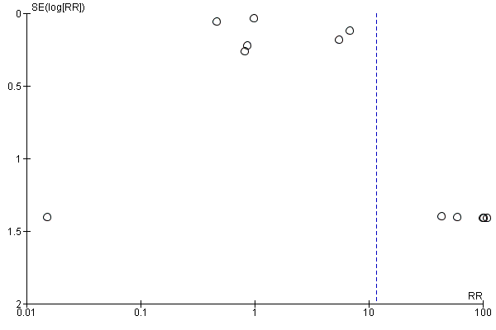
4. Funnel Plot Joint Mobility Arcs

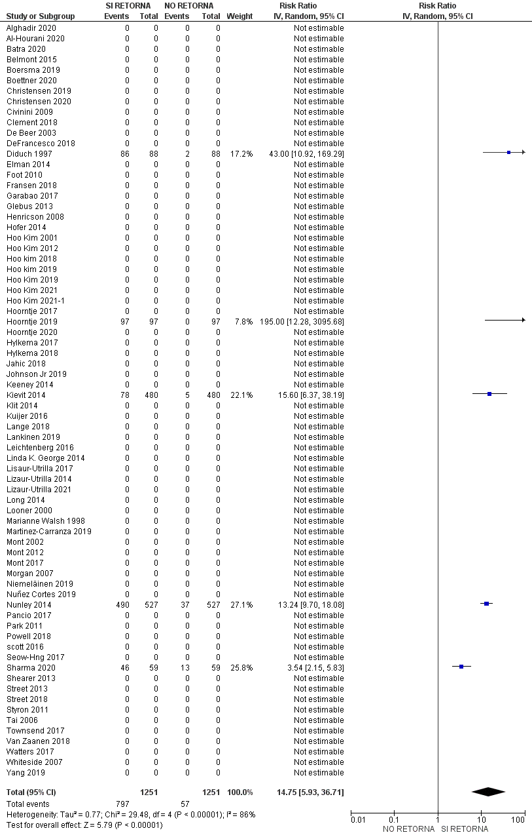
5. Forest Plot return to physical activities
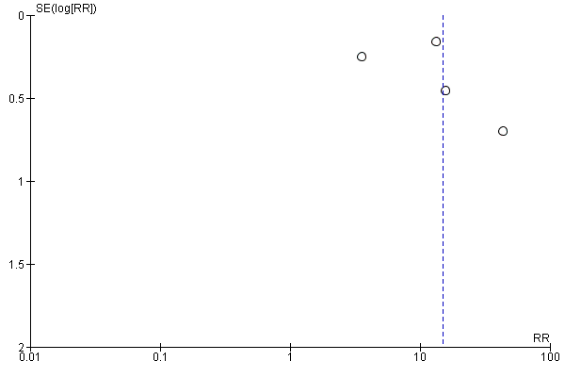
6. Funnel Plot return to physical activities
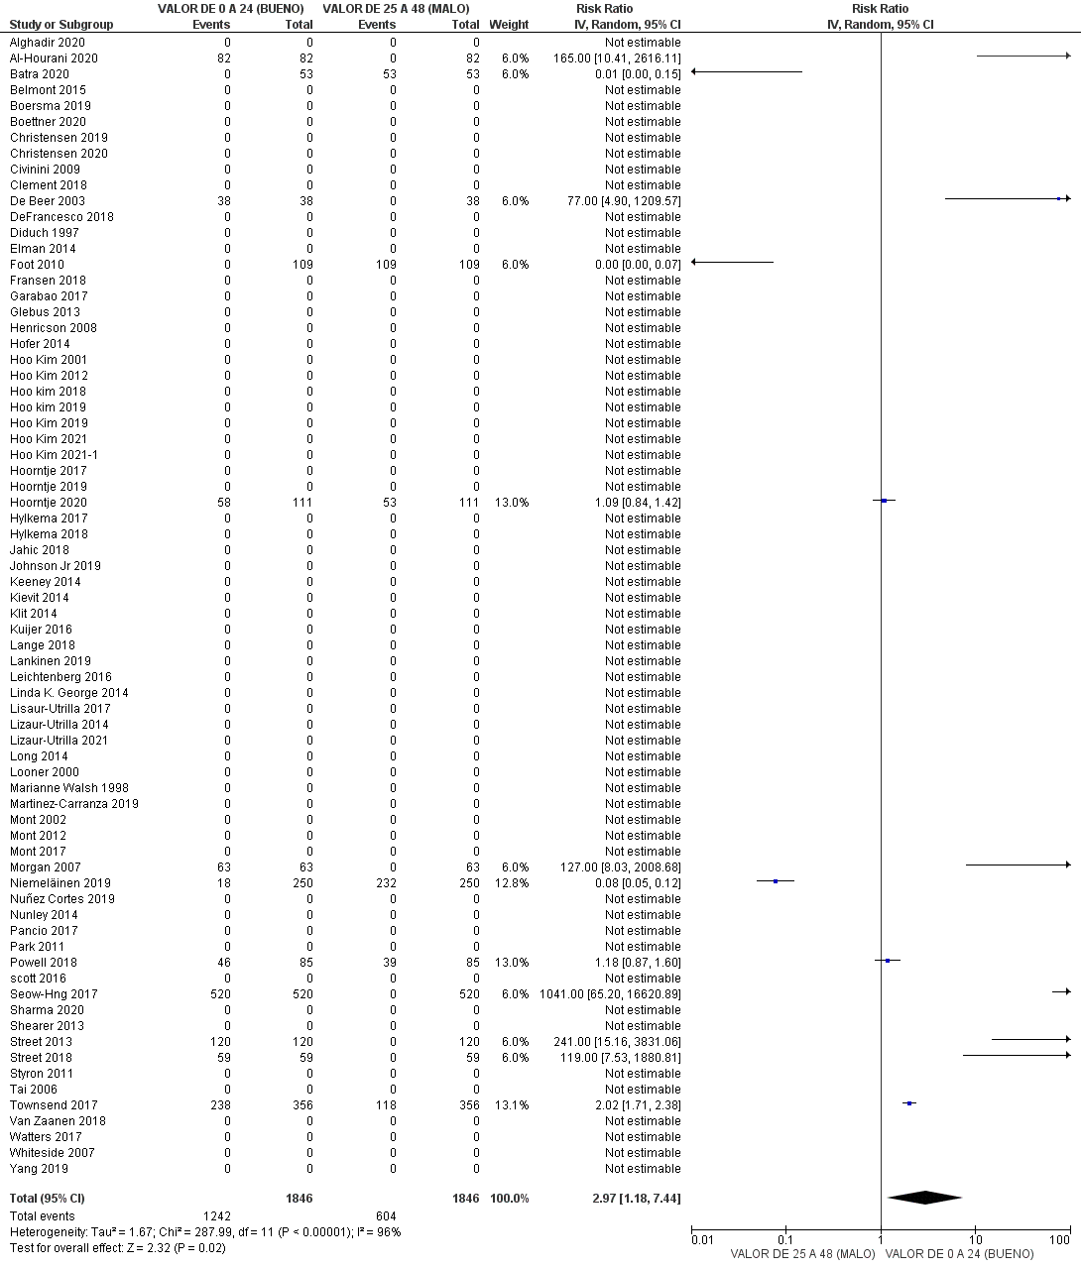
7. Forest Plot OKS scale
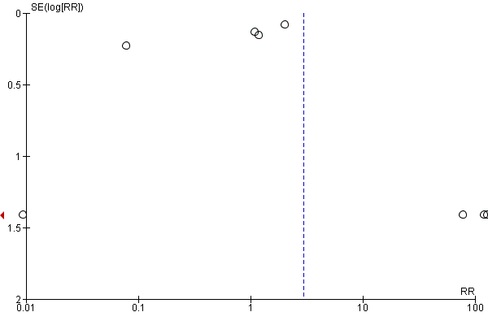
8. Funnel Plot OKS scale
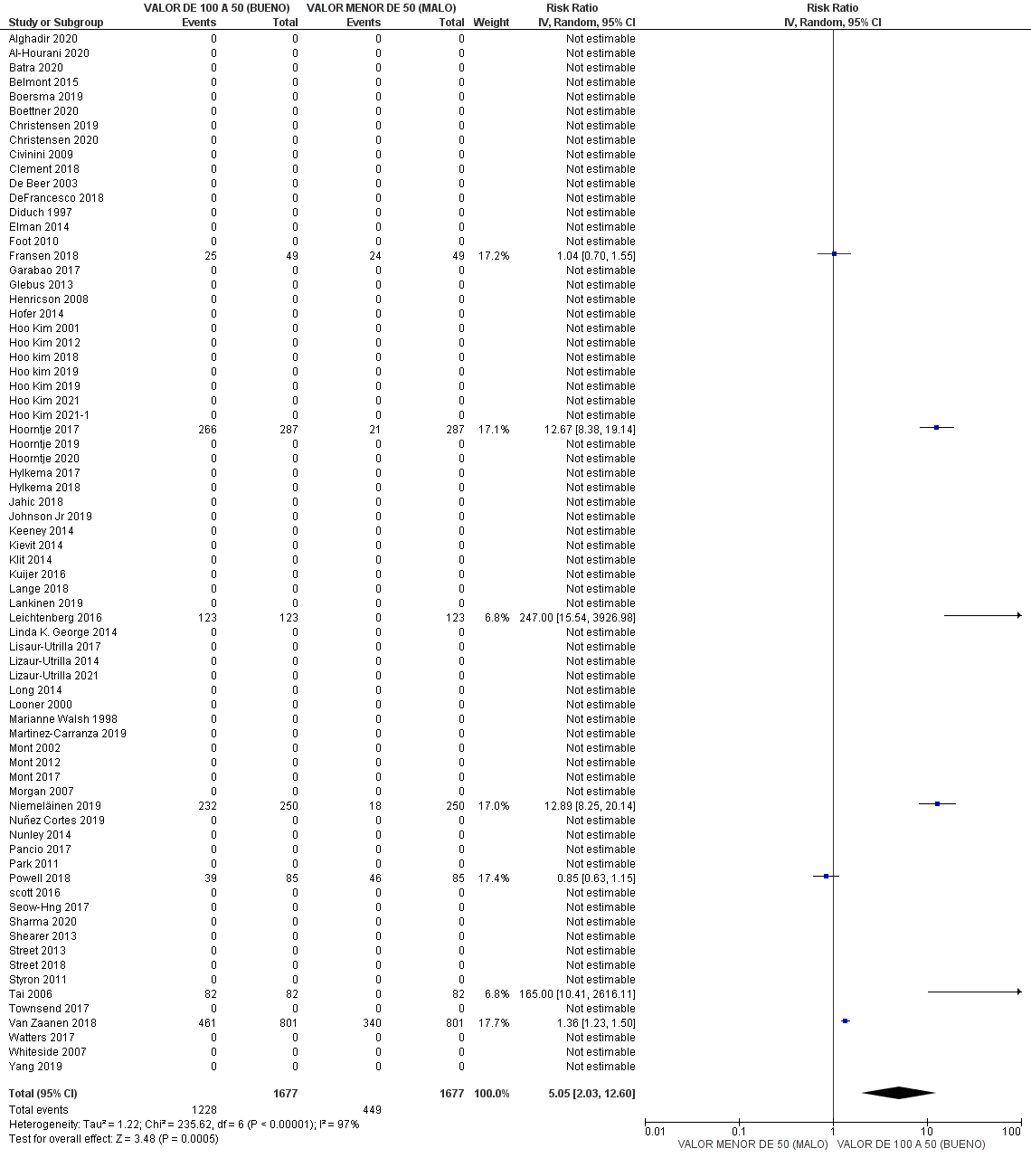
9. Forest Plot KOOS scale
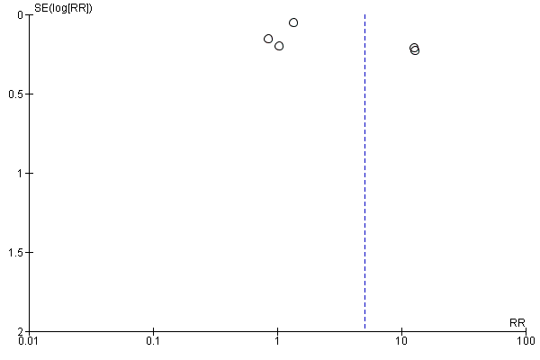
10. Funnel Plot KOOS scale
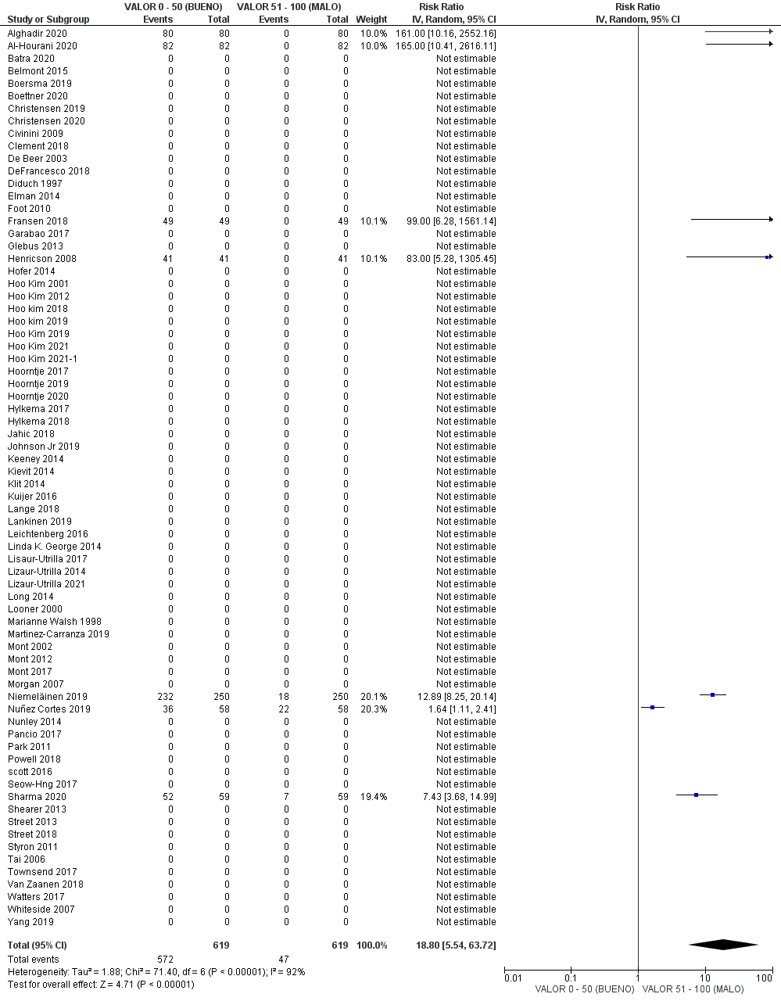
11. Forest Plot VAS scale
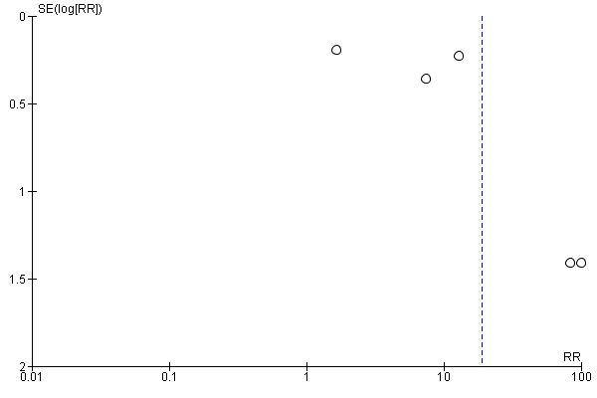
12. Funnel Plot VAS scale
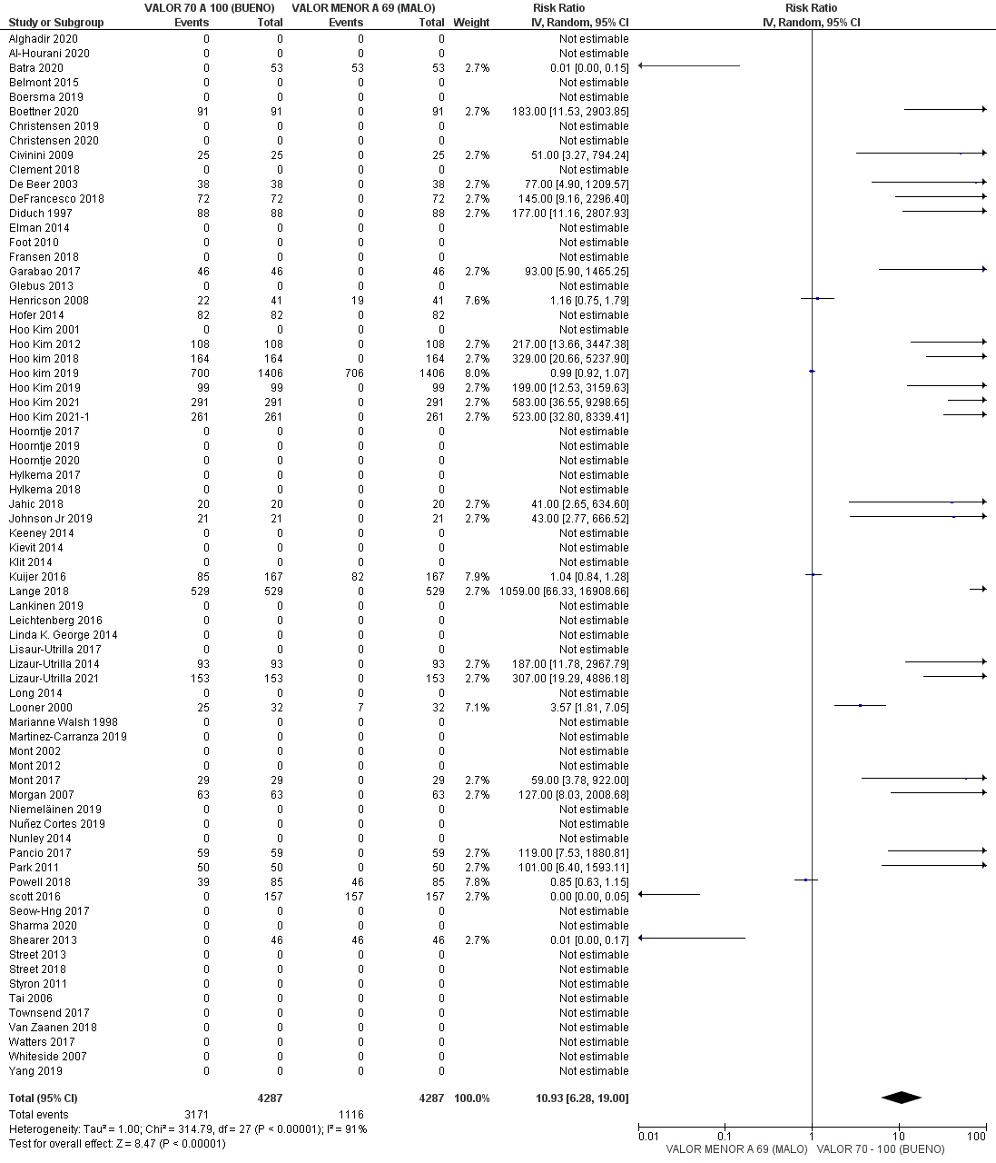
13. Forest Plot AKSS
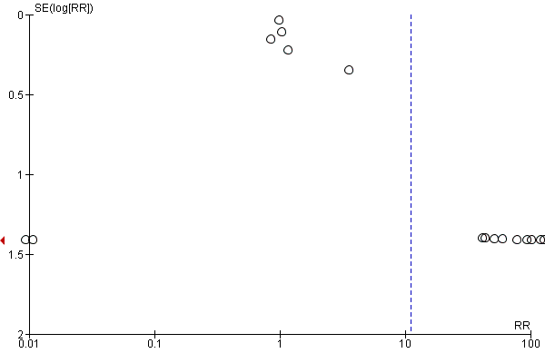14. Funnel Plot AKSS
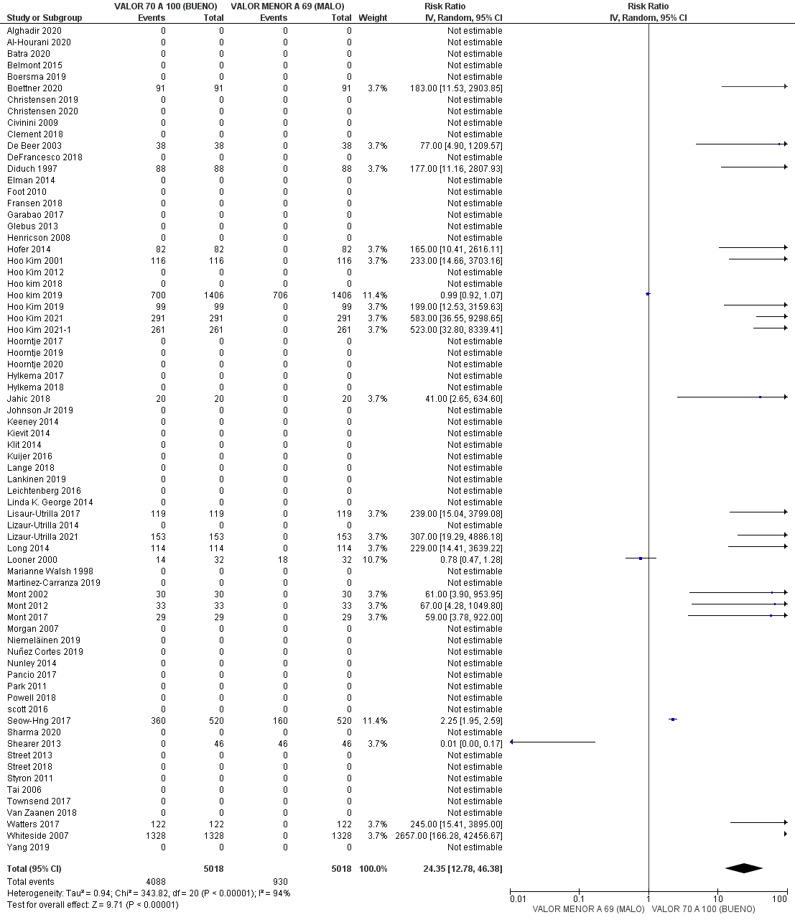
15. Forest Plot Function AKSS
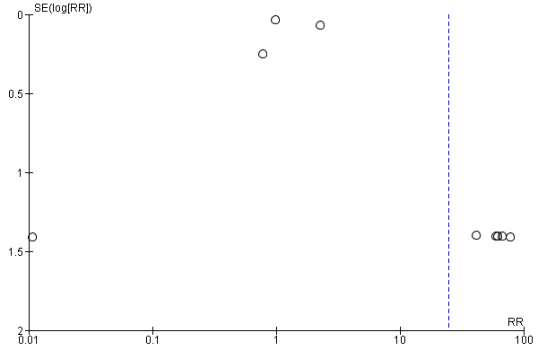
16. Funnel Plot Function AKSS
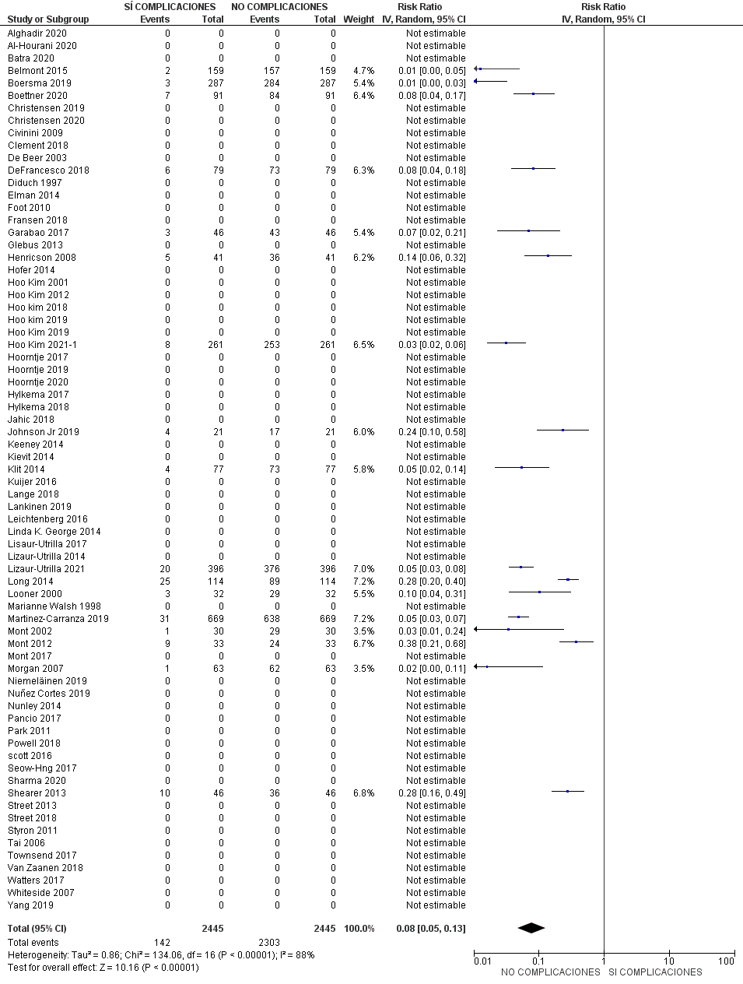
17. Forest Plot post-operative complications
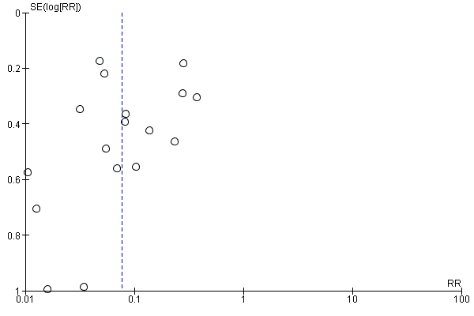
18. Funnel Plot post-operative complications

