Supplementary information for:

Cognitive bias in slow-growing broiler chickens raised in low- or high-complexity environments: using a social-pair testing approach

M. I. Lourenço-Silva¹ ², A. Ulans², A.M. Campbell² , I.C.L. Almeida Paz¹ , L. Jacobs²*

¹ Department of Animal Production and Preventive Veterinary Medicine, School of
Veterinary Medicine and Animal Sciences (FMVZ), São Paulo State University “Júlio de
Mesquita Filho” (UNESP), Botucatu, São Paulo, Brazil

² School of Animal Sciences, Virginia Tech, Blacksburg, VA, 24061 USA.

*Corresponding author: jacobsl@vt.edu

Figure S1. Judgment bias test arena. Chickens were placed in the start box prior to all training or testing sessions. Colored cues and associated containers (black or white) were placed at either reinforced location (left or right). During testing, three additional ambiguous-colored cues were placed at intermediate locations (near positive, middle, near neutral). During all training and testing phases, cues were individually presented.
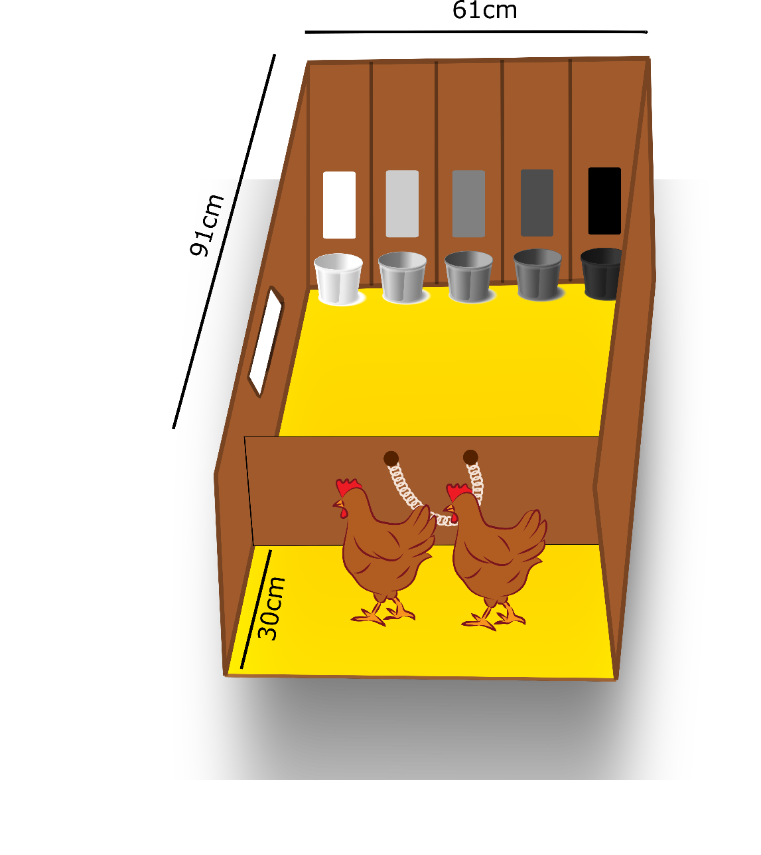
Figure S2. Diagram of the judgment bias habituation phase protocol (n = 24 chickens). All chicks undergo 4 habituation rounds. Blue boxes represent habituation phase methods, white boxes represent bird responses. Adapted from ⁵⁹.

Figure S3. Diagram of the judgment bias training phase 1A protocol for round 1 (n = 24 chickens). Blue boxes represent training phase 1A methods, white boxes represent bird responses. Adapted from ⁵⁹.

Figure S4. Diagram of the judgment bias training phase 1B protocol (shaping) (n = 24 chickens). Blue boxes represent training phase 1B methods, white boxes represent bird responses. Adapted from ⁵⁹.

Figure S5. Diagram of the shaping procedure that was applied in each round of training phase 1B (n = 24 chickens). Learning criteria were orient (round 1), approach (round 2, or peck cue (round 3). Chicks will remain in this phase until successful, or the birds will be excluded from the trial after 7 rounds. Blue boxes represent shaping procedure methods, white boxes represent bird responses.

Figure S6. Diagram of the judgment bias training phase 2 protocol (n = 22 chickens). Blue boxes represent training phase 2 methods, white boxes represent bird responses. (A) Chicks are presented with a reward cue. (B) Chicks are presented with a neutral cue. Adapted from ⁵⁹.

