Supplementary Table S1. Read counts in each library from embryogenic cultures of Araucaria angustifolia before and after filtering and cleaning.
Sampleª | Total reads | Trimmed Reads | Reads Too Short (<18nt) | Reads Too Long (<25nt) | Total clean sRNA reads | % clean reads
RP.1 | 42,023,198 | 39,491,087 | 7,165,141 | 18,997,257 | 13,328,689 | 32%
RP.2 | 44,547,140 | 42,021,988 | 7,307,188 | 20,654,008 | 14,060,792 | 32%
RP.3 | 40,865,651 | 38,104,481 | 6,880,353 | 18,432,314 | 12,791,814 | 31%
Total-RP | 127,435,989 | 119,617,556 | 21,352,682 | 58,083,579 | 40,181,295 | 31.50%
RM.1 | 32,445,237 | 29,075,515 | 4,062,480 | 10,514,057 | 14,498,978 | 45%
RM.2 | 41,217,854 | 37,740,650 | 4,168,594 | 11,938,410 | 21,633,646 | 52%
RM.3 | 36,793,187 | 33,487,701 | 4,080,168 | 12,670,208 | 16,737,325 | 45%
Total-RM | 110,456,278 | 100,303,866 | 12,311,242 | 35,122,675 | 52,869,949 | 47.90%
BP.1 | 23,227,481 | 20,964,572 | 3,349,117 | 12,018,149 | 5,597,306 | 24%
BP.2 | 22,983,993 | 20,582,147 | 3,667,783 | 11,209,061 | 5,705,303 | 25%
BP.3 | 22,737,428 | 20,303,566 | 3,419,823 | 11,310,093 | 5,573,650 | 25%
Total-BP | 68,948,902 | 61,850,285 | 10,436,723 | 34,537,303 | 16,876,259 | 24.50%
BM.1 | 29,059,124 | 24,601,609 | 4,805,289 | 9,398,786 | 10,397,534 | 36%
BM.2 | 26,552,616 | 22,613,315 | 4,347,171 | 8,748,694 | 9,517,450 | 36%
BM.3 | 29,686,845 | 24,994,666 | 4,830,140 | 9,186,361 | 10,978,165 | 37%
Total-BM | 85,298,585 | 72,209,590 | 13,982,600 | 27,333,841 | 30,893,149 | 36.20%
TOTAL | 392,139,754 | 353,981,297 | 58,083,247 | 155,077,398 | 140,820,652 | 36%
ª RP, responsive cell line in proliferation stage; RM, responsive cell line during maturation stage; BP, blocked cell line in proliferation stage; BM, blocked cell line in maturation stage.

Supplementary Table S2. Number of reads aligned to the different types of sRNA for each library used in the study.
Sampleª | Input | % | rRNA | % | tRNA | % | snRNA | % | snoRNA | % | tmRNA | % | scRNA | % | siRNA | % | other sRNAs | % | Unmatched | %
RP.1 | 13,328,689 | 100 | 11,234,207 | 84.29 | 237,412 | 1.78 | 302,163 | 2.27 | 49,449 | 0.37 | 27 | 0.00 | 840 | 0.01 | 2,266 | 0.02 | 22,552 | 0.17 | 1,479,773 | 11.10
RP.2 | 14,060,792 | 100 | 11,776,404 | 83.75 | 264,593 | 1.88 | 334,316 | 2.38 | 54,061 | 0.38 | 32 | 0.00 | 862 | 0.01 | 2,196 | 0.02 | 23,508 | 0.17 | 1,604,820 | 11.41
RP.3 | 12,791,814 | 100 | 10,714,913 | 83.76 | 243,151 | 1.9 | 287,913 | 2.25 | 45,717 | 0.36 | 24 | 0.00 | 825 | 0.01 | 2,109 | 0.02 | 20,747 | 0.16 | 1,476,415 | 11.54
RM.1 | 14,498,978 | 100 | 3,222,725 | 22.23 | 510,560 | 3.52 | 209,235 | 1.44 | 39,113 | 0.27 | 29 | 0.00 | 1,001 | 0.01 | 10,071 | 0.07 | 55,554 | 0.38 | 10,450,690 | 72.08
RM.2 | 21,633,646 | 100 | 3,644,709 | 16.85 | 494,596 | 2.29 | 210,473 | 0.97 | 47,703 | 0.22 | 44 | 0.00 | 1,346 | 0.01 | 12,825 | 0.06 | 94,478 | 0.44 | 17,127,472 | 79.17
RM.3 | 16,737,325 | 100 | 3,269,235 | 19.53 | 880,460 | 5.26 | 163,838 | 0.98 | 44,319 | 0.26 | 35 | 0.00 | 1,092 | 0.01 | 10,357 | 0.06 | 71,017 | 0.42 | 12,296,972 | 73.47
BP.1 | 5,597,306 | 100 | 4,521,378 | 80.78 | 37,779 | 0.67 | 159,544 | 2.85 | 34,911 | 0.62 | 19 | 0.00 | 1,517 | 0.03 | 1,717 | 0.03 | 17,206 | 0.31 | 823,235 | 14.71
BP.2 | 5,705,303 | 100 | 4,619,539 | 80.97 | 42,548 | 0.75 | 189,996 | 3.33 | 34,568 | 0.61 | 22 | 0.00 | 1,969 | 0.03 | 1,712 | 0.03 | 18,995 | 0.33 | 795,954 | 13.95
BP.3 | 5,573,650 | 100 | 4,466,994 | 80.14 | 43,258 | 0.78 | 165,126 | 2.96 | 34,120 | 0.61 | 7 | 0.00 | 1,670 | 0.03 | 1,708 | 0.03 | 19,160 | 0.34 | 841,607 | 15.10
BM.1 | 10,397,534 | 100 | 4,545,406 | 43.72 | 153,113 | 1.47 | 337,537 | 3.25 | 33,457 | 0.32 | 16 | 0.00 | 572 | 0.01 | 5,875 | 0.06 | 44,936 | 0.43 | 5,276,622 | 50.75
BM.2 | 9,517,450 | 100 | 4,154,003 | 43.65 | 146,511 | 1.54 | 320,306 | 3.37 | 34,427 | 0.36 | 20 | 0.00 | 527 | 0.01 | 5,309 | 0.06 | 41,617 | 0.44 | 4,814,730 | 50.59
BM.3 | 10,978,165 | 100 | 4,532,953 | 41.29 | 192,500 | 1.75 | 312,926 | 2.85 | 37,052 | 0.34 | 27 | 0.00 | 597 | 0.01 | 5,971 | 0.05 | 53,055 | 0.48 | 5,843,084 | 53.22
Total | 140,820,652 | 100 | 70,702,466 | 50.21 | 3,246,481 | 2.31 | 2,993,373 | 2.13 | 488,897 | 0.35 | 302 | 0.00 | 12,818 | 0.01 | 62,116 | 0.04 | 482,825 | 0.34 | 62,831,374 | 44.60
ª RP, responsive cell line in proliferation stage; RM, responsive cell line during maturation stage; BP, blocked cell line in proliferation stage; BM, blocked cell line in maturation stage.

Supplementary Figure S1. Size distribution of clean sRNA reads from Araucaria angustifolia embryogenic cell lines.
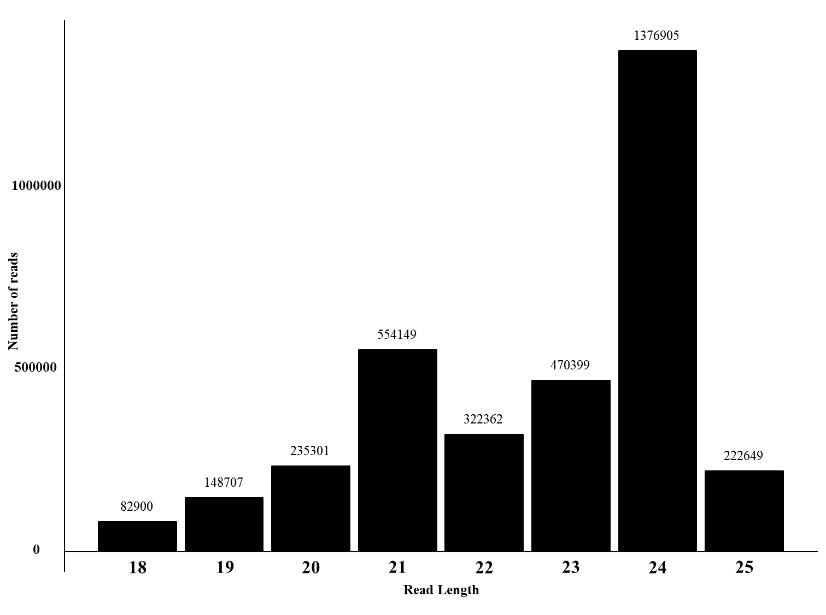
Supplementary Figure S2. Distribution of sRNAs by first or last base preference of 18 to 24-nucleotide (nt) small RNAs in Araucaria angustifolia cell lines. The Y-axis displays the proportion of sRNAs with a certain first base, and the X-axis represents the sRNA length. (A) Proportion of cytosine or guanine at the start position. (B) Proportion of sRNAs with a certain last base. (C) Proportion of cytosine or guanine at the last position. (D) Proportion of adenosine or uridine at the last position.

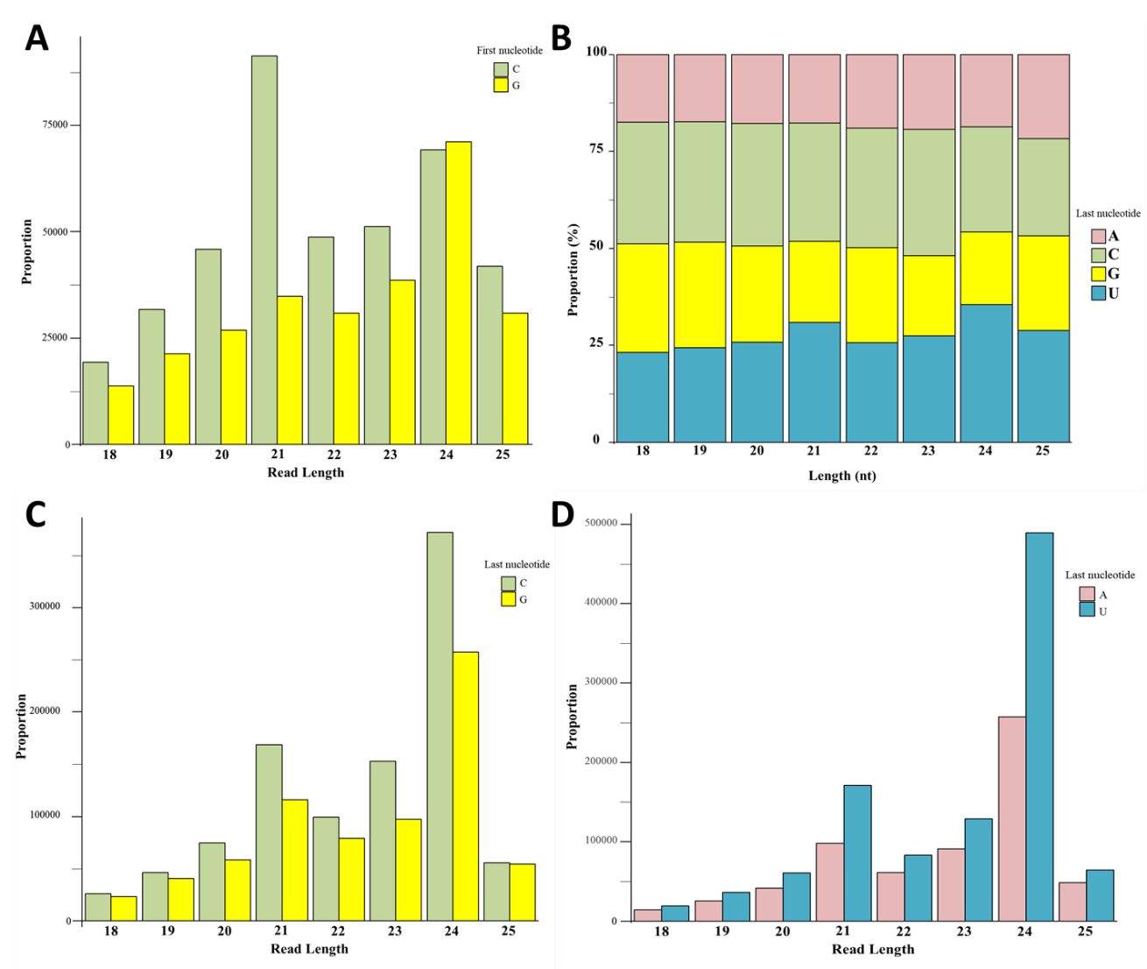

Supplementary Figure S3. Distribution of miRNAs identified in A. angustifolia according to the conserved miRNA families annotated in the sRNA libraries.
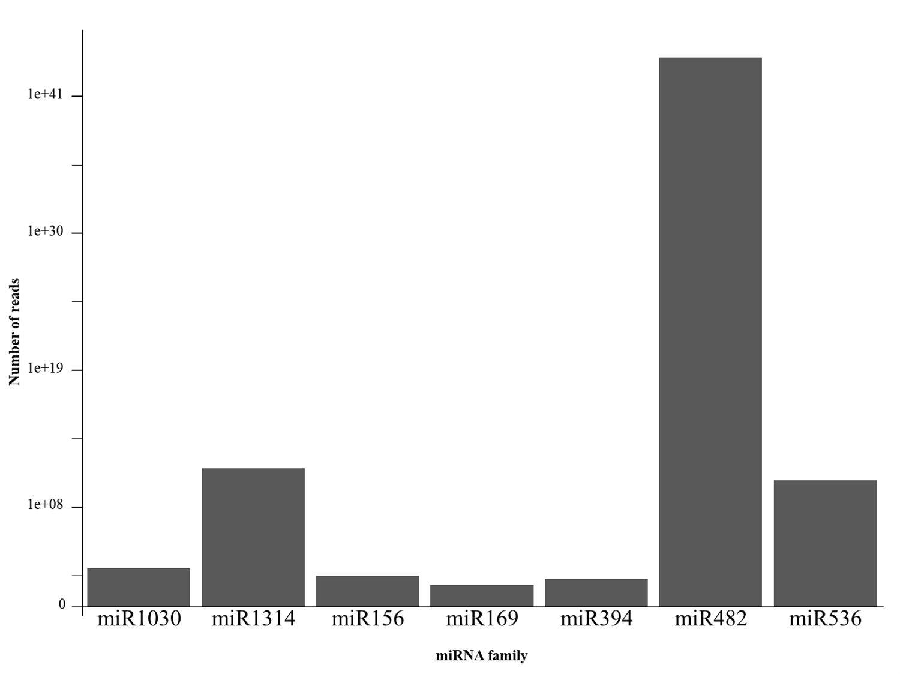
Supplementary Table S3. Conserved miRNAs identified during somatic embryogenesis of Araucaria angustifolia.
Familiy | miRNA name | ID miRNA sequence | Mature length | Mature sense | Mature read counts | Mature sequence | Star length | Star read counts | Star sequence
miR482 | Aang-miR482a | comp50433_c0_seq4_14610 | 22 | 3P | 633406 | UUUUGCCAAUACCUCCCAUGCC | 22 | 3525 | CGUGGGGGCGUUGGACAAAACC
miR482 | Aang-miR482b | comp50433_c0_seq6_14612 | 22 | 3P | 633406 | UUUUGCCAAUACCUCCCAUGCC | 22 | 3525 | CGUGGGGGCGUUGGACAAAACC
miR482 | Aang-miR482c | comp50433_c0_seq3_14608 | 22 | 3P | 633406 | UUUUGCCAAUACCUCCCAUGCC | 22 | 3525 | CGUGGGGGCGUUGGACAAAACC
miR482 | Aang-miR482d | comp50433_c0_seq2_14606 | 22 | 3P | 633406 | UUUUGCCAAUACCUCCCAUGCC | 22 | 3525 | CGUGGGGGCGUUGGACAAAACC
miR482 | Aang-miR482e | comp45262_c0_seq4_9880 | 21 | 5P | 4069 | AGUGAGAGGCCUGAAAAGACU | 22 | 152 | UCUUUCCAAGGCCUCCCAUUCC
miR482 | Aang-miR482f | comp45262_c0_seq9_9882 | 21 | 5P | 4069 | AGUGAGAGGCCUGAAAAGACU | 22 | 152 | UCUUUCCAAGGCCUCCCAUUCC
miR482 | Aang-miR482g | comp45262_c0_seq1_9878 | 21 | 5P | 4069 | AGUGAGAGGCCUGAAAAGACU | 22 | 152 | UCUUUCCAAGGCCUCCCAUUCC
miR482 | Aang-miR482h | comp26057_c0_seq2_2942 | 22 | 5P | 2093 | AGUGGGAUGCGAGGAUAAGACU | 22 | 221 | UCUUUCCUACGCCUCCCAUUCC
miR482 | Aang-miR482i | comp26057_c0_seq1_2940 | 22 | 5P | 2093 | AGUGGGAUGCGAGGAUAAGACU | 22 | 221 | UCUUUCCUACGCCUCCCAUUCC
miR482 | Aang-miR482j | comp51212_c0_seq1_15864 | 21 | 3P | 2015 | CUUCCCUAAACCUCCCAUACC | 21 | 139 | AAUGGGAGAAUUGGGGAAACC
miR1314 | Aang-miR1314a | comp51383_c0_seq4_16103 | 22 | 3P | 4177 | UCGGCCUUGAAUGUUAGGAGAG | 21 | 902 | CUUCUAAAUUUAAGGUCGCCG
miR1314 | Aang-miR1314b | comp51383_c0_seq1_16099 | 22 | 3P | 4177 | UCGGCCUUGAAUGUUAGGAGAG | 21 | 902 | CUUCUAAAUUUAAGGUCGCCG
miR1314 | Aang-miR1314c | comp51383_c0_seq3_16101 | 22 | 3P | 4177 | UCGGCCUUGAAUGUUAGGAGAG | 21 | 902 | CUUCUAAAUUUAAGGUCGCCG
miR394 | Aang-miR394a | comp95472_c0_seq1_43881 | 20 | 3P | 145 | AGGCGGACGGUAUGCCAAGU | 24 | 24 | CUGGCAUUCUGUCCACCUCCAUAU
miR536 | Aang-miR536a | comp48681_c0_seq6_12822 | 21 | 5P | 100 | UGCAGACUGCCUGGCACAAUU | 21 | 8 | UCGUGCCAAGCUGUGUGCACC
miR536 | Aang-miR536b | comp48681_c0_seq2_12816 | 21 | 5P | 100 | UGCAGACUGCCUGGCACAAUU | 21 | 8 | UCGUGCCAAGCUGUGUGCACC
miR536 | Aang-miR536c | comp48681_c0_seq5_12820 | 21 | 5P | 100 | UGCAGACUGCCUGGCACAAUU | 21 | 8 | UCGUGCCAAGCUGUGUGCACC
miR536 | Aang-miR536d | comp48681_c0_seq3_12818 | 21 | 5P | 100 | UGCAGACUGCCUGGCACAAUU | 21 | 8 | UCGUGCCAAGCUGUGUGCACC
miR536 | Aang-miR536e | comp48681_c0_seq1_12814 | 21 | 5P | 100 | UGCAGACUGCCUGGCACAAUU | 21 | 8 | UCGUGCCAAGCUGUGUGCACC
miR169 | Aang-miR169a | comp14283_c0_seq1_1666 | 20 | 3P | 39 | GCAGGUCAUUCUUGGUGCUG | 23 | 15 | CAGCCAAGAAUGAUUUGCCCGCC
miR1030 | Aang-miR1030a | comp31610_c0_seq1_4280 | 21 | 5P | 1191 | UUUGCAUCUGCACCUGCACCG | 21 | 0 | GUGCAGAGGAAGAUGCAAACA
miR156 | Aang-miR156a | comp60523_c0_seq1_43213 | 23 | 3P | 280 | GCUCACCAUCUCUUUCUGUCAGC | 20 | 0 | UGACAGAAGAGAGUGAGCAC
Detailed miRDeep2 output (score, sensitivity, consensus precursor sequence, and precursor coordinate) are shown in the Supplementary Excel file E1.

Supplementary Table S4. Novel miRNAs identified during somatic embryogenesis of Araucaria angustifolia.
miRNA name | ID miRNA sequence | Mature length | Mature sense | Mature read counts | Mature sequence | Star length | Star read counts | Star sequence
Aang-novel_1 | comp49106_c0_seq1_13371 | 22 | 3P | 732613 | UCCCCGGUGAUUGAUGAAGACA | 22 | 707 | UAUUCAUCUAUCACUGUGGAAA
Aang-novel_2 | comp49106_c0_seq2_13373 | 22 | 3P | 732613 | UCCCCGGUGAUUGAUGAAGACA | 22 | 707 | UAUUCAUCUAUCACUGUGGAAA
Aang-novel_3 | comp23423_c0_seq1_2647 | 22 | 3P | 651324 | UUUUCCCUGAUCCGCCCAUGCC | 21 | 36 | CGUGGGCGACCGGGGAAAAUU
Aang-novel_4 | comp53719_c0_seq14_29315 | 21 | 5P | 531721 | UUGAGAUGCUGCAGACAUGUA | 21 | 50 | UAUCCGGCAGCCUUUCAAAUU
Aang-novel_5 | comp11699_c0_seq2_1438 | 22 | 3P | 304595 | UCAGCAGACAUGUAGGCCAACC | 22 | 35 | UGGGCUUACAUGUCUGUCGAUG
Aang-novel_6 | comp11699_c0_seq1_1436 | 22 | 3P | 304595 | UCAGCAGACAUGUAGGCCAACC | 22 | 35 | UGGGCUUACAUGUCUGUCGAUG
Aang-novel_7 | comp48991_c0_seq2_13230 | 22 | 3P | 222304 | CUUUUCCGCACCCUCCCAUGCC | 21 | 1689 | CAUGGGAGGAAGGGAAAAACU
Aang-novel_8 | comp48991_c0_seq3_13232 | 22 | 3P | 222304 | CUUUUCCGCACCCUCCCAUGCC | 21 | 1689 | CAUGGGAGGAAGGGAAAAACU
Aang-novel_9 | comp53106_c1_seq5_23109 | 22 | 3P | 163704 | UCUUGCCUGUUCCGCCCAUGCC | 20 | 4052 | AUUGGCGGACUGGCAUGACU
Aang-novel_10 | comp49664_c0_seq1_13887 | 22 | 3P | 132380 | UUUGACAUCACACCCGCGGUGA | 19 | 1174 | ACUGUGGGAUGAUGUCAAA
Aang-novel_11 | comp35927_c0_seq1_5553 | 21 | 3P | 90527 | UUCUUCACAUCCUUUCCUCGG | 21 | 1669 | CGAGGAAAUAAUGUGAAGAAC
Aang-novel_12 | comp49106_c0_seq4_13377 | 21 | 3P | 83807 | UCCCCGUGAUUGAUGAAGACA | 22 | 707 | UAUUCAUCUAUCACUGUGGAAA
Aang-novel_13 | comp49106_c0_seq6_13381 | 21 | 3P | 83807 | UCCCCGUGAUUGAUGAAGACA | 22 | 707 | UAUUCAUCUAUCACUGUGGAAA
Aang-novel_14 | comp49106_c0_seq5_13379 | 21 | 3P | 83807 | UCCCCGUGAUUGAUGAAGACA | 22 | 4 | UUUUCAUCUAUCACUGUGGAAA
Aang-novel_15 | comp49106_c0_seq3_13375 | 21 | 3P | 83807 | UCCCCGUGAUUGAUGAAGACA | 22 | 4 | UUUUCAUCUAUCACUGUGGAAA
Aang-novel_16 | comp44150_c0_seq1_9186 | 21 | 3P | 42520 | UGCUAUUCAUACUGCCUGGUG | 21 | 5646 | CCGGCCAGUAUGAAUAGCAGG
Aang-novel_17 | comp51146_c0_seq1_15793 | 22 | 3P | 44452 | UGACGUCAGGUCCUCGAUGGUU | 22 | 35 | CCAUCCGGCACUUGAUGUCAAA
Aang-novel_18 | comp29359_c0_seq2_3716 | 22 | 3P | 32459 | UUACGUCAGGUCCUCGAUGAUU | 21 | 217 | UCAUCGUGGACUGCUGUAAAA
Aang-novel_19 | comp47373_c0_seq1_11604 | 21 | 3P | 21380 | UAAAUCCUUCUGCUGUCCAUA | 21 | 13 | UGGAUAGGAGGAGGAUUCAUG
Aang-novel_20 | comp47373_c0_seq2_11608 | 21 | 3P | 21380 | UAAAUCCUUCUGCUGUCCAUA | 21 | 13 | UGGAUAGGAGGAGGAUUCAUG
Aang-novel_21 | comp126453_c0_seq1_44792 | 21 | 3P | 16904 | UGACAUCUUUCCCACUGUGGU | 21 | 1823 | CGCCGUGGAAAUGAUGUCAGG
Aang-novel_22 | comp35417_c0_seq2_5325 | 22 | 3P | 16035 | UUACCACGCCCGCCCAUGCCUA | 21 | 228 | GGCGUUCGCGGUCUGGUAAAA
Aang-novel_23 | comp35417_c0_seq1_5321 | 22 | 3P | 16035 | UUACCACGCCCGCCCAUGCCUA | 21 | 228 | GGCGUUCGCGGUCUGGUAAAA
Aang-novel_24 | comp47512_c0_seq2_11688 | 21 | 5P | 10889 | CACCGUGGAAUUGAUGUUAAA | 21 | 1218 | UAACAUCACUCCCACGGUGGU
Aang-novel_25 | comp47512_c0_seq1_11686 | 21 | 5P | 10889 | CACCGUGGAAUUGAUGUUAAA | 21 | 1218 | UAACAUCACUCCCACGGUGGU
Aang-novel_26 | comp37802_c0_seq1_6101 | 22 | 3P | 7341 | UUUUCCCUAUGCCUCCGACACC | 21 | 4 | UGUUGGCGGCCGGGUAAAAGA
Aang-novel_27 | comp37802_c0_seq2_6103 | 22 | 3P | 7341 | UUUUCCCUAUGCCUCCGACACC | 21 | 4 | UGUUGGCGGCCGGGUAAAAGA
Aang-novel_28 | comp51146_c1_seq2_15797 | 22 | 3P | 6830 | UGACAUCAGGCCCUCGAUGAUU | 22 | 460 | CCAUUGAGCACUUGGUGUUAAA
Aang-novel_29 | comp11730_c0_seq2_1439 | 24 | 3P | 4505 | AUUGGACCACAAUGAGCACCUUCU | 24 | 21 | AAGUCUCAUAGGUGUCCAAUUGUG
Aang-novel_30 | comp26057_c0_seq2_2943 | 22 | 3P | 4201 | UUUUCCCUAUGCCCCCGAUUCC | 21 | 195 | AAUUGGUGGCGAGGGUAAAGC
Aang-novel_31 | comp44794_c0_seq3_9552 | 22 | 5P | 3831 | UGACAGCCCGAAAUCAGCGAGU | 21 | 422 | UGGCUGAUUCGGACUAUCAAG
Aang-novel_32 | comp35417_c0_seq2_5327 | 22 | 3P | 2633 | UUACCAGGUCCGCCCAUGCCUA | 21 | 273 | GGCGUUGCCGGUCUGGUAAAA
Aang-novel_33 | comp35417_c0_seq1_5323 | 22 | 3P | 2633 | UUACCAGGUCCGCCCAUGCCUA | 21 | 273 | GGCGUUGCCGGUCUGGUAAAA
Aang-novel_34 | comp51405_c0_seq1_16148 | 22 | 3P | 1990 | UUCAACAACUUAAGCUGUCCAA | 21 | 1 | GGACAGCUCAAGCUUUGAAAU
Aang-novel_35 | comp46126_c0_seq2_10568 | 22 | 3P | 1338 | CUCACAGCAAUUUAACCCCUUC | 21 | 59 | AGGGUUAAAUUGCUGUGUAUG
Aang-novel_36 | comp43148_c0_seq1_8735 | 21 | 3P | 1143 | CAAGCUUCAACCGCCUCCUUC | 21 | 38 | AAGGAGGCGGUUGAAGCUUGC
Aang-novel_37 | comp130754_c0_seq1_44933 | 21 | 3P | 984 | UAUGAUGACCGGAGGCUUCAU | 24 | 54 | GAAUCCUCCGAGUCAUGUCAUAUG
Aang-novel_38 | comp28037_c0_seq1_3378 | 21 | 5P | 669 | CCUUGUUCCUAUUUACUGGCA | 22 | 305 | UCAAUAAAUAGGAACACAGGUU
Aang-novel_39 | comp28037_c0_seq2_3380 | 21 | 5P | 669 | CCUUGUUCCUAUUUACUGGCA | 22 | 305 | UCAAUAAAUAGGAACACAGGUU
Aang-novel_40 | comp50616_c0_seq1_14973 | 21 | 5P | 840 | UUUUGCAAGCUGCGCAUGGGA | 21 | 10 | CCAUCCACAGCUUGCAAAAUG
Aang-novel_41 | comp50616_c0_seq2_14977 | 21 | 5P | 840 | UUUUGCAAGCUGCGCAUGGGA | 21 | 10 | CCAUCCACAGCUUGCAAAAUG
Aang-novel_42 | comp22980_c0_seq1_2606 | 22 | 3P | 835 | UUUUUCCAAUGCCGCCCAUGCC | 22 | 6 | CGUGGGCGUCUUGGACAAAGCU
Aang-novel_43 | comp52040_c0_seq7_17548 | 21 | 3P | 678 | UCCUUCAAGAUUUCUAAGACU | 21 | 30 | UCUUAAAAAUCUUGACGGAGU
Aang-novel_44 | comp52040_c0_seq5_17546 | 21 | 3P | 678 | UCCUUCAAGAUUUCUAAGACU | 21 | 30 | UCUUAAAAAUCUUGACGGAGU
Aang-novel_45 | comp52040_c0_seq2_17540 | 21 | 3P | 678 | UCCUUCAAGAUUUCUAAGACU | 21 | 30 | UCUUAAAAAUCUUGACGGAGU
Aang-novel_46 | comp161221_c0_seq1_45734 | 24 | 3P | 630 | AAGGAGUGCAAAAAUUUUAGGCCU | 24 | 11 | ACUUUAUUAUUUUCCCAUUCCCCU
Aang-novel_47 | comp23676_c0_seq1_2664 | 20 | 3P | 331 | UUUUACCGCCACCUCCCAUU | 22 | 3 | UGGGAAUGUGGAGGAAAAAACA
Aang-novel_48 | comp47443_c0_seq1_11661 | 25 | 3P | 161 | AUGGAUUUGUGCGUGUCUGAGCCCC | 21 | 104 | GGGCGAUGAUGUGAAAAGACG
Aang-novel_49 | comp19529_c0_seq1_2158 | 21 | 3P | 174 | UGACAUCUUUUCCACGGUGGU | 21 | 86 | CGCCGUGGAAUUGAUGUCAAG
Aang-novel_50 | comp48285_c0_seq1_12379 | 21 | 5P | 199 | AGCUGCUGUAUCAUGGAUUCC | 21 | 22 | UGUGCAUGAGCCGGGAGCUGU
Aang-novel_51 | comp44047_c0_seq1_9079 | 24 | 3P | 220 | CCAAAAAGGGGCAUCUGUAGACAC | 23 | 1 | UGUCUUUGGUUAUUUUUGCUCUG
Aang-novel_52 | comp54009_c1_seq21_34412 | 24 | 3P | 123 | ACACCCAGAAGUGCUACAAGGCUG | 23 | 1 | AACCUGUUGCGCUUCUUGGUAUG
Aang-novel_53 | comp54009_c1_seq2_34324 | 24 | 3P | 123 | ACACCCAGAAGUGCUACAAGGCUG | 23 | 1 | AACCUGUUGCGCUUCUUGGUAUG
Aang-novel_54 | comp327523_c0_seq1_48069 | 24 | 5P | 122 | UGAGAUCUUUGGAGUUGCACACUU | 24 | 1 | UGAUUAACUUUAAUACUCUUUGGU
Aang-novel_55 | comp48539_c0_seq1_12672 | 22 | 3P | 60 | CUUCUAAUACAAGAGGAAUGCC | 21 | 16 | CAUCCUCUUGUAGUAGAAAUG
Aang-novel_56 | comp48539_c0_seq2_12674 | 22 | 3P | 60 | CUUCUAAUACAAGAGGAAUGCC | 21 | 16 | CAUCCUCUUGUAGUAGAAAUG
Aang-novel_57 | comp48976_c0_seq5_13220 | 22 | 3P | 67 | UUUACAUCAGGACCACGGUGAU | 22 | 3 | CACCGUGGAUAUGAUGGAAAAA
Aang-novel_58 | comp54271_c0_seq18_41146 | 24 | 5P | 61 | GCACCGGCAGAUCUUUGGAGCACU | 23 | 1 | GUGUUUCUGAAGUUUGUGGGUGC
Aang-novel_59 | comp54271_c0_seq6_41142 | 24 | 5P | 61 | GCACCGGCAGAUCUUUGGAGCACU | 23 | 1 | GUGUUUCUGAAGUUUGUGGGUGC
Aang-novel_60 | comp54271_c0_seq15_41144 | 24 | 5P | 61 | GCACCGGCAGAUCUUUGGAGCACU | 23 | 1 | GUGUUUCUGAAGUUUGUGGGUGC
Aang-novel_61 | comp236499_c0_seq1_47109 | 24 | 3P | 68 | AAACUUGGUGUGUGAUAAUGGACC | 24 | 1 | UAAAUAUCAUCACCAGGUUUGGAG
Aang-novel_62 | comp43251_c0_seq1_8814 | 21 | 5P | 53 | UGACCGUCGUGCAUGUACAUG | 21 | 2 | UAUACAUCCACGACGGUCACG
Aang-novel_63 | comp502_c0_seq1_101 | 24 | 3P | 53 | AUAAGGAUGAGGAUGGGGAUUCAU | 21 | 1 | UGAAAUCCCAUUAUCCUUCCA
Aang-novel_64 | comp48991_c0_seq1_13228 | 23 | 3P | 412 | GUUUUUCCGGAUCCUCCCAUGCC | 21 | 0 | CAUGGGAGGAAGGGAAAUUUU
Aang-novel_65 | comp45731_c0_seq1_10215 | 19 | 3P | 84 | UUACAUCACAACCGCGAUG | 20 | 5 | CAUCGUGGACUGAUGUAAAA
Aang-novel_66 | comp53599_c0_seq6_27797 | 24 | 5P | 129 | UAACCGGGCUUUGAAUUCUCAACC | 26 | 0 | UCGAGAGCGUCAAAGUCCACAAUAAU
Aang-novel_67 | comp53599_c0_seq7_27799 | 24 | 5P | 129 | UAACCGGGCUUUGAAUUCUCAACC | 26 | 0 | UCGAGAGCGUCAAAGUCCACAAUAAU
Aang-novel_68 | comp53599_c0_seq2_27793 | 24 | 5P | 129 | UAACCGGGCUUUGAAUUCUCAACC | 26 | 0 | UCGAGAGCGUCAAAGUCCACAAUAAU
Aang-novel_69 | comp53987_c0_seq7_33939 | 24 | 5P | 140 | UUACUUGACAUAGAGGCUUUGGCU | 28 | 0 | CCAAGCCAAUCGAGUGUUGUUGGUGCUA
Aang-novel_70 | comp78970_c0_seq1_43521 | 19 | 5P | 71 | UUGGACAUGUGUGAUAUGA | 19 | 0 | AUUUCUCACAUGUCCUAGA
Aang-novel_71 | comp51438_c0_seq1_16205 | 23 | 5P | 72 | GGAAUGGAAGUGAUAGUAGGCUC | 24 | 5 | GAGCUCACUAUCCAUCCAUUCCCA
Aang-novel_72 | comp47433_c0_seq3_11658 | 19 | 3P | 298 | GGUGGUAUUUCUGACGGCU | 17 | 0 | CUUCAGAGAUACAUCGC
Aang-novel_73 | comp51438_c0_seq2_16209 | 23 | 5P | 72 | GGAAUGGAAGUGAUAGUAGGCUC | 22 | 0 | GCUCACUAUCCAUCCAUUCCAA
Aang-novel_74 | comp5100_c0_seq1_777 | 24 | 3P | 309 | GUUUGUUCUCAUACUCGAAGGCCU | 20 | 0 | GCCUUGAGUAUGGCAUUCCA
Aang-novel_75 | comp41882_c0_seq1_8160 | 22 | 5P | 10967 | AGGUUGAUGAAACGCACUGGGC | 18 | 411 | AAGCCUUAUCUGACUUGC
Aang-novel_76 | comp52894_c0_seq7_21358 | 24 | 5P | 44 | AUGGCAUUGACGUUUGUGGGACCC | 26 | 0 | GUCUCUUCACAUGUUGCUGCUCAUAU
Aang-novel_77 | comp54255_c0_seq2_40271 | 24 | 5P | 49 | ACUUCCAUGUGACAUUAGAGCAUC | 24 | 1 | UUUGAAUCAAUUGUUCCCUUUUCU
Aang-novel_78 | comp51709_c0_seq4_16689 | 21 | 5P | 405 | UCUUUGGCAGGGCCAACGCUC | 21 | 0 | GCGUUGGCCCUCCCAAAGAAG
Aang-novel_79 | comp51709_c0_seq7_16693 | 21 | 5P | 405 | UCUUUGGCAGGGCCAACGCUC | 21 | 0 | GCGUUGGCCCUCCCAAAGAAG
Aang-novel_80 | comp21546_c0_seq1_2437 | 23 | 3P | 2075 | AGAGAAAGCUGAACCUGAUGAUG | 25 | 15 | UCUUAGGACACCUUCUUACACACUC
Aang-novel_81 | comp51709_c0_seq2_16685 | 21 | 5P | 405 | UCUUUGGCAGGGCCAACGCUC | 21 | 0 | GCGUUGGCCCUCCCAAAGAAG
Aang-novel_82 | comp53784_c0_seq26_30308 | 21 | 5P | 16465 | UUUCCAGUAACUCAGAGUCUG | 21 | 155 | CCGAGUUACUGGAAAUUUCUG
Aang-novel_83 | comp53784_c0_seq33_30312 | 21 | 5P | 16465 | UUUCCAGUAACUCAGAGUCUG | 21 | 155 | CCGAGUUACUGGAAAUUUCUG
Aang-novel_84 | comp53784_c0_seq14_30304 | 21 | 5P | 16465 | UUUCCAGUAACUCAGAGUCUG | 21 | 155 | CCGAGUUACUGGAAAUUUCUG
Aang-novel_85 | comp53784_c0_seq18_30306 | 21 | 5P | 16465 | UUUCCAGUAACUCAGAGUCUG | 21 | 155 | CCGAGUUACUGGAAAUUUCUG
Aang-novel_86 | comp53784_c0_seq31_30310 | 21 | 5P | 16465 | UUUCCAGUAACUCAGAGUCUG | 21 | 155 | CCGAGUUACUGGAAAUUUCUG
Aang-novel_87 | comp53333_c0_seq1_25003 | 24 | 3P | 1888 | UUGUAAGAAGCUGACCCUUGGACC | 22 | 0 | ACCAAUUUCAGUUUCUGCCCUA
Aang-novel_88 | comp6906_c0_seq1_985 | 21 | 5P | 196 | UUCUGCCUGGGGGACCUGGAU | 22 | 0 | CAGGGUCCGCCCAAGCAGAACC
Aang-novel_89 | comp477300_c0_seq1_48724 | 21 | 3P | 1298 | CCCAAGAAGAACCCUGGACGG | 21 | 0 | GUCCAAGAUUCUGCCUGGGGG
Aang-novel_90 | comp43251_c0_seq1_8816 | 21 | 5P | 6416 | UGACCGUCGUGGAUGUAUAUC | 21 | 74 | UGUACAUGCACGACGGUCACG
Aang-novel_91 | comp33825_c0_seq1_4908 | 22 | 3P | 2452 | UUUCCGGGUCCUCCCAUGCCUA | 20 | 313 | AUGGAAGGAAGGGAAAGACU
Aang-novel_92 | comp33825_c0_seq3_4912 | 22 | 3P | 2452 | UUUCCGGGUCCUCCCAUGCCUA | 20 | 313 | AUGGAAGGAAGGGAAAGACU
Aang-novel_93 | comp53864_c0_seq1_31544 | 24 | 5P | 23 | UUGGGAACUGAUGAUCGAUUUGAU | 26 | 0 | CUGGUCUUGUUUCAACAUUUCCAGUC
Aang-novel_94 | comp46703_c0_seq3_10911 | 24 | 5P | 142 | AGUGAUGUUGCAAAUGAAUGGCCU | 19 | 0 | ACCAUAUCGCAACCACUUU
Aang-novel_95 | comp46703_c0_seq2_10909 | 24 | 5P | 142 | AGUGAUGUUGCAAAUGAAUGGCCU | 19 | 0 | ACCAUAUCGCAACCACUUU
Aang-novel_96 | comp46703_c0_seq1_10907 | 24 | 5P | 142 | AGUGAUGUUGCAAAUGAAUGGCCU | 19 | 0 | ACCAUAUCGCAACCACUUU
Aang-novel_97 | comp33825_c0_seq2_4910 | 22 | 3P | 2452 | UUUCCGGGUCCUCCCAUGCCUA | 20 | 313 | AUGGAAGGAAGGGAAAGACU
Aang-novel_98 | comp7683_c0_seq1_1073 | 24 | 3P | 89 | ACUUCCGGUUGGCUAUCUGGCAUG | 24 | 0 | UACAAAAUAGCCAACCGGAAGUCA
Aang-novel_99 | comp50713_c0_seq2_15157 | 21 | 3P | 485 | ACGAUCAUGUCGGAGUACGCC | 20 | 0 | CUGGGCUUCGGCAUAGGUGG
Aang-novel_100 | comp50616_c0_seq2_14976 | 21 | 5P | 21 | UUUUGCAAGCUGUGGAUGGGA | 21 | 0 | CCAUGCGCAGCUUGCAAAAUG
Aang-novel_101 | comp50616_c0_seq1_14972 | 21 | 5P | 21 | UUUUGCAAGCUGUGGAUGGGA | 21 | 0 | CCAUGCGCAGCUUGCAAAAUG
Aang-novel_102 | comp35639_c0_seq3_5428 | 24 | 5P | 17 | UAUUGGUCUGGUAGGCGGUAGUCU | 23 | 0 | ACAUUACUGCAACAACCGGUUCA
Aang-novel_103 | comp44321_c0_seq1_9259 | 24 | 5P | 37 | UGAAGAGCUUGAAGGCCCCGAGGC | 23 | 0 | CAUCGGCCCCGUUUUUCUUCCCG
Aang-novel_104 | comp52040_c0_seq4_17542 | 21 | 3P | 678 | UCCUUCAAGAUUUCUAAGACU | 21 | 0 | UCUUAGAAAUCUUGACUAAGA
Aang-novel_105 | comp53432_c0_seq1_25895 | 22 | 5P | 4456 | UCAAUCGGGACCGGCUCUGGCC | 24 | 146 | AGAAAGUCGGUCCAGAUUUGGGCU
Aang-novel_106 | comp53555_c0_seq2_27193 | 22 | 5P | 769 | GGUAGUUUGAUCGUGUAAUUAC | 24 | 9 | AGUAUACGAUUGGUUCGAAGAGCG
Aang-novel_107 | comp47189_c0_seq1_11281 | 24 | 5P | 60 | AGCGGUGGCUGUGGAGGCAGAGAA | 24 | 0 | AAAGGCUGCCGCGGCCGCGGCGGC
Aang-novel_108 | comp53555_c0_seq1_27077 | 22 | 5P | 769 | GGUAGUUUGAUCGUGUAAUUAC | 24 | 9 | AGUAUACGAUUGGUUCGAAGAGCG
Aang-novel_109 | comp47189_c0_seq2_11283 | 24 | 5P | 60 | AGCGGUGGCUGUGGAGGCAGAGAA | 24 | 0 | AAAGGCUGCCGCGGCCGCGGCGGC
Aang-novel_110 | comp24830_c0_seq1_2772 | 22 | 5P | 90 | CGUGUUUGAGGUUUCUCUGGCU | 25 | 0 | UCGUACAGAAAGAUCAAACUUCGUG
Aang-novel_111 | comp44300_c0_seq2_9245 | 21 | 5P | 28 | GGAAGAACCAGGUCGCCGACA | 24 | 0 | UCUCUGUUGAUUCCAUUCUUUUUC
Aang-novel_112 | comp54159_c0_seq4_36987 | 24 | 5P | 1873 | AGGAUAUUUACUCCAUGCUCGCCU | 25 | 0 | GCGGCCAUCACAUAGUGUAUCUCUA
Aang-novel_113 | comp34992_c0_seq1_5219 | 21 | 3P | 14 | UCUGUUUUAAUUGCCGAUGGC | 21 | 0 | CAUUGACAAUUUAAAUAGAAC
Aang-novel_114 | comp45537_c0_seq3_10109 | 24 | 3P | 55 | UCUAAUGUCUCCUCUCCUUGGCCU | 29 | 0 | UCCAUUAUGAGGGGAGCAUCCAUUAUAGG
Aang-novel_115 | comp9968_c0_seq1_1294 | 21 | 3P | 58 | UAGAAUUUAUAAUUGUAGGCC | 25 | 0 | CCAAACAAGUUGUGCAAAUACUGCU
Aang-novel_116 | comp37707_c0_seq2_6022 | 24 | 5P | 331 | AGAUAGACUGCGGGACAUGCGCCU | 24 | 9 | AUCCGCGUCAUGAUGUUCUACAAG
Aang-novel_117 | comp26155_c0_seq2_2984 | 24 | 3P | 56 | UCCCAGAUAGAAUCUCAUGAGCCC | 23 | 4 | UGAAUGUAUUUUUGCUGGGUUAG
Aang-novel_118 | comp47034_c0_seq1_11161 | 22 | 5P | 107 | UAUGAAGCAGAGCCAGUGGACU | 21 | 0 | GAUGCCGGCCUGCUUUAGCAU
Aang-novel_119 | comp51479_c0_seq2_16320 | 21 | 3P | 1241 | UUGGAGCGAGCCAGUUGGAGC | 21 | 0 | GUCAACUGGUUCGCUUAGAGU
Aang-novel_120 | comp35566_c0_seq1_5403 | 25 | 5P | 2481 | AUGCCCUGCUCUGAGCCCUUCUGCU | 25 | 210 | AGGGUAUGGAUUCCAGGGCUACAAA
Aang-novel_121 | comp37707_c0_seq1_6016 | 24 | 5P | 331 | AGAUAGACUGCGGGACAUGCGCCU | 24 | 9 | AUCCGCGUCAUGAUGUUCUACAAG
Aang-novel_122 | comp53203_c0_seq4_24161 | 24 | 5P | 480 | UUCUAGAGAGUCCGUUGGCUGCAU | 21 | 10 | UGCAUGCUUCUCGGACUCCUC
Aang-novel_123 | comp465753_c0_seq1_48690 | 21 | 3P | 3253 | UGUAGUAGACCAAACUCGCCA | 21 | 0 | UUGAGUGGGGAAUACUAUCGC
Aang-novel_124 | comp53203_c0_seq1_24121 | 24 | 5P | 480 | UUCUAGAGAGUCCGUUGGCUGCAU | 21 | 10 | UGCAUGCUUCUCGGACUCCUC
Aang-novel_125 | comp123480_c0_seq1_44706 | 25 | 3P | 38 | UUGCCUUCUCUGGGCCACGGCCACC | 28 | 0 | AAGCCACGGCUCAUGCGAAGUUGCAUGU
Aang-novel_126 | comp52140_c0_seq1_17779 | 21 | 3P | 136 | UCCGGCGACAGAAAGAGUACC | 18 | 1 | AAAUUUUAAUCGCCUGUG
Aang-novel_127 | comp54190_c0_seq10_37468 | 24 | 5P | 45 | AUGAUCAUUCAUCGCACCUUGGAC | 24 | 0 | CGGAGUGGGUAUGGAUGAUCAUUC
Aang-novel_128 | comp54190_c0_seq11_37470 | 24 | 5P | 45 | AUGAUCAUUCAUCGCACCUUGGAC | 24 | 0 | CGGAGUGGGUAUGGAUGAUCAUUC
Aang-novel_129 | comp54190_c0_seq22_37474 | 24 | 5P | 45 | AUGAUCAUUCAUCGCACCUUGGAC | 24 | 0 | CGGAGUGGGUAUGGAUGAUCAUUC
Aang-novel_130 | comp54190_c0_seq17_37472 | 24 | 5P | 45 | AUGAUCAUUCAUCGCACCUUGGAC | 24 | 0 | CGGAGUGGGUAUGGAUGAUCAUUC
Aang-novel_131 | comp92063_c0_seq1_43787 | 24 | 3P | 559 | AAAAUGAGAUCGAGGAGUUUGCCU | 20 | 0 | GUAAACUCUUUCGAUAUUCG
Aang-novel_132 | comp48837_c0_seq2_12988 | 24 | 3P | 494 | UACCGAAAAGUUGAAUUGGGUACC | 23 | 0 | UACCCAUUUCAACAUUGGGUACG
Aang-novel_133 | comp38812_c0_seq1_6777 | 21 | 5P | 1367 | UUUCCUCUAAUUGAUAAGCAU | 26 | 0 | AUUUAUCUAAGGAUAAGAGUGAAAAA
Aang-novel_134 | comp21446_c0_seq1_2419 | 24 | 5P | 183 | GUAGAGGAUGUAGAUCUUGGUGAU | 24 | 1 | AAGCUUGUUGCUUUAGAUAGAGUU
Aang-novel_135 | comp38812_c0_seq2_6781 | 21 | 5P | 1367 | UUUCCUCUAAUUGAUAAGCAU | 26 | 0 | AUUUAUCUAAGGAUAAGAGUGAAAAA
Aang-novel_136 | comp34463_c0_seq1_5065 | 22 | 5P | 759 | UUGGAGCUCGAGUGAAGGGGAC | 23 | 0 | CCACUUCUCAUGAAGCUCCAUAU
Aang-novel_137 | comp51965_c1_seq2_17284 | 24 | 5P | 298 | AAUCUCAGAGAAUCAAGGACCAAU | 20 | 0 | UGGAAUUUUUUUGAGAUAUU
Aang-novel_138 | comp52858_c0_seq15_21253 | 21 | 3P | 571 | AUGCGCGACCAACUUUGAGAU | 19 | 0 | UUUAAGGUUUUGCAAGUCU
Aang-novel_139 | comp52858_c0_seq26_21295 | 21 | 3P | 571 | AUGCGCGACCAACUUUGAGAU | 19 | 0 | UUUAAGGUUUUGCAAGUCU
Aang-novel_140 | comp52858_c0_seq24_21287 | 21 | 3P | 571 | AUGCGCGACCAACUUUGAGAU | 19 | 0 | UUUAAGGUUUUGCAAGUCU
Aang-novel_141 | comp52858_c0_seq5_21219 | 21 | 3P | 571 | AUGCGCGACCAACUUUGAGAU | 19 | 0 | UUUAAGGUUUUGCAAGUCU
Aang-novel_142 | comp52858_c0_seq25_21291 | 21 | 3P | 571 | AUGCGCGACCAACUUUGAGAU | 19 | 0 | UUUAAGGUUUUGCAAGUCU
Aang-novel_143 | comp54145_c0_seq36_36815 | 21 | 5P | 65 | UAGGAGAAUGGCUUGAAUGGA | 19 | 0 | CUUCAGCCAUUCUUGGAGG
Detailed miRDeep2 output (score, sensitivity, consensus precursor sequence, and precursor coordinate) are shown in the Supplementary Excel file E1.

Supplementary Figure S4. Venn diagram of all mature miRNAs identified and their distribution in the four group samples analyzed. RP, responsive cell line in proliferation stage; RM, responsive cell line in maturation stage; BP, blocked cell line in proliferation stage; BM, blocked cell line in maturation stage. Exclusive and common miRNAs among the four group samples are listed in Supplementary File E2.

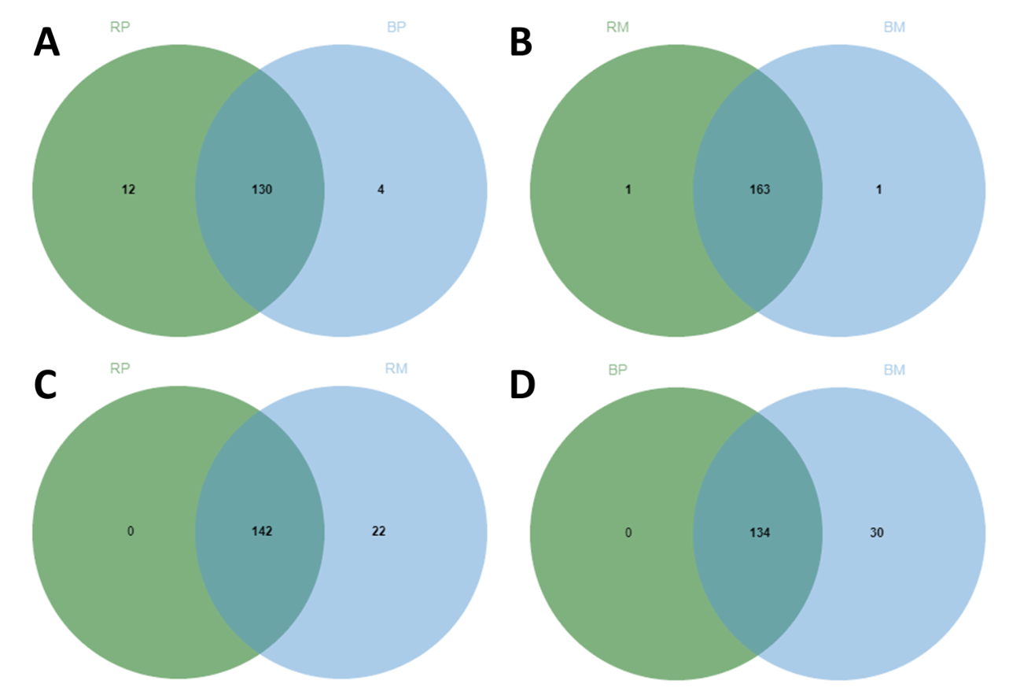

Supplementary Figure S5. Venn diagram of differentially expressed mature miRNAs which are exclusively or shared among the four pairwise comparison groups. Data were retrieved from Table 4. miRNAs were considered differentially expressed when FDR<0.05 and LogFC>1.5. RP, responsive cell line in proliferation stage; RM, responsive cell line in maturation stage; BP, blocked cell line in proliferation stage; BM, blocked cell line in maturation stage. Exclusive and common miRNAs among the four pairwise comparisons are listed in Supplementary File E3.

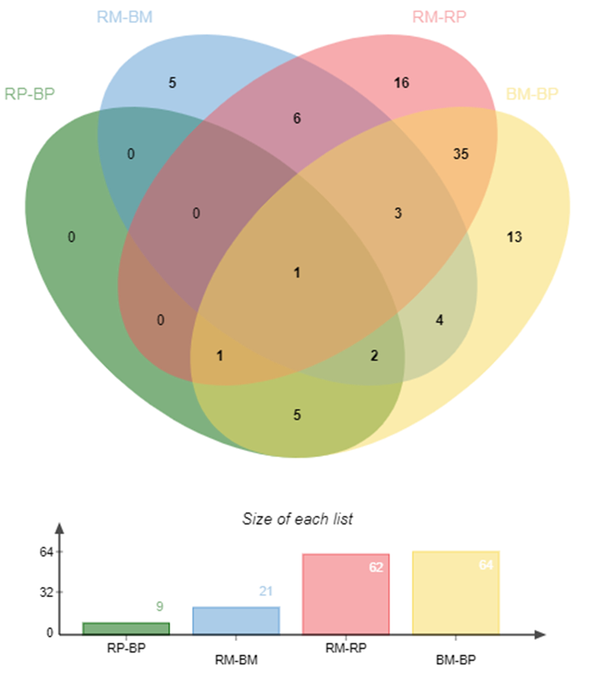

Supplementary Table S5. Targets of conserved miRNAs identified during somatic embryogenesis of Araucaria angustifolia.
miRNA family | Target annotation | Expectationª | UPE | Inhibition
Aang-miR169 | Probable disease resistance protein RPP1 | 0 | -1 | Cleavage
Aang-miR394 | CMP-sialic acid transporter 1 | 2.5 | -1 | Cleavage
Aang-miR482 | Probable disease resistance protein At4g33300 | 0.5 | -1 | Cleavage
Aang-miR482 | ER lumen protein-retaining receptor B | 2 | -1 | Cleavage
Aang-miR482 | Pentatricopeptide repeat-containing protein At1g62930, chloroplastic | 2.5 | -1 | Cleavage
Aang-miR482 | Protein RIK | 2.5 | -1 | Cleavage
Aang-miR482 | Plastocyanin, chloroplastic | 2 | -1 | Cleavage
Aang-miR482 | Disease resistance protein Roq1 {ECO:0000305} | 2 | -1 | Cleavage
Aang-miR1030 | Protein pleiotropic regulatory locus 1 | 2.5 | -1 | Cleavage
Aang-miR1314 | Probable disease resistance protein At4g33300 | 1 | -1 | Cleavage
Aang-miR1314 | Protein DETOXIFICATION 29 {ECO:0000303|PubMed:11739388} | 2.5 | -1 | Cleavage
ª Targets were predicted by psRNAtarget tool using an expectation cut-off of 2.5. Annotation was performed using Trinotate v.3.2.1 pipeline.

Supplementary Table S6. Majority of the predictedª target genes, their putative functions, and corresponding annotation of novel miRNAs in Araucaria angustifolia.
Novel miRNA | Target annotation | Expectation | UPE | Inhibition
Aang-novel_1 | TMV resistance protein N | 2 | -1 | Cleavage
Aang-novel_2 | TMV resistance protein N | 2 | -1 | Cleavage
Aang-novel_4 | Putative disease resistance protein At3g14460 | 2 | -1 | Cleavage
Aang-novel_4 | Transmembrane 9 superfamily member 11 {ECO:0000305} | 2 | -1 | Cleavage
Aang-novel_4 | Wall-associated receptor kinase-like 1 | 2.5 | -1 | Cleavage
Aang-novel_7 Aang-novel_8 | Pentatricopeptide repeat-containing protein At5g50390, chloroplastic | 2.5 | -1 | Cleavage
Aang-novel_7 Aang-novel_8 | Pentatricopeptide repeat-containing protein At5g50390, chloroplastic | 2.5 | -1 | Cleavage
Aang-novel_9 Aang-novel_10 | Disease resistance protein Roq1 {ECO:0000305} | 2.5 | -1 | Cleavage
Aang-novel_9 Aang-novel_10 | Disease resistance protein Roq1 {ECO:0000305} | 2 | -1 | Cleavage
Aang-novel_11 | Chaperone protein dnaJ GFA2, mitochondrial {ECO:0000305} | 2.5 | -1 | Cleavage
Aang-novel_11 | Protein MEI2-like 2 | 2.5 | -1 | Cleavage
Aang-novel_12 Aang-novel_13 Aang-novel_14 Aang-novel_15 | TMV resistance protein N | 2.5 | -1 | Cleavage
Aang-novel_12 Aang-novel_13 Aang-novel_14 Aang-novel_15 | TMV resistance protein N | 2.5 | -1 | Cleavage
Aang-novel_12 Aang-novel_13 Aang-novel_14 Aang-novel_15 | TMV resistance protein N | 2.5 | -1 | Cleavage
Aang-novel_12 Aang-novel_13 Aang-novel_14 Aang-novel_15 | TMV resistance protein N | 2.5 | -1 | Cleavage
Aang-novel_19 Aang-novel_20 | Cyclin-T1-4 | 2.5 | -1 | Cleavage
Aang-novel_19 Aang-novel_20 | Malate dehydrogenase, mitochondrial | 2.5 | -1 | Cleavage
Aang-novel_19 Aang-novel_20 | Probable inactive receptor kinase At2g26730 | 2.5 | -1 | Cleavage
Aang-novel_19 Aang-novel_20 | Probable leucine-rich repeat receptor-like protein kinase At1g68400 | 2.5 | -1 | Cleavage
Aang-novel_19 Aang-novel_20 | Putative disease resistance protein At3g14460 | 2.5 | -1 | Cleavage
Aang-novel_19 Aang-novel_20 | Putative E3 ubiquitin-protein ligase LIN | 2.5 | -1 | Cleavage
Aang-novel_21 | Pentatricopeptide repeat-containing protein At1g09900 | 2.5 | -1 | Cleavage
Aang-novel_22 Aang-novel_23 | Disease resistance protein | 2.5 | -1 | Cleavage
Aang-novel_24 Aang-novel_25 | Transcription factor ILR3 | 2.5 | -1 | Cleavage
Aang-novel_30 | Disease resistance protein RPP2B {ECO:0000305} | 2.5 | -1 | Cleavage
Aang-novel_30 | NADH-ubiquinone oxidoreductase chain 5 | 2.5 | -1 | Cleavage
Aang-novel_30 | NADH-ubiquinone oxidoreductase chain 5 | 2.5 | -1 | Translation
Aang-novel_31 | Probable serine/threonine-protein kinase PBL21 {ECO:0000305} | 2 | -1 | Cleavage
Aang-novel_31 | Salt tolerance receptor-like cytoplasmic kinase 1 {ECO:0000303|PubMed:29581216} | 2 | -1 | Cleavage
Aang-novel_32 Aang-novel_33 | Disease resistance protein | 2.5 | -1 | Cleavage
Aang-novel_34 | Leucine-rich repeat receptor-like protein kinase TDR | 2.5 | -1 | Cleavage
Aang-novel_34 | Probable inactive leucine-rich repeat receptor kinase XIAO {ECO:0000305} | 2.5 | -1 | Cleavage
Aang-novel_37 | Switch 2 {ECO:0000312|EMBL:AEE27606.1} | 2 | -1 | Cleavage
Aang-novel_42 | Disease resistance protein RUN1 {ECO:0000305} | 1.5 | -1 | Translation
Aang-novel_42 | Probable magnesium transporter NIPA4 | 2.5 | -1 | Cleavage
Aang-novel_42 | Protein LONG AFTER FAR-RED 3 {ECO:0000303|PubMed:14645728} | 2.5 | -1 | Cleavage
Aang-novel_42 | Superoxide dismutase [Cu-Zn] | 2.5 | -1 | Cleavage
Aang-novel_43 Aang-novel_44 Aang-novel_45 Aang-novel_57 Aang-novel_104 | Disease resistance protein Roq1 {ECO:0000305} | 1.5 | -1 | Cleavage
 | Disease resistance protein Roq1 {ECO:0000305} | 2 | -1 | Cleavage
 | Putative pentatricopeptide repeat-containing protein At3g23330 | 2.5 | -1 | Cleavage
Aang-novel_46 | Heat shock factor protein HSF24 | 2.5 | -1 | Cleavage
Aang-novel_47 | Probable disease resistance protein At4g33300 | 0.5 | -1 | Cleavage
Aang-novel_47 | Probable disease resistance protein At4g33300 | 2 | -1 | Cleavage
Aang-novel_47 | Probable disease resistance protein At4g33300 | 2 | -1 | Translation
Aang-novel_48 | Zeaxanthin epoxidase, chloroplastic {ECO:0000255|PIRNR:PIRNR036989} | 2.5 | -1 | Cleavage
Aang-novel_50 | Aluminum-activated malate transporter 12 | 2.5 | -1 | Cleavage
Aang-novel_61 | Heat shock 70 kDa protein, mitochondrial | 2.5 | -1 | Cleavage
Aang-novel_61 | Protein trichome berefringence-like 7 | 2.5 | -1 | Cleavage
Aang-novel_63 | 3-hydroxy-3-methylglutaryl-coenzyme A reductase 1 | 2 | -1 | Cleavage
Aang-novel_63 | Dynamin-related protein 3A | 2 | -1 | Cleavage
Aang-novel_63 | Eukaryotic translation initiation factor 3 subunit C {ECO:0000255|HAMAP-Rule:MF_03002} | 2.5 | -1 | Cleavage
Aang-novel_63 | Pentatricopeptide repeat-containing protein At1g12775, mitochondrial | 2.5 | -1 | Cleavage
Aang-novel_63 | Probable alpha-amylase 2 | 2.5 | -1 | Cleavage
Aang-novel_64 | Probable disease resistance protein At1g12290 | 2 | -1 | Cleavage
Aang-novel_64 | Probable disease resistance protein At5g66910 | 2.5 | -1 | Cleavage
Aang-novel_64 | RNA-dependent RNA polymerase 6 | 2.5 | -1 | Cleavage
Aang-novel_65 | Disease resistance protein Roq1 {ECO:0000305} | 2 | -1 | Translation
Aang-novel_69 | Transcriptional elongation regulator MINIYO {ECO:0000303|PubMed:21620701} | 2.5 | -1 | Translation
Aang-novel_70 | ABC transporter I family member 19 | 2.5 | -1 | Cleavage
Aang-novel_71 Aang-novel_73 | UDP-glycosyltransferase 84A1 {ECO:0000303|PubMed:11042215} | 2.5 | -1 | Cleavage
Aang-novel_74 | Pentatricopeptide repeat-containing protein At5g27270 | 2 | -1 | Cleavage
Aang-novel_76 | Mechanosensitive ion channel protein 2, chloroplastic | 2 | -1 | Translation
Aang-novel_76 | Uroporphyrinogen decarboxylase, chloroplastic | 2.5 | -1 | Cleavage
Aang-novel_78 Aang-novel_79 Aang-novel_81 Aang-novel_143 | Heavy metal-associated isoprenylated plant protein 26 {ECO:0000303|PubMed:21072340, ECO:0000303|PubMed:23368984} | 1 | -1 | Cleavage
Aang-novel_80 | Oligopeptide transporter 3 | 2.5 | -1 | Cleavage
Aang-novel_80 | Phosphatidylinositol/phosphatidylcholine transfer protein SFH1 | 2.5 | -1 | Cleavage
Aang-novel_82 Aang-novel_83 Aang-novel_84 Aang-novel_85 Aang-novel_86 | Putative pentatricopeptide repeat-containing protein At1g74580 | 1 | -1 | Cleavage
 | Xyloglucan endotransglucosylase/hydrolase | 2.5 | -1 | Cleavage
Aang-novel_90 | Beta-glucosidase 40 | 2.5 | -1 | Cleavage
Aang-novel_91 Aang-novel_92 | RNA-dependent RNA polymerase 6 | 2 | -1 | Cleavage
Aang-novel_94 Aang-novel_95 Aang-novel_96 | Isocitrate dehydrogenase [NAD] regulatory subunit 1, mitochondrial | 2 | -1 | Cleavage
Aang-novel_94 Aang-novel_95 Aang-novel_96 | Pentatricopeptide repeat-containing protein PPR5, chloroplastic {ECO:0000305} | 2.5 | -1 | Cleavage
Aang-novel_94 Aang-novel_95 Aang-novel_96 | Probable glycosyltransferase STELLO1 {ECO:0000303|PubMed:27277162} | 2.5 | -1 | Cleavage
Aang-novel_94 Aang-novel_95 Aang-novel_96 | Probable protein S-acyltransferase 22 | 2.5 | -1 | Cleavage
Aang-novel_94 Aang-novel_95 Aang-novel_96 | Tripeptidyl-peptidase 2 | 2.5 | -1 | Cleavage
Aang-novel_97 | RNA-dependent RNA polymerase 6 | 2 | -1 | Cleavage
Aang-novel_99 | Probable inorganic phosphate transporter 1-4 | 2.5 | -1 | Cleavage
Aang-novel_100 Aang-novel_101 | Protein RDM16 {ECO:0000303|PubMed:24068953} | 2.5 | -1 | Cleavage
Aang-novel_100 Aang-novel_101 | Protein RDM16 {ECO:0000303|PubMed:24068953} | 2.5 | -1 | Cleavage
Aang-novel_103 | 7-deoxyloganetin glucosyltransferase | 0 | -1 | Cleavage
Aang-novel_103 | Endoribonuclease Dicer homolog 1 | 2.5 | -1 | Cleavage
Aang-novel_103 | Pentatricopeptide repeat-containing protein At1g77360, mitochondrial | 2.5 | -1 | Cleavage
Aang-novel_103 | Pentatricopeptide repeat-containing protein At3g62470, mitochondrial | 2.5 | -1 | Cleavage
Aang-novel_105 Aang-novel_134 | Probable disease resistance protein At4g33300 | 2.5 | -1 | Cleavage
Aang-novel_106 Aang-novel_108 | Photosystem II CP47 reaction center protein {ECO:0000255|HAMAP-Rule:MF_01495} | 0 | -1 | Cleavage
Aang-novel_107 Aang-novel_109 | ABC transporter F family member 1 | 2.5 | -1 | Translation
Aang-novel_113 | Nuclear pore complex protein NUP96 {ECO:0000303|PubMed:21189294} | 2 | -1 | Cleavage
Aang-novel_114 | Pentatricopeptide repeat-containing protein At3g61360 | 2.5 | -1 | Cleavage
Aang-novel_115 | Probable L-type lectin-domain containing receptor kinase S.5 | 2 | -1 | Cleavage
Aang-novel_115 | Protein TRIGALACTOSYLDIACYLGLYCEROL 2, chloroplastic {ECO:0000303|PubMed:16818883} | 2 | -1 | Cleavage
Aang-novel_115 | Serine/threonine-protein kinase STY8 {ECO:0000305} | 2.5 | -1 | Cleavage
Aang-novel_117 | Leucine--tRNA ligase, cytoplasmic {ECO:0000305} | 0 | -1 | Cleavage
Aang-novel_117 | Retrovirus-related Pol polyprotein from transposon | Reverse transcriptase (RNA-dependent DNA polymerase) domain | 2.5 | -1 | Cleavage
Aang-novel_118 | F-box/kelch-repeat protein At5g15710 | 0 | -1 | Cleavage
Aang-novel_120 | Calpain-type cysteine protease DEK1 | 2 | -1 | Cleavage
Aang-novel_120 | Pentatricopeptide repeat-containing protein At5g18390, mitochondrial | 2.5 | -1 | Cleavage
Aang-novel_122 Aang-novel_124 | F-box/LRR-repeat protein 3 | 1.5 | -1 | Cleavage
Aang-novel_123 | TIR-only protein {ECO:0000303|PubMed:31439793} | 0 | -1 | Cleavage
Aang-novel_125 | Putative RING-H2 finger protein ATL12 | 2.5 | -1 | Cleavage
Aang-novel_125 | Zeatin O-xylosyltransferase | 2.5 | -1 | Cleavage
Aang-novel_131 | DExH-box ATP-dependent RNA helicase DExH14 {ECO:0000305} | 2.5 | -1 | Cleavage
Aang-novel_133 Aang-novel_135 | ACT domain-containing protein ACR9 {ECO:0000305} | 1.5 | -1 | Cleavage
Aang-novel_133 Aang-novel_135 | Valine--tRNA ligase, mitochondrial 1 {ECO:0000305} | 2.5 | -1 | Cleavage
Aang-novel_136 | UDP-glycosyltransferase 91C1 | 2.5 | -1 | Cleavage
Aang-novel_137 | Receptor-like protein kinase THESEUS 1 | 2.5 | -1 | Cleavage
Aang-novel_143 | Allantoinase | 2.5 | -1 | Cleavage
Aang-novel_143 | Histidine-containing phosphotransfer protein 5 | 2.5 | -1 | Cleavage
ª Targets were predicted by psRNAtarget tool using an expectation cut-off of 2.5. Annotation was performed using Trinotate v.3.2.1 pipeline.

Supplementary Figure S6. RT-qPCR expression profile of 9 selected differentially regulated miRNAs at different somatic embryogenesis stages in two contrasting Araucaria angustifolia cell lines. RP, responsive cell line during proliferation stage; BP, blocked cell line during proliferation stage; RM, responsive during maturation stage; and BM, blocked during the maturation stage. The values were obtained by sRNA-seq (Log₂ CPM) and RT-qPCR (Relative expression). Bars represent means ± standard error of three biological replicates.
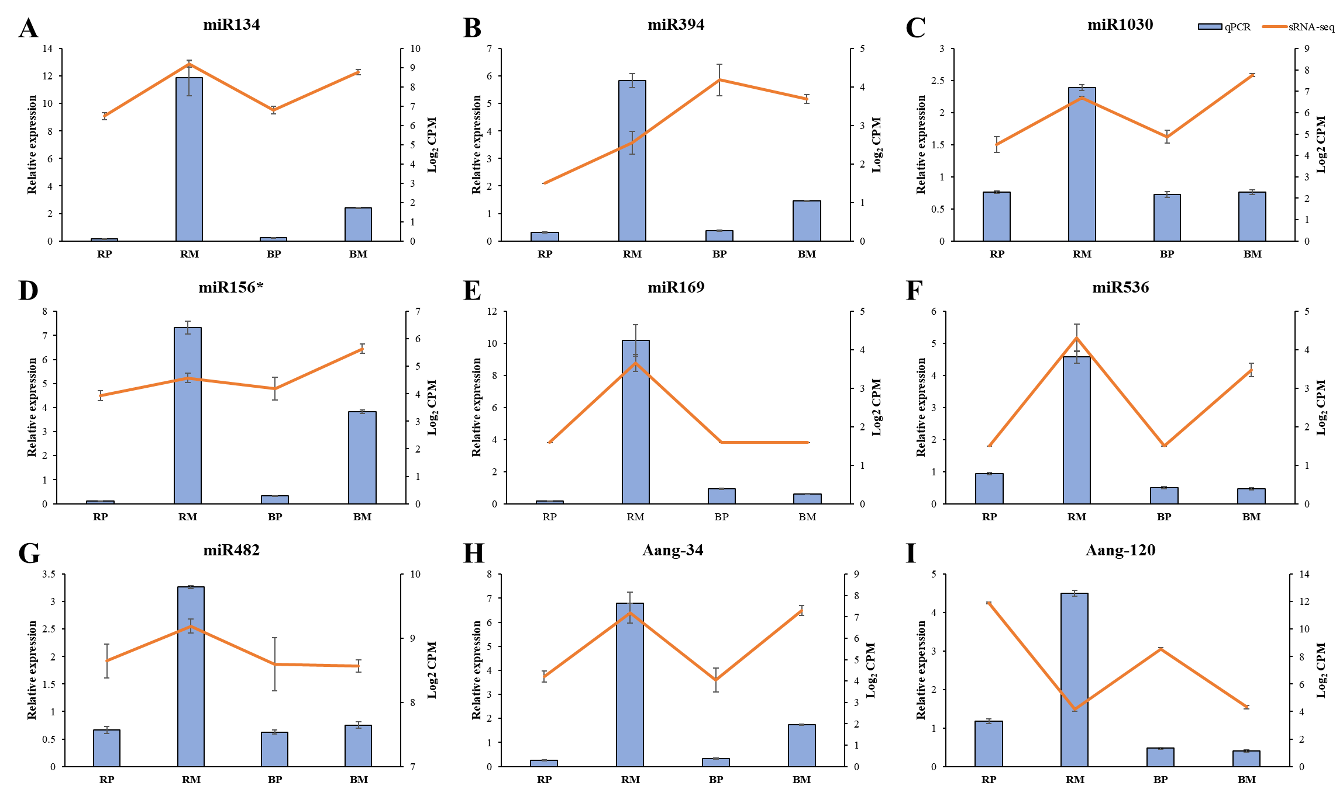

Supplementary Figure 7. RT-qPCR expression profile of selected differentially regulated miRNAs and their target genes involved in somatic embryogenesis stages in two contrasting Araucaria angustifolia cell lines. RP, responsive cell line during proliferation stage; BP, blocked cell line during proliferation stage; RM, responsive during maturation stage; and BM, blocked during the maturation stage. Bars represent means ± standard error of three biological replicates. Significant differences between cell lines at a given step are indicated by asterisk (* P<0.05, **P<0.01, ***P<0.001).
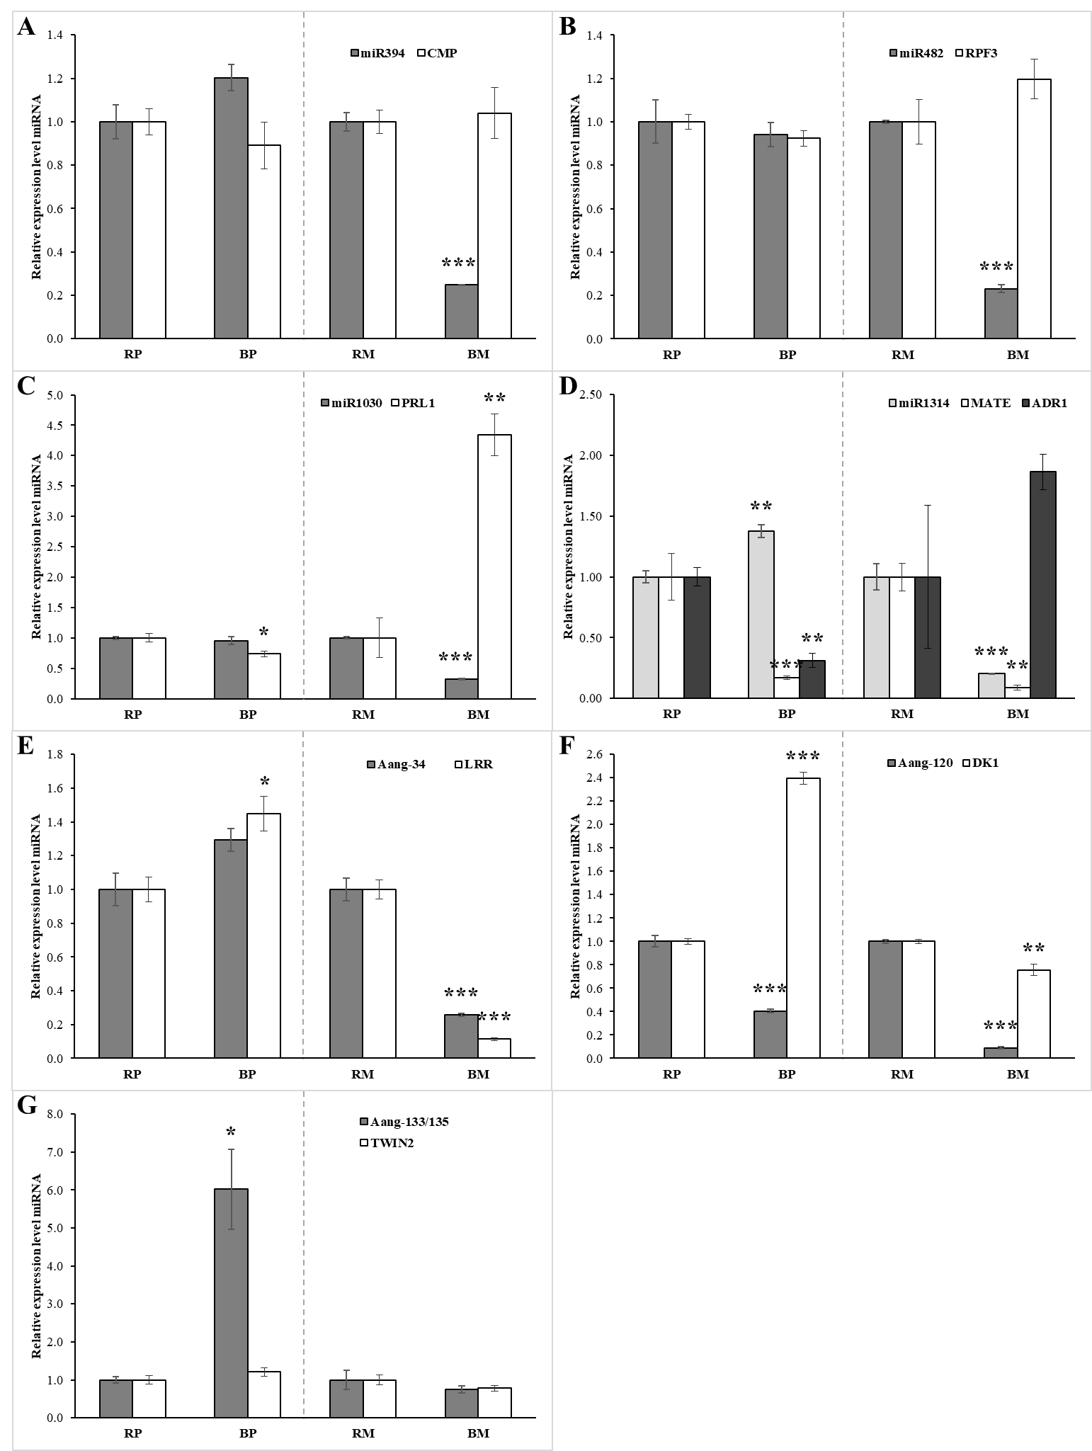

Supplementary Table S7. Specific stem-loop primers for the synthesis of cDNA from conserved and novel miRNAs.
miRNA | Sequence 5' 3'
miR156* | gTCgTATCCAgTgCAgggTCCgAggTATTCgCACTggATACgACGCTGAC
miR169 | gTCgTATCCAgTgCAgggTCCgAggTATTCgCACTggATACgACCAGCAC
miR394 | gTCgTATCCAgTgCAgggTCCgAggTATTCgCACTggATACgACACTTGG
miR482 | gTCgTATCCAgTgCAgggTCCgAggTATTCgCACTggATACgACGGCATG
miR536 | gTCgTATCCAgTgCAgggTCCgAggTATTCgCACTggATACgACAATTGT
miR1030 | gTCgTATCCAgTgCAgggTCCgAggTATTCgCACTggATACgACCGGTGC
miR1314 | gTCgTATCCAgTgCAgggTCCgAggTATTCgCACTggATACgACCTCTCC
Aang-novel_34 | gTCgTATCCAgTgCAgggTCCgAggTATTCgCACTggATACgACTTGGAC
Aang-novel_120 | gTCgTATCCAgTgCAgggTCCgAggTATTCgCACTggATACgACAGCAGA
Aang-novel_133/135 | gTCgTATCCAgTgCAgggTCCgAggTATTCgCACTggATACgACATGCTT

Supplementary Table S8. Primers used for amplification of miRNAs.
Gene | Sequence 5' 3'
miR156* | cctccGCTCACCATCTCTT
miR169 | ggtggGCAGGTCATTCTTG
miR394 | gtggAGGCGGACGGTATG
miR482 | cccaccTTTTGCCAATACCT
miR536 | ggtggTGCAGACTGCCTGG
miR1030 | ggtggTTTGCATCTGCACC
miR1314 | cctccTCGGCCTTGAATGT
novel_34 | cccctcccTTCAACAACTTAA
novel_120 | cctccATGCCCTGCTCTGA
novel_133/135 | cccctcccTTTCCTCTAATTGA
Reverse Universal | GTGCAGGGTCCGAGG

Supplementary Table S9. Primers used for amplification of target-mRNAs.
Gene | Sequence 5' 3' Foward / Reverse
ADR1-LIKE 1 | CAGTTGTGCGTGTGTTATCAGA
ADR1-LIKE 1 | AAAGAGGAAGGCAGGAATAAGC
MATE efflux | GTCCCCCCTGTTGTTCTCTC
MATE efflux | TTCGACTCCTTCCAGAATTGCCTAC
TWIN 2 Val | CTCATCCATTTGCTTACCCGT
TWIN 2 Val | TCCTCCTTCTTCTTCTTCTTCTCC
LRR-RK TDR | CCTTTAATCACTTGACGGGTCC
LRR-RK TDR | CAGTTTGCTAGAGACGAGGGG
PRL1 | CCCCAGAGACCCATCCAATAAAT
PRL1 | CAAGTACAACCAAGATCACCCC
RPF3 | GGTGAAATGGGGATAAGTGACC
RPF3 | TGTCCTCAGGTCTCAATAATTCCA
CMP-sialic acid | GGCGTTCTTACTCTTCTTACCAG
CMP-sialic acid | ATGGAGGGAATCGGGAATAATCG
DK1 | CGTTTACTTCAAGCACACTGGT
DK1 | ACTATCTTTCCTCCCACTGACAT

Supplementary File F1. Predicted secondary structures of conserved miRNAs identified in Araucaria angustifolia, through the Mfold algorithm. The sequences labeled in red or blue correspond to the 5p and 3p, respectively, position in the arm of the hairpin.

Supplementary File F2. Predicted secondary structures of novel miRNAs identified in Araucaria angustifolia, through the Mfold algorithm. The sequences labeled in red or blue correspond to the 5p and 3p, respectively, position in the arm of the hairpin.

Supplementary Excel File E1. MiRDeep2 output table.

Supplementary Excel File E2. Exclusive and common miRNAs identified among the samples and compared by Venn Diagram (Figure 4Cand Supplementary Figure S4).

Supplementary Excel File E3. Exclusive and common differentially expressed miRNAs identified among the four pairwise comparisons and compared by Venn Diagram (Supplementary Figure S5).

