The ER chaperone, BIP protects Microglial cells from ER stress-mediated Apoptosis in Hyperglycemia

Antonisamy William James, Ghaith A. Bahader, Mohammad Albassan, and Zahoor A Shah*

Department of Medicinal and Biological Chemistry, College of Pharmacy and Pharmaceutical Sciences, Toledo Ohio USA
¶Corresponding Author: Zahoor A. Shah, Ph.D., Department of Medicinal and Biological Chemistry, University of Toledo, 3000 Arlington Avenue, Toledo, Ohio, 43614. Phone: 419-383-1587. Email: zahoor.shah@utoledo.edu
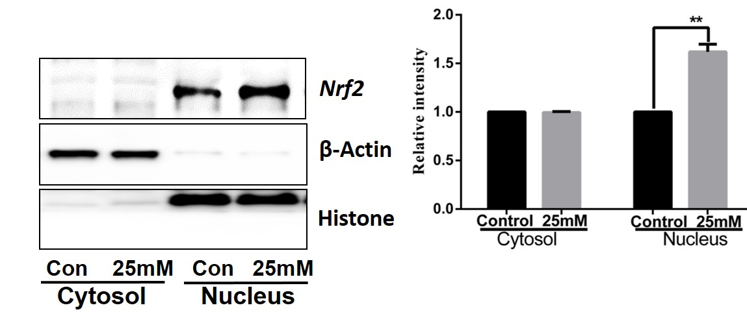

Additional file 1: Figure S1: Expression of Nrf2 in hyperglycemia, Nrf2 protein expression was increased in the nucleus fraction of hyperglycemia condition. Beta-actin is used as a cytosolic marker and histone is used as a nucleus marker.

Additional file 1: figure S2. Flowcytometry analysis of Apoptosis, Apoptotic cells were increased in 35mM glucose than control cells.
b)

Additional file 1: Figure S3, Flowcytometry analysis for ROS production, ROS level was increased in 35mM glucose than control cells.

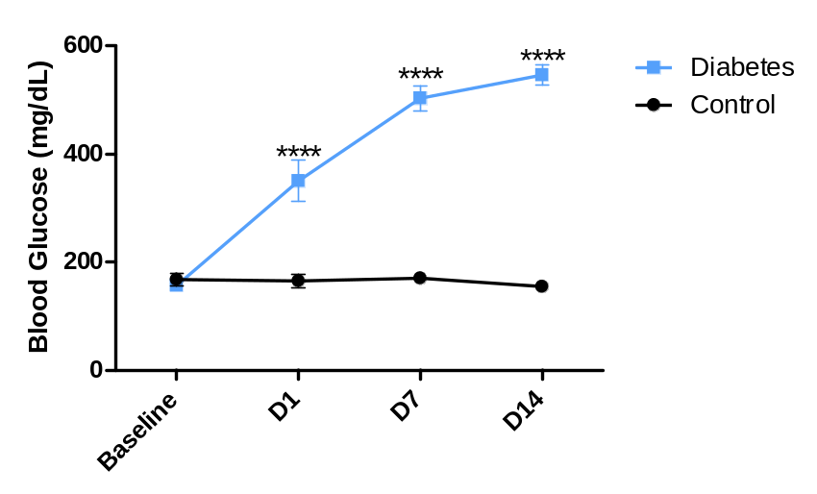
C)
Additional file 1: Figure S4, Blood glucose was increased in STZ injected group than the control group. Hyperglycemia was induced in C57BL/6J mice by two consecutive intraperitoneal injections of streptozotocin (STZ 100/kg) and confirmed by measuring the blood glucose from day 2 to day 14.

Additional file 1: Table S5: Primers used in qRT-PCR.
 | Forward primers (5’-3’) | Reverse primers (5’-3’)
Bip | ACGGGCAAAGATGTCAGGAAG | AGGGCCTTGGCCTTTTCTACC
Pdi | TCCAGGACACACCCTAGAAC | AGTCGAGTCCATCTTGGCGA
Chop | ATGAACGGCTCAAGCAGGAA | GGGAAAGGTGGGTAGTGTGG
Atf4 | GGGTTTTGGATTGGTGGGGT | CGCTCGTTAAATCGCTTCCC
Actin | GATTCCTATGTGGGCGACGA | TGTAGAAGGTGTGGTGCCAG

