A comparative analysis of lipoprotein transport proteins – LolA and LolB from Vibro cholerae and LolA from Porphyromonas gingivalis

Deepika Jaiman^{1,2}, Raghavendra Nagampalli^{1,2} and Karina Persson^{1,2}*
¹Umeå Centre for Microbial Research (UCMR).
²Department of Chemistry, Umeå University, 90187, Umeå, Sweden.

* Corresponding author:

Karina Persson
E-mail: karina.persson@umu.se
Tel: +46-90-7865926

.

Supplementary figures:
a
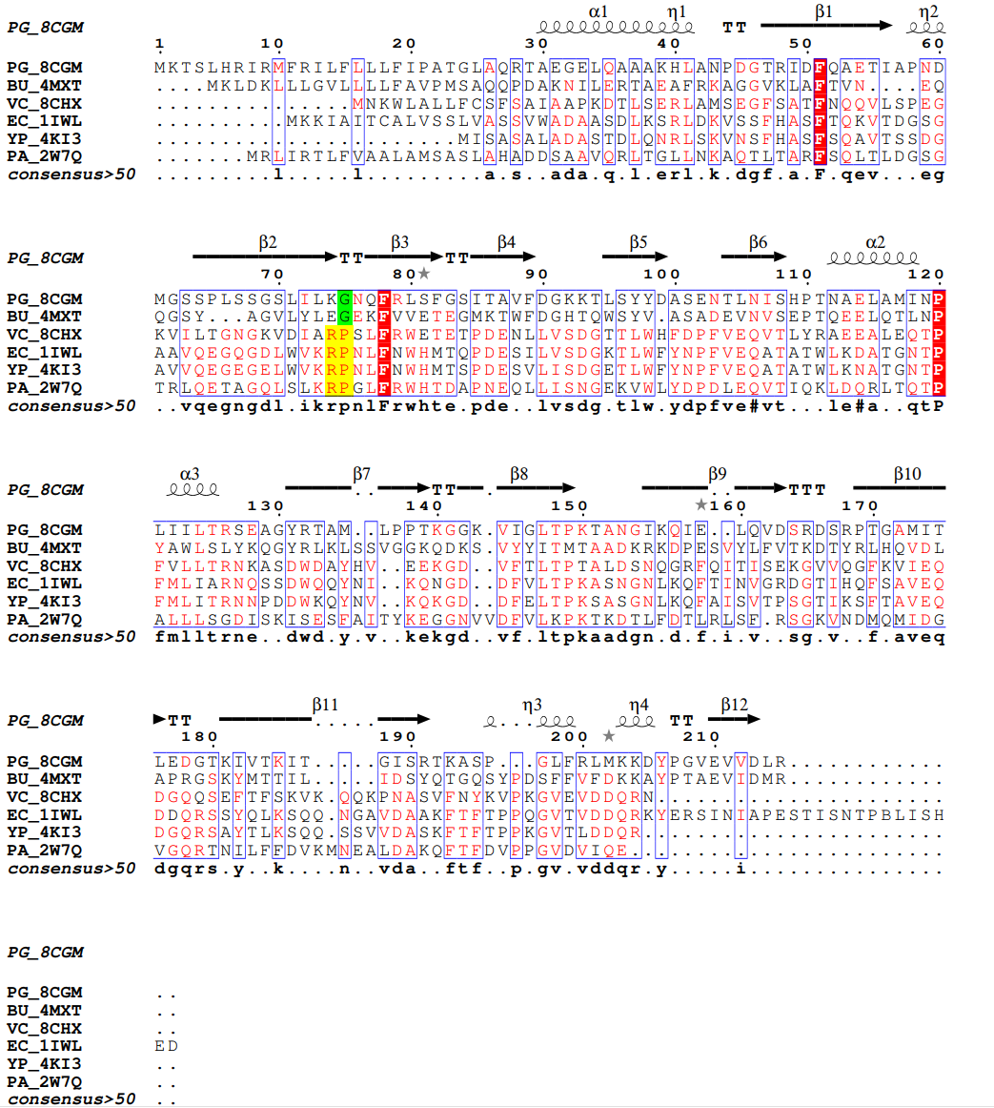

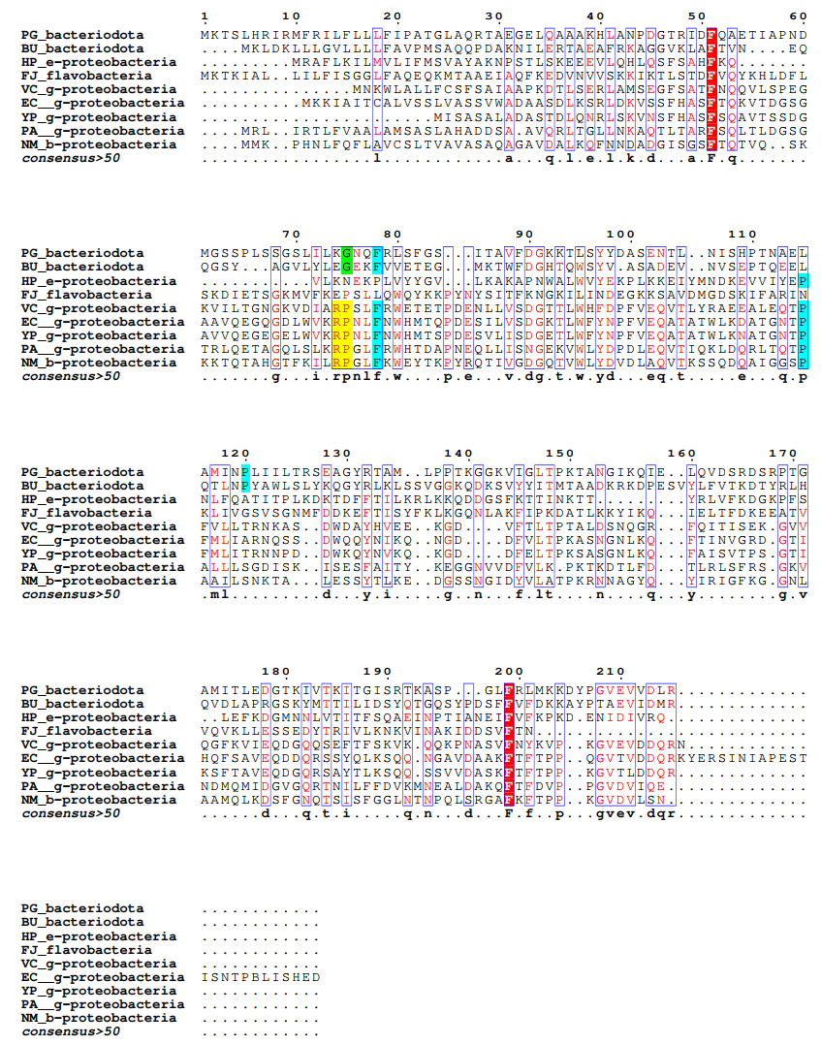
b
Supplementary Figure S1: A sequence alignment of LolA from different bacterial species. (a) A structure-based sequence alignment with LolA from P. gingivalis (PG_8CGM) on B. uniformis (BU_4MXT), V. cholera (VC_8CHX), E. coli (EC_1ILW), Y. pestis (YP_4KI3), and P. aeruginosa (PA_2W7Q). Identical residues are shown in red and the Arg-Pro motif present in γ-proteobacteria is highlighted in yellow. The glycine located in the equivalent position in bacteriodota is highlighted in green. Secondary structure elements, based on PG_8CGM, are indicated above the sequences. (b) LolA sequences from additional bacteria have been included in a sequence alignment. LolA protein sequences from P. gingivalis (PG), B. uniformis (BU), Helicobacter pylori (HP), Flavobacterium johnsoniae (FJ), V. cholera (VC), E. coli (EC), Y. pestis (YP), P. aeruginosa (PA) and Neisseria meningitidis (NM) representing different phyla and classes. Identical residues are shown in red. Residues that were classed as identical in (a) are highlighted in blue. The Arg-Pro motif is highlighted in yellow and is found in γ-protobacteria and β-proteobacteria. The glycine in the same position found in P. gingivalis and B. uniformis is highlighted in green.

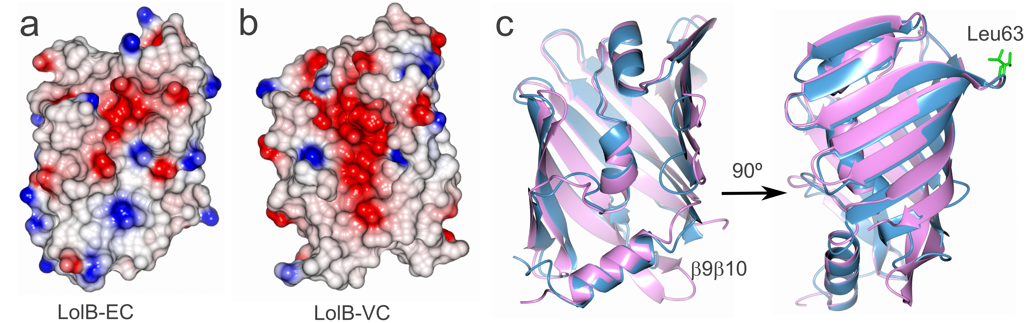

Supplementary Figure S2
Comparison between LolB_EC and LolB_VC. (a) Electrostatic surface representations show that (b) LolB-VC has a prominent electronegative patch present in the center of the protein whereas the surface of LolB_EC has less charges. They also have different calculated isoelectric points, 5.1 and 8.7 respectively. (c) Superposition of LolB_VC (pink) and LolB_EC (blue) illustrating the same size and shape of the binding cleft. The longer β9β10-loop in LolB_VC and Leu63 (Leu68 in LolB-EC) are labelled.
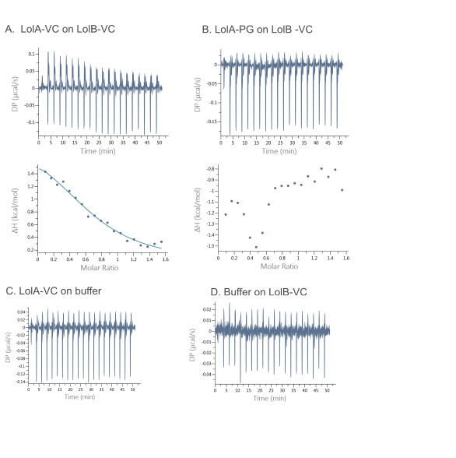

Supplementary Figure S3
The interaction between Lol proteins measured with ITC. (a) association of LolA-VC and LolB-VC, (b) the lack of association between LolA-PG and LolB-VC. For each titration, the thermogram is shown in the upper panel and the fitted curve of background-subtracted heats of injection in the lower panel. The shown thermograms which have been subtracted from heat of injection of LolA-VC to buffer. (c) The heat of injection of LolA-VC on buffer and (d) buffer on LolB-VC. Affinities and thermodynamic parameters are presented in Table S2.

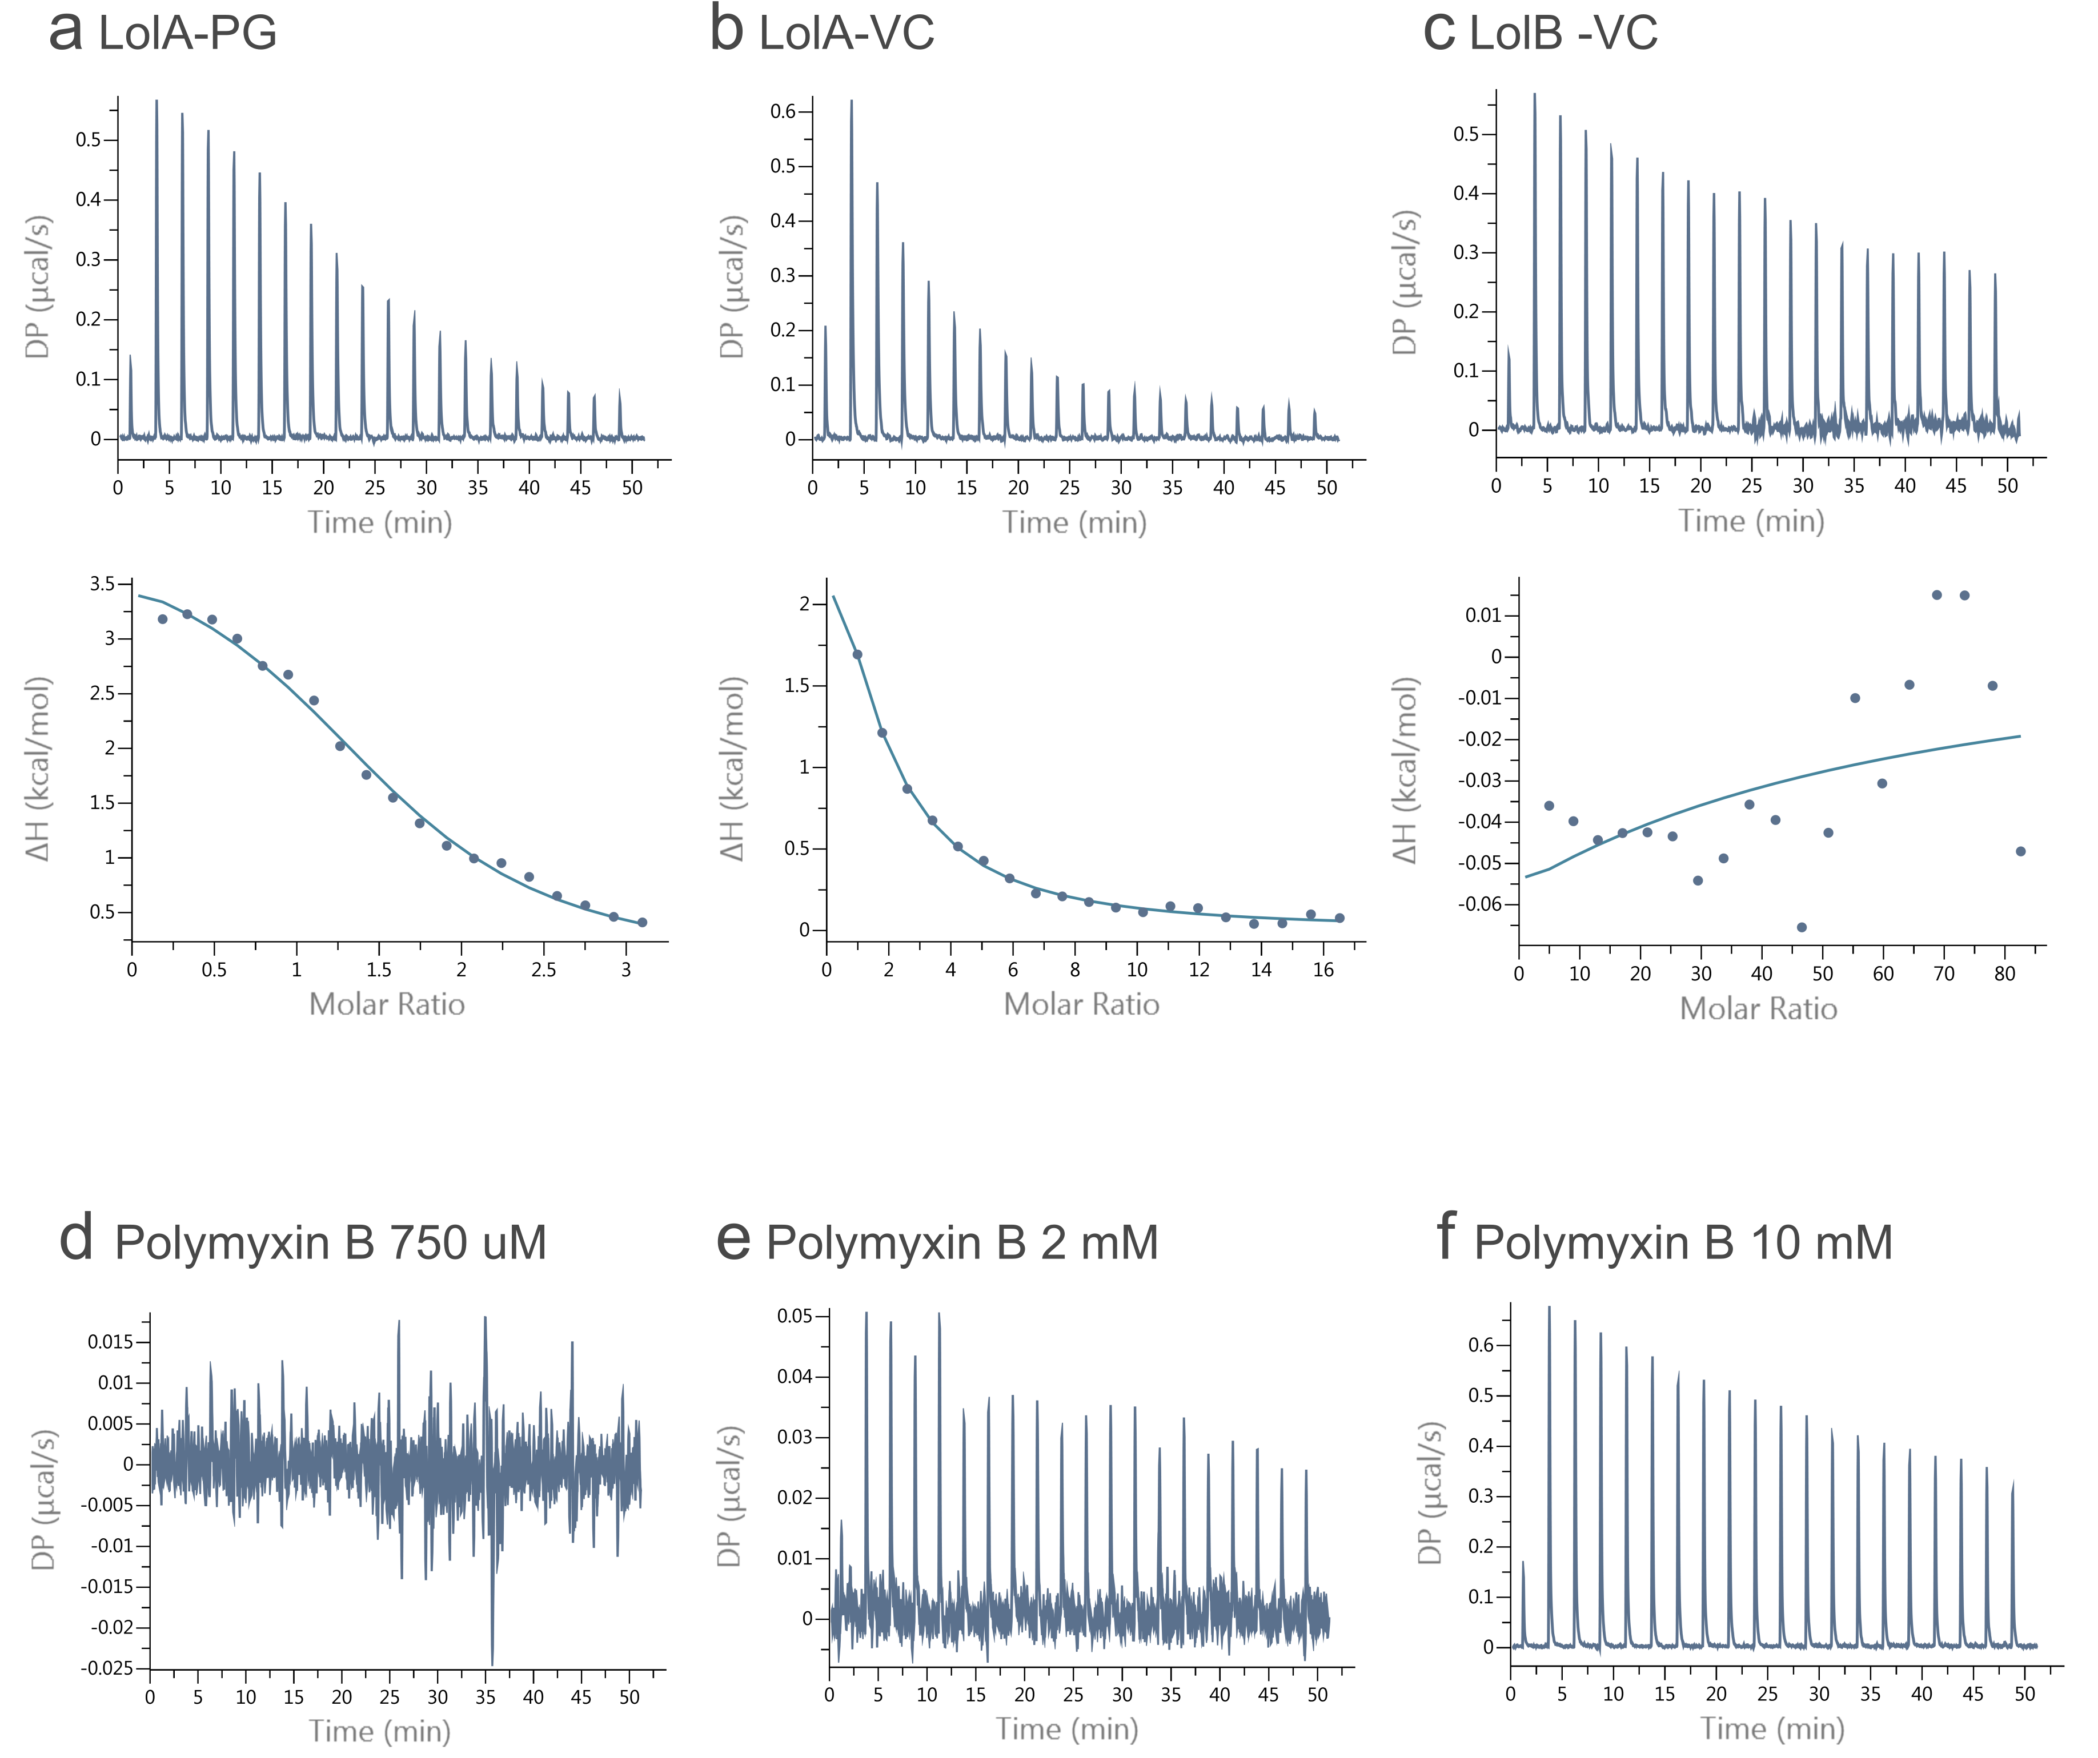
Supplementary Figure S4. The interaction between Lol proteins and polymyxin B. ITC profiles that illustrate the association between the antibiotic polymyxin B and (a) LolA-PG (b) LolA-VC and (c) LolB-VC. For each titration, the thermogram is shown in the upper panel and the fitted curve of background-subtracted heats of injection in the lower panel. The heat of injection of different concentrations of polymyxin B on buffer are shown in (d) 750 μM, (e) 2 mM and (f) 10 mM. Affinities and thermodynamic parameters are presented in Table S2 and S3.
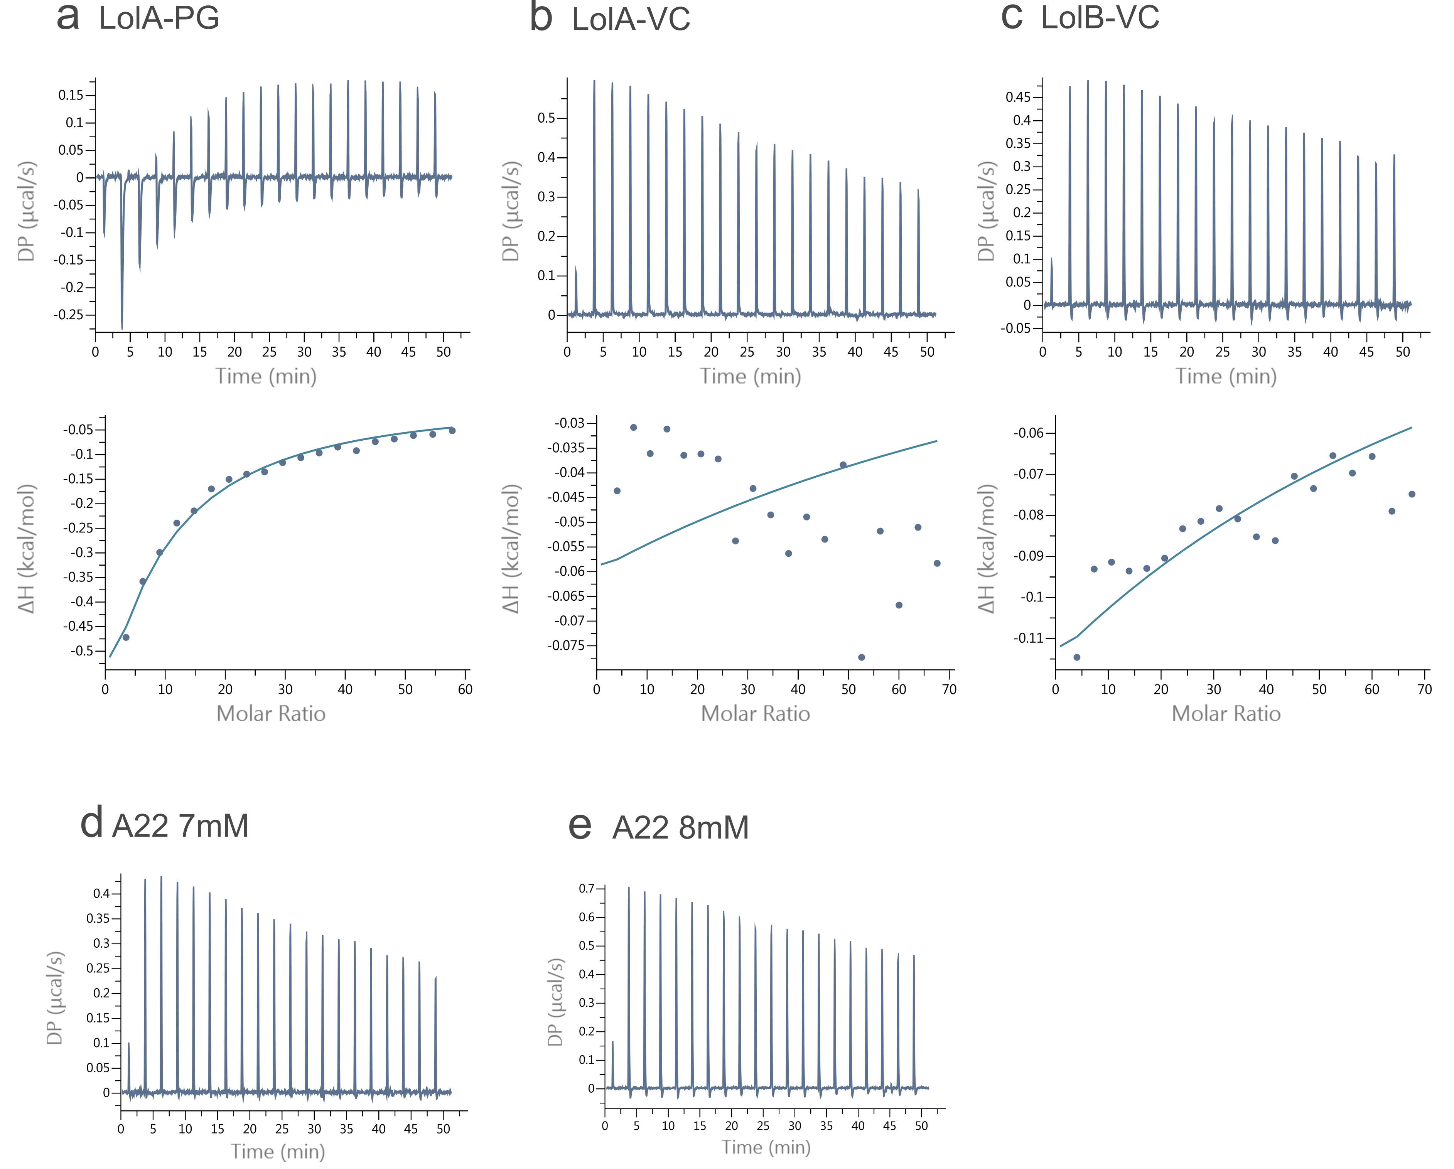

Supplementary Figure S5. The interaction between Lol proteins and the inhibitor A22. ITC profiles illustrating the association between A22 and (a) LolA-PG (b) LolA-VC and (b) LolB-VC. The thermogram is shown in the upper panel and the fitted curve of background-subtracted heats of injection in the lower panel. The heat of injection of two concentrations of A22 on buffer are shown in (d) 7 mM and (e) 8 mM. Affinities and thermodynamic parameters are presented in Table S2 and S3.

Supplementary Table S1: Data processing and refinement statistics

 | LolA-PG-SeMet | LolA-VC | LolB-VC
Data collection
Beamline | DESY, P13 | ESRF, ID23-2 | MaxIV,BioMAX
Wavelength (Å) | 0.9762 | 0.8731 | 0.9762
Space group | P2₁2₁2₁ | P2₁ | P 4₁ 2₁ 2
Molecules in au | 2 | 2 | 1
Cell dimensions
a, b, c (Å) | 48.8, 76,5. 99.4 | 56.089 67.059 | 113.4, 113.4, 34.2
α, β, γ (°) | 90, 90, 90 | 90, 106.579, 90 | 90, 90, 90
Resolution (Å) * | 49.7-1.7 (1.73-1.70) | 45.8-1.80 (1.84-1.80) | 32.7 - 1.46 (1.51- 1.46)
R_{merge} | 0.134 (1.299) | 0.095 (0.675) | 0.127 (2.410)
I /σI | 20.3(13.6) | 15.3 (3.5) | 19.6 (1.7)
Completeness (%) | 100(100) | 99.9 (100) | 99.98 (99.97)
Redundancy | 25.4(26.9) | 9.9 (10.2)
CC1/2 | 0.999(0.865) | 0.998 (0.871) | 0.999 (0.681)
Molecules in a.u. | 2 | 2 | 1
Refinement
Resolution (Å) | 49.7-1.70 (1.76-1.70) | 42.8-1,80 (1.84.1.80) | 35.9 - 1.46 (1.51 - 1.46)
No. reflections  (work/test) | 40327/1382 | 37460/3752 | 39342/1932
R_{work} / R_{free} | 0.1792/0.2221 | 0.2134/0.2547 | 0.1658/0.1972
No. atoms | 3369 | 3497 | 1692
Protein | 2891 | 2921 | 1477
Ligand/ion | 36 | 7 | 0
Water | 442 | 562 | 192
B-factors (Å²)
Protein | 26.7 | 25.71 | 21.73
Ligand/ion | 44.0 | 28.89 | 0
Water | 33.5 | 32.44 | 34.76
R.m.s. deviations
Bond lengths (Å) | 0.018 | 0.006 | 0.006
Bond angles (°) | 1.509 | 0.860 | 0.95
PDB code | 8CGM | 8CHX | 8CM1
*Values in parentheses are for the highest-resolution shell.

Supplementary Table S2: ITC Data for titrations with Kd in micromolar range

 |  | Kd in µM | N sites | ΔH | ΔG | -TΔS
Cell  Syringe | 100 µM LolB-VC  750 µM LolA-VC | 27.5, 32.9  30.2 ± 3.8 | 0.72, 0.83  0.78 ± 0.08 | 2.04, 2.41  2.23 ± 0.26 | -6.22, -6.12  -6.17 ± 0.07 | -8.26, -8.53  -8.4 ± 0.19
Cell  Syringe | 750 µM LolA-PG  100 µM LolB-VC | No binding
Cell  Syringe | 50 µM LolA-PG  750 µM Polymyxin B | 13.2, 13.7, 14.5  13.8 ± 0.655 | 1.56, 1.34, 1.39  1.43 ± 0.11 | 3.97, 4.82, 4.62  4.47± 0.44 | -6.66, -6.63, -6.60  -6.63 ± 0.03 | -10.6, -11.5, -11.2  -11.1 ± 0.45
Cell  Syringe | 25 µM LolA-VC  2 mM Polymyxin B | 61.1, 48.7, 58.2  56 ± 6.48 | 0.619, 1.83, 1.08  1.17 ± 0.61 | 11.2, 3.98, 6.67  7.2± 3.6 | -5.75, -5.88, -5.784  -5.80 ± 0.06 | -17, -9.86, -12.5  -13.2 ± 3.6
Cell  Syringe | 25 µM LolA-PG  7 mM A22 | 732, 657, 654  681 ± 44 | 0.17, 0.17, 0.16  0.17 ± 0.005 | -80.0, -80.0, -80.0  -80.0 | -4.28, -4.34, -4.34  -4.34 | 75.7, 75.7, 75.7  75.7

The table presents each measurement and the average and standard deviation calculated on two or three replicates. V. cholera (VC), P. gingivalis (PG). Mean ± Standard deviation in blue. ΔH, ΔG and –TΔS in kcal/mol. T = 25˚C
Supplementary Table S3: ITC Data for titrations with Kd in millimolar range
 |  | Kd in mM | N sites | ΔH | ΔG | -TΔS
Cell  Syringe | 25 µM LolB-VC  10 µM Polymyxin B | 4.0 ± 43.4  0.37 ± 4.1 | 10 ± 889  10 ± 156 | -0.923 ± 86.9  -0.042 ± 0.749 | -3.27  -4.68 | -2.35  -4.64
Cell  Syringe | 25 µM LolA-VC  8 mM A22 | 13.7 ± 898  14.5 ± 1150 | 10 ± 10⁻⁴  10 ± 1.3*10⁻⁴ | -3.11 ± 3333  -3.47 ± 4580 | -2.54  -2.51 | 0.57  0.956
Cell  Syringe | 25 µM LolB-VC  8 mM A22* | 9.05 ± 83.7  1*10⁻¹²±14.1*10⁻³ | 10 ± 1160  5.57 ± 1.51 | -4.19  7.7*10⁻² | 511  4.5*10⁻² | 1.4  -16.4

Values are shown with error values for individual experiments. A22 on LolB_VC * - Lost binding after subtraction of control experiment. The large deviations are due to the limited solubility of polymyxin A22.

