The effects of novel macrocyclic chelates on the targeting of the ⁶⁸Ga-labeled Gastrin releasing peptide receptor antagonist RM2

Yinwen Wang^{1,2,3}, Hongmei Yuan^{1,2,3}, Sufan Tang^{1,2,3}, Yang Liu^{1,2,4}, Ping Cai^{1,2,3}, Nan Liu⁵, Yue Chen^{1,2,4}, Zhijun Zhou^{1,2,3,4,}*
¹The Department of Nuclear Medicine, Affiliated Hospital of Southwest Medical University, Jiangyang District, Luzhou, Sichuan, China
²Nuclear Medicine and Molecular Imaging Key Laboratory of Sichuan Province, Jiangyang District, Luzhou, Sichuan, China
³Department of Pharmaceutics, School of Pharmacy, Southwest Medical University, Jiangyang District, Luzhou, Sichuan, China
⁴Institute of Nuclear Medicine, Southwest Medical University, Jiangyang District, Luzhou, Sichuan, China
⁵Department of Nuclear Medicine, Sichuan Provincial People’s Hospital, University of Electronic Science and Technology of China, Chengdu, Sichuan, China
*Corresponding author: Zhijun Zhou, zhouzjiang@gmail.com, the Department of Nuclear Medicine, Affiliated Hospital of Southwest Medical University, Luzhou, China. Yue Chen, chenyue5523@126.com, the Department of Nuclear Medicine, Affiliated Hospital of Southwest Medical University.

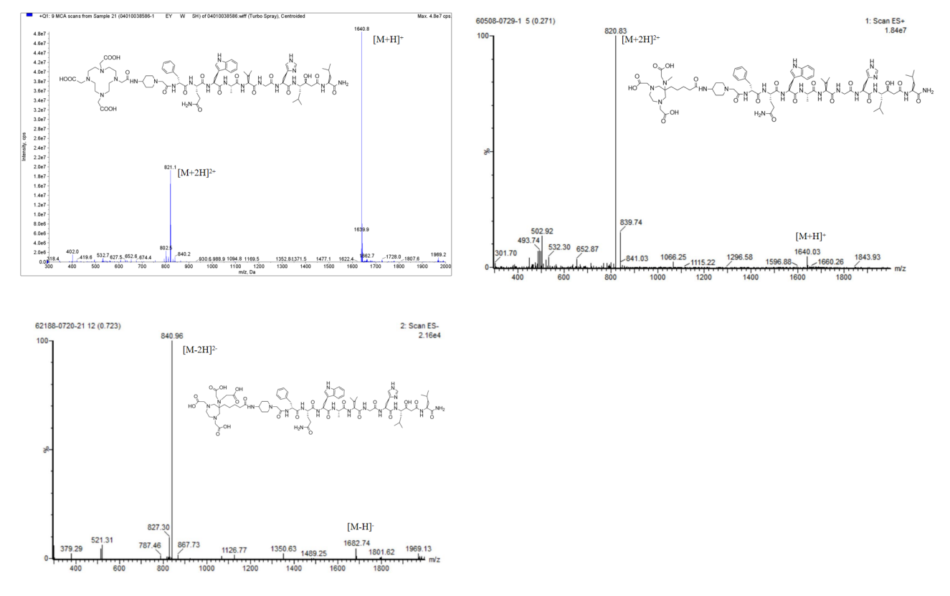

Figure S1. ESI-MS data for the X-RM2.

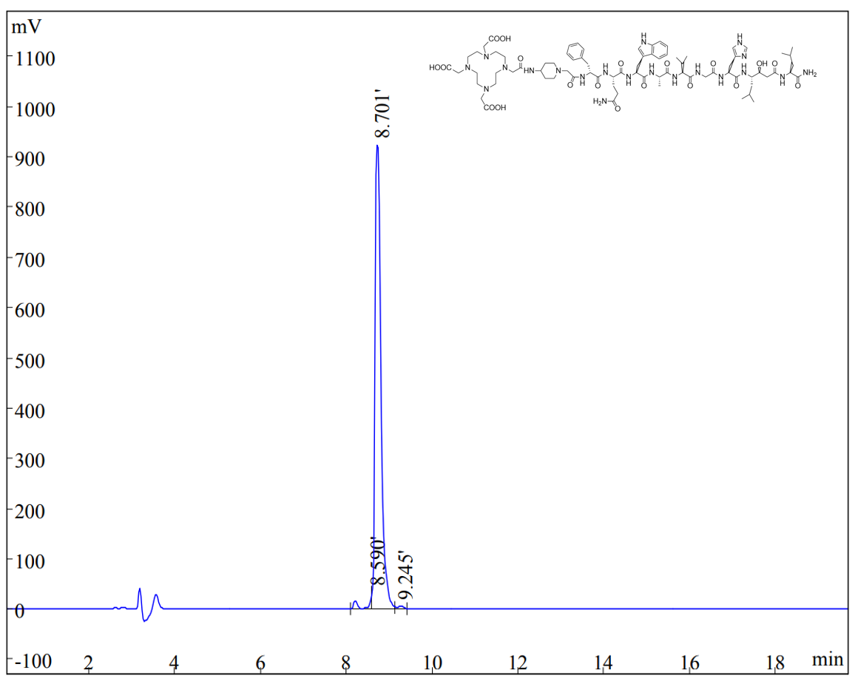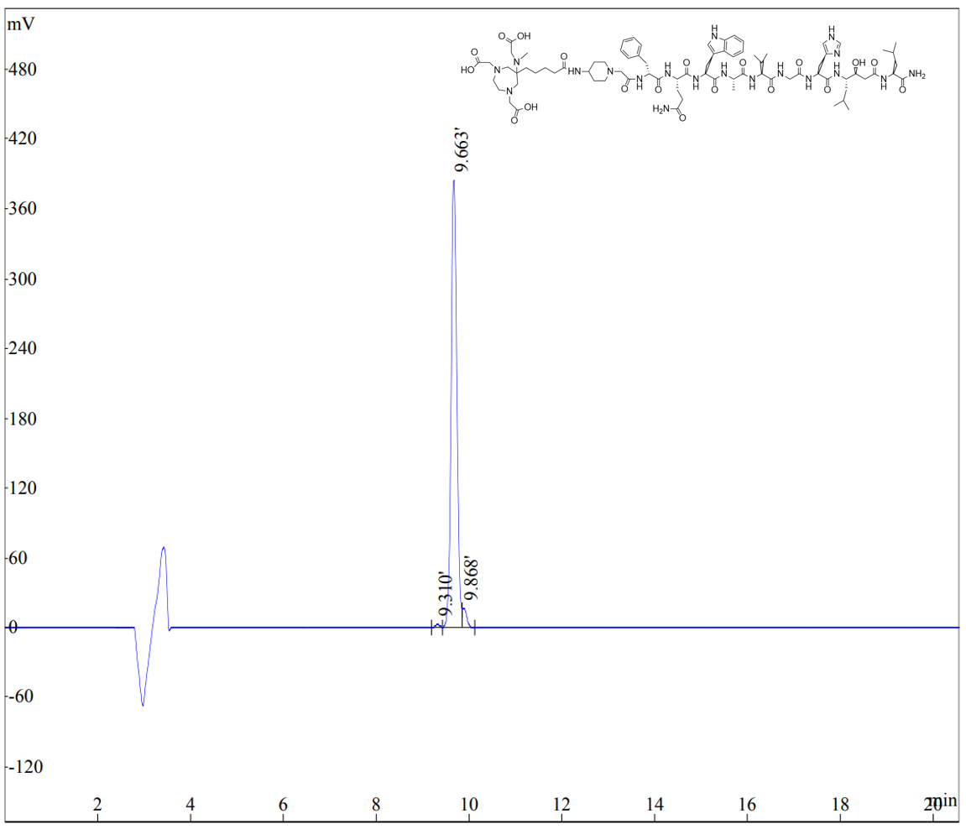
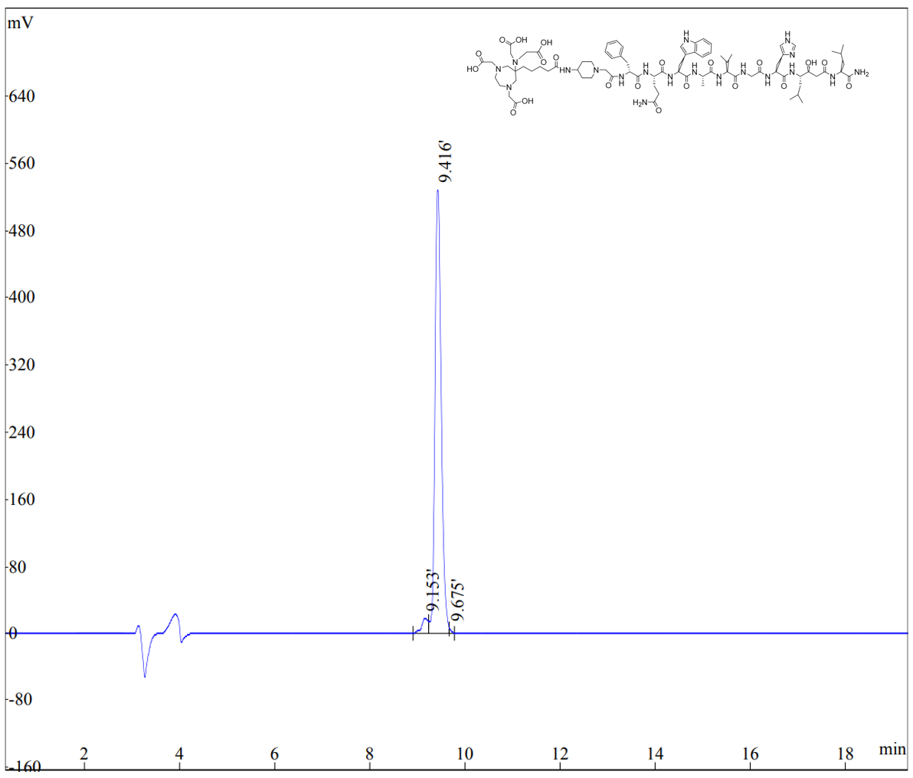

Figure S2. HPLC chromatograms of X-RM2 at UV₂₂₀. An Agilent analytical column (250×4.6 mm) was utilized with mobile phases consisting of 0.1% TFA in water (A) and ACN (B). For analytical runs, a linear gradient of solvent A (95–10% in 15 min) in solvent B at a flow rate of 1.0 mL/min was used for a 15 min run.

Table S1. Biodistribution of ⁶⁸Ga-X-RM2 in male nude mice bearing PC-3 tumours. Values are means ± SD %ID/g (n=5)

