Supplementary Materials
Hot metacognition: poorer metacognitive efficiency following acute but not traumatic stress
Alicia J. Smith, James A. Bisby, Quentin Dercon, Anna Bevan, Tim Dalgleish, Caitlin Hitchcock & Camilla L. Nord

S1: Questionnaires Description
Positive and Negative Affect Scale – Short Form (PANAS-SF). The PANAS measures positive and negative emotions. The short form comprises of 5 questions on each subscale which are scored on a Likert scale ranging from 0 (very slightly or not at all) to 4 (extremely). Scores on the Positive and Negative Affect subscales range from 0-20, with higher scores representing higher levels of positive or negative affect, respectively.
A visual analogue scale was used to assess subjective stress related to the Maastricht Acute Stress test (MAST). Participants were asked how stressful, painful and unpleasant that had thought the task was on a scale from 0-100 (from ‘not at all’ to ‘very’).
Table S1. Difference in item memory performance between the image pair types at pre- and post-stress in Experiment 1.
 | negative-negative | negative-neutral | neutral-negative | neutral-neutral
neutral-neutral | Pre: t(26) = 0.554  Post: t(26) = 0.377 | Pre: t(26) = 1.16  Post: t(26) = 0.239 | Pre: t(26) = 0.220  Post: t(26) = 0.285
neutral-negative | Pre: t(26) = 0.363  Post: t(26) = 0.093 | Pre: t(26) = 1.13  Post: t(26) = 0.401
negative-neutral | Pre: t(26) = 1.94  Post: t(26) = 0.610
negative-negative

Table S2. Difference in associative memory performance between the image pair types at pre- and post-stress in Experiment 1. Results reported in bold represent p < 0.05.
 | negative-negative | negative-neutral | neutral-negative | neutral-neutral
neutral-neutral | Pre: t(26) = 5.57  Post: t(26) = 3.46 | Pre: t(26) = 1.48  Post: t(26) = 1.56 | Pre: t(26) = 1.17  Post: t(26) = 0.975
neutral-negative | Pre: t(26) = 4.38  Post: t(26) = 1.78 | Pre: t(26) = 0.321  Post: t(26) = 0.252
negative-neutral | Pre: t(26) = 4.44  Post: t(26) = 1.91
negative-negative

Table S3. Descriptive results (mean and standard deviation) of the subjective affect and stress measures recorded at pre- and post-stress for Experiment 1. The final column presents the results of paired sample t-tests applied to evaluate the differences between time points for the PANAS-SF subscales. Significantly lower subjective ratings of negative affect were recorded at post- relative to pre-stress.
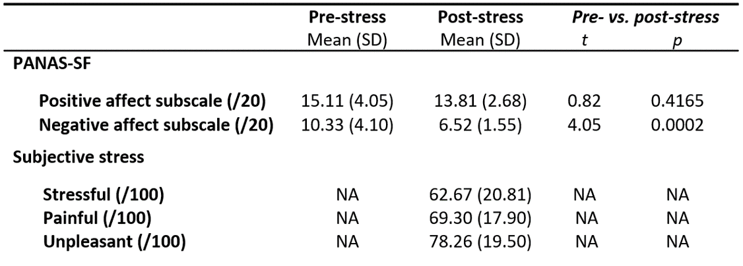

Table S4. Difference in item memory performance between the image pair types in Experiment 2 for the control and intrusive memories groups. Results reported in bold represent p < 0.05.
 | negative-negative | negative-neutral | neutral-negative | neutral-neutral
neutral-neutral | Controls: t(43) = 4.51  Intrusions: t(35) = 6.74 | Controls: t(43) = 5.32  Intrusions: t(35) = 5.42 | Controls: t(43) = 1.69  Intrusions: t(35) = 3.64
neutral-negative | Controls: t(43) = 2.22  Intrusions: t(35) = 4.50 | Controls: t(43) = 2.41  Intrusions: t(35) = 2.50
negative-neutral | Controls: t(43) = 0.378  Intrusions: t(35) = 1.61
negative-negative

 | negative-negative | negative-neutral | neutral-negative | neutral-neutral
neutral-neutral | Controls: t(43) = 1.73  Intrusions: t(35) = 1.58 | Controls: t(43) = 4.15  Intrusions: t(35) = 3.82 | Controls: t(43) = 7.52  Intrusions: t(35) = 5.63
neutral-negative | Controls: t(43) = 5.52  Intrusions: t(35) = 3.91 | Controls: t(43) = 3.66  Intrusions: t(35) = 1.79
negative-neutral | Controls: t(43) = 2.38  Intrusions: t(35) = 2.00
negative-negative
Table S5. Difference in associative memory performance between the image pair types in Experiment 2 for the control and intrusive memories groups. Results reported in bold represent p < 0.05.

Figure S1. Overall confidence reports. At pre- (A) and post-stress (B) in Experiment 1, and for both the intrusive memories group (C) and control group (D) in Experiment 2, across trials confidence reports were reliably related to memory accuracy, with participants reporting higher confidence ratings for correct than incorrect responses.
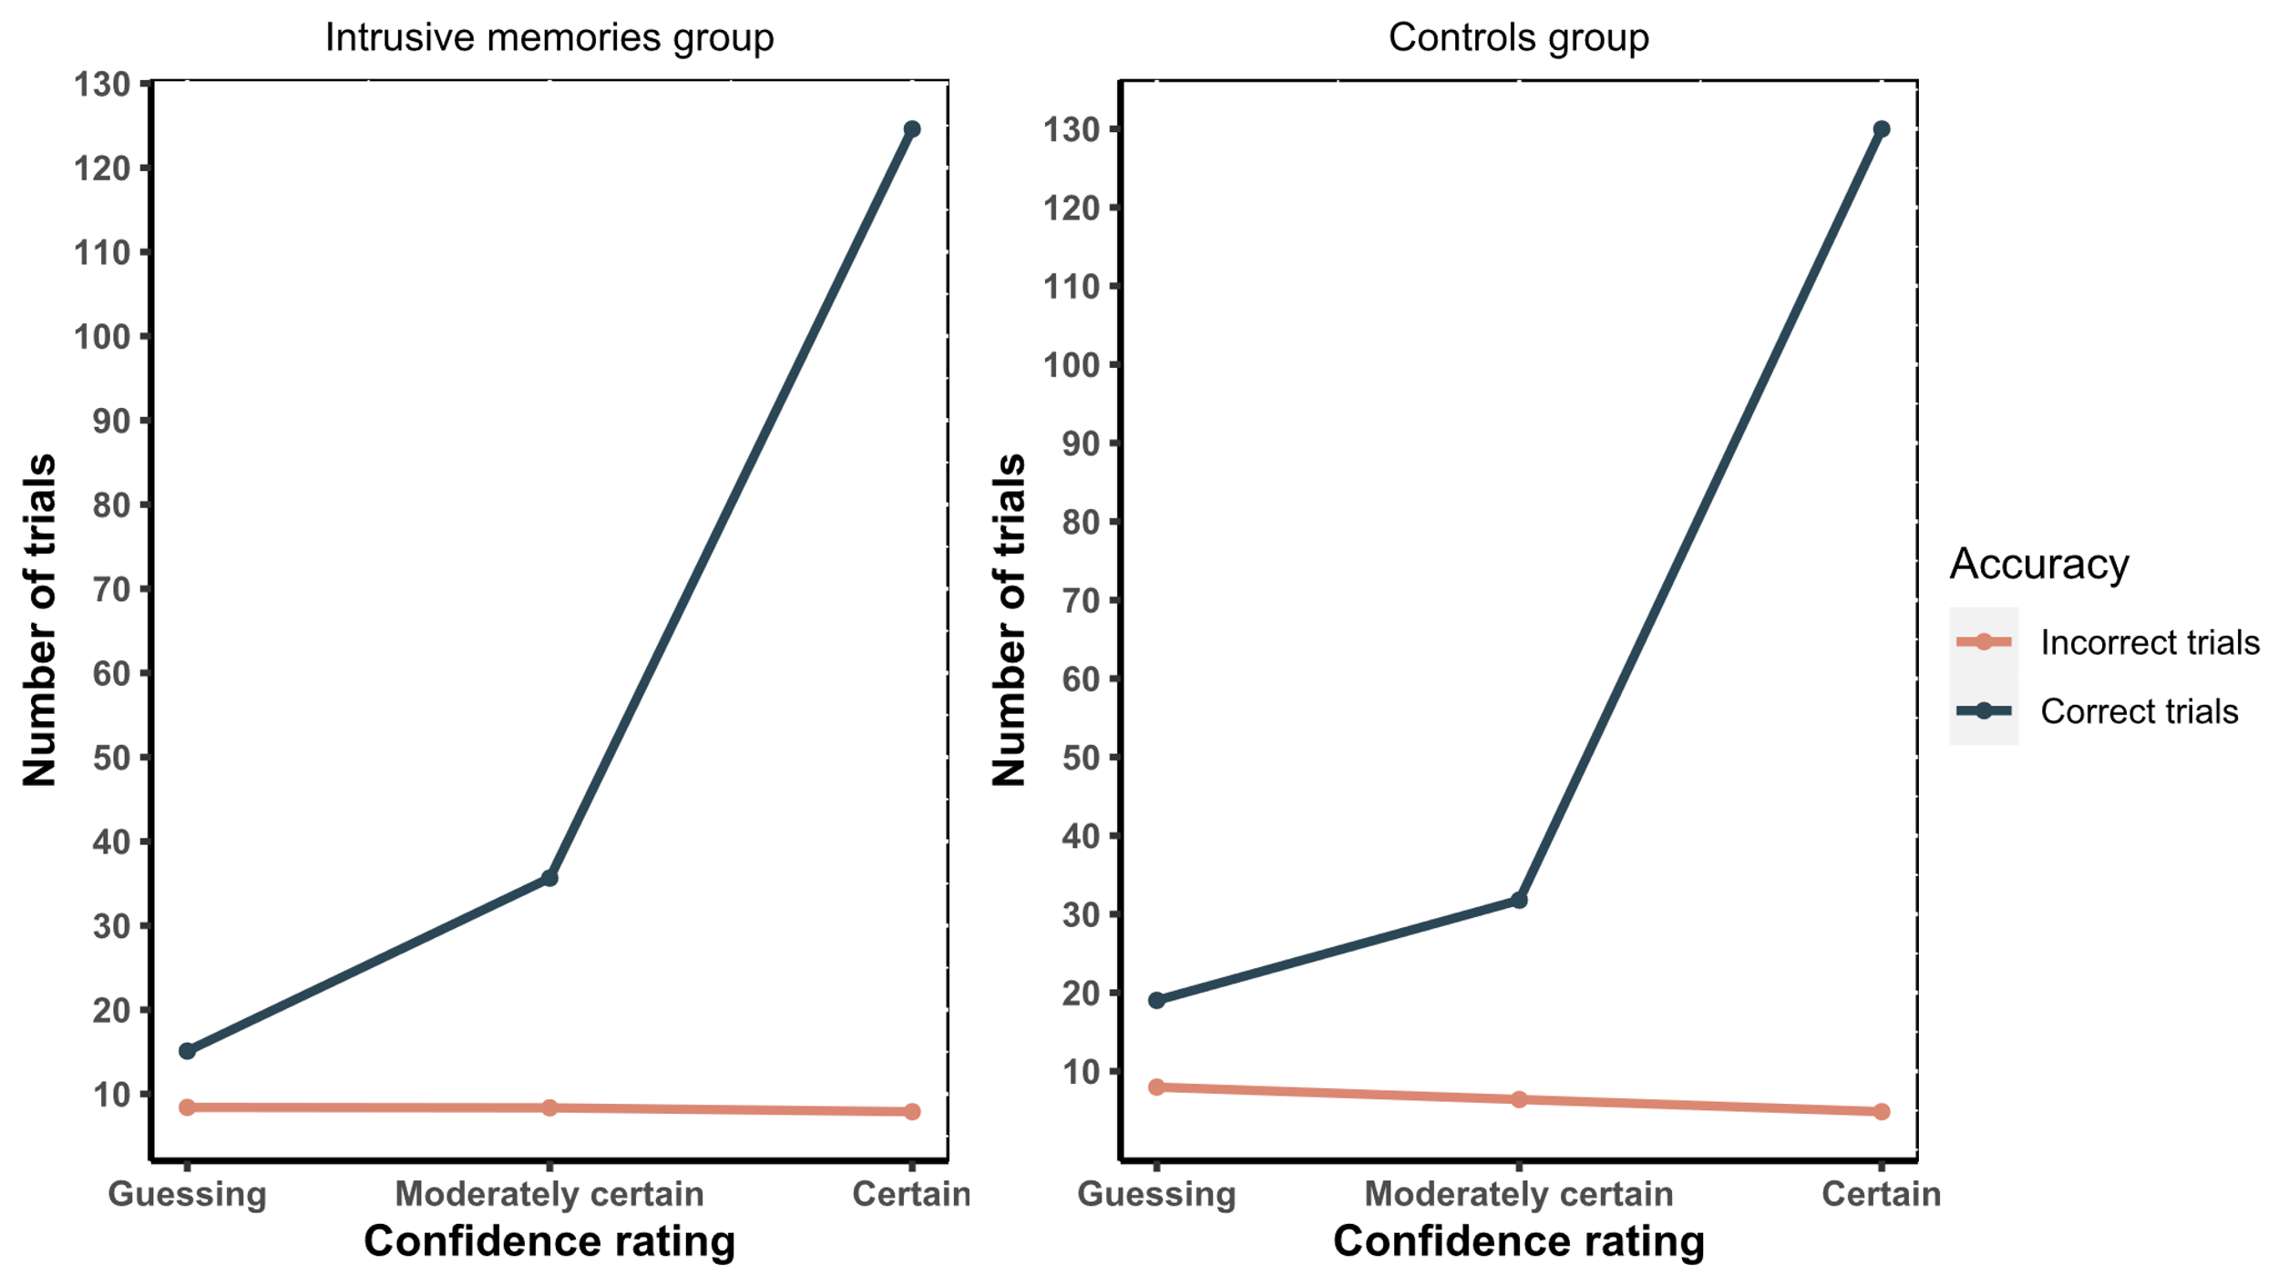
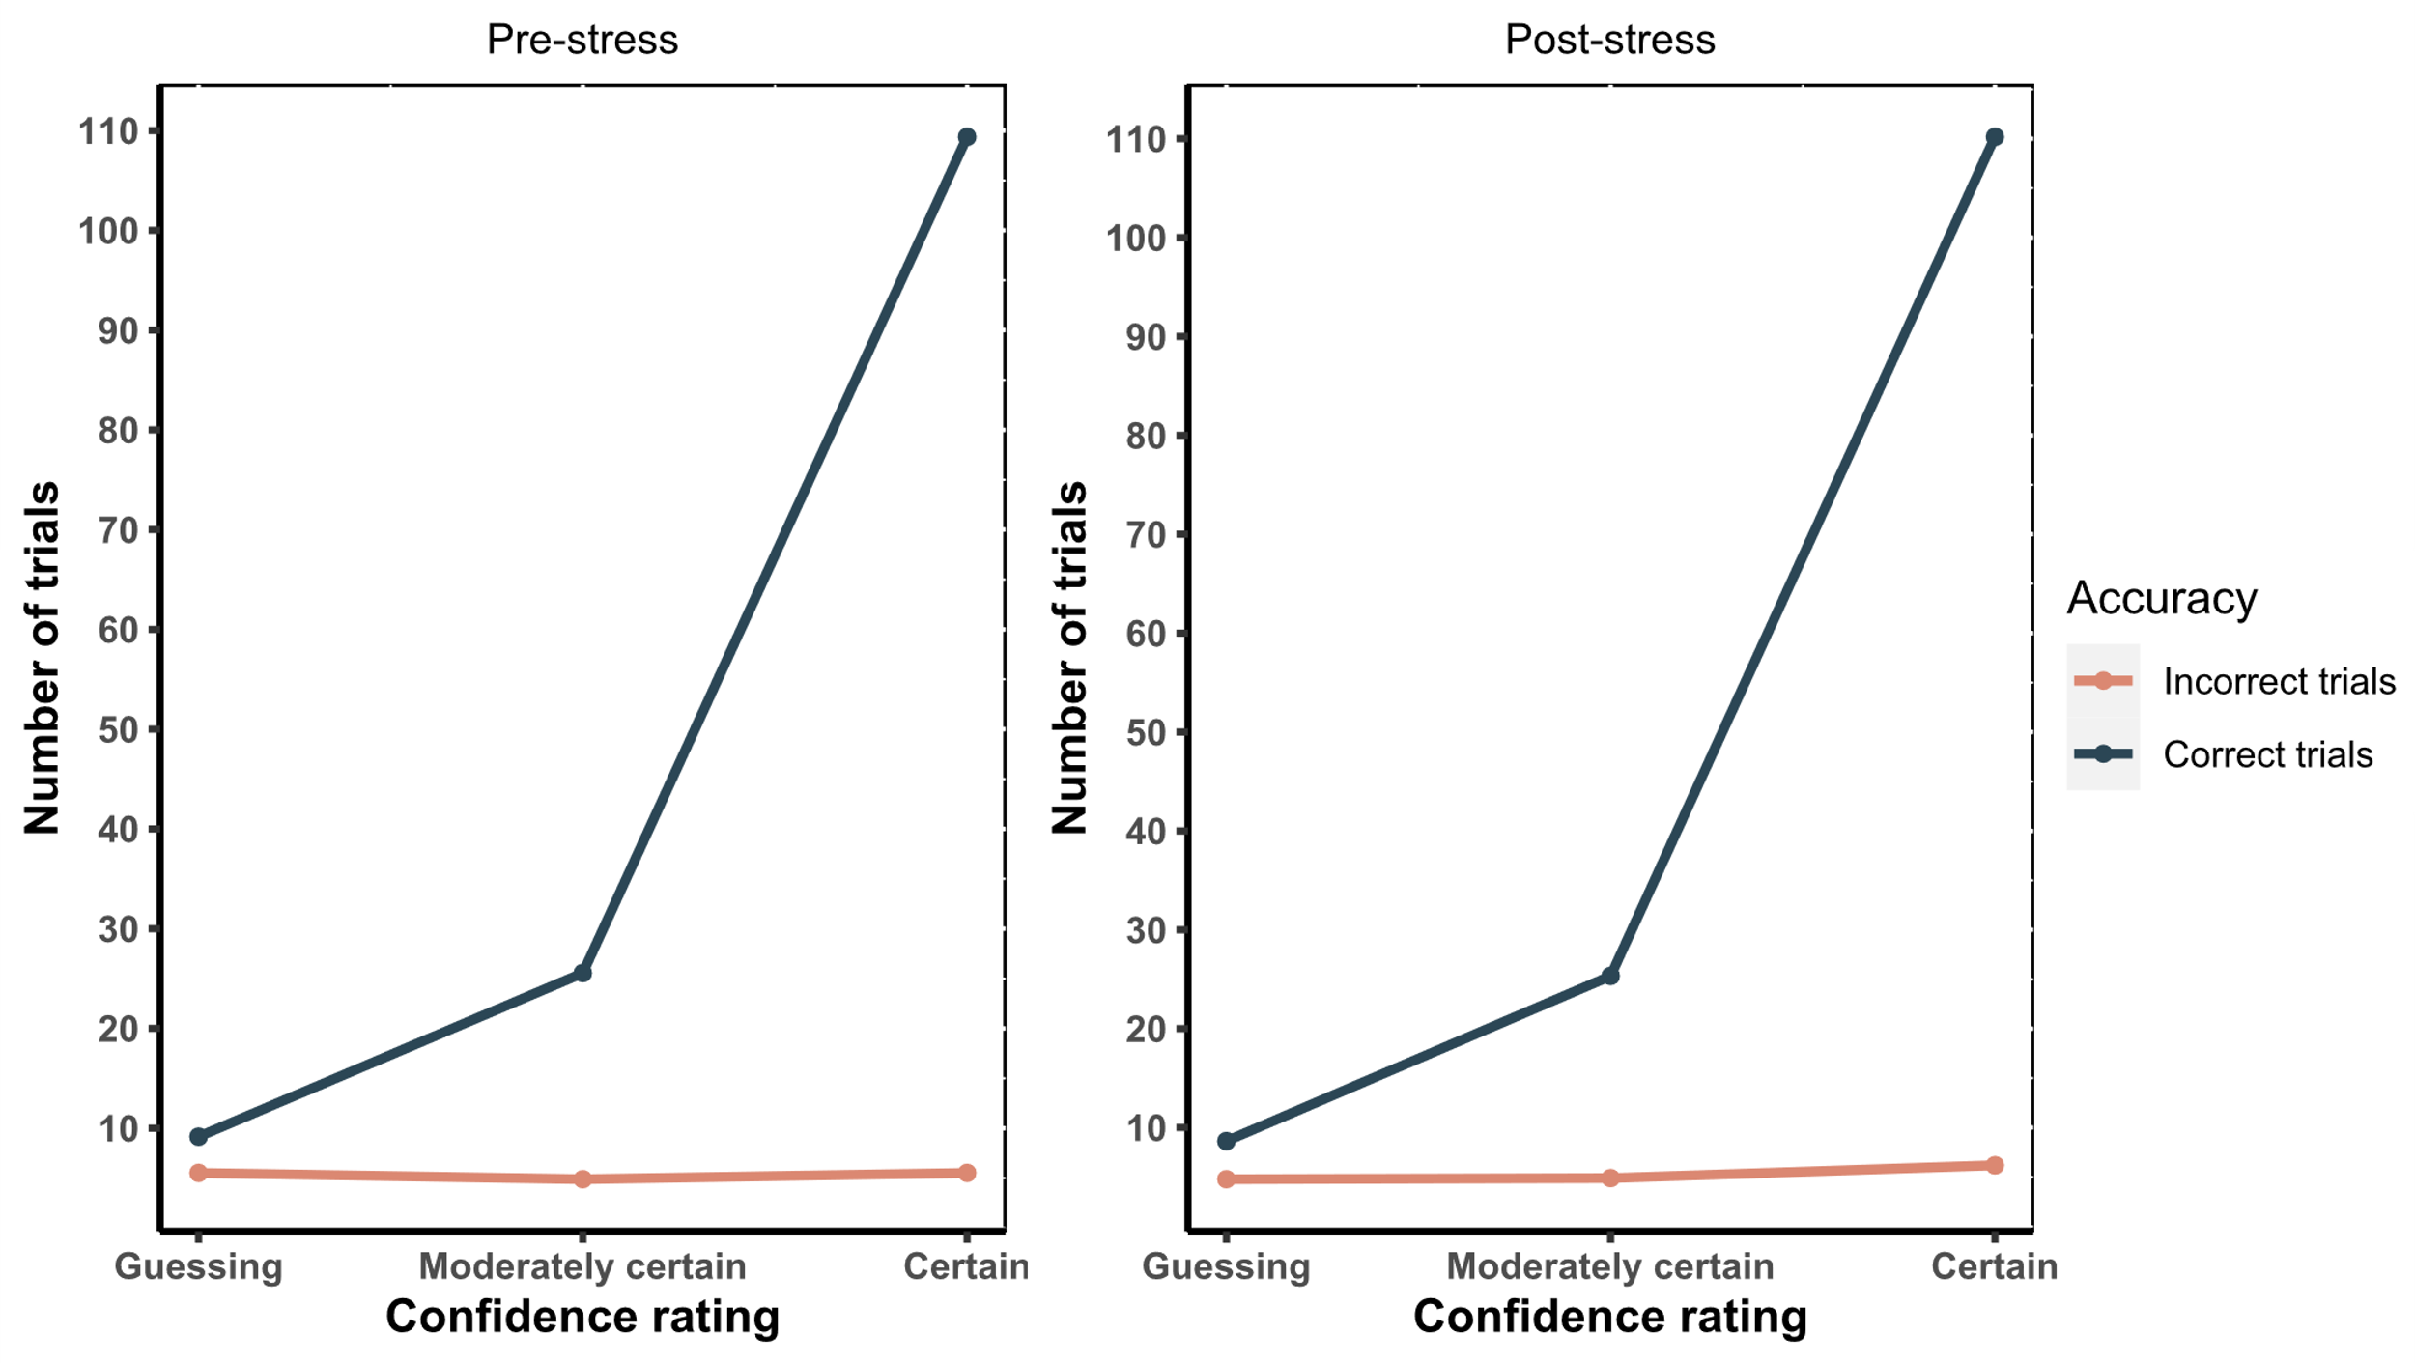
A
C
B
D

Figure S2. Overall recognition memory performance (d’) used in the HMeta-d model. There was no significant difference in overall d’ between either pre- and post-stress (A), or between the control and intrusive memories group (B).
