Supplemental Information for Shimokawa et al.

Supplementary Figures
Supplementary Fig. 1. Time course of MsLAM degradation by nEndoMA
Supplementary Fig. 2. Selection procedure for candidate genes for endo-d-arabinanase
Supplementary Fig. 3. Purification and characterization of recombinant EndoMA1 and EndoMA2
Supplementary Fig. 4. ESI-TOF MS analysis of the hydrolysis of A22BβT by EndoMA1
Supplementary Fig. 5. NMR analysis of the transglycosylation product by EndoMA1
Supplementary Fig. 6. Analysis of the purified samples of ExoMA1 and ExoMA2
Supplementary Fig. 7. Substrate specificity and kinetic analysis of ExoMA1
Supplementary Fig. 8. Substrate specificity and kinetic analysis of ExoMA2
Supplementary Fig. 9. Cooperative action of d-arabinan degrading enzymes
Supplementary Fig. 10. Electron density maps of the bound oligo-d-arabinofuranosides and quaternary structure of EndoMA1 in the crystal structure
Supplementary Fig. 11. Size exclusion chromatography and SDS-PAGE of EndoMA1
Supplementary Fig. 12. Results of SEC-MALS/RI and SEC-SAXS measurements for EndoMA1
Supplementary Fig. 13. Size exclusion chromatography, protomer interface, and electron microscopy of ExoMA1
Supplementary Fig. 14. Structural comparison of ExoMA1 with homolog enzymes.
Supplementary Fig. 15. Electron density maps, quaternary structure, and size exclusion chromatography of EndoMA2
Supplementary Fig. 16. Phylogenetic tree of ExoMA1 and GH172 proteins.
Supplementary Fig. 17. Phylogenetic tree of ExoMA2 and homologs
Supplementary Fig. 18. Amino acid sequence alignment of ExoMA2 and GH116 proteins

Supplementary Tables
Supplementary Table 1. General features of the draft genome of Mi. arabinogalactanolyticum JCM 9171
Supplementary Table 2. Previously reported NMR data of Me-α-A4B
Supplementary Table 3. Crystallographic data statistics of EndoMA1
Supplementary Table 4. SAXS results for EndoMA1
Supplementary Table 5. Dali structural similarity search of the two domains of EndoMA1
Supplementary Table 6. Crystallographic data statistics of ExoMA1 and ExoMA2
Supplementary Table 7. Sequences of primers used for gene cloning and mutagenesis

Supplementary Methods
Synthesis of oligo-d-arabinofuranosides
Details of protein production for crystallography
Software and servers for protein crystallography
Details of SEC-MALS/RI and SEC-SAXS experiments and analysis

Supplementary References

Supplementary Figures

Supplementary Fig. 1. Time course of MsLAM degradation by nEndoMA. a, SDS-PAGE of MsLAM with silver-PAS staining. b, HPAEC-PAD analysis. MsLAM (0.25 mg/mL) was incubated with nEndoMA in 50 mM sodium phosphate buffer (pH 6.5) at 37°C. The reaction was stopped for 0, 0.5, 3, and 20 h by boiling the sample for 3 min.

Supplementary Fig. 2. Selection procedure for candidate genes for endo-d-arabinanase. a, Two-dimensional electrophoresis of the purified protein (nEndoMA) with silver-staining. b, Flowchart of the candidate gene selection. c, Domain structures of the selected candidate gene products. SP: signal peptide.

Supplementary Fig. 3. Purification and characterization of recombinant EndoMA1 and EndoMA2. a and b, SDS-PAGE of purified EndoMA1 (a) and EndoMA2 (b) proteins. c and d, pH (left) and temperature (right) profiles of the activity of EndoMA1 (c) and EndoMA2 (d). Data points measured in sodium acetate and sodium phosphate buffers are shown by closed squares and open triangles, respectively. The standard assay condition is in sodium phosphate buffer (pH 6.5) at 37°C. Detailed assay conditions are described in Methods.

Supplementary Fig. 4. ESI-TOF MS analysis of the hydrolysis of A22BβT by EndoMA1. a, Mass spectrum of the sample obtained from the hydrolysis of A22BβT by EndoMA1. The red and blue circles indicate the peaks related to the reducing hemiacetals and acetonide derivatives, respectively. The assignment displayed on the spectrum is based on the analysis from (b) and (c). The difference between peaks in both reducing (red) and acetonide-tagged (blue) oligo-d-arabinofuranosides was 132 Da which indicates the one d-arabinose residue. (b) Observed mass data of the reducing hemiacetals (Araf_{2–8}). (c) Observed mass data of the acetonide derivatives (Araf_{2–7}-acetonide). (d) The EndoMA1 cleavage site of A22BβT for major reducing hemiacetals and acetonide derivatives. The reducing fragments (Araf₇ and Araf₈) with high intensity were obtained from the non-reducing side of A22BβT. Detection of Araf₇ concomitant with Araf₈ also in the MASS analysis indicates that the endo-cleavage of the fragments might occur by EndoMA1. Other smaller reducing fragments (Araf_{2–6}) might be obtained by the action of multiple actions of EndoMA1 from initial products accepted as the substrate again.

Supplementary Fig. 5. NMR analysis of the transglycosylation product by EndoMA1. The reaction product from A5BT in the presence of methanol was analyzed using HPAEC-PAD (a) and NMR (b). c, Comparison of the ¹H NMR spectra of the reaction product (upper panel) and the authentic sample (lower panel) of Me-α-A4B (Methyl α-d-arabinofuranosyl-(1→5)-[α-d-arabinofuranosyl-(1→3)]-α-d-arabinofuranosyl-(1→5)-α-d-arabinofuranoside). Details of the NMR analysis is described in Methods.

Supplementary Fig. 6. Analysis of the purified samples of ExoMA1 and ExoMA2. a and b, SDS-PAGE of ExoMA1 (a) and ExoMA2 (b). c and d, pH (left) and temperature (right) profiles of the activities of ExoMA1 (c) and ExoMA2 (d). Standard assay conditions for ExoMA1 and ExoMA2 were 1 mM pNP-α-d-Araf in 50 mM sodium acetate (pH 5.5) and 4 mM pNP-β-d-Araf in 50 mM sodium phosphate (pH 6.0), respectively. Data points measured in sodium acetate and sodium phosphate buffers are shown by closed squares and open triangles, respectively. Detailed assay conditions are described in Methods.

Supplementary Fig. 7. Substrate specificity and kinetic analysis of ExoMA1. a, TLC analysis using various pNP-substrates. Each pNP-substrate (1.25 mM) was incubated with or without ExoMA1 (1.0 μg/mL) in 50 mM sodium acetate (pH 5.5) at 37°C for 22 h. TLC plates were visualized by spraying the orcinol-sulfate reagent. b, S-v plot of the activity toward pNP-α-d-Araf. The activity for 0.125-2.5 mM pNP-α-d-Araf was measured in 50 mM sodium acetate (pH 5.5) at 37°C. The kinetic parameters calculated by curve fitting are shown.

Supplementary Fig. 8. Substrate specificity and kinetic analysis of ExoMA2. a, TLC analysis using various pNP-substrates. Each pNP-substrate (1.25 mM) was incubated with or without ExoMA2 in 50 mM sodium phosphate (pH 6.0) at 37°C for 22 h. TLC plates were visualized by spraying diphenyl amine-aniline-phosphoric acid (upper panel) and orcinol-sulfate reagent (lower panel). b, S-v plot of the activity toward pNP-β-d-Araf. The activity for 0.25-2.5 mM pNP-β-d-Araf was measured in 50 mM sodium phosphate (pH 6.0) at 37°C. The kinetic parameters calculated by curve fitting are shown.

Supplementary Fig. 9. Cooperative action of d-arabinan degrading enzymes. a and b, HPAEC-PAD analysis of the combination reactions of EndoMA1, ExoMA1, and ExoMA2 with MsLAM (a) and A22BβT (b). MsLAM (0.25 mg/mL) or A22BβT (40 μg/mL) were incubated with enzymes (1.0 μg/mL each) in 50 mM sodium phosphate buffer (pH 6.0) at 37°C for 18 h. The reaction products were analyzed using HPAEC-PAD. Numbers in parentheses indicate the peak area of d-Ara.

Supplementary Fig. 10. Electron density maps of the bound oligo-d-arabinofuranosides and quaternary structure of EndoMA1 in the crystal structure. a and b, Polder maps (3.0σ) of A4LT in the active site (a) and A4L in the d-arabinan binding site of the putative CBM domain (b). The furanose ring conformations of Araf are shown in parentheses. c, Tetramer in the asymmetric unit viewed from two orientations. PISA analysis suggested that the assembly in the solution is a dimer. ⊿G_{int}, solvation-free energy gain upon formation of the assembly at the interface indicated by the box with a red dotted line.

Supplementary Fig. 11. Size exclusion chromatography and SDS-PAGE of EndoMA1. a, Chromatogram of EndoMA1 using a Superdex size exclusion column. b, SDS-PAGE of the fractions. c, Molecular mass estimation using molecular marker proteins. EndoMA1 eluted at a position behind the expected molecular mass, probably due to interaction with the carrier.

Supplementary Fig. 12. Results of SEC-MALS/RI and SEC-SAXS measurements for EndoMA1. a, Red, blue, and black lines show light scattering intensity, differential refractive index, and molar mass, respectively. The light scattering intensity and differential refractive index are normalized with the maximum peak value set at 1.0. b, Chromatogram of the forward scattering intensity I(0) for all data (line) overlaid with the distribution of R_{g} for frame numbers 96 to 146 (open circle). c, Guinier plot of the experimental SAXS profile displayed in Fig. 4d (black open circle). The red line represents the result of the linear approximation based on the Guinier analysis. The residuals in the linear approximation are drawn at the bottom of the graph. d, Pair distance distribution function P(r). e, Normalized Kratky plot calculated using the values of I(0) and R_{g} obtained by the Guinier analysis. The dashed and the dotted lines show √3 and 3 e⁻¹, respectively. f, Superposition between the experimental SAXS profile (black) and the theoretical SAXS profile calculated from the bead model in Fig. 4e (red). The residuals of both profiles are drawn at the bottom of the graph.

Supplementary Fig. 13. Size exclusion chromatography, protomer interface, and electron microscopy of ExoMA1. a, Size exclusion chromatography of molecular markers (upper panel) and ExoMA1 (lower panel). The molecular mass of the molecular markers and ExoMA1 (estimated) are indicated. b, Interface between two trimers in the dodecamer. One trimer is colored green, blue, and orange. One molecule of PO₄ per protomer is bound at the interface in focus. Details of the interaction between PO₄ and the protein are shown in the inset. ⊿G_{int}, solvation-free energy gain upon formation of the assembly at the interface indicated by the box with a red dotted line. c, Electron micrographs of negatively stained ExoMA1.

Supplementary Fig. 14. Structural comparison of ExoMA1 with homolog enzymes. Overall oligomer structure (left) and monomer structure (right) are shown. Structural elements involved in the oligomer assembly are shown in orange in the monomer structures, and four important loops are indicated by arrows (right). a, ExoMA1. The basal trimer of the dodecamer is colored green, blue, and orange (left). b, GH172 αFFase1. One protomer in the hexamer is shown in magenta (left). Calcium ion is shown as a green sphere (right). c, DUF2961 family protein (BACUNI_00161) from Bacteroides uniformis (PDB ID: 4KQ7). One protomer in the hexamer is shown in yellow (left). Sodium ions are shown as purple spheres (right).

Supplementary Fig. 15. Electron density maps, quaternary structure, and size exclusion chromatography of ExoMA2. A and b, Polder maps (3.0σ) of Tris molecule (a) and β-d-Araf (a) in the active site. The furanose ring conformation of β-d-Araf is shown in parentheses. C, Dimer in the asymmetric unit viewed from two orientations. PISA analysis suggested that the assembly in the solution is a dimer. ⊿G_{int}, solvation-free energy gain upon formation of the assembly at the interface indicated by the box with a red dotted line. d, Size exclusion chromatography of molecular markers (blue lines) and ExoMA2. Inset, molecular mass estimation of ExoMA2 (red) using molecular markers (blue).

Supplementary Fig. 16. Phylogenetic tree of ExoMA1 and GH172 proteins. The bar indicates branch length measures in the number of substitutions per amino acid site. The locus tags are shown alongside bacterial strains or protein names. Proteins encoded in the gene clusters in Extended Fig. 8 are indicated by green star symbols.

Supplementary Fig. 17. Phylogenetic tree of ExoMA2 and homologs. Proteins that are currently included in GH116 are below the dotted line. Amino acid sequence identities to ExoMA2 are shown in parentheses. Characterized GH116 enzymes are labeled with blue characters. The bar indicates branch length measures in the number of substitutions per amino acid site. The locus tags are shown alongside bacterial strains or protein names. Proteins encoded in the gene clusters in Extended Fig. 8 are indicated by green star symbols.

Supplementary Fig. 18. Amino acid sequence alignment of ExoMA2 and GH116 proteins. The catalytic residues and residues involved in the substrate recognition of β-d-Araf are boxed with magenta and black lines, respectively. The amino acid residues for ExoMA2 and TxGH115 are shown above and below the box, respectively.

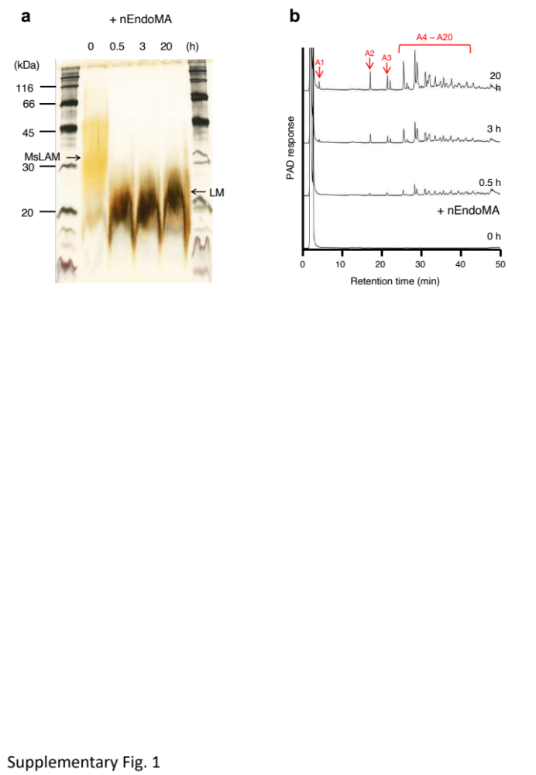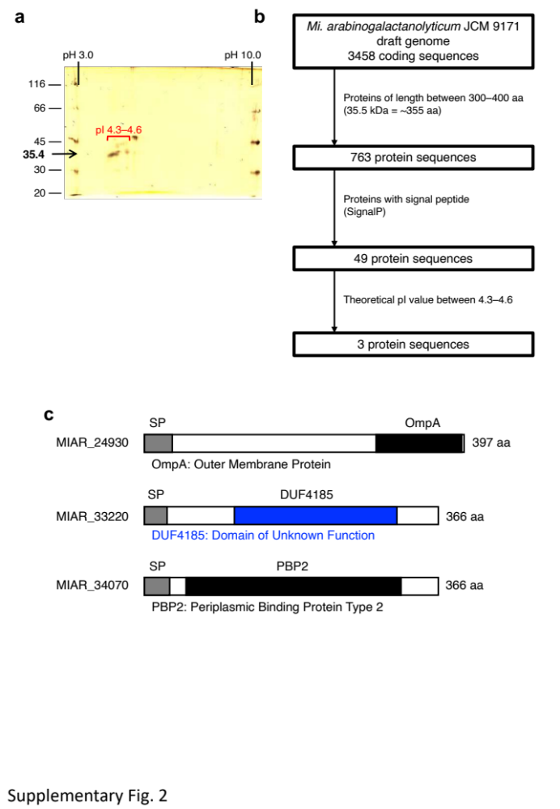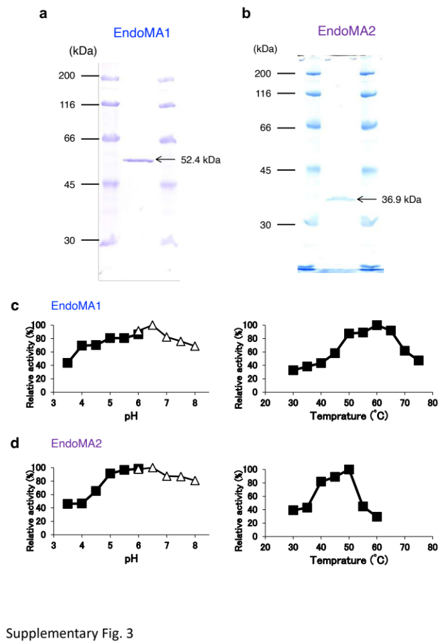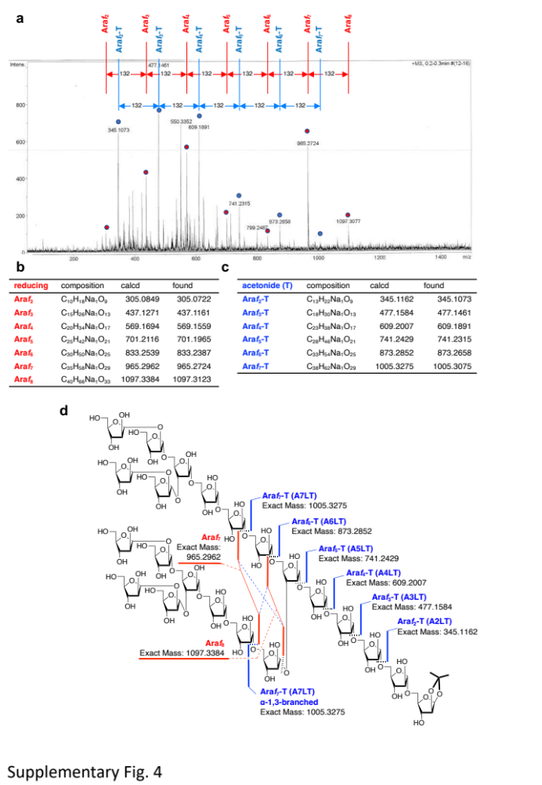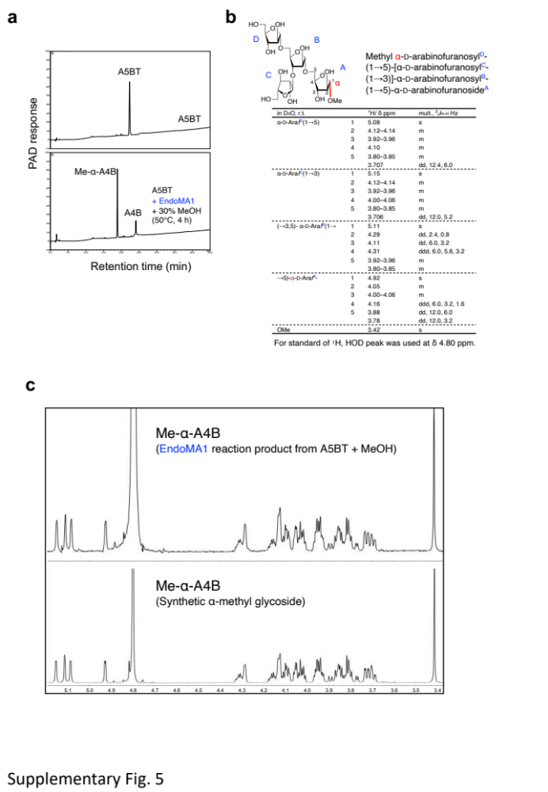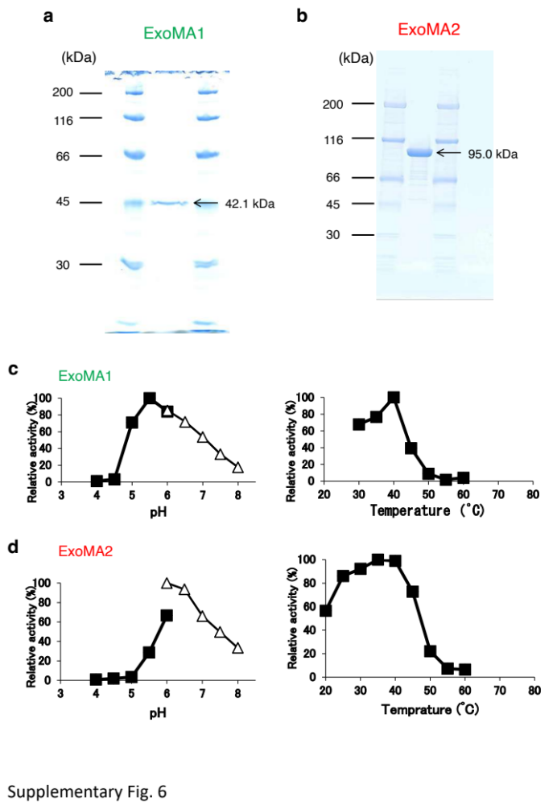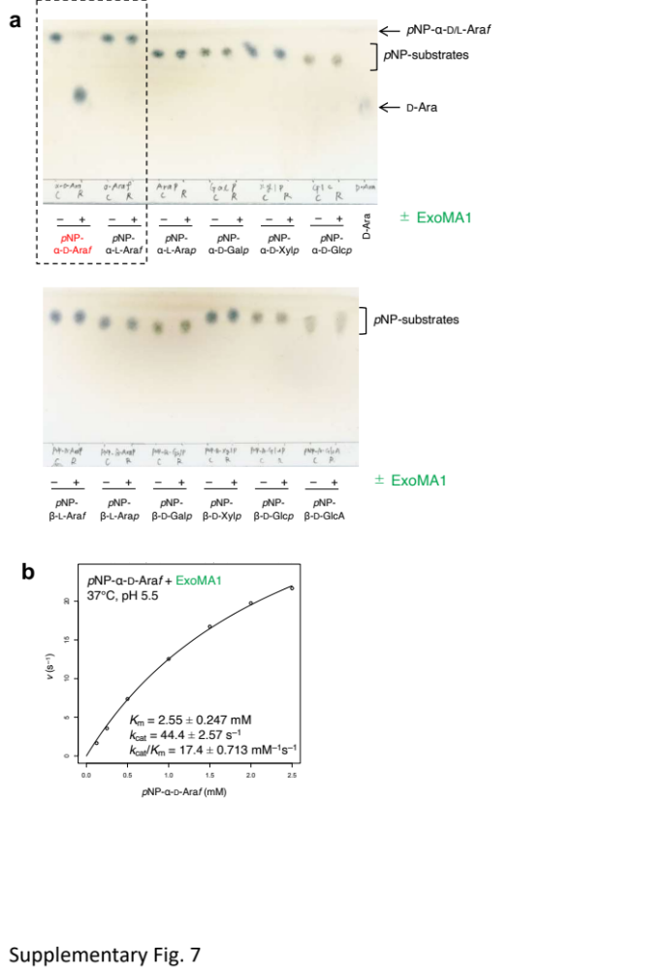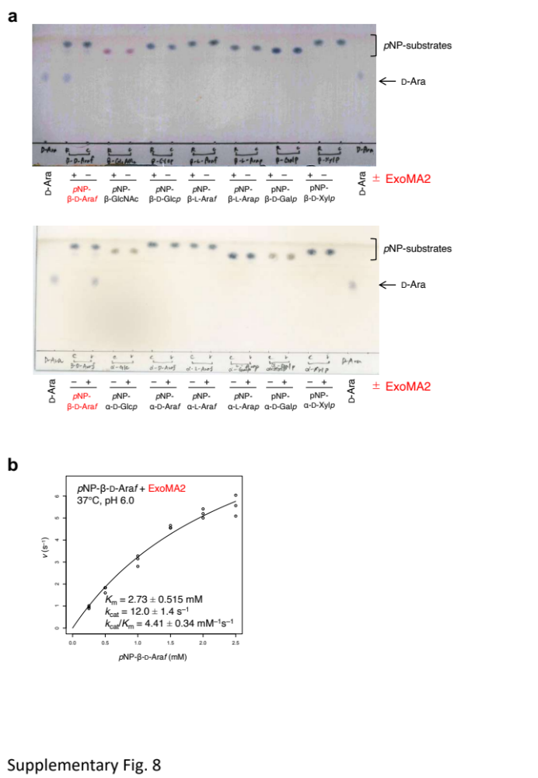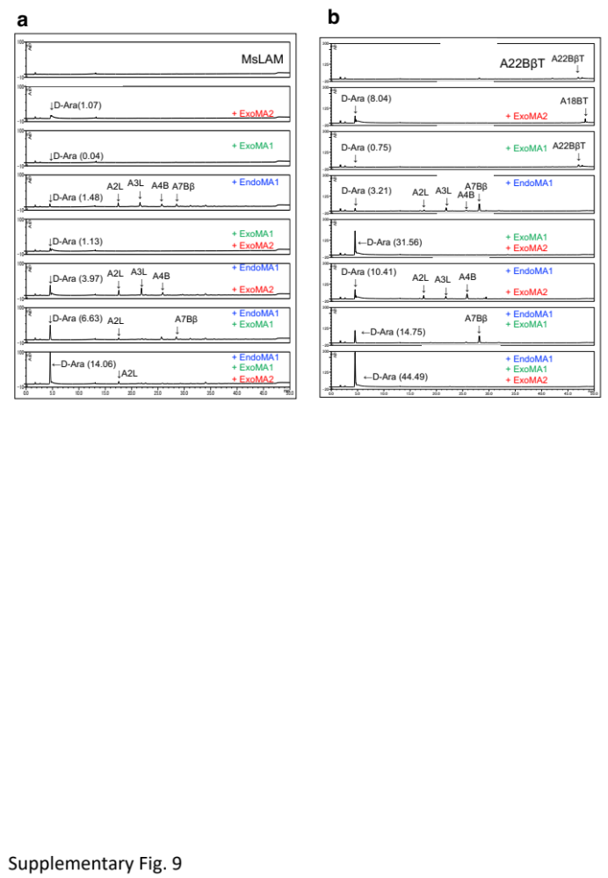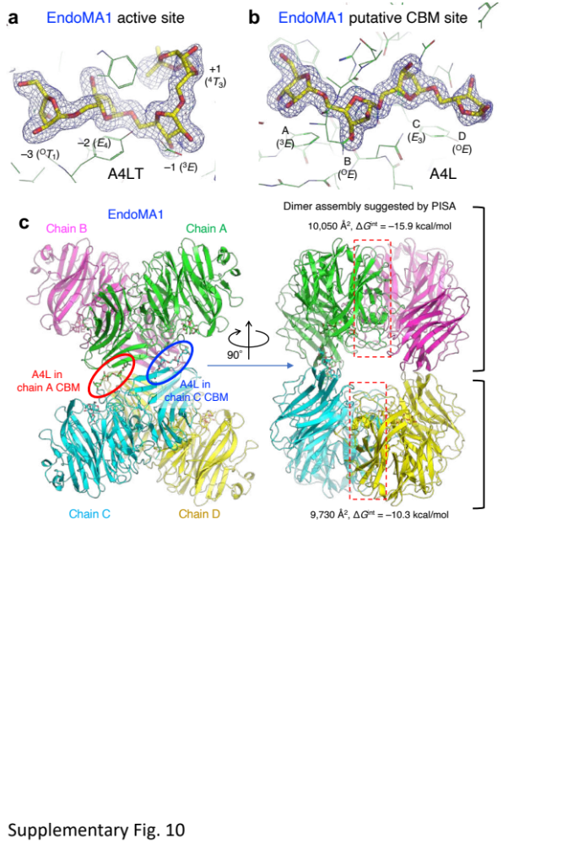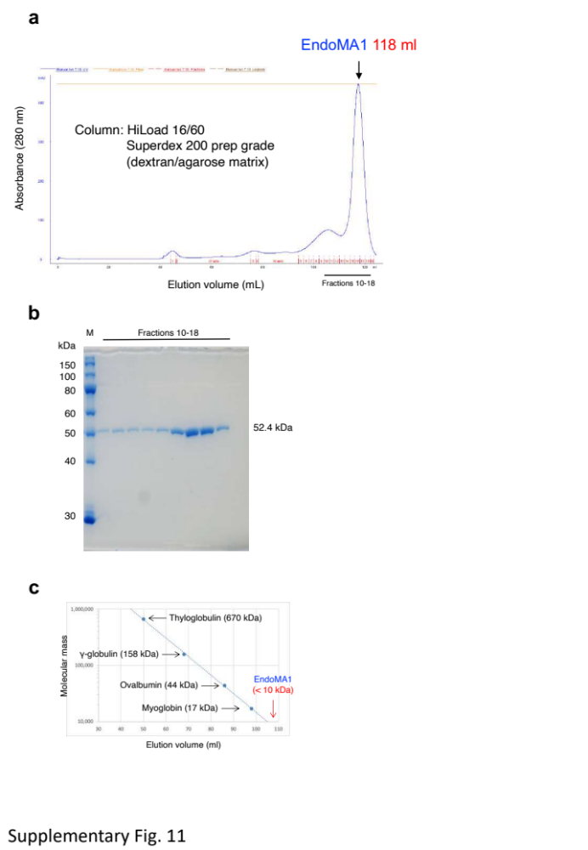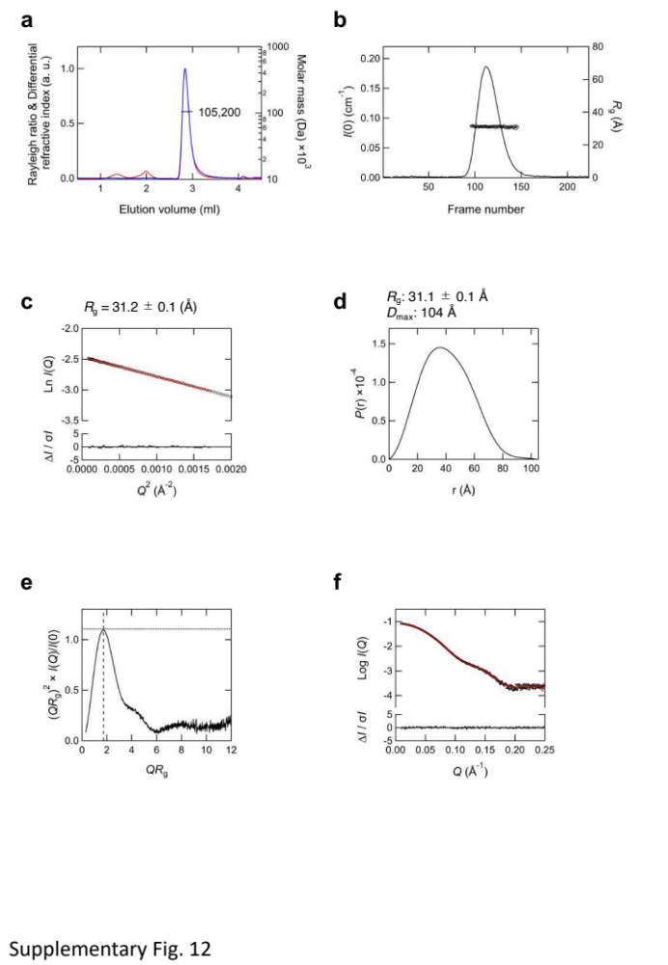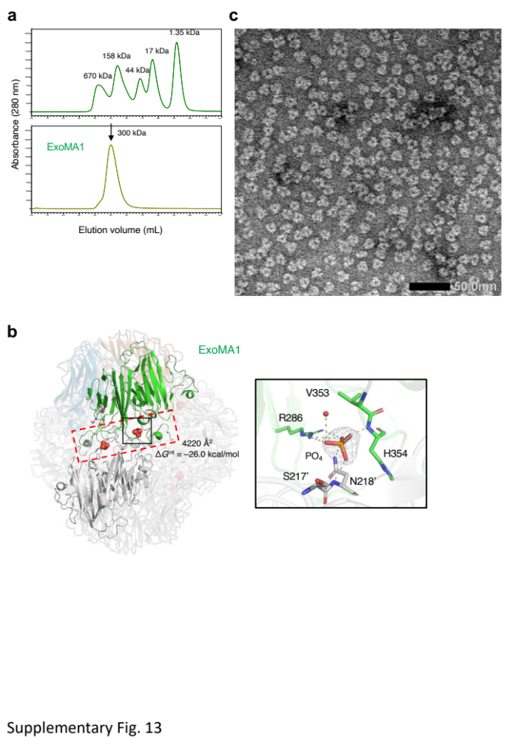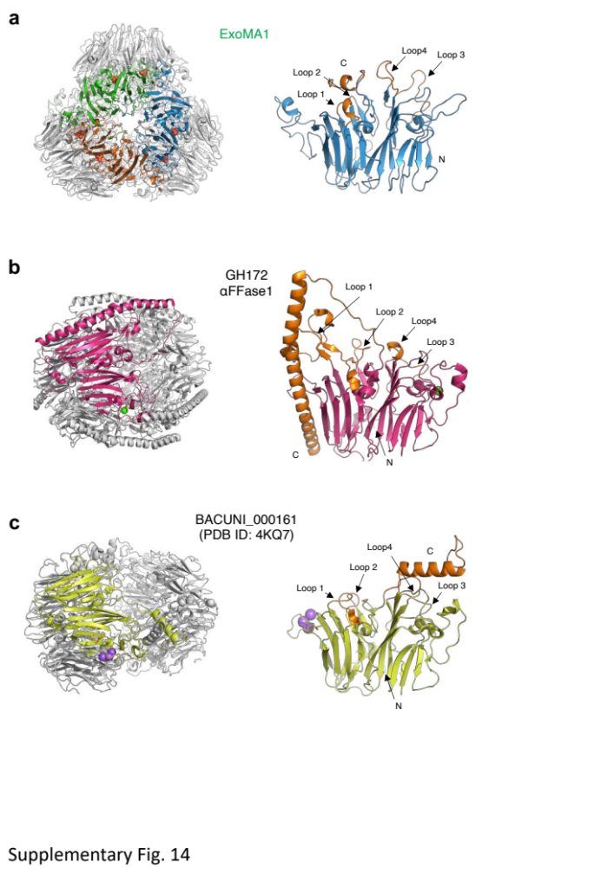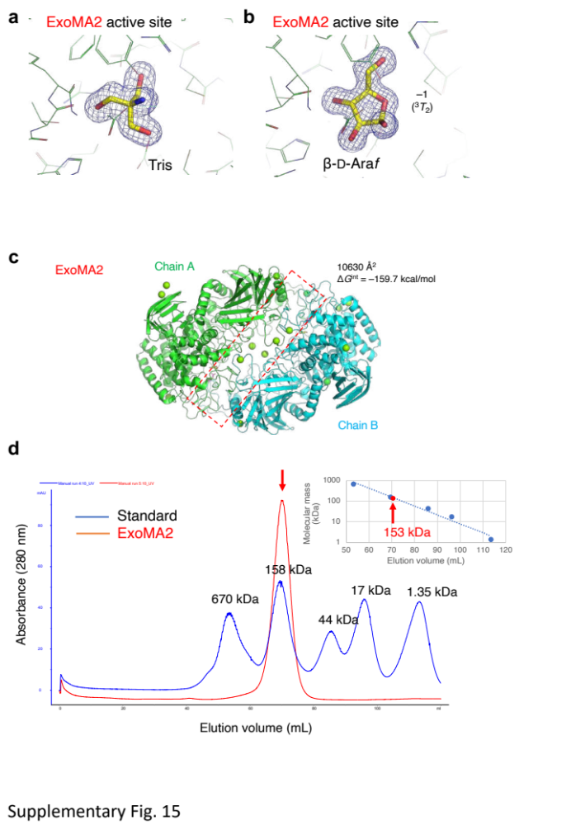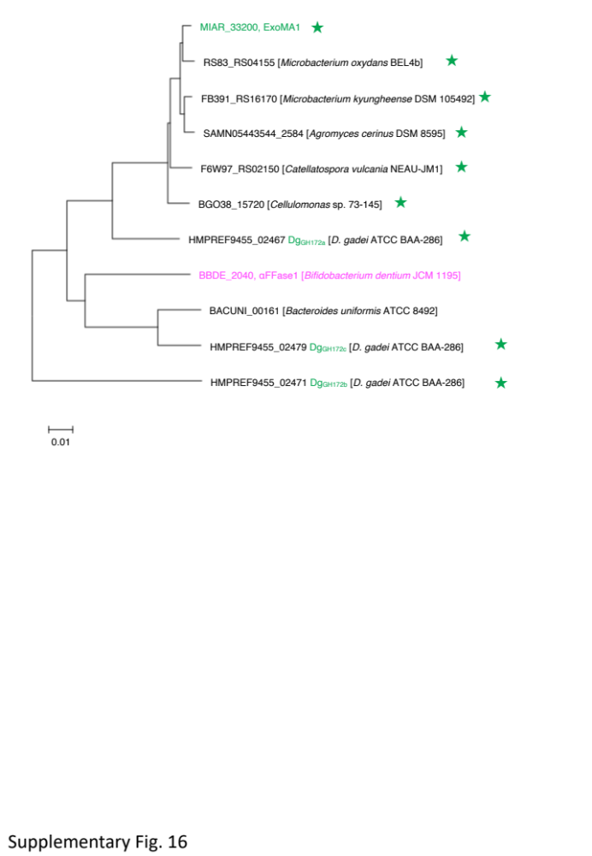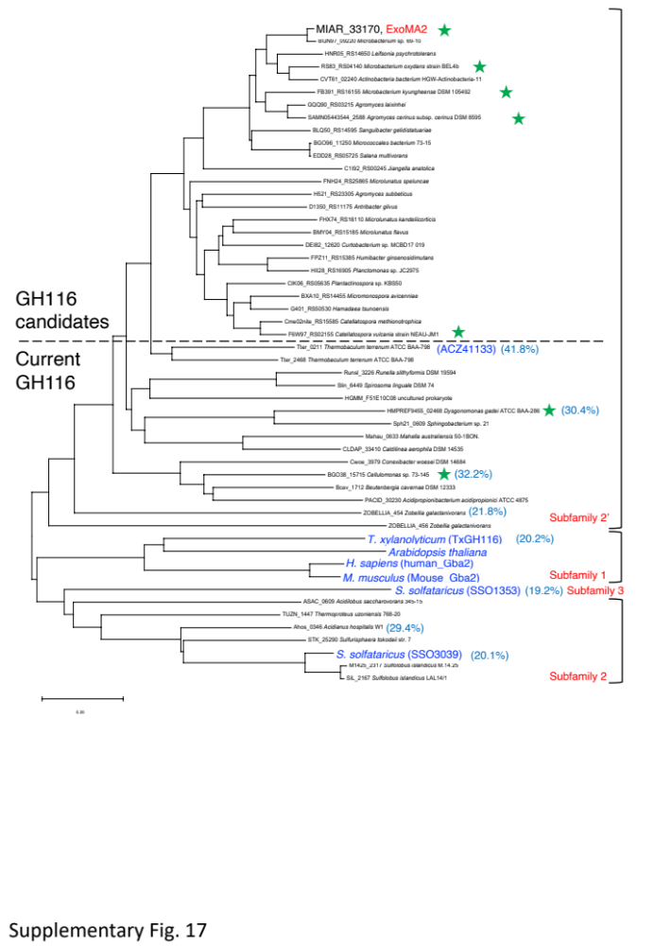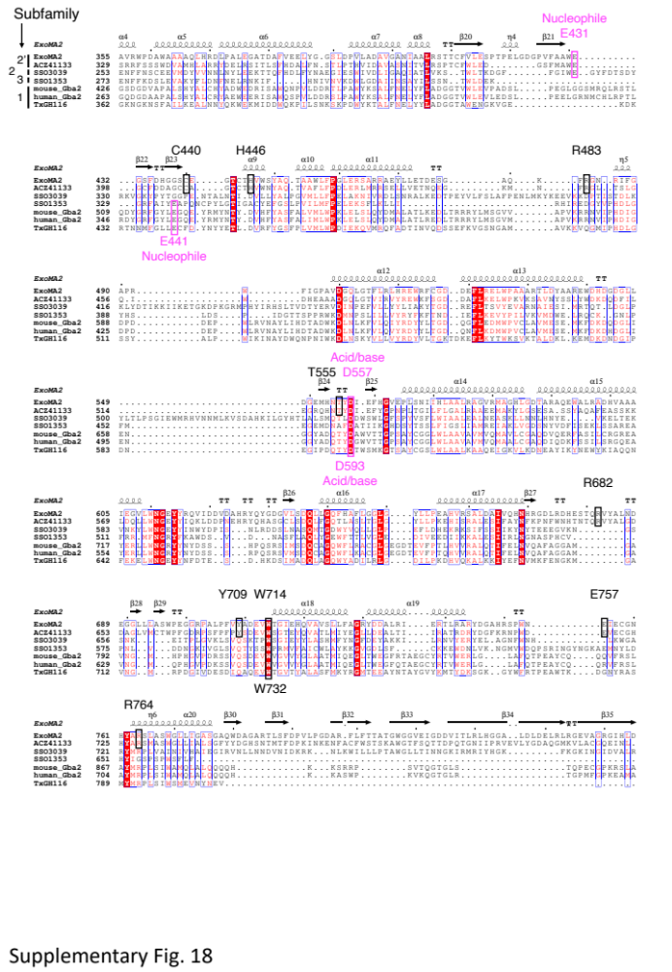

Supplementary Tables

Supplementary Table 1. General features of the draft genome of Mi. arabinogalactanolyticum JCM 9171
Genome size (bp) | 3,665,624
GC content (%) | 69.8
Number of contigs | 13
Number of coding sequences | 3458
rRNA genes | 2
tRNA genes | 53
CRISPR | 0
The draft genome sequence has been submitted to DDBJ with accession numbers BRZC01000001-BRZC01000013.

Supplementary Table 2. Previously reported NMR data of Me-α-A4B
in D₂O, r.t. |  | ¹H/ δ ppm | mult., ³J_{H–H} Hz | ¹³C/ δ ppm
α-d-Araf^{D}(1→5) | 1 | 5.09 | d, 1.6 | 108.22
 | 2 | 4.07 | dd, 3.3, 1.6 | 82.11
 | 3 | 3.86–3.90 | dd, 6.0, 3.3 | 77.45
 | 4 | 3.97 | ddd, 6.0, 5.7, 3.2 | 84.80
 | 5 | 3.76 | dd, 12.3, 3.2 | 61.99
 |  | 3.65 | dd, 12.3, 5.7
α-d-Araf^{C}(1→3) | 1 | 5.02 | d, 1.6 | 108.01
 | 2 | 4.06 | dd, 3.3, 1.6 | 81.82
 | 3 | 3.86–3.90 | dd, 5.8, 3.3 | 77.43
 | 4 | 4.04 | ddd, 5.8, 5.7, 3.2 | 84.86
 | 5 | 3.76 | dd, 12.3, 3.2 | 62.05
 |  | 3.66 | dd, 12.3, 5.7
(→3,5)-α-d-Araf^{B}(1→ | 1 | 5.04 | d, 1.0 | 108.33
 | 2 | 4.22 | dd, 2.0, 1.0 | 79.99
 | 3 | 4.02 | dd, 5.5, 2.0 | 83.53
 | 4 | 4.25 | ddd, 5.5, 5.4, 3.0 | 82.56
 | 5 | 3.86–3.90 | dd, 11.5, 5.4 | 67.31
 |  | 3.78 | dd, 11.5 3.0
→5)-α-d-Araf^{A}- | 1 | 4.85 | d, 1.8 | 109.27
 | 2 | 3.99 | d, 3.4, 1.8 | 81.53
 | 3 | 3.96 | d, 5.9, 3.4 | 77.31
 | 4 | 4.16 | ddd, 5.9, 5.4, 3.1 | 82.96
 | 5 | 3.88 | dd, 11.5, 5.4 | 67.31
 |  | 3.72 | dd, 11.5, 3.1
OMe |  | 3.35 | S | 55.9
NMR data of methyl α-d-arabinofuranosyl^{D}-(1→5)-[α-d-arabinofuranosyl^{C}-(1→3)]-α-d-arabinofuranosyl^{B}-(1→5)-α-d-arabinofuranoside^{A} (Me-α-A4B in the main text and SI-15 in Supplementary Methods) reported by D’Souza et al.¹ Our synthesis and analysis suggested that chemical shifts for some anomeric protons written in bold should be revised.

Supplementary Table 3. Crystallographic data statistics of EndoMA1
Data set | EndoMA1 Se-Met | EndoMA1 apo | EndoMA1 D51N +A9LT
Crystallization
Protein solution | 18.2 mg/mL EndoMA1 | 19.2 mg/mL EndoMA1 | 32 mg/mL EndoMA1, 10 mM A9LT
Reservoir solution | 0.4 M sodium thiocyanate, 23% PEG 3350 | 0.4 M sodium thiocyanate, 23% PEG 3350 | 0.12 M MES-NaOH (pH 6.0), 5% PEG3000, 20% PEG200
Cryoprotectant | + 30% glycerol | + 30% glycerol | + 10% glycerol
Data collection ª
Beamline | PF BL-5A | PF BL-5A | PF AR-NE3A
Wavelength (Å) | 0.9791 | 1.0000 | 1.0000
Space group | P2₁ | P2₁ | P2₁2₁2₁
Unit cell (Å, °) | a = 80.959, b = 127.085, c = 103.412, β = 109.534 | a = 81.285, b = 128.296, c = 104.019, β = 109.378 | a = 114.708, b = 137.731, c = 148.589
Resolution (Å) | 49.20–1.78  (1.81–1.78) | 46.13–1.60  (1.63–1.60) | 46.61–1.80  (1.83–1.80)
Total reflections | 2,884,158 (68,698) | 985,559 (47,737) | 1,456,432 (67,939)
Unique reflections | 172,300 (4,881) | 261,209 (12,725) | 217,228 (10,677)
R_{merge} | 0.195 (1.372) | 0.067 (0.485) | 0.114 (1.235)
R_{pim} | 0.062 (0.516) | 0.041 (0.289) | 0.047 (0.528)
Mean I/σ(I) | 10.4 (1.9) | 9.9 (1.9) | 12.0 (2.0)
CC_{1/2} | 0.995 (0.773) | 0.989 (0.844) | 0.996 (0.625)
Completeness (%) | 91.6 (52.5) | 99.0 (98.0) | 100.0 (99.9)
Multiplicity | 16.7 (14.1) | 3.8 (3.8) | 6.7 (6.4)
Anomalous completeness (%) | 91.1 (50.7)
Anomalous multiplicity | 8.2 (7.0)
Mol/ASU ^{b} | 4 | 4 | 4
Refinement
Resolution (Å) |  | 46.18–1.60 | 46.65–1.80
No. of reflections |  | 261,169 | 217,104
R_{work}/R_{free} ^{c} |  | 0.177/0.211 | 0.157/0.192
Number of atoms
Amino acids |  | 14,847 | 14,872
Ions |  | 12 | 8
Ligands |  | 96 | 416
Waters |  | 1760 | 1,314
B-factors (Å²)
Amino acids |  | 19.3 | 23.51
Ions |  | 14.5 | 22.17
Ligands |  | 26.5 | 34.99
Waters |  | 28.01 | 34.21
RMSD from ideal values
Bond lengths (Å) |  | 0.0157 | 0.0213
Bond angles (°) |  | 2.01 | 2.02
Ramachandran plot (%)
Favored |  | 95.28 | 95.49
Allowed |  | 4.25 | 3.88
Outlier |  | 0.47 | 0.63
PDB code |  | 8HHV | 8IC1
ªValues in parentheses represent the highest resolution shell. ^{b}Number of molecules per asymmetric unit. ^{c}R_{free} was calculated for a randomly chosen 5% of reflections that were not used for structure refinement, and R_{work} was calculated for the remaining reflections.

Supplementary Table 4. SAXS results for EndoMA1
Sample name | EndoMA1
A. Sample details
Organism | Microbacterium arabinogalactanolyticum
Source | E. coli expressed
Uniprot ID (residues in construct) | (Submitted to DDBJ)
Extinction coefficient (A_{280nm}, 0.1%(w/v)) | 2.643
P.S.V (cm³ g⁻¹) | 0.727
Contrast (cm⁻²) | 2.955×10¹⁰
Theoretical MW (Da) | 53,678
SEC-SAXS column | KW403-4F (Shodex)
Initial conc. (mg ml⁻¹) | 2.406
Injection Volume (μL) | 130
Flow rate (ml min⁻¹) | 0.2–0.02
Conc. range (mg ml⁻¹) | 2.190–0.136
Solvent composition | 20 mM Tris-HCl, pH 7.5, 200 mM NaCl
Concentration method | UV-Visible spectroscopy
B. SAS data collection
Instrument | PF BL-10C
Wavelength (Å) | 1.000
Beam geometry (μm) | V430 × H870, Bent cylindrical mirror + 2 slits + 1 pinhole
Camera length (mm) | 2081.4
Q range (Å⁻¹) | 0.0073–0.3997
Absolute scaling method | Comparison with scattering from 1 mm pure H₂O
Exposure time (sec), No. of frames | 20, 247
Sample path length (mm) | 1
Sample temperature (K) | 293
Normalization | To transmit intensity by beam-stop counter
Method for monitoring radiation damage | Data frame-by-frame comparison
C. Software employed for SAS data reduction, analysis, and interpretation
SAS data processing | SAngler, MOLASS
Extinction coefficient estimate | ProtParam
Calculation of contrast and PSV values | MULCh
Basic analyses: (Guinier, P(r), Porod Volume) | PRIMUSqt from ATSAS 3.0.5
Shape modeling | DAMMIF module of PRIMUSqt from ATSAS 3.0.5
Atomistic modeling | CRYSOL from ATSAS 3.0.5
D. Structural parameters
Guinier Analysis
I(0) (cm⁻¹) | 0.0854 ± 0.0002
R_{g} (Å) | 31.2 ± 0.1
Q-range (Å⁻¹), Q×R_{g} | 0.0093–0.0415, 0.29–1.29
P(r) analysis
I(0) (cm⁻¹) | 0.0854 ± 0.0002
R_{g} (Å) | 31.1 ± 0.1
D_{max} (Å) | 104
Q-range (Å⁻¹) | 0.0093–0.2563
Porod volume (Å⁻³) | 131,472
Molar mass from I(0) (*) | 110,914 (2.066)
E. Shape modeling results
DAMMIF (default parameters, 20 calculations)
Q-range for fitting | 0.0093-0.2563
Symmetry, anisotropy | P1, none
NSD (standard deviation), clusters | 0.941 (0.027), 1
χ² range | 0.073–0.076
Model Mm (×0.5 V_{model}) (Da) | 84,000
Model resolution (Å) | 50
DAMMIN (default parameters)
Q-range for fitting | 0.0093-0.2563
Symmetry, anisotropy | P1, none
χ² value, CORMAP P-value | 0.059, 0.014
Constant adjustment to intensities | 1.061×10⁻⁴
F. Atomistic modeling
Crystal structure | PDB entry 8HHV
Q-range for all modeling | 0.0093-0.3997
CRYSOL (default parameters, Constant subtraction allowed)
χ² value, P-value | 0.065, 0.00
Predicted R_{g} (Å) | 31.0
Vol (Å), Ra (Å), Dro (e Å⁻³) | 129,563, 1.400, 0.025
G. SASBDB ID
EndoMA1 apo | SASDQQ8
* Ratio to the expected value.

Supplementary Table 5. Dali structural similarity search of the two domains of EndoMA1
PDB IDª | Z score | RMSD (Å) | LALI^{b} | Identity (%) | Protein name | Organism | Reference
N-terminal catalytic domain (2-235)
4HBS (A) | 23.8 | 3.3 | 286 | 15 | Putative hydrolase (BACOVA_04882) | Bacteroides ovatus ATCC 8483 | –
6N1A (A) | 22.8 | 2.8 | 253 | 11 | N-Acetylgalactosamine deacetylase | Flavonifractor plautii | ²
4NOV (A) | 22.3 | 3.1 | 249 | 10 | Xylosidase/arabinofuranosidase Xsa43E (GH43) | Butyrivibrio proteoclasticus B316 | ³
3QEF (B) | 22.0 | 2.9 | 246 | 14 | α-1,2-arabinofuranosidase CjAbf43A (GH43) | Cellvibrio japonicus Ueda107 | ⁴
C-terminal putative CBM domain (336-480)
2Y6L (A) | 16.8 | 2.2 | 139 | 16 | CBM4-2 in GH10 xylanase Xyn10A | Rhodothermus marinus | ⁵
5X7Q (A) | 16.6 | 2.1 | 132 | 24 | PsCBM61 (1128-1281) in GH31 α-1,6-glucosyltransferase Ps6TG31A | Paenibacillus sp. 598K | ⁶
2ZXQ (A) | 16.3 | 2.1 | 129 | 18 | Domain 5 (1102-1255) in GH101 endo-α-N-acetylgalactosaminidase | Bifidobacterium longum | ⁷
ªChain ID is shown in parentheses. ^{b}Number of aligned residues.

Supplementary Table 6. Crystallographic data statistics of ExoMA1 and ExoMA2
Data set | ExoMA1 apo | ExoMA2 +Tris | ExoMA2 +β-d-Araf
Crystallization
Protein solution | 10 mg/mL ExoMA1 | 7.5 mg/mL ExoMA2 + 20 mM d-Ara | 7.5 mg/mL ExoMA2 + 200 mM d-Ara
Reservoir solution | 0.2 M NaCl, 0.1 M phosphate citrate, 20% PEG8000 | 0.18 M MgCl₂, 0.1 M Tris-HCl (pH 9.0), 14% PEG8000 | 0.2 M MgCl₂, 0.1 M CHES-NaOH (pH 8.9), 14% PEG8000
Cryoprotectant | + 20% trehalose | + 20% MPD | + 20% MPD
Data collection ª
Beamline | PF AR-NW12A | PF BL-5A | PF AR-NW12A
Unit cell (Å, °) | 1.0000 | 1.0000 | 1.0000
Space group | P2₁2₁2₁ | P2₁ | P2₁
Unit cell | a = 131.11, b = 207.54, c = 253.88 | a = 66.552, b = 97.511, c = 139.978, β = 100.549 | a = 66.763, b = 97.249, c = 139.681, β = 101.250
Resolution (Å) | 48.24–2.42  (2.46–2.42) | 48.76–1.75  (1.78–1.75) | 48.62–1.35  (1.37–1.35)
Total reflections | 2,008,067 (98,598) | 601,258 (27,247) | 1,287,075 (61,133)
Unique reflections | 264,416 (12,946) | 176,777 (8,703) | 382,283 (18,879)
R_{merge} | 0.147 (0.616) | 0.052 (0.366) | 0.056 (0.965)
R_{pim} | 0.057 (0.239) | 0.043 (0.308) | 0.036 (0.629)
Mean I/σ(I) | 9.9 (2.8) | 14.8 (2.9) | 9.5 (1.0)
CC_{1/2} | 1.00 (0.85) | 0.998 (0.873) | 0.988 (0.609)
Completeness (%) | 100 (100) | 100.0 (99.9) | 99.9 (99.7)
Multiplicity | 7.6 (7.6) | 3.4 (3.1) | 3.4 (3.2)
Mol/ASU ^{b} | 12 | 2 | 2
Refinement
Resolution (Å) | 48.92-2.42 | 48.80–1.75 | 45.87–1.35
No. of reflections | 264,283 | 176,748 | 382,249
R_{work}/R_{free} ^{c} | 0.199/0.229 | 0.138/0.174 | 0.159/0.183
Number of atoms
Amino acids | 34,813 | 13,274 | 13,234
Ions | 0 | 16 | 18
Ligands | 60 | 55 | 66
Waters | 1,027 | 1,661 | 1,630
B-factors (Å²)
Amino acids | 62.82 | 21.91 | 19.37
Ions | – | 27.11 | 24.43
Ligands | 65.79 | 29.17 | 28.7
Waters | 57.31 | 29.28 | 28.39
RMSD from ideal values
Bond lengths (Å) | 0.0088 | 0.0147 | 0.0129
Bond angles (°) | 1.267 | 1.91 | 1.69
Ramachandran plot (%)
Favored | 94.01 | 96.13 | 96.07
Allowed | 5.35 | 3.58 | 3.58
Outlier | 0.63 | 0.29 | 0.35
PDB code | 8IC8 | 8IC6 | 8IC7
ªValues in parentheses represent the highest resolution shell. ^{b}Number of molecules per asymmetric unit. ^{c}R_{free} was calculated for a randomly chosen 5% of reflections that were not used for structure refinement, and R_{work} was calculated for the remaining reflections.

Supplementary Table 7. Sequences of primers used for gene cloning and mutagenesis
Name | Sequence
Gene cloning
EndoMA1 (MIAR_33230) Fw | 5’-AGGAGATATACCATGACCACGGCACGCACACCGGCGA-3’
EndoMA1 (MIAR_33230) Rev | 5’- GTGGTGGTGCTCGAGGCGGACCTTCGTCAGCG-3’
EndoMA2 (MIAR_33270) Fw | 5’-AGGAGATATACCATGGCGTCGGCCGCCGGGC-3’
EndoMA2 (MIAR_33270) Rev | 5’- GTGGTGGTGCTCGAGCGCCAGGCCCTGCACC-3’
MIAR_33220 Fw | 5’-AGGAGATATACCATGCCGATCGAGGCCGTGACCGT -3’
MIAR_33220 Rev | 5’-GTGGTGGTGCTCGAGGCCCGGGAGCGTCATCTGC -3’
MIAR_33320 Fw | 5’-AGGAGATATACCATGGCGAAGGGGCCGGTCG-3’
MIAR_33320 Rev | 5’-GTGGTGGTGCTCGAGAGGCGCTCTGCGATCG -3’
ExoMA1 (MIAR_33200) Fw | 5’-AGGAGATATACCATGCCCGATCTCAACTCCA -3’
ExoMA1 (MIAR_33200) Rev | 5’-GTGGTGGTGCTCGAGCACCCGCGGAGGAGT -3’
ExoMA2 (MIAR_33170) Fw | 5’-ATGTCTAAAATAAAAAGCCGCCGCGCCCGCCGCATCCCG-3’
ExoMA2 (MIAR_33170) Rev | 5’-GTGGTGGTGCTCGAGGGTGAGAGTCAGGGTGCGGGTCTC-3’
Mutagenesis
EndoMA1 D33N Fw | 5’-GCCACCAACCTCGGCATCATGTGG-3’
EndoMA1 D33N Rv | 5’-GCCGAGGTTGGTGGCCTTGATGTC-3’
EndoMA1 D51N Fw | 5’-TTCGGCAACACGTTCGGCAACTCC-3’
EndoMA1 D51N Rv | 5’-GAACGTGTTGCCGAAAGCCGTGAG-3’
EndoMA1 E243A Fw | 5’-ATGAGTGCGATGTCGGTGCAGTAC-3’
EndoMA1 E243A Rv | 5’-CGACATCGCACTCATCGGAGCATC-3’
EndoMA1 E243Q Fw | 5’-ATGAGTCAAATGTCGGTGCAGTAC-3’
EndoMA1 E243Q Rv | 5’-CGACATTTGACTCATCGGAGCATC-3’
Underlined regions indicate the mutation sites.

Supplementary Methods

Synthesis of oligo-d-arabinofuranosides

Akihiro Ishiwata,* Katsunori Tanaka,
Yukishige Ito

*Correspondence to A. Ishiwata. Email: aishiwa@riken.jp

General procedure
All reactions sensitive to air and/or moisture were carried out under argon atmosphere with anhydrous solvents. Substrates of glycosylations were dried by azeotropic removal with toluene. Column chromatography was performed on silica gel 60N, 100–210 mesh (Kanto Kagaku Co., Ltd.). Preparative thin layer chromatography (PTLC) was performed on silica gel 60 F254, 0.5 mm (E. Merck). Optical rotations were measured with a JASCO DIP 370 polarimeter. ¹H NMR and ¹³C NMR spectra were recorded on a JEOL ECX400 spectrometer. ¹H NMR spectra were referenced to CHCl₃ at 7.24, HOD at 4.80, and MeOH at 3.31 ppm. ¹³C NMR spectra were referenced to the central peak of CDCl₃ at 77.0 ppm, CD₃OD at 49.0 ppm, and native scale except otherwise mentioned. Assignments were made by standard pfg COSY, pfg HMQC or pfg HMBC, and so on. HRMS determinations were made by the use of a JEOL AccuTOF JMS-T700LCK mass spectrometer with CF₃CO₂Na as the internal standard. All other reagents were purchased from Wako Pure Chemical Industries Ltd., Kanto Chemicals Co. Inc., Tokyo Chemical Industries Co., Ltd., and Sigma-Aldrich Chemical Co. p-Nitrophenyl β-d-Araf (pNP-β-d-Araf) synthesized according to the previous procedure for the synthesis of the pNP-β-l-Araf⁸ from d-arabinose instead of l-arabinose, methyl β-d-Araf (Me-β-d-Araf)^{8,9} was synthesized according to the reported procedure, and A22BβT was synthesized as reported previously¹⁰.
v
Synthesis

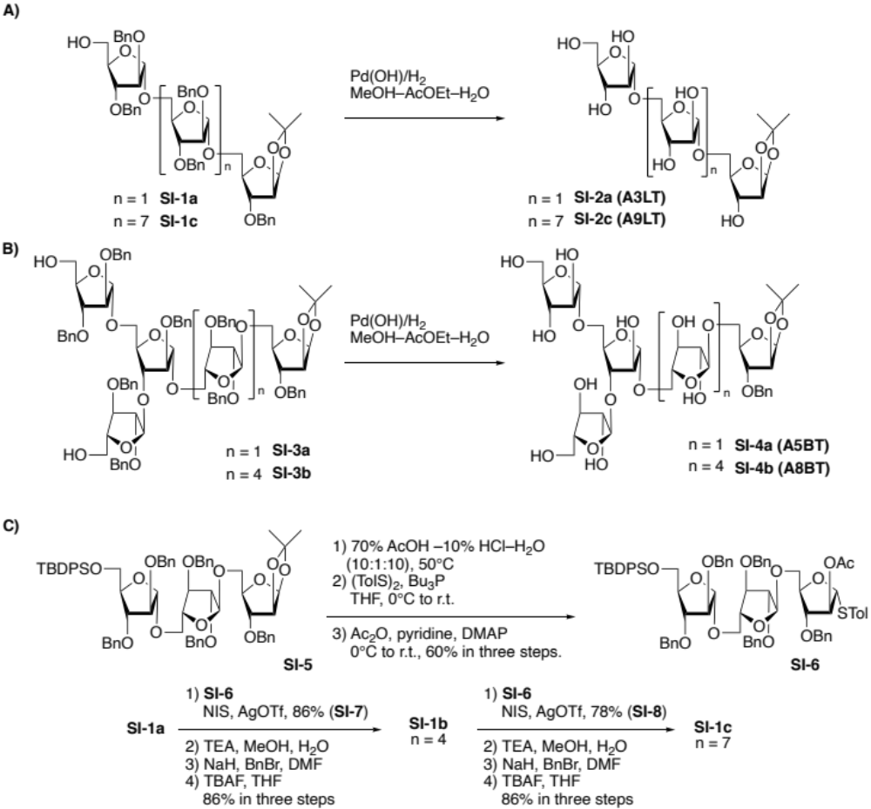

Scheme SI-1. Preparation of acetonide derivative of oligo-d-arabinofuranosides, A3LT, A5BT, A8BT and A9LT. A) Synthesis of A3LT and A9LT from protected starting materials: B) Synthesis of A5BT and A8BT from protected starting materials: C) Fragment couplings toward the protected A9LT. Abbreviations; Bn: benzyl, MeOH: methanol, AcOEt: ethyl acetate, TBDPS: tert-butyldiphenylsilyl, AcOH: acetic acid, Tol: tolyl, Bu: normal-butyl, Ac: acetyl, DMAP: 1-(N,N-dimethylamino)pyridine, NIS: N-iodosuccinimide, DMF: N,N-dimethylformamide, TBAF: tetra-(normal-butyl)-ammonium fluoride, THF: tetrahydrofuran.

1) Synthesis of A3LT (SI-2a).
α-d-Arabinofuranosyl-(1→5)-α-d-arabinofuranosyl-(1→5)-1,2-O-isopropylidene-β-d-arabinofuranose (SI-2a).

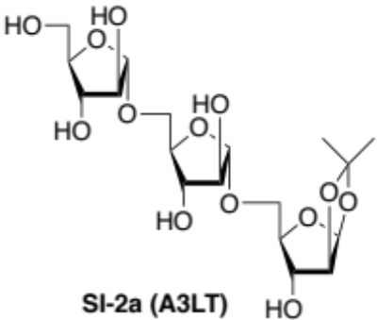

Hydrogenolysis of 2,3-di-O-benzyl-α-d-arabinofuranosyl-(1→5)-2,3-di-O-benzyl-α-d-arabinofuranosyl-(1→5)-3-O-benzyl-1,2-O-isopropylidene-β-d-arabinofuranose (SI-1a)¹⁰ (130 mg, 118 μmol) was carried out in the presence of Pd(OH)₂ (130 mg) in EtOAc–MeOH–H₂O (5:5:1, 11 mL) for 16 h at room temperature. After replacement to Ar from H₂ atmosphere, the mixture was filtered through a Celite pad, and the filtrate was concentrated in vacuo to give the trisaccharide A3LT (SI-2a, 47.1 mg, 88%).
α-d-Arabinofuranosyl^{C}-(1→5)-α-d-arabinofuranosyl^{B}-(1→5)-1,2-O-isopropylidene-β-d-arabinofuranose^{A} (A3LT, SI-2a): [α]²⁶_{D} 102.79° (c 1.00, CH₃OH); ¹H NMR (CD₃OD, 400 MHz): δ 1.39 (s, 3 H, CH₃), 1.60 (s, 3 H, CH₃), 3.67 (dd, J = 10.4, 6.4 Hz, 1 H, C5^{A}-H), 3.73 (dd, J = 12.0, 5.6 Hz, 1 H, C5^{C}-H), 3.74 (dd, J = 12.0, 4.4 Hz, 1 H, C5^{B}-H), 3.84 (dd, J = 12.0, 3.2 Hz, 1 H, C5^{C}-H), 3.93 (td, J = 5.6, 3.2 Hz, 1 H, C3^{C}-H), 3.94 (dd, J = 12.0, 5.2 Hz, 1 H, C5^{B}-H), 3.95 (dd, J = 10.4, 7.6 Hz, 1 H, C5^{A}-H), 3.99 (td, J = 6.4, 3,6 Hz, 1 H, C3^{B}-H), 4.07 (td, J = 5.6, 3.2 Hz, 1 H, C4^{C}-H), 4.08 (d, J = 3.6 Hz, 1 H, C2^{B}-H), 4.09 (dd, J = 3.2, 0.8 Hz, 1 H, C2^{C}-H), 4.18 (ddd, J = 6.4, 5.2, 3.6 Hz, 1 H, C4^{B}-H), 4.19 (ddd, J = 7.6, 6.4, 2.0 Hz, 1 H, C4^{A}-H), 4.26 (d, J = 2.0 Hz, 1 H, C3^{A}-H), 4.71 (d, J = 4.0 Hz, 1 H, C2^{A}-H), 4.98 (s, 1 H, C1^{B}-H), 5.03 (d, J = 0.8 Hz, 1 H, C1^{C}-H), 5.98 (d, J = 4.0 Hz, 1 H, C1^{A}-H); ¹³C NMR (CD₃OD, 100 MHz): δ 26.2 (CH₃), 27.2 (CH₃), 63.1 (C5^{C}), 68.0 (C5^{B}), 68.5 (C5^{A}), 76.6 (C3^{A}), 78.7 (C3^{C}), 79.3 (C3^{B}), 83.1 (C2^{C}), 83.4 (C2^{B}), 84.0 (C4^{B}), 85.8 (C4^{C}), 87.7 (C4^{A}), 88.2 (C2^{A}), 107.2 (C1^{A}), 109.5 (C1^{B}) 109.6 (C1^{C}), 113.7 (acetonide); MALDI-TOF MS: calcd for C₁₈H₃₀Na₁O₁₃ [M+Na]⁺ 477.16, found 477.23.

2) Synthesis of A5BT (SI-4a).
α-d-Arabinofuranosyl-(1→5)-[α-d-arabinofuranosyl-(1→3)]-α-d-arabinofuranosyl-(1→5)-α-d-arabinofuranosyl-(1→5)-1,2-O-isopropylidene-β-d-arabinofuranose (SI-4a).

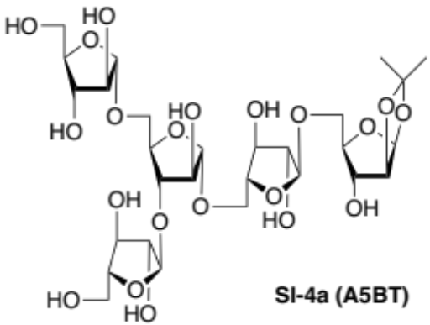

Hydrogenolysis of 2,3-di-O-benzyl-α-d-arabinofuranosyl-(1→5)-[2,3-di-O-benzyl-α-d-arabinofuranosyl-(1→3)]-2-O-benzyl-α-d-arabinofuranosyl-(1→5)-2,3-di-O-benzyl-α-d-arabinofuranosyl-(1→5)-3-O-benzyl-1,2-O-isopropylidene-β-d-arabinofuranose (SI-3a)¹⁰ (34.4 mg, 23.5 μmol) was carried out in the presence of Pd(OH)₂ (34.3 mg) in MeOH–H₂O (5:1, 6.0 mL) for 16 h at room temperature. After replacement to Ar from H₂ atmosphere, the mixture was filtered through a Celite pad, and the filtrate was concentrated in vacuo to give the title compound A5BT (SI-4a, 16.1 mg, 95%).
α-d-Arabinofuranosyl^{E}-(1→5)-[α-d-arabinofuranosyl^{D}-(1→3)]-α-d-arabinofuranosyl^{C}-(1→5)-α-d-arabinofuranosyl^{B}-(1→5)-1,2-O-isopropylidene-β-d-arabinofuranose^{A} (A5BT, SI-4a): [α]²²_{D} 178.18 (c 0.88, H₂O); ¹H NMR (D₂O, 400 MHz): δ 1.35 (s, 3 H, CH₃), 1.55 (s, 3 H, CH₃), 3.64–3.71 (m, 3 H, C5^{A}-H, C5^{D}-H, C5E-H), 3.75 (dd, J = 12.0, 3.2 Hz, 1 H, C5^{B}-H), 3.78–3.86 (m, 4 H, C5^{B}-H, C5^{C}-H, C5^{D}-H, C5E-H), 3.87–3.95 (m, 4 H, C3^{D}-H, C3E-H, C5^{A}-H, C5^{C}-H), 3.98–4.03 (m, 2 H, C3^{B}-H, C4^{D}-H), 4.05–4.11 (m, 5 H, C2^{B}-H, C2^{D}-H, C2E-H, C3^{C}-H, C4E-H), 4.16 (ddd, J = 6.0, 5.6, 3.2 Hz, 1 H, C4^{B}-H), 4.23–4.29 (m, 4 H, C2^{C}-H, C3^{A}-H, C4^{A}-H, C4^{C}-H), 4.71 (d, J = 4.0 Hz, 1 H, C2^{A}-H), 5.02 (d, J = 1.6 Hz, 1 H, C1_{B}-H), 5.05 (d, J = 1.2 Hz, 1 H, C1^{D/E}-H), 5.08 (s, 1 H, C1^{C}-H), 5.12 (d, J = 1.6 Hz, 1 H, C1^{D/E}-H), 6.03 (d, J = 4.0 Hz, 1 H, C1^{A}-H); ¹³C NMR (D₂O, 100 MHz): δ 24.9 (CH₃), 25.7 (CH₃), 61.07 (C5^{D/E}), 61.13 (C5^{D/E}), 66.1 (C5^{B}), 66.4 (C5^{C}), 67.1 (C5^{A}), 74.7 (C3^{A}), 76.5 (x2) (C3^{D}, C3E), 76.7 (C3^{B}), 79.1 (C2^{C}), 80.9 (C3^{C}), 81.0 (C2^{D/E}), 81.2 (C2^{D/E}), 81.6 (C2^{b}), 82.0 (C4^{C}), 82.3 (C4^{B}), 83.9 (C4 ^{D/E}), 84.0 (C4 ^{D/E}), 85.9 (C4^{A}), 86.1 (C2^{A}), 105.5 (C1^{A}), 107.1, 107.34, 107.36, 107.42 (C1 x4), 113.4 (acetonide); MALDI-TOF MS: calcd for C₂₈H₄₆Na₁O₂₁ [M+Na]⁺ 741.24, found 741.69.

3) Synthesis of A8BT (SI-4B).
α-d-Arabinofuranosyl-(1→5)-[α-d-arabinofuranosyl-(1→3)]-α-d-arabinofuranosyl-(1→5)-α-d-arabinofuranosyl-(1→5)-α-d-arabinofuranosyl-(1→5)-α-d-arabinofuranosyl-(1→5)-α-d-arabinofuranosyl-(1→5)-1,2-O-isopropylidene-β-d-arabinofuranose (SI-4B).

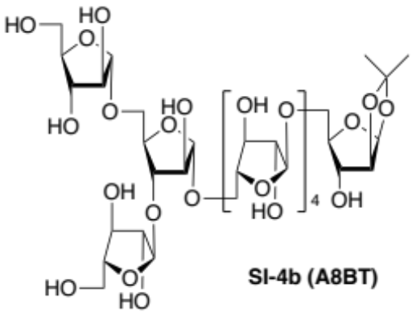

Hydrogenolysis of 2,3-di-O-benzyl-α-d-arabinofuranosyl-(1→5)-[2,3-di-O-benzyl-α-d-arabinofuranosyl-(1→3)]-2-O-benzyl-α-d-arabinofuranosyl-(1→5)-2,3-di-O-benzyl-α-d-arabinofuranosyl-(1→5)-2,3-di-O-benzyl-α-d-arabinofuranosyl-(1→5)-2,3-di-O-benzyl-α-d-arabinofuranosyl-(1→5)-2,3-di-O-benzyl-α-d-arabinofuranosyl-(1→5)-3-O-benzyl-1,2-O-isopropylidene-β-d-arabinofuranose (SI-3b)¹⁰ (8.9 mg, 3.7 μmol) was carried out in the presence of Pd(OH)₂ (8.9 mg) in EtOAc–MeOH–H₂O (5:10:2, 8.5 mL) for 16 h at room temperature. After replacement to Ar from H₂ atmosphere, the mixture was filtered through a Celite pad, and the filtrate was concentrated in vacuo to give the title compound A8BT (SI-4b, 4.1 mg, quant.).
α-d-Arabinofuranosy^{E}-(1→5)-[α-d-arabinofuranosyl^{D}-(1→3)]-α-d-arabinofuranosyl^{C}-(1[→5)-α-d-arabinofuranosyl^{B}-(1]₄→5)-1,2-O-isopropylidene-β-d-arabinofuranose^{A} (A8BT, SI-4b): [α]²²_{D} 68.00 (c 0.10, H₂O); ¹H NMR (D₂O, 400 MHz): δ 1.35 (s, 3 H, CH₃), 1.55 (s, 3 H, CH₃), 3.59–3.73 (m, 3 H, C5^{A}-H, C5^{D}-H, C5E-H), 3.74–3.90 (m, 11 H, C5^{B}-H x8, C5^{C}-H, C5^{D}-H, C5E-H), 3.90–3.95 (m, 4 H, C3^{D}-H, C3E-H, C5^{A}-H, C5^{C}-H), 3.96–4.04 (m, 5 H, C3^{B}-H x4, C4E-H), 4.05–4.13 (m, 8 H, C2^{B}-H x4, C2^{C}-H, C3^{C}-H, C2E-H, C4^{D}-H), 4.15–4.21 (m, 4 H, C4^{B}-H x4), 4.22–4.31 (m, 4 H, C2^{D}-H, C3^{A}-H, C4^{A}-H, C4^{C}-H), 4.71 (d, J = 4.4 Hz, 1 H, C2^{A}-H), 5.03 (s, 1 H, C1E-H), 5.06 (s, 4 H, C1^{B}-H x4), 5.09 (s, 1 H, C1^{D}-H), 5.13 (s, 1 H, C1^{C}-H), 6.03 (d, J = 4.4 Hz, 1 H, C1^{A}-H); ¹³C NMR (D₂O, 100 MHz): δ 61.08 (C5^{D/E}), 61.13 (C5^{D/E}), 66.2, 66.4, 66.7, 66.8 (x2) (C5), 67.1 (C5^{A}), 74.7 (C3^{A}), 76.3, 76.4 (x3), 76.5, 76.7, 76.9 (C3), 79.1 (C2^{D}), 80.7, 80.8 (x2), 80.9 (x2), 81.0, 81.2 (C2^{B} x4, C2^{C}, C2E, C4^{C}), 82.17 (C4^{B}), 82.19 (C4^{B}), 82.3 (C4^{B} x 2), 83.9 (C4E), 84.0 (C4^{D}), 85.9 (C2^{A}), 86.0 (C4^{A}), 105.5 (C1^{A}), 107.1 (C1^{C}), 107.3 (C1^{D}), 107.4 (C1^{B} x4, C1E), 113.5 (acetonide); MALDI-TOF MS: calcd for C₄₃H₇₀Na₁O₃₃ [M+Na]⁺ 1137.37, found 1137.81.

4) Synthesis of A9LT (SI-2c):
The A9LT (SI-2c) has been synthesized by fragment couplings (Scheme SI-1, C). The hexasaccharide acceptor (SI-1b) was obtained by the first fragment coupling between the trisaccharide donor (SI-6) and trisaccharide acceptor (SI-1a) followed by deprotection in one step. The second fragment coupling of the trisaccharide donor (SI-6) with the resultant acceptor (SI-1b) afforded nonasaccharide derivative (SI-1c) which was then converted to the desired A9LT (SI-2c) (Scheme SI-1, A).

Tolyl 5-O-t-butyldiphenylsilyl-2,3-di-O-benzyl-α-d-arabinofuranosyl-(1→5)-2,3-di-O-benzyl-α-d-arabinofuranosyl-(1→5)-2-O-acetyl-3-O-benzyl-1-thio-α-d-arabinofuranoside (SI-6).

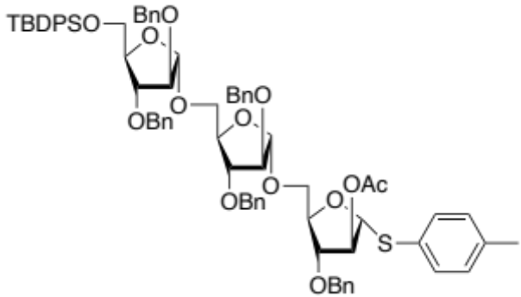

The trisaccharide donor was synthesized from 5-O-t-butyldiphenylsilyl-2,3-di-O-benzyl-α-d-arabinofuranosyl-(1→5)-2,3-di-O-benzyl-α-d-arabinofuranosyl-(1→5)-3-O-benzyl-1,2-O-isopropylidene-β-d-arabinofuranose (SI-5) as reported previously¹⁰. A solution of 5-O-t-butyldiphenylsilyl-2,3-di-O-benzyl-α-d-arabinofuranosyl-(1→5)-2,3-di-O-benzyl-α-d-arabinofuranosyl-(1→5)-3-O-benzyl-1,2-O-isopropylidene-β-d-arabinofuranose (SI-5) (567 mg, 486 μmol) in THF (10.0 mL), 10% aqueous HCl (1.0 mL) and 70% aqueous AcOH (10.0 mL) was stirred at 50°C for 2 h. After cooling to room temperature, the reaction was quenched with saturated aqueous NaHCO₃, extracted with ethyl acetate, washed with brine, dried over Na₂SO₄, concentrated in vacuo, and azeotropic removal of H₂O with toluene. The residue was used without further purification. To a solution of the crude hemiacetal and di-p-tolyl disulfide (180 mg, 729 μmol) in dry CH₂Cl₂ (10.0 mL) was added n-Bu₃P (188 μL, 730 μmol) at 0°C under Ar atmosphere. After stirring for 2 h at the same temperature, the mixture was concentrated in vacuo (MALDI-TOF MS: calcd for C₇₃H₈₀Na₁O₁₂S₁Si₁ [M+Na]⁺ 1231.5, found 1232.0.). To the mixture in pyridine (5.0 mL) was added Ac₂O (1.0 mL) and DMAP (50.0 mg) at 0°C, and the mixture was stirred for 1 h during which time the temperature was going up to room temperature. After being concentrated in vacuo, the residue was purified by flash column chromatography using a gradient solvent system (hexane/ethyl acetate) to give the title compound (SI-6) (366 mg, 60% in three steps) as the mixture of anomers.
Tolyl 5-O-t-butyldiphenylsilyl-2,3-di-O-benzyl-α-d-arabinofuranosyl^{C}-(1→5)-2,3-di-O-benzyl-α-d-arabinofuranosyl^{B}-(1→5)-2-O-acetyl-3-O-benzyl-1-thio-α-d-arabinofuranoside^{A} (SI-6); major isomer: ¹H NMR (CDCl₃, 400 MHz): δ 0.96 (s, 9 H, TBDPS), 1.81 (s, 3 H, Ac), 2.21 (s, 3 H, CH₃Ph) 3.46–3.64 (m, 2 H, C5^{A}-H, C5^{B}-H), 3.68–3.83 (m, 4 H, C5^{A}-H, C5^{B}-H, C5^{C}-H₂), 3.90–4.10 (m, 6 H, C2^{B}-H, C2^{C}-H, C3^{A}-H, C3^{C}-H, C4^{B}-H, C4^{C}-H), 4.31–4.65 (m, 11 H, Bn-H x10, C4 ^{A}-H), 4.99 (s, 1 H, C1-H), 5.06 (s, 1 H, C1-H), 5.20 (t, J = 1.6 Hz, 1 H, C2^{A}-H), 5.39 (s, 1 H, C1^{A}-H), 6.96–7.62 (m, 39 H, Ar); ¹³C NMR (CDCl₃, 100 MHz): δ 19.3 (TBDPS), 20.8 (Ac), 21.1 (CH₃Ph), 26.8 (TBDPS), 63.7 (C5^{C}), 65.58 (C5^{A}), 65.62 (C5^{B}), 71.7 (Bn), 71.9 (Bn), 72.0 (Bn), 72.3 (Bn x2), 80.6 (C3^{C}), 81.5 (C4^{A}), 81.9 (C2^{A}), 82.6 (C4^{C}), 82.9 (C3^{A}), 83.1 (C3^{B}), 83.2 (C3^{C}), 88.0 (C2^{C}), 88.5 (C2^{B}), 91.3 (C1^{A}), 106.2 (C1^{B}), 106.4 (C1^{C}), 127.60, 127.63, 127.7, 127.8, 127.9, 128.27, 128.32, 128.37, 128.41, 129.6, 129.7, 132.4, 133.4, 135.6, 135.7, 137.5, 135.6, 138.0 (Ar), 169.8 (Ac).; MALDI-TOF MS: calcd for C₇₅H₈₂Na₁O₁₃S₁Si₁ [M+Na]⁺ 1273.5, found 1272.9; ESI-TOF MS: Calcd for C₇₅H₈₂Na₁O₁₃S₁Si₁ [M+Na]⁺ (m/z) 1273.52 found 1273.53; HR ESI-TOF MS: Calcd for C₇₅H₈₂Na₁O₁₃S₁Si₁ [M+Na]⁺ (m/z) 1273.5161, found 1273.5143.

5-O-t-Butyldiphenylsilyl-2,3-di-O-benzyl-α-d-Arabinofuranosyl-(1→5)-2,3-di-O-benzyl-α-d-arabinofuranosyl-(1→5)-2-O-acetyl-3-O-benzyl-α-d-arabinofuranosyl-(1→5)-2,3-di-O-benzyl-α-d-arabinofuranosyl-(1→5)-2,3-di-O-benzyl-α-d-arabinofuranosyl-(1→5)-3-O-benzyl-1,2-O-isopropylidene-β-d-arabinofuranose (SI-7).

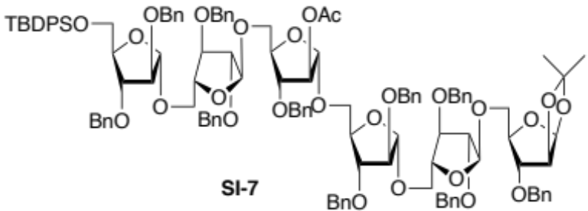

To the mixture of Araf₃ acceptor (SI-1a)¹⁰ (68.2 mg, 75.4 μmol) and Araf₃ donor (SI-6) (99.0 mg, 79.1 μmol) in dry CH₂Cl₂ (2 mL), MS 4Å (250 mg, freshly dried) was added at room temperature. After cooling to –30°C, NIS (29.6 mg, 128 μmol) and AgOTf (2.0 mg, 7.8 μmol) were added to the mixture and the mixture was stirred for 24 h during which time temperature was going up to 0 °C. Then the reaction was quenched by triethylamine followed by filtration through a Celite pad and washing of the pad with CHCl₃. The combined solutions were washed with 20% aqueous Na₂S₂O₃, saturated aqueous NaHCO_{3,} and brine, dried over Na₂SO_{4,} and concentrated in vacuo. The residue was purified by gel filtration (Bio beads SX-3, toluene/ethyl acetate = 1/1) to give the title compound Araf₆ (132 mg, 86%).
5-O-t-Butyldiphenylsilyl-2,3-di-O-benzyl-α-d-arabinofuranosyl^{F}-(1→5)-2,3-di-O-benzyl-α-d-arabinofuranosyl^{E}-(1→5)-2-O-acetyl-3-O-benzyl-α-d-arabinofuranosyl^{D}-(1→5)-2,3-di-O-benzyl-α-d-arabinofuranosyl^{C}-(1→5)-2,3-di-O-benzyl-α-d-arabinofuranosyl^{B}-(1→5)-3-O-benzyl-1,2-O-isopropylidene-β-d-arabinofuranose^{A} (SI-7): [α]²⁴_{D} 66.0° (c 1.00, CHCl₃); ¹H NMR (CDCl₃, 400 MHz): δ 0.96 (s, 9 H, TBDPS), 1.25 (s, 3 H, acetonide), 1.42 (s, 3 H, acetonide), 1.81 (s, 3 H, Ac), 3.46–3.62 (m, 5 H, C5^{A}-H, C5^{B}-H, C5^{C}-H, C5^{D}-H, C5E-H), 3.68–3.83 (m, 8 H, C3^{D}-H, C5^{A}-H, C5^{B}-H, C5^{C}-H, C5^{D}-H, C5E-H, C5^{F}-H x2), 3.91–4.01 (m, 10 H, C2^{B}-H, C2^{C}-H, C2E-H C2^{F}-H, C3^{A}-H, C3^{B}-H, C3^{C}-H, C3E-H, C3^{F}-H, C4E-H), 4.02–4.18 (m, 5 H, C4^{A}-H, C4^{B}-H, C4^{C}-H, C4^{D}-H, C4^{F}-H), 4.28–4.52 (m, 19 H, Bn-H x19), 4.56 (d, J = 4.0 Hz, 1 H, C2^{A}-H), 4.62 (d, J = 12.4 Hz, 1 H, Bn-H), 4.94 (s, 1 H, C1^{B/C/E/F}-H), 4.98 (s, 1 H, C1^{B/C/E/F}-H), 5.02 (s, 1 H, C1^{D}-H), 5.04 (s, 1 H, C1^{B/C/E/F}-H), 5.06 (s, 1 H, C1^{B/C/E/F}-H), 5.09 (s, 1 H, C2^{D}-H), 5.81 (d, J = 4.0 Hz, 1 H, C1^{A}-H), 7.14–7.70 (m, 65 H, Ar); ¹³C NMR (CDCl₃, 100 MHz): δ 19.3 (TBDPS), 20.8 (Ac), 26.4 (Acetonide), 26.8 (TBDPS), 27.2 (Acetonide), 63.6 (C5^{F}), 65.57 (C1^{B/C/D/E}), 65,66 (C1^{B/C/D/E}), 65.69 (C1^{B/C/D/E}), 65.79 (C1^{B/C/D/E}), 66.8 (C5^{A}), 71.66 (Bn x2), 71.74 (Bn), 71.8 (Bn), 72.0 (Bn x2), 72.14 (Bn), 72.17 (Bn), 72.21 (Bn), 72.3 (Bn), 80.3 (C4^{F}), 80.53 (C4^{B/C/E}), 80.56 (C4^{B/C/E} x2), 81.3 (C2^{D}), 82.0 (C4^{D}), 82.5 (C4^{A}), 82.8 (C3^{A–F}), 82.9 (C3^{A–F}), 83.0 (C3^{A–F}), 83.1 (C3^{A–F}), 83.2 (C3^{A–F} x2), 85.3 (C2^{A}), 87.9 (C2^{B/C/E/F}), 88.0 (C2^{B/C/E/F}), 88.5 (C2^{B/C/E/F} x2), 105.5 (C1^{A}), 106.0 (C1^{D}), 106.20 (C1^{B/C/E/F}), 106.3 (C1^{B/C/E/F}), 106.4 (C1^{B/C/E/F} x2), 112.8 (Acetonide), 127.56, 127.61, 127.68, 127.71, 127.8, 128.27, 128.30, 128.34, 128.4, 129.56, 129.59, 133.4, 135.58, 135.62, 137.28, 137.49, 137.51, 137.62, 137.67, 137.78, 137.91, 137.99 (Ar), 167.7 (Ac); MALDI-TOF MS: calcd for C₁₂₁H₁₃₄Na₁O₂₆Si₁ [M+Na]⁺ 2053.9, found 2053.2; HR ESI-TOF MS: Calcd for C₁₂₁H₁₃₄Na₁O₂₆Si₁ [M+Na]⁺ (m/z) 2053.88, found 2053.07; HR ESI-TOF MS: Calcd for C₁₂₁H₁₃₄Na₁O₂₆Si₁ [M+Na]⁺ (m/z) 2053.8830, found 2053.8825.

2,3-Di-O-benzyl-α-d-arabinofuranosyl-(1→5)-2,3-di-O-benzyl-α-d-arabinofuranosyl-(1→5)-2,3-di-O-benzyl-α-d-arabinofuranosyl-(1→5)-2,3-di-O-benzyl-α-d-arabinofuranosyl-(1→5)-2,3-di-O-benzyl-α-d-arabinofuranosyl-(1→5)-3-O-benzyl-1,2-O-isopropylidene-β-d-arabinofuranose (SI-1b).

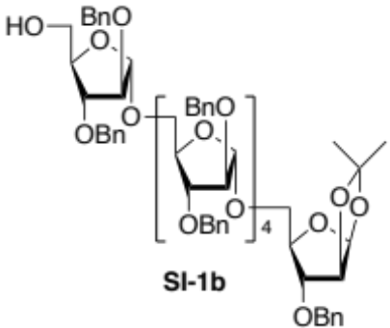

To a solution of 5-O-t-butyldiphenylsilyl-2,3-di-O-benzyl-α-d-arabinofuranosyl-(1→5)-2,3-di-O-benzyl-α-d-arabinofuranosyl-(1→5)-2-O-acetyl-3-O-benzyl-α-d-arabinofuranosyl-(1→5)-2,3-di-O-benzyl-α-d-arabinofuranosyl-(1→5)-2,3-di-O-benzyl-α-d-arabinofuranosyl-(1→5)-3-O-benzyl-1,2-O-isopropylidene-β-d-arabinofuranose (SI-7) (86.0 g, 42.3 μmol) in MeOH (2 mL) and H₂O (0.5 mL) was added Et₃N (2.0 mL) at room temperature. After stirring for 24 h at the same temperature, the mixture was concentrated in vacuo to give a crude deacylated compound. After azeotropic removal of residual H₂O with toluene, to a solution of the residue in dry DMF (1.0 mL) was added NaH (2.4 mg, 60.0 μmol) and BnBr (5.5 μL, 46 μmol) at 0°C, and the mixture was stirred for 2 h during which time temperature was going up to room temperature. The reaction was quenched by sat. NH₄Cl aq., extracted with EtOAc washed with brine, dried over Na₂SO₄, and evaporated in vacuo. The residue was used without further purification. To a solution of the residue in dry THF (1.0 mL), 1 M solution of TBAF in THF (0.5 mL) was added at room temperature. After stirring for 4 h at the same temperature, the mixture was concentrated in vacuo. The residue was purified by PTLC (hexane/ethyl acetate =1/1) to give the title compound (SI-1b) (76.0 mg, 86% in three steps).
2,3-Di-O-benzyl-α-d-arabinofuranosyl^{C}-(1[→5)-2,3-di-O-benzyl-α-d-arabinofuranosyl^{B}-(1]₄→5)-3-O-benzyl-1,2-O-isopropylidene-β-d-arabinofuranose^{A} (SI-1b): [α]²⁵_{D} 81.8° (c 1.00, CHCl₃); ¹H NMR (CDCl₃, 400 MHz): δ 1.25 (s, 3 H, acetonide), 1.42 (s, 3 H, acetonide), 1.65 (br s, 1 H, OH), 3.46–3.62 (m, 6 H, C5^{A}-H, C5^{B}-H x4, C5^{C}-H), 3.68–3.83 (m, 6 H, C5^{A}-H, C5^{B}-H x4, C5^{C}-H), 3.88 (dd, J = 5.6, 4.0 Hz, 1 H, C3^{C}-H), 3.92–4.10 (m, 14 H, C2^{B}-H x4, C2^{C}-H, C3^{A}-H, C3^{B}-H x4, C4^{B}-H x4, C4^{C}-H), 4.14 (ddd, J = 6.8, 5.2, 3.6 Hz, 1 H, C4^{A}-H), 4.28–4.52 (m, 22 H, Bn x22), 4.57 (d, J = 4.0 Hz, 1 H, C2^{A}-H), 4.94 (s, 1 H, C1^{B}-H), 5.03 (s, 2 H, C1^{B/C}-H x2), 5.04 (s, 1 H, C1^{B/C}-H), 5.05 (s, 1 H, C1^{B/C}-H), 5.81 (d, J = 4.0 Hz, 1 H, C1^{A}-H), 7.14–7.25 (m, 55 H, Ar); ¹³C NMR (CDCl₃, 100 MHz): δ 26.4 (Acetonide), 27.2 (Acetonide), 62,1 (C5^{C}), 65.7 (C5^{B}), 65.9 (C5^{B} x3), 66.8 (C5^{A}), 71.7 (Bn), 71.8 (Bn), 71.9 (Bn x3), 72.0 (Bn), 72.20 (Bn x2), 72.23 (Bn x2), 72.3 (Bn), 80.34, 80.36, 80.42, 80.5 (C4^{B} x3, C4^{C}), 82.0 (C4^{A}), 82.7, 82.8, 82.9, 83.12, 83.15 (x3), 83.23 (C3^{A}, C3^{B} x4, C3^{C}, C4^{B}), 85.3 (C2^{A}), 87.6, 88.20, 88.24, 88.3, 88.5 (C2^{B} x4, C2^{C}), 105.5 (C1^{B}), 106.2 (C1^{B/C}), 106.41 (C1^{B/C}), 106.45 (C1^{B/C} x2), 106.48 (C1^{A}), 112.9 (Acetonide), 127,7, 127.8, 127.9, 128.30, 128.34, 137.4, 137.6, 137.89, 137.93 (Ar); MALDI-TOF MS: calcd for C₁₁₀H₁₂₀Na₁O₂₅ [M+Na]⁺ 1863.8, found 1862.8; HR ESI-TOF MS: Calcd for C₁₁₀H₁₂₀Na₁O₂₅ [M+Na]⁺ (m/z) 1863.80, found 1863.83; HR ESI-TOF MS: Calcd for C₁₁₀H₁₂₀Na₁O₂₅ [M+Na]⁺ (m/z) 1863.8016, found 1863.8063.

5-O-t-Butyldiphenylsilyl-2,3-di-O-benzyl-α-d-arabinofuranosyl-(1→5)-2,3-di-O-benzyl-α-d-arabinofuranosyl-(1→5)-2-O-acetyl-3-O-benzyl-α-d-arabinofuranosyl-(1→5)-2,3-di-O-benzyl-α-d-arabinofuranosyl-(1→5)-2,3-di-O-benzyl-α-d-arabinofuranosyl-(1→5)-2,3-di-O-benzyl-α-d-arabinofuranosyl-(1→5)-2,3-di-O-benzyl-α-d-arabinofuranosyl-(1→5)-2,3-di-O-benzyl-α-d-arabinofuranosyl-(1→5)-3-O-benzyl-1,2-O-isopropylidene-β-d-arabinofuranose Araf₉LT (SI-8).

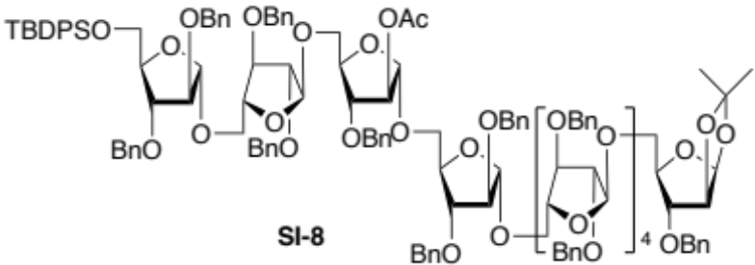

Araf₉ has been synthesized from the Araf₆ acceptor (SI-1b) with the Araf₃ donor (SI-6) according to a general fragment coupling procedure for the synthesis of SI-7 from SI-1a with SI-6.

To the mixture of Araf₆ acceptor (SI-1b) (12.0 mg, 6.5 μmol) and Araf₃ donor (SI-6) (8.1 mg, 6.5 μmol) in dry CH₂Cl₂ (2 mL) was added MS 4Å (250 mg, freshly dried) at room temperature. After cooling to –40°C, NIS (2.6 mg, 11.2 μmol) and AgOTf (1.0 mg, 3.9 μmol) were added to the mixture and the mixture was stirred for 24 h during which time temperature was going up to 0°C. Then the reaction was quenched by triethylamine followed by filtration through a Celite pad and washing of the pad with CHCl₃. The combined solutions were washed with 20% aqueous Na₂S₂O₃, saturated aqueous NaHCO_{3,} and brine, dried over Na₂SO_{4,} and concentrated in vacuo. The residue was purified by PTLC (hexane/ethyl acetate = 2/1) to give the title compound Araf₉ (SI-8) (15.0 mg, 788%).
5-O-t-Butyldiphenylsilyl-2,3-di-O-benzyl-α-d-arabinofuranosyl^{I}-(1→5)-2,3-di-O-benzyl-α-d-arabinofuranosyl^{H}-(1→5)-2-O-acetyl-3-O-benzyl-α-d-arabinofuranosyl^{G}-(1→5)-2,3-di-O-benzyl-α-d-arabinofuranosyl^{F}-(1→5)-2,3-di-O-benzyl-α-d-arabinofuranosyl^{E}-(1→5)-2,3-di-O-benzyl-α-d-arabinofuranosyl^{D}-(1→5)-2,3-di-O-benzyl-α-d-arabinofuranosyl^{C}-(1→5)-2,3-di-O-benzyl-α-d-arabinofuranosyl^{B}-(1→5)-3-O-benzyl-1,2-O-isopropylidene-β-d-arabinofuranose^{A} (SI-8): [α]²⁸_{D} 88.0° (c 1.00, CHCl₃); ¹H NMR (CDCl₃, 400 MHz): δ 0.96 (s, 9 H, TBDPS), 1.25 (s, 3 H, acetonide), 1.42 (s, 3 H, acetonide), 1.80 (s, 3 H, Ac), 3.45–3.60 (m, 8 H, C5^{A}-H, C5^{B}-H, C5^{C}-H, C5^{D}-H, C5E-H, C5^{F}-H, C5^{G}-H, C5^{H}-H), 3.69–3.85 (m, 11 H, C3^{G}-H, C5^{A}-H, C5^{B}-H, C5^{C}-H, C5^{D}-H, C5E-H, C5^{F}-H, C5^{G}-H, C5^{H}-H, C5^{I}-H x2), 3.92–4.00 (m, 16 H, C2^{B}-H, C2^{C}-H, C2^{D}-H, C2E-H, C2^{F}-H, C2^{H}-H, C2^{I}-H, C3^{A}-H, C3^{B}-H, C3^{C}-H, C3^{D}-H, C3E-H, C3^{F}-H, C3^{H}-H, C3^{I}-H, C4^{G}-H), 4.02–4.17 (m, 8 H, C4^{A}-H, C4^{B}-H, C4^{C}-H, C4^{D}-H, C4E-H, C4^{F}-H, C4^{H}-H, C4^{I}-H), 4.28–4.51 (m, 31 H, Bn x31), 4.56 (d, J = 4.0 Hz, 1 H, C2^{A}-H), 4.62 (d, J = 12.4 Hz, 1 H, Bn-H), 4.98 (s, 2 H, C1^{B/C/D/E/F/H/I}-H x2), 4.98 (s, 1 H, C1^{B/C/D/E/F/H/I}-H), 5.03 (s, 3 H, C1^{B/C/D/E/F/H/I}-H x3), 5.04 (s, 1 H, C1^{G}-H), 5.05 (s, 1 H, C1^{B/C/D/E/F/H/I}-H), 5.08 (d, J = 1.2Hz, 1 H, C2^{G}-H), 5.81 (d, J = 4.0 Hz, 1 H, C1^{A}-H), 7.10–7.62 (m, 90 H, Ar); ¹³C NMR (CDCl₃, 100 MHz): δ 19.3 (TBDPS), 20.8 (Ac), 26.4 (Acetonide), 26.8 (TBDPS), 27.2 (Acetonide), 63.6 (C5^{I}), 65.6 (C5^{B/C/D/E/F/G/H}), 65.7 (C5^{B/C/D/E/F/G/H}), 65.8 (C5^{B/C/D/E/F/G/H} x5), 66.8 (C5^{A}), 71.68 (Bn x2), 71.75 (Bn), 71.81 (Bn), 72.0 (Bn x5), 72.1 (Bn), 72.2 (Bn x7), 72.3 (Bn), 80.3 (C4^{I}), 80.37 (C4^{B/C/D/E/F/H} x2), 80.41 (C4^{B/C/D/E/F/H} x2), 80.5 (C4^{B/C/D/E/F/H}), 80.6 (C4^{B/C/D/E/F/H}), 81.3 (C2^{G}), 82.0 (C4^{G}), 82.5 (C4^{A}), 82.8 (C3^{A–I}), 82.9, (C3^{A–I}), 83.0 (C3^{A–I}), 83.1 (C3^{A–I} x5), 83.18 (C3^{A–I}), 83.22 (C3^{A–I}), 85.3 (C2^{A}), 87.97 (C2^{B/C/D/E/F/H/I}), 88.01 (C2^{B/C/D/E/F/H/I}), 88.2 (C2^{B/C/D/E/F/H/I} x3), 88.5 (C2^{B/C/D/E/F/H/I} x2), 105.5 (C1^{A}), 106.0 (C1^{G}), 106.2 (C1^{B/C/D/E/F/H/I}), 106.3 (C1^{B/C/D/E/F/H/I}), 106.4 (C1^{B/C/D/E/F/H/I}), 106.5 (C1^{B/C/D/E/F/H/I} x4), 112.9 (acetonide), 127.5, 127.6, 127.69, 127.73, 127.86, 127.91, 128.3, 128.4, 129.59, 129.61, 130.1, 133.4, 135.6, 135.7, 137.30, 137.49, 137.55, 137.59, 137.65, 137.70, 137.89, 137.94, 138.0 (Ar), 169.7 (Ac); ESI-TOF MS: Calcd for C₁₇₆H₁₉₂Na₂O₃₇Si₁ [M+Na]⁺ (m/z) 2990.29, found 2990.29; HR ESI-TOF MS: Calcd for C₁₇₆H₁₉₂Na₂O₃₇Si₁ [M+Na₂]²⁺/2 (m/z) 1485.6354, found 1485.6331; Calcd for C₁₇₆H₁₉₂Na₂O₃₇Si₁ [M+Na]⁺ (m/z) 2990.2915, found 2990.2871.

2,3-Di-O-benzyl-α-d-arabinofuranosyl-(1→5)-2,3-di-O-benzyl-α-d-arabinofuranosyl-(1→5)-2,3-di-O-benzyl-α-d-arabinofuranosyl-(1→5)-2,3-di-O-benzyl-α-d-arabinofuranosyl-(1→5)-2,3-di-O-benzyl-α-d-arabinofuranosyl-(1→5)-2,3-di-O-benzyl-α-d-arabinofuranosyl-(1→5)-2,3-di-O-benzyl-α-d-arabinofuranosyl-(1→5)-2,3-di-O-benzyl-α-d-arabinofuranosyl-(1→5)-3-O-benzyl-1,2-O-isopropylidene-β-d-arabinofuranose (SI-1c).

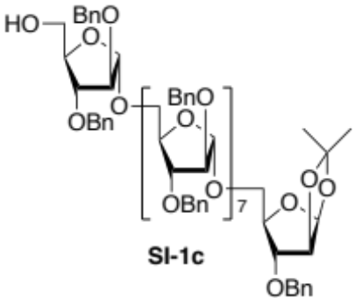

Araf₉ derivative (SI-1c) has been synthesized from Araf₉ derivative (SI-8) according to a general procedure for the synthesis of SI-1c from SI-7.

To a solution of 5-O-t-butyldiphenylsilyl-2,3-di-O-benzyl-α-d-arabinofuranosyl-(1→5)-2,3-di-O-benzyl-α-d-arabinofuranosyl-(1→5)-2-O-acetyl-3-O-benzyl-α-d-arabinofuranosyl-(1→5)-2,3-di-O-benzyl-α-d-arabinofuranosyl-(1→5)-2,3-di-O-benzyl-α-d-arabinofuranosyl-(1→5)-2,3-di-O-benzyl-α-d-arabinofuranosyl-(1→5)-2,3-di-O-benzyl-α-d-arabinofuranosyl-(1→5)-2,3-di-O-benzyl-α-d-arabinofuranosyl-(1→5)-3-O-benzyl-1,2-O-isopropylidene-β-d-arabinofuranose (SI-8) (8.6 g, 2.9 μmol) in MeOH (2 mL) and H₂O (0.5 mL) was added Et₃N (2.0 mL) at room temperature. After stirring for 24 h at the same temperature, the mixture was concentrated in vacuo to give a crude deacylated compound. After azeotropic removal of residual H₂O with toluene, to a solution of the residue in dry DMF (1.0 mL) was added NaH (1.0 mg, 25 μmol) and BnBr (3.8 μL, 32.0 μmol) at 0°C, and the mixture was stirred for 2 h during which time temperature was going up to room temperature. The reaction was quenched by sat. NH₄Cl aq., extracted with EtOAc washed with brine, dried over Na₂SO₄, and evaporated in vacuo. The residue was used without further purification. To a solution of the residue in dry THF (1.0 mL), 1 M solution of TBAF in THF (0.5 mL) was added at room temperature. After stirring for 4 h at the same temperature, the mixture was concentrated in vacuo. The residue was purified by PTLC (hexane/ethyl acetate =1/1) to give the title compound (SI-1c) (7.1 mg, 88% in three steps).
2,3-Di-O-benzyl-α-d-arabinofuranosyl^{I}-(1→5)-2,3-di-O-benzyl-α-d-arabinofuranosyl^{H}-(1→5)-2,3-di-O-benzyl-α-d-arabinofuranosyl^{G}-(1→5)-2,3-di-O-benzyl-α-d-arabinofuranosyl^{F}-(1→5)-2,3-di-O-benzyl-α-d-arabinofuranosyl^{E}-(1→5)-2,3-di-O-benzyl-α-d-arabinofuranosyl^{D}-(1→5)-2,3-di-O-benzyl-α-d-arabinofuranosyl^{C}-(1→5)-2,3-di-O-benzyl-α-d-arabinofuranosyl^{B}-(1→5)-3-O-benzyl-1,2-O-isopropylidene-β-d-arabinofuranose^{A} (SI-1c): [α]²⁶_{D} 147.99° (c 1.00, CHCl₃); ¹H NMR (CDCl₃, 400 MHz): δ 1.32 (s, 3 H, acetonide), 1.49 (s, 3 H, acetonide), 1.80 (br s, 1 H, OH), 3.52–3.70 (m, 9 H, C5^{A–I}-H x 9), 3.75–3.90 (m, 9 H, C5^{A–I}-H x 9), 3.95 (dd, J = 6.4, 3.2 Hz, 1 H, C3^{I}-H), 4.00–4.25 (m, 17 H, C2^{B–I}-H x8, C3^{A–H}-H x8, C4^{I}-H), 4.02–4.17 (m, 8 H, C4^{A–H}-H x8), 4.35–4.60 (m, 34 H, Bn x34), 4.64 (d, J = 4.0 Hz, 1 H, C2^{A}-H), 5.01 (s, 1 H, C1^{I}-H), 5.09 (s, 5 H, C1^{B–H}-H x5), 5.11 (s, 1 H, C1^{B–H}-H), 5.12 (s, 1 H, C1^{B–H}-H), 5.88 (d, J = 4.0 Hz, 1 H, C1^{A}-H), 7.15–7.50 (m, 90 H, Ar); ¹³C NMR (CDCl₃, 100 MHz): δ 26.3 (Acetonide), 27.0 (Acetonide), 61.8 (C5^{I}), 65.6 (C5^{B–H} x7), 66.6 (C5^{A}), 71.4 (Bn), 71.6 (Bn x2), 71.7 (Bn x4), 71.8 (Bn x2), 71.9 (Bn x2), 72.0 (Bn x4), 72.1 (Bn x2), 80.2 (C4^{B–H} x7), 80.4 (C4^{I}), 81.9 (C3^{I}), 82.5 (C4^{A}), 82.65 (C3^{A}), 82.9 (C3^{B–H} x5), 83.0 (C3^{B–H} x2), 85.0 (C2^{A}), 87.5 (C2^{I}), 88.1 (C2^{B–H} x6), 88.3 (C2^{B–H} x1), 105.53 (C1^{A}), 106.0 (C1^{I}), 106.3 (C1^{B–I} x7), 112.6 (Acetonide), 127.0, 127.2, 127.4, 127.5, 127.6, 127.7, 128.1, 128.2, 128.6, 137.1, 137.2, 137.3, 137.4, 137.6, 137.8 (Ar); MALDI-TOF MS: calcd for C₁₆₇H₁₈₀Na₁O₃₇ [M+Na]⁺ 2800.2, found 2799.6; ESI-TOF MS: Calcd for C₁₆₇H₁₈₀Na₂O₃₇ [M+Na₂]²⁺/2 (m/z) 1411.60, found 1411.90; ESI-TOF MS: Calcd for C₁₆₇H₁₈₀Na₁O₃₇ [M+Na]⁺ (m/z) 2800.21, found 2800.79; HR ESI-TOF MS: Calcd for C₁₆₇H₁₈₀Na₂O₃₇ [M+Na₂]²⁺/2 (m/z) 1411.5999, found 1411.5990; HR ESI-TOF MS: Calcd for C₁₆₇H₁₈₀Na₁O₃₇ [M+Na]⁺ (m/z) 2800.2101, found 2800.2130.

α-d-Arabinofuranosyl-(1→5)-α-d-arabinofuranosyl-(1→5)-α-d-arabinofuranosyl-(1→5)-α-d-arabinofuranosyl-(1→5)-α-d-arabinofuranosyl-(1→5)-α-d-arabinofuranosyl-(1→5)-α-d-arabinofuranosyl-(1→5)-α-d-arabinofuranosyl-(1→5)-1,2-O-isopropylidene-β-d-arabinofuranose A9LT (SI-2c).

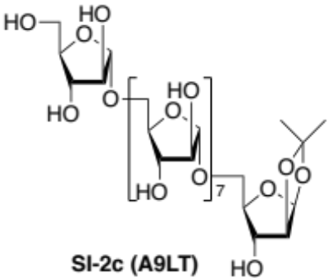
Hydrogenolysis of protected Araf₉ (SI-1c) (14.2 mg, 5.1 μmol) was carried out in the presence of Pd(OH)₂ (14.2 mg) in EtOAc–MeOH–H₂O (5:10:2, 8.5 mL) for 16 h at room temperature. After replacement to Ar from H₂ atmosphere, the mixture was filtered through a Celite pad, and the filtrate was concentrated in vacuo to give the title compound A9LT (SI-2c, 5.6 mg, 88%).

α-d-Arabinofuranosyl^{E}-(1→5)-α-d-arabinofuranosyl^{D}-(1[→5)-α-d-arabinofuranosyl^{C}-(1]₅→5)-α-d-arabinofuranosyl^{B}-(1→5)-1,2-O-isopropylidene-β-d-arabinofuranose^{A} (A9LT, SI-2c): [α]²²_{D} 340.00 (c 0.46, H₂O); ¹H NMR (D₂O, 400 MHz): δ 1.34 (s, 3 H, CH₃), 1.55 (s, 3 H, CH₃), 3.63–3.71 (m, 2 H, C5^{A}-H, C5E-H), 3.72–3.80 (m, 8 H, C5^{B}-H, C5^{C}-H x5, C5^{D}-H, C5E-H), 3.81–3.94 (m, 10 H, C2^{B/D}-H, C3E-H, C5^{A}-H, C5^{B}-H, C5^{C}-H x5, C5^{D}-H), 3.95–4.00 (m, 6 H, C2^{B/D}-H, C3^{C}-H x5), 4.04–4.12 (m, 9 H, C2^{C}-H x5, C2E-H, C3^{B}-H, C3^{D}-H, C4E-H), 4.14–4.21 (m, 7 H, C4^{B}-H, C4^{C}-H x5, C4^{D}-H), 4.22–4.27 (m, 2 H, C3^{A}-H, C4^{A}-H), 4.71 (d, J = 4.4 Hz, 1 H, C2^{A}-H), 5.03 (d, J = 1.6 Hz, 1 H, C1E-H), 5.05 (s, 2 H, C1^{B}-H, C1^{D}-H), 5.06 (s, 5 H, C1^{C}-H x5), 6.02 (d, J = 4.4 Hz, 1 H, C1^{A}-H); ¹³C NMR (D₂O, 100 MHz): δ 25.0 (CH₃), 25.7 (CH₃), 61.1 (C5E), 66.7 (C5^{B}, C5^{D}), 66.8 (C5^{C} x 5), 67.1 (C5^{A}), 74.7(C3^{A}), 76.50 (C3^{B/D}), 76.54 (C3^{B}/^{D}), 76.7 (C3^{C} x5), 76.9 (C3E), 80.8 (x6) (C2E, C2^{C} x5,), 80.9 (C2^{B/D}), 81.0 (C2^{B/D}), 81.7 (C4^{B/D}), 82.2 (C4^{B/D}), 82.3 (C4^{C}x5), 83.9 (C4E), 85.9 (C2^{A}), 86.0 (C4^{A}), 105.5 (C1^{A}), 107.4 (x3), 107.5 (x5) (C1^{B}, C1^{C} x5, CI^{D}, C1E), 113.4 (acetonide); MALDI-TOF MS: calcd for C₄₈H₇₈Na₁O₃₇ [M+Na]⁺ 1269.41, found 1269.99.

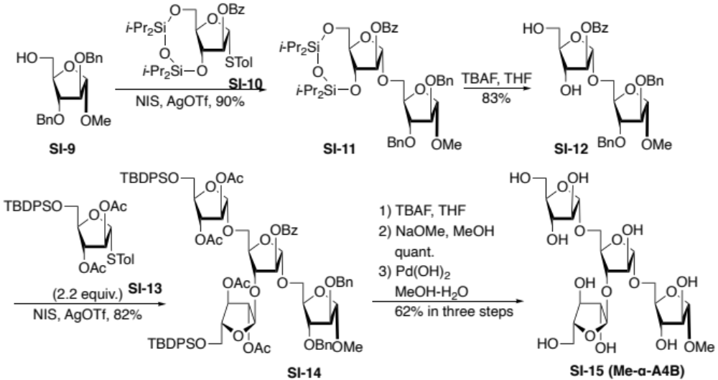

Scheme SI-2. Preparation of α-methyl glycoside of A4B (Me-α-A4B, SI-15) as the authentic for the enzymatic degradation of A5BT (SI-4b). Abbreviations; Bn: benzyl, Me: methyl, Tol: tolyl, i-Pr: isopropyl, Bz: benzoyl, NIS: N-iodosuccinimide, Tf: trifluoromethanesulfonyl, TBAF: tetra-(normal-butyl)ammonium fluoride, THF: tetrahydrofuran. TBDPS: tert-butyldiphenylsilyl, Bu: normal-butyl, Ac: acetyl,

Methyl α-d-arabinofuranosyl-(1→5)-[α-d-arabinofuranosyl-(1→3)]-α-d-arabinofuranosyl-(1→5)-α-d-arabinofuranoside¹¹ Me-α-A4B (SI-15).
To the mixture of methyl 2,3-di-O-benzyl-α-d-arabinofuranoside (SI-9)¹¹ (537 mg, 1.56 mmol) and tolyl 2-O-benzoyl-3.5-O-(1’,1’,3’,3’-tetraisopropyldisiloxanilidene)-α-d-arabinofuranoside (SI-10)¹ (987 mg, 1.64 mmol) in dry CH₂Cl₂ (5 mL) was added MS 4Å (2 g, freshly dried) at room temperature. After cooling to 0°C, NIS (608 mg, 2.70 mmol) and AgOTf (40.9 mg, 159 μmol) were added to the mixture and the mixture was stirred for 2 h at the same temperature. Then the reaction was quenched by triethylamine followed by filtration through a Celite pad and washing of the pad with ethyl acetate. The combined diluted solutions in ethyl acetate were washed with 20% aqueous Na₂S₂O₃, saturated aqueous NaHCO_{3,} and brine, dried over Na₂SO_{4,} and concentrated in vacuo. The residue was purified by SiO₂ column chromatography using gradient solvent system (hexane/ethyl acetate = 50 to 25 to 10 to 5) to give the methyl 2-O-benzoyl-3.5-O-(1’,1’,3’,3’-tetraisopropyldisiloxanilidene)-α-d-arabinofuranosyl^{B}-(1→5)-di-O-benzyl-α-d-arabinofuranoside^{A} (SI-11) (1.12 g, 90%):¹H NMR (CDCl₃, 400 MHz): δ 0.88–1.14 (m, 21 H, TIPDS), 3.35 (s, 3 H, Me), 3.59 (dd, J = 11.2, 5.6 Hz, 1 H, C5-H^{A}), 3.87 (dd, J = 11.2, 5.2 Hz, 1 H, C5-H^{A}), 3.90–4.08 (m, 5 H, C2-H^{A}, C3-H^{A}, C4-H^{B} C5-H₂^{B}), 4.21 (dt, J = 5.6, 5.2 Hz, 1 H, C4-H^{A}), 4.44 (d, J = 12.0 Hz, 1 H, Bn), 4.47 (dd, J = 8.0, 5.2 Hz, 1 H, C3-H^{B}), 4.48 (d, J = 12.0 Hz, 1 H, Bn), 4.57 (s, 2 H, Bn), 4.90 (s, 1 H, C1-H^{A}), 5.05 (d, J = 1.2 Hz, 1 H, C1-H^{B}), 5.49 (d, J = 5.2, 1.2 Hz, 1 H, C2-H^{B}) 7.22–8.04 (m, 15 H, Ar); ¹³C NMR (CDCl₃, 100 MHz): δ 12.5 (TIPDS), 12.8 (TIPDS), 13.1 (TIPDS), 13.4 (TIPDS), 16.86 (TIPDS), 16.90 (TIPDS), 17.0 (TIPDS), 17.31 (TIPDS), 17.39 (TIPDS), 17.44 (TIPDS), 54.9 (OMe), 61.6 (C5^{B}), 67.5 (C5^{A}), 71.8 (Bn), 72.1 (Bn), 76.1 (C3^{B}), 80.8 (C4^{A}), 81.1 (C4^{B}), 83.6 (C2 ^{A}/3^{A}), 84.1 (C2^{B}), 88.0 (C2 ^{A}/3^{A}), 105.5 (C1^{B}), 107.2 (C1^{A}), 127.67 (Ar), 127.73 (Ar), 127.8 (Ar), 127.9 (Ar), 128.4 (Ar), 129.7 (Ar), 133.2 (Ar), 137.6 (Ar), 137.9 (Ar), 165.4 (Bz); MALDI-TOF MS: calcd for C₄₄H₆₂Na₁O₁₁Si₂ [M+Na]⁺ 845.37, found 845.58. To the mixture of Araf₂ derivative (SI-11) (1.12 g, 1.36 mmol) in dry THF (5 mL) was added TBAF in THF (1 M, 3.39 mL, 3.39 mmol) at 0°C and the mixture was stirred for 2 h at the same temperature. After quenching with AcOH (2 mL), the mixture was concentrated in vacuo and the residue was purified by SiO₂ column chromatography using gradient solvent system (toluene/acetone = 50 to 25 to 10 to 5 to 2 to 1) to give the methyl 2-O-benzoyl-α-d-arabinofuranosyl^{B}-(1→5)-di-O-benzyl-α-d-arabinofuranoside^{A} (SI-12) (651 mg, 83%):¹H NMR (CDCl₃, 400 MHz): δ 3.36 (s, 3 H, Me), 3.70 (dd, J = 10.8, 3.6 Hz, 1 H, C5-H^{A}), 3.71 (dd, J = 12.4, 4.4 Hz, 1 H C5-H^{B}), 3.83 (dd, J = 12.4, 3.6 Hz, 1 H, C5-H^{B}), 3.86 (dd, J = 10.8, 5.2 Hz, 1 H, C5-H^{A}), 3.89 (dd, J = 6.0, 2.4 Hz, 1 H, C3-H^{A}), 3.97 (d, J = 2.4 Hz, 1 H, C2-H^{A}), 4.03 (ddd, J = 6.0, 5.2, 3.2 Hz, 1 H, C4-H^{B}), 4.12 (dd, J = 6.0, 2.4 Hz, 1 H, C3-H^{B}), 4.19 (ddd, J = 6.0, 4.8, 3.6 Hz, 1 H, C4-H^{A}), 4.44 (d, J = 12.0 Hz, 1 H, Bn), 4.46 (d, J = 12.4 Hz, 1 H, Bn), 4.54 (d, J = 12.0 Hz, 1 H, Bn), 4.57 (d, J = 12.4 Hz, 1 H, Bn), 4.93 (s, 1 H, C1-H^{A}), 5.13 (d, J = 2.4 Hz, 1 H, C2-H^{B}), 5.26 (s, 1 H, C1-H^{B}), 7.25–8.00 (m, 15 H, Ar); ¹³C NMR (CDCl₃, 100 MHz): δ 54.9 (OMe), 62.0 (C5^{B}), 66.2 (C5^{A}), 71.9 (Bn), 72.1 (Bn), 76.2 (C3^{B}), 80.7 (C4^{A}), 83.3 (C3^{A}), 84.9 (C4^{B}), 85.0 (C2^{B}), 87.4 (C2^{A}), 105.0 (C1^{B}), 107.2 (C1^{A}), 127.83 (Ar), 127.86 (Ar), 127.95 (Ar), 128.01 (Ar), 128.41 (Ar), 128.44 (Ar), 128.48 (Ar), 129.0 (Ar), 129.7 (Ar), 133.5 (Ar), 137.2 (Ar), 137.5 (Ar), 166.3 (Bz); MALDI-TOF MS: calcd for C₃₂H₃₆Na₁O₁₀ [M+Na]⁺ 603.22, found 603.63. To the mixture of Araf₂ diol acceptor (SI-12) (149 mg, 257 μmol) and tolyl 2,3-di-O-acetyl-5-O-t-butyldiphenylsilyl-1-deoxy-1-thio-α-d-arabinofuranoside¹² (SI-13) (327 mg, 566 μmol) in dry CH₂Cl₂ (5 mL) was added MS 4Å (2 g, freshly dried) at room temperature. After cooling to 0°C, NIS (201 mg, 892 μmol) and AgOTf (13.4 mg, 52.2 μmol) were added to the mixture and the mixture was stirred for 4 h at the same temperature. Then the reaction was quenched with triethylamine followed by filtration through a Celite pad and washing of the pad with ethyl acetate. The combined diluted solutions in ethyl acetate were washed with 20% aqueous Na₂S₂O₃, saturated aqueous NaHCO_{3,} and brine, dried over Na₂SO_{4,} and concentrated in vacuo. The residue was purified by SiO₂ column chromatography using gradient solvent system (toluene/acetone = 50 to 25 to 10 to 5 to 2 to 1) to give the 2,3-di-O-acetyl-5-O-t-butyldiphenylsilyl-α-d-arabinofuranosyl^{D}-(1→5)-[2,3-di-O-acetyl-5-O-t-butyldiphenylsilyl-α-d-arabinofuranosyl^{C}-(1→3)]-2-O-benzoyl-α-d-arabinofuranosyl^{B}-(1→5)-di-O-benzyl-α-d-arabinofuranoside^{A} (SI-14) (132 mg, 86%): ¹H NMR (CDCl₃, 400 MHz): δ 0.99 (s, 9 H, t-Bu), 1.01 (s, 9 H, t-Bu), 1.77 (s, 3 H, Ac), 1.94 (s, 9 H, Ac x3), 3.35 (s, 3 H, Me), 3.64 (dd, J = 11.2, 4.8 Hz, 1 H, C5-H^{A}), 3.69 (dd, J = 11.6, 2.4 Hz, 1 H, C5-H^{B}), 3.72–3.82 (m, 4 H, C5-H₂^{C}, C5-H₂^{D}), 3.86 (dd, J = 11.6, 4.8 Hz, 1 H, C5-H^{B}), 3.86 (dd, J = 11.2, 4.8 Hz, 1 H, C5-H^{A}), 3.96 (dd, J = 3.2, 0.8 Hz, 1 H, C2-H^{A}), 3.99 (dd, J = 6.0, 3.2 Hz, 1 H, C3-H^{A}), 4.01–4.06 (m, 2 H, C4-H^{C}, C4-H^{D}), 4.19 (ddd, J = 6.0, 5.2, 4.4 Hz, 1 H, C4-H^{A}), 4.24 (ddd, J = 6.4, 4.0, 2.4 Hz, 1 H, C4-H^{B}), 4.29 (d, J = 6.4 Hz, 1 H, C3-H^{B}), 4.44 (d, J = 12.0 Hz, 1 H, Bn), 4.50 (d, J = 12.0 Hz, 1 H, Bn), 4.58 (s, 2 H, Bn), 4.90 (s, 1 H, C1-H^{A}), 5.08 (d, J = 1.6 Hz, 1 H, C2-H^{D}), 5.10 (s, 1 H, C1-H^{D}), 5.15 (d, J = 1.6 Hz, 1 H, C2-H^{C}), 5.21 (d, J = 6.0 Hz, 1 H, C3-H^{D}), 5.21–5.24 (m, 1 H, C3-H^{C}), 5.23 (s, 1 H, C1-H^{B}), 5.38 (s, 2 H, C1-H^{C}, C2-H^{B}), 7.25–8.05 (m, 25 H, Ar); ¹³C NMR (CDCl₃, 100 MHz): δ 19.22 (TBDPS), 19.27 (TBDPS), 20.47 (TBDPS), 20.66 (TBDPS), 26.65 (TBDPS), 55.0 (OMe), 62.79 (C5^{C/D}), 62.84 (C5^{C/D}), 65.4 (C5^{B}), 66.3 (C5^{A}), 71.8 (Bn), 72.2 (Bn), 76.8 (C3^{C},C3^{D}), 80.2 (C3^{B}), 80.5 (C4^{A}), 81.6 (C4^{B}), 81.7 (C2^{D}), 81.9 (C2^{C}), 82.3 (C2^{B}), 83.2 (C4^{C},C4^{D}), 83.3 (C3^{A}), 87.7 (C2^{A}), 105.0 (C1^{C}), 105.6 (C1^{D}), 105.9 (C1^{B}), 107.2 (C1^{A}), 127.61 (Ar), 127.63 (Ar), 127.73 (Ar), 127.77 (Ar), 127.88 (Ar), 127.92 (Ar), 128.4 (Ar), 128.5 (Ar), 129.4 (Ar), 129.6 (Ar), 129.7 (Ar), 129.8 (Ar), 133.0 (Ar), 133.12 (Ar), 133,14 (Ar), 133.2 (Ar), 133.4 (Ar), 135.58 (Ar), 135.60 (Ar), 137.5 (Ar), 137.9 (Ar), 165.3 (Bz), 169.6 (Ac x2), 170.0 (Ac), 170.1 (Ac); HMBC: irradiated 5.23 (C1-H^{B}) → enhanced 66.3 (C5^{A}); irr. 5.10 (C1-H^{D}) → enhanced 65.4 (C5^{B}); irr. 4.90 (C1-H^{A}) → enhanced 55.0 (OMe); irr. 4.29 (C3-H^{B}) → enhanced 105.0 (C1^{C}). MALDI-TOF MS: calcd for C₈₂H₉₆Na₁O₂₂Si₂ [M+Na]⁺ 1511.58 found 1511.75. To the solution of SI-14 (105 mg, 70.5 μmol) in dry THF (2 mL) was added TBAF in THF (1 M, 353 μL, 353 μmol) at room temperature and the mixture was stirred for 12 h at the same temperature. Then the mixture was concentrated in vacuo. The residue was used without further purification. To a solution of the residue in MeOH (5 mL), 72% solution NaOMe in MeOH (20 μL) was added at room temperature and the mixture was stirred for 2 h at the same temperature. After addition of Amberlyst® 15(H) resin followed by filtration through Celite pad, the filtrate was then evaporated in vacuo and the residue was purified by PTLC (SiO₂, CHCl₃/MeOH = 10/1) to afford the methyl α-d-arabinofuranosyl^{D}-(1→5)-[α-d-arabinofuranosyl^{C}-(1→3)]-α-d-arabinofuranosyl^{B}-(1→5)-di-O-benzyl-α-d-arabinofuranoside^{A} (54.0 mg, quant.): ¹H NMR (CD₃OD, 400 MHz): δ 3.35 (s, 3 H, Me), 3.61 (dd, J = 12.0, 4.0 Hz, 1 H, C5-H^{A}), 3.63 (dd, J = 12.0, 4.0 Hz, 1 H, C5-H^{C/D}), 3.64 (dd, J = 12.0, 3.6 Hz, 1 H, C5-H^{C/D}),3.80 (dd, J = 12.0, 3.2 Hz, 1 H, C5-H^{B}), 3.75 (dd, J = 12.0, 4.0 Hz, 1 H, C5-H^{C/D}), 3.76 (dd, J = 12.0, 3.6 Hz, 1 H, C5-H^{C/D}), 3.80 (dd, J = 12.0, 5.2 Hz, 1 H, C5-H^{A}), 3.82–3.86 (m, 2 H, C3-H^{C}, C3-H^{D}), 3.92 (dd, J = 12.0, 4.8 Hz, 1 H, C5-H^{B}), 3.92–3.96 (m, 2 H, C2-H^{A}, C4-H^{C/D}), 3.98 (dd, J = 6.4, 3.2 Hz, 1 H, C3-H^{A}), 3.92–3.96 (m, 1 H, C4-H^{C/D}), 4.09 (dd, J = 3.6, 0.8 Hz, 1 H, C2-H^{D}), 4.09 (dd, J = 4.0, 2.0 Hz, 1 H, C2-H^{C}), 4.06–4.11 (m, 1 H, C4-H^{A}), 4.09 (d, J = 2.8 Hz, 1 H, C3-H^{B}), 4.12–4.16 (m, 1 H, C4-H^{B}), 4.16 (dd, J = 2.4, 0.8 Hz, 1 H, C2-H^{B}), 4.48 (d, J = 12.4 Hz, 1 H, Bn), 4.54 (s, 2 H, Bn), 4.57 (d, J = 12.4 Hz, 1 H, Bn), 4.89 (s, 1 H, C1-H^{A}), 4.90 (d, J = 0.8 Hz, 1 H, C1-H^{B}), 4.96 (d, J = 0.8 Hz, 1 H, C1-H^{D}), 5.07 (d, J = 2.0 Hz, 1 H, C1-H^{C}), 7.26–7.36 (m, 10 H, Ar); ¹³C NMR (CD₃OD, 100 MHz): δ 55.1 (OMe), 62.9 (C5^{C/D}), 63.1 (C5^{C/D}), 67.47 (C5^{B}), 67.51 (C5^{A}), 72.9 (Bn), 73.3 (Bn), 78.6 (C3^{C/D}), 78.8 (C3^{C/D}), 81.8 (C2^{B},C3^{B}), 82.8 (C2^{C/D}), 83.0 (C2^{C/D}), 83.6 (C4^{B}), 84.1 (C4^{A}), 84.6 (C3^{A}), 85.4 (C4^{C/D}), 85.8 (C4^{C/D}), 89.1 (C2^{A}), 108.5 (C1^{A}), 109.0 (C1^{C}), 109.4 (C1^{D}), 109.6 (C1^{B}), 128.8 (Ar), 129.0 (Ar), 129.1 (Ar), 129.3 (Ar), 129.4 (Ar), 129.5 (Ar), 138.9 (Ar), 139.3 (Ar); HMBC: irradiated 4.90 (C1-H^{B}) → enhanced 67.51 (C5^{A}); irr. 4.96 (C1-H^{D}) → enhanced 67.47 (C5^{B}); irr. 4.89 (C1-H^{A}) → enhanced 55.1 (OMe); irr. 4.09 (C3-H^{B}) → enhanced 109.0 (C1^{C}); MALDI-TOF MS: calcd for C₃₅H₄₈Na₁O₁₇ [M+Na]⁺ 763.74, found 763.42. Hydrogenolysis of the resultant dibenzyl ether (30.0 mg, 39.3 μmol) was carried out in the presence of Pd(OH)₂ (30.0 mg) in MeOH–H₂O (1:1, 4.0 mL) for 18 h at room temperature. After replacement to Ar from H₂ atmosphere, the mixture was filtered through a Celite pad and filtrate was concentrated in vacuo and the residue was purified by PTLC (SiO₂, CHCl₃/MeOH = 4/1) to afford the title compound Me-α-A4B (SI-15, 14.2 mg, 62%).
Methyl α-d-arabinofuranosyl^{D}-(1→5)-[α-d-arabinofuranosyl^{C}-(1→3)]-α-d-arabinofuranosyl^{B}-(1→5)-α-d-arabinofuranoside^{A} (Me-α-A4B, SI-15)¹: ¹H NMR (D₂O, 400 MHz): δ 3.42 (s, 3 H, Me), 3.708 (dd, J = 12.8, 6.0 Hz, 1 H, C5-H^{C}), 3.712 (dd, J = 12.4, 5.6 Hz, 1 H, C5-H^{D}), 3.78 (dd, J = 12.0, 3.2 Hz, 1 H, C5-H^{A}), 3.80–3.85 (m, 2 H, C5-H^{C}, C5-H^{D}), 3.84 (dd, J = 12.0, 3.2 Hz, 1 H, C5-H^{B}), 3.88 (dd, J = 12.0, 5.2 Hz, 1 H, C5-H^{A}), 3.94 (dd, J = 6.4, 3.2 Hz, 1 H, C3-H^{C}), 3.95 (dd, J = 12.0, 5.6 Hz, 1 H, C5-H^{B}), 3.96 (dd, J = 5.6, 2.8 Hz, 1 H, C3-H^{D}), 4.00–4.06 (m, 1 H, C4-H^{C}), 4.03 (dd, J = 6.0, 3.2 Hz, 1 H, C3-H^{A}), 4.05 (dd, J = 3.2, 1.6 Hz, 1 H, C2-H^{A}), 4.07–4.12 (m, 1 H, C4-H^{D}), 4.10 (dd, J = 6.0, 3.6 Hz, 1 H, C3-H^{B}), 4.12–4.13 (m, 1 H, C2-H^{D}), 4.13–4.14 (m, 1 H, C2-H^{C}), 4.16 (ddd, J = 6.0, 5.2, 3.2 Hz, 1 H, C4-H^{A}), 4.29 (brs, 1 H, C2-H^{B}), 4.31 (dd, J = 6.0, 5.6, 3.2 Hz, 1 H, C4-H^{B}), 4.93 (d, J = 1.6 Hz, 1 H, C1-H^{A}), 5.09 (d, J = 1.6 Hz, 1 H, C1-H^{D}), 5.11 (s, 1 H, C1-H^{B}), 5.15 (d, J = 0.8 Hz, 1 H, C1-H^{C}); ¹³C NMR (D₂O, 100 MHz): δ 55.6 (OMe), 61.7 (C5^{D}), 61.8 (C5^{C}), 67.0 (C5^{B}, C5^{A}), 77.0 (C3^{A}), 77.2 (C3^{C}, C3^{D}), 79.7 (C2^{B}), 81.3 (C2^{A}), 81.6 (C2^{C}), 81.9 (C2^{D}), 82.3 (C4^{B}), 82.7 (C4^{A}), 83.0 (C3^{B}), 84.5 (C4^{C}), 84.6 (C4^{D}), 107.8 (C1^{D}), 108.0 (C1^{C}), 108.1 (C1^{B}), 109.0 (C1^{A}); HMBC: irradiated 5.11 (C1-H^{B}) → enhanced 67.0 (C5^{A}); irr. 5.09 (C1-H^{D}) → enhanced 67.0 (C5^{B}); irr. 4.93 (C1-H^{A}) → enhanced 55.6 (OMe); irr. 4.10 (C3-H^{B}) → enhanced 108.1 (C1^{C}); irr. 3.42 (Me) → enhanced 109.0 (C1^{C}) (Table SI-1); MALDI-TOF MS: calcd for C₂₁H₃₆Na₁O₁₇ [M+Na]⁺ 583.19, found 583.18.

Table SI-1. Methyl α-d-arabinofuranosyl^{D}-(1→5)-[α-d-arabinofuranosyl^{C}-(1→3)]-α-d-arabinofuranosyl^{B}-(1→5)-α-d-arabinofuranoside^{A} (Me-α-A4B, SI-15)
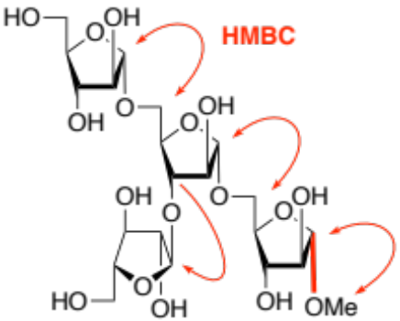
in D₂O, r.t. |  | ¹H/ δ ppm | mult., ³J_{H–H} Hz | ¹³C/ δ ppm | ¹J_{C1–H} | HMBC
α-d-Araf^{D}(1→5) | 1 | 5.09 | d, 1.6 | 107.8 | 180.7 | → 67.0
 | 2 | 4.13 | m | 81.9
 | 3 | 3.96 | dd, 5.6, 2.8 | 77.2
 | 4 | 4.10 | m | 84.6
 | 5 | 3.83 | dd, 12.4, 3.2 | 61.7
 |  | 3.712 | dd, 12.4, 5.6
α-d-Araf^{C}(1→3) | 1 | 5.15 | d, 0.8 | 108.1 | 177.8
 | 2 | 4.14 | m | 81.6
 | 3 | 3.94 | dd, 6.4, 3.2 | 77.2
 | 4 | 4.03 | m | 84.5
 | 5 | 3.83 | dd, 12.8, 3.2 | 61.8
 |  | 3.708 | dd, 12.8, 6.0
(→3,5)- | 1 | 5.11 | s | 108.1 | 179.0 | → 67.0
α-d-Araf^{B}(1→ | 2 | 4.29 | brs | 79.7
 | 3 | 4.10 | dd, 6.0, 3.6 | 83.0 |  | →108.1
 | 4 | 4.31 | ddd, 6.0, 5.6, 3.2 | 82.3
 | 5 | 3.95 | dd, 12.0, 5.6 | 67.0
 |  | 3.84 | dd, 12.0, 3.2
→5)- α-d-Araf^{A}- | 1 | 4.93 | d, 1.6 | 109.0 | 180.7 | → 55.6
 | 2 | 4.05 | d, 3.2, 1.6 | 81.3
 | 3 | 4.03 | d, 6.0, 3.2 | 77.0
 | 4 | 4.16 | ddd, 6.0, 5.2, 3.2 | 82.7
 | 5 | 3.88 | dd, 12.0, 5.2 | 67.0
 |  | 3.78 | dd, 12.0, 3.2
OMe |  | 3.42 | s | 55.6 |  | →109.0
For the standard of ¹H, the HOD peak was used at δ 4.80 ppm, and for ¹³C NMR, data were processed using a native scale.

Enzymatic cleavage of a branched pentasaccharide acetonide A5BT (SI-4b) in the presence of MeOH afforded the corresponding branched methyl tetrasaccharide Me-α-A4B (SI-15).
Methyl α-d-arabinofuranosyl^{D}-(1→5)-[α-d-arabinofuranosyl^{C}-(1→3)]-α-d-arabinofuranosyl^{B}-(1→5)-α-d-arabinofuranoside^{A} Me-α-A4B (SI-15): ¹H NMR (D₂O, 400 MHz): δ 3.42 (s, 3 H, Me), 3.706 (dd, J = 12.0, 5.2 Hz, 1 H, C5-H^{C}), 3.707 (dd, J = 12.4, 6.0 Hz, 1 H, C5-H^{D}), 3.78 (dd, J = 12.0 3.2 Hz, 1 H, C5-H^{A}), 3.80–3.85 (m, 3 H, C5-H^{C}, C5-H^{D}, C5-H^{B}), 3.88 (dd, J = 12.0, 6.0 Hz, 1 H, C5-H^{A}), 3.92–3.96 (m, 3 H, C3-H^{C}, C5-H^{B}, C3-H^{D}), 4.00–4.06 (m, 2 H, C4-H^{C}, C3-H^{A}), 4.04–4.06 (m, 1 H, C2-H^{A}), 4.07–4.12 (m, 1 H, C4-H^{D}), 4.11 (dd, J = 6.0, 3.2 Hz, 1 H, C3-H^{B}), 4.12–4.14 (m, 2 H, C2-H^{D}, C2-H^{C}), 4.16 (ddd, J = 6.0, 3.2, 1,6 Hz, 1 H, C4-H^{A}), 4.29 (dd, J = 2.4, 0.8 Hz, 1 H, C2-H^{B}), 4.31 (dd, J = 6.0, 5.6, 3.2 Hz, 1 H, C4-H^{B}), 4.92 (s 1 H, C1-H^{A}), 5.08 (s, 1 H, C1-H^{D}), 5.11 (s, 1 H, C1-H^{B}), 5.15 (s, 1 H, C1-H^{C}).

The reason why we resynthesized the known compound Me-α-A4B (SI-15)¹ is that the degraded product with MeOH does not match the reported ¹H NMR peaks at some anomeric positions and we wanted to make sure. We revised them by completing the synthesis of the authentic Me-α-A4B (SI-15) and could confirm that the degraded product is the α-methyl glycoside of tetrasaccharide A4B.

Details of protein production for crystallography
Recombinant EndoMA1 (WT and D51N mutant), ExoMA1, and ExoMA2 proteins were expressed in E. coli BL21 CodonPlus RIL (DE3) cultured in lysogeny broth (LB) medium. SeMet-labeled EndoMA1 protein was expressed in E. coli B834 (DE3), and the cells were cultured in 23.5 g/L SeMet core medium (FUJIFILM Wako Pure Chemical Corp, Osaka, Japan) supplemented with 25 mg/L Se-Met, 10 g/L glucose, 250 mg/L MgSO₄·7H₂O, 4.2 mg/L FeSO₄·7H₂O, and 10 mL/L Kao & Michayluk Vitamin Solution (Sigma-Aldrich Co., St. Louis, MO, USA). After cultivation in 100 mg/L ampicillin at 37°C, 0.1 mM (ExoMA1 and ExoMA2) or 0.3 mM (EndoMA1), isopropyl-β-d-thiogalactopyranoside was added until the absorbance at 600 nm reached 0.3-0.6. The cultures were incubated for 16-20 h at 37°C (ExoMA1 native and ExoMA1) or 25°C (EndoMA1 SeMet and ExoMA2). Cells were harvested by centrifugation and suspended in 50 mM Tris-HCl (pH 7.5) for EndoMA1 and ExoMA1) or in 50 mM MES-NaOH (pH 6.5) and 350 mM NaCl for ExoMA2. The cells were disrupted by sonication on ice, and the supernatant was filtered using Minisart Syringe filter 0.45 um (Sartorius Stedim Biotech, Göttingen, Germany). The crude extract was purified using immobilized metal affinity, anion exchange, and size-exclusion column chromatography. EndoMA1 and ExoMA1 were purified using columns of cOmplete His-tag Purification Resin (Roche Diagnostics GmbH, Mannheim, Germany), Hiload 16/60 Superdex 200 prep grade, and Mono Q 10/100 GL (Cytiva, Malborough, MA, USA), respectively, whereas ExoMA2 was purified using His-tag, Mono Q, and Superdex columns, respectively. For EndoMA1 and ExoMA1, immobilized metal affinity chromatography was performed in 50 mM Tris-HCl (pH 7.5), 5 mM (wash), or 500 mM (elution) imidazole; size exclusion chromatography was performed in 50 mM Tris-HCl (pH 7.5) and 200 mM NaCl; and anion exchange chromatography was performed in 50 mM Tris-HCl (pH 7.5) and 0-1 M NaCl. For ExoMA2, immobilized metal affinity chromatography was performed in 50 mM MES-NaOH (pH 6.5) and 25 mM (wash) or 500 mM (elution) imidazole; anion exchange chromatography was performed in 25 mM MES-NaOH (pH 6.5) and 0-500 mM NaCl; and size exclusion chromatography was performed in 25 mM MES-NaOH (pH 6.5) and 350 mM NaCl. The purified proteins were concentrated using an Amicon Ultracel-30K centrifugal filter (Millipore, Billerica, MA, USA).

Software and servers for protein crystallography
Crystallographic datasets were processed using XDS¹³ and Aimless software¹⁴. SeMet phase determination and automated model building of the EndoMA1 crystal structure were performed using PHENIX software¹⁵. Molecular replacement was performed using MoRDA software¹⁶. Manual model building was performed using Coot.¹⁷ Crystallographic refinement was performed using Refmac¹⁸ or PHENIX.¹⁵ Polder maps¹⁹ were created using PHENIX software. Molecular graphic images were prepared using PyMOL (Shrödinger LLC, New York, NY, USA). Molecular interface analysis was performed using PISA server²⁰. A structural similarity search was performed using the Dali server²¹.

Details of SEC-MALS/RI and SEC-SAXS experiments and analysis
SEC-MALS/RI was performed using DAWN HELEOS II (Wyatt Technology) and an HPLC system (Alliance 2695, Waters)²². The sample concentration required to calculate the absolute molar mass was derived from the differential refractive index using a 2414 online differential refractometer (Waters). A KW403-4F column (Shodex) equilibrated in a buffer containing 20 mM Tris-HCl (pH 7.5) and 200 mM NaCl, was used as the SEC column. The sample was dissolved in the column buffer and concentrated to 2.406 mg/mL for the SEC-SAXS experiments. The flow rate of the HPLC pump was 0.2 mL/min, and 0.03 ml of sample was injected into the column. The measured data were analyzed using the ASTRA 6.1 software (Wyatt Technology).
The SEC-SAXS experiment was carried out at the beamline BL-10C of the Photon Factory (Tsukuba, Japan)²³. The X-ray wavelength was 1.000 Å, and the camera length was 2081.4 mm. SEC was performed using an HPLC system, Prominence-i (SHIMADZU), with the same KW403-4F column (Shodex) equilibrated with a buffer of 20 mM Tris-HCl, 200 mM NaCl, pH 7.5 as for SEC-MALS. The column temperature was maintained at 293 K. The sample was also identical to that of SEC-MALS (2.406 mg/ml), and a volume of 0.13 ml was injected into the column. The HPLC pump flow rate was set to 0.2 ml min-1 from the start to 2.5 ml and 0.02 mL/min from 2.5 ml to adapt to the peak measurement, referring to the chromatogram measured in SEC-MALS. The SAXS sample cell was composed of stainless steel, and the X-ray irradiated area covered with 0.02 mm-thickness quartz glasses was 3.0 mm horizontal × 1.5 mm vertical × 1.0 mm thickness; it was directly connected to the HPLC system by a tube. 2D SAXS image data were recorded using a PILATUS3 2M detector (DECTRIS). The exposure time and the number of frames measured were 20 s and 247, respectively. All the 2D data were converted to 1D data by azimuthal averaging, and the background data for the buffer region (average data of 20 frames) measured before the sample measurement were subtracted from all the data. The scattering intensities were converted to an absolute intensity scale based on the water scattering intensities. These data reduction processes were performed using SAngler software²⁴. The system allows simultaneous UV-visible absorption spectroscopy using a SAXS sample cell and a fiber spectrophotometer (QE65pro, Ocean Insight) positioned at a 45-degree angle to the X-ray to estimate the concentration of the sample during SAXS measurements. Measurements of absorption spectra in the wavelength range from 200 to 450 nm were performed at 10-second intervals with an integration time of 1 s and repeated 495 times. The SAXS and UV-visible absorption data were analyzed using MOLASS software²⁵. Because the ascending and descending sides of the elution peak showed no differences in scattering profile shape, R_{g} values, etc., and no interparticle interference effects were observed throughout the peak, almost the entire peak from frame numbers 96 to 146 was used to calculate the SAXS profile for the form factor, that is, the SAXS profile extrapolated to zero concentration. The software AUTORG and GNOM from ATSAS were used for the Guinier analysis and the calculation of the pair distance distribution function (PDDF), respectively^{26,27}. The DAMMIF module of PRIMUSqt from ATSAS was used to calculate the bead model²⁸. CRYSOL calculated the theoretical SAXS profile from the crystal structure of EndoMA1 (PDB entry 8HHV) and fitted it to the experimental profile²⁹. The superposition of the crystal structure and the bead model was performed using SUPCOMB software from ATSAS³⁰. The details of the experimental conditions and analysis of these SEC-SAXS experiments are summarized in Supplementary Table 4. The SAXS data for the structure modeling were submitted to the small-angle scattering biological data bank (SASBDB) with the deposition ID of SASDQQ8. Fig. 4d and Supplementary Fig. 13 were created using Igor Pro 8 (WaveMetrics). The outer shape of the bead model in Fig. 4e is drawn in Chimera 1.16³¹. The resolution value, indicating the smoothness of the outer shape, was set to 15 Å.

Supplementary References

1. D’Souza, F. W., Ayers, J. D., McCarren, P. R. & Lowary, T. L. Arabinofuranosyl oligosaccharides from mycobacteria: Synthesis and effect of glycosylation on ring conformation and hydroxymethyl group rotamer populations. J Am Chem Soc 122, 1251–1260 (2000).
2. Rahfeld, P. et al. An enzymatic pathway in the human gut microbiome that converts A to universal O type blood. Nature Microbiology 2019 4:9 4, 1475–1485 (2019).
3. Till, M. et al. Structural analysis of the GH43 enzyme Xsa43E from Butyrivibrio proteoclasticus. urn:issn:2053-230X 70, 1193–1198 (2014).
4. Cartmell, A. et al. The structure and function of an arabinan-specific α-1,2-arabinofuranosidase identified from screening the activities of bacterial GH43 glycoside hydrolases. Journal of Biological Chemistry 286, 15483–15495 (2011).
5. von Schantz, L. et al. Structural basis for carbohydrate-binding specificity—A comparative assessment of two engineered carbohydrate-binding modules. Glycobiology 22, 948–961 (2012).
6. Fujimoto, Z. et al. Carbohydrate-binding architecture of the multi-modular α-1,6-glucosyltransferase from Paenibacillus sp. 598K, which produces α-1,6-glucosyl-α-glucosaccharides from starch. Biochemical Journal 474, 2763–2778 (2017).
7. Suzuki, R. et al. Crystallographic and mutational analyses of substrate recognition of endo-alpha-N-acetylgalactosaminidase from Bifidobacterium longum. J Biochem 146, 389–98 (2009).
8. Kaeothip, S. et al. Preparation of p-nitrophenyl β-L-arabinofuranoside as a substrate of β-L-arabinofuranosidase. Carbohydr Res 382, 95–100 (2013).
9. Désiré, J. & Prandi, J. Synthesis of methyl β-d-arabinofuranoside 5-[1d (and l)-myo-inositol 1-phosphate], the capping motif of the lipoarabinomannan of Mycobacterium smegmatis. Carbohydr Res 317, 110–118 (1999).
10. Ishiwata, A. & Ito, Y. Synthesis of docosasaccharide arabinan motif of mycobacterial cell wall. J Am Chem Soc 133, 2275–2291 (2011).
11. Yin, H., D’Souza, F. W. & Lowary, T. L. Arabinofuranosides from mycobacteria: Synthesis of a highly branched hexasaccharide and related fragments containing β-arabinofuranosyl residues. Journal of Organic Chemistry 67, 892–903 (2002).
12. Ishiwata, A., Akao, H. & Ito, Y. Stereoselective synthesis of a fragment of mycobacterial arabinan. Org Lett 8, 5525–5528 (2006).
13. Kabsch, W. XDS. Acta Crystallogr D Biol Crystallogr 66, 125–132 (2010).
14. Evans, P. R. & Murshudov, G. N. How good are my data and what is the resolution? Acta Crystallogr D Biol Crystallogr 69, 1204–1214 (2013).
15. Adams, P. D. et al. PHENIX: A comprehensive Python-based system for macromolecular structure solution. Acta Crystallogr D Biol Crystallogr 66, 213–221 (2010).
16. Vagin, A. & Lebedev, A. MoRDa , an automatic molecular replacement pipeline. Acta Crystallogr A Found Adv 71, s19–s19 (2015).
17. Emsley, P., Lohkamp, B., Scott, W. G. & Cowtan, K. Features and development of Coot. Acta Crystallogr D Biol Crystallogr 66, 486–501 (2010).
18. Murshudov, G. N. et al. REFMAC5 for the refinement of macromolecular crystal structures. Acta Crystallogr D Biol Crystallogr 67, 355–367 (2011).
19. Liebschner, D. et al. Polder maps: Improving OMIT maps by excluding bulk solvent. Acta Crystallogr D Struct Biol 73, 148–157 (2017).
20. Krissinel, E. & Henrick, K. Inference of macromolecular assemblies from crystalline state. J Mol Biol 372, 774–797 (2007).
21. Holm, L. & Laakso, L. M. Dali server update. Nucleic Acids Res 44, W351–W355 (2016).
22. Bernadó, P., Shimizu, N., Zaccai, G., Kamikubo, H. & Sugiyama, M. Solution scattering approaches to dynamical ordering in biomolecular systems. Biochimica et Biophysica Acta (BBA) - General Subjects 1862, 253–274 (2018).
23. Shimizu, N. et al. BL-10C, the small-angle x-ray scattering beamline at the photon factory. AIP Conf Proc 2054, 060041 (2019).
24. Shimizu, N. et al. Software development for analysis of small-angle x-ray scattering data. AIP Conf Proc 1741, 050017 (2016).
25. Yonezawa, K., Takahashi, M., Yatabe, K., Nagatani, Y. & Shimizu, N. MOLASS: Software for automatic processing of matrix data obtained from small-angle X-ray scattering and UV–visible spectroscopy combined with size-exclusion chromatography. Biophys Physicobiol 20, e200001 (2023).
26. Petoukhov, M. v., Konarev, P. v., Kikhney, A. G. & Svergun, D. I. ATSAS 2.1 – towards automated and web-supported small-angle scattering data analysis. J Appl Crystallogr 40, s223–s228 (2007).
27. Svergun, D. I. Determination of the regularization parameter in indirect-transform methods using perceptual criteria. J Appl Cystallogr 25, 495–503 (1992).
28. Manalastas-Cantos, K. et al. ATSAS 3.0: expanded functionality and new tools for small-angle scattering data analysis. J Appl Crystallogr 54, 343–355 (2021).
29. Franke, D. et al. ATSAS 2.8: a comprehensive data analysis suite for small-angle scattering from macromolecular solutions. J Appl Crystallogr 50, 1212–1225 (2017).
30. Kozin, M. B. & Svergun, D. I. Automated matching of high- and low-resolution structural models. J Appl Crystallogr 34, 33–41 (2001).
31. Pettersen, E. F. F. et al. UCSF Chimera - A visualization system for exploratory research and analysis. J Comput Chem 25, 1605–1612 (2004).

