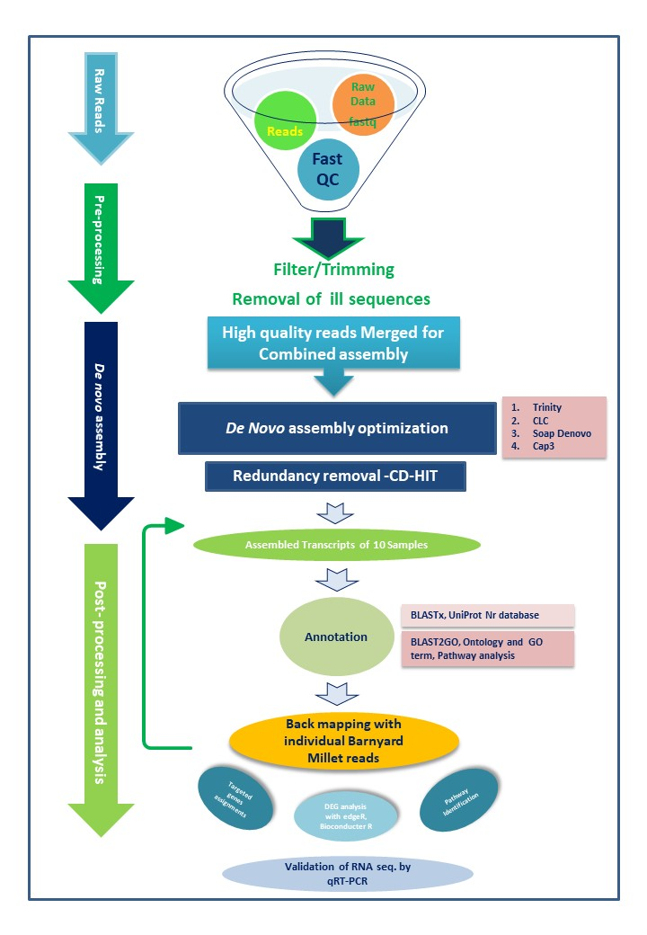
Supplementary Fig 1: Detailed workflow of barnyard millet transcriptome analysis
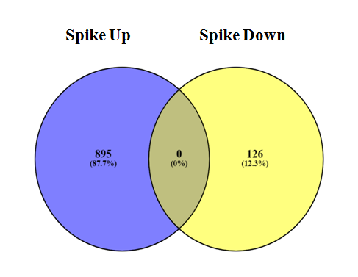 | 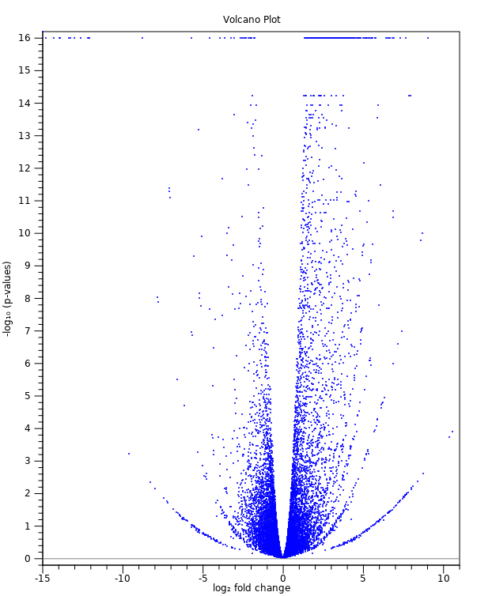
2a | 2b
Supplementary Fig 2: Characterization of Differentially Expressed Genes (DEGs) in Barnyard millet genotype during Spike Developmental Stage. 1a - Over-all distribution of differentially expressed transcripts; 1b - Volcano plot representing differentially expressed transcripts during spike stage

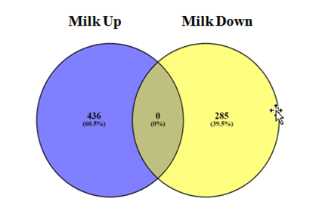 | 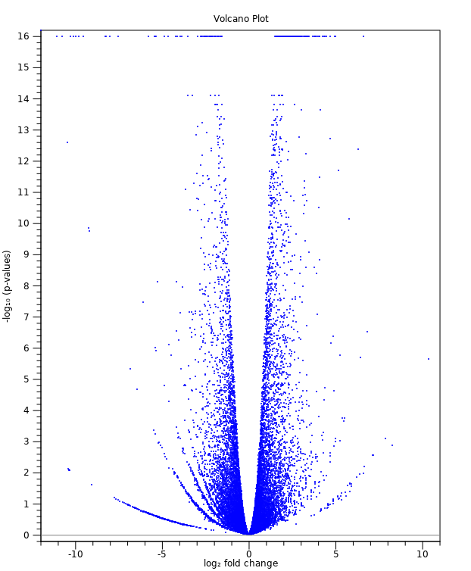
3a | 3b
Supplementary Fig 3: Characterization of Differentially Expressed Genes (DEGs) in Barnyard millet genotype during milking Stage. 2a - Over-all distribution of differentially expressed transcripts; 2b - Volcano plot representing differentially expressed transcripts during milking stage

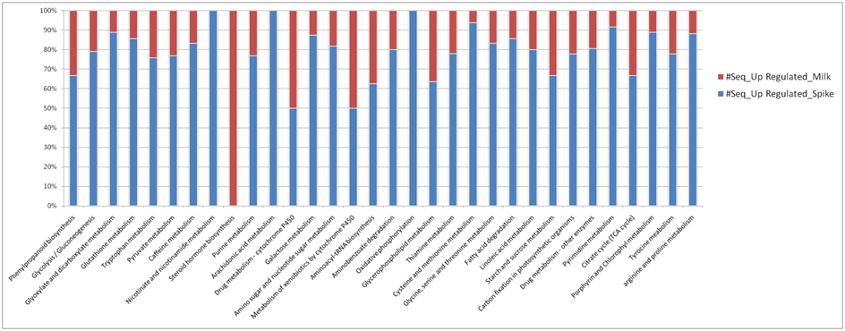
Supplementary Fig 4: All metabolic pathways and associated genes encoding enzymes that participated in different metabolic pathways of Barnyard Millet

