Additional file 6. HPV detection methodologies, overall and by study design, disease stage and site of assessment
Supplementary file 6. HPV detection methodologies, (a) overall and (b) by study design, disease stage and anatomical site of assessment
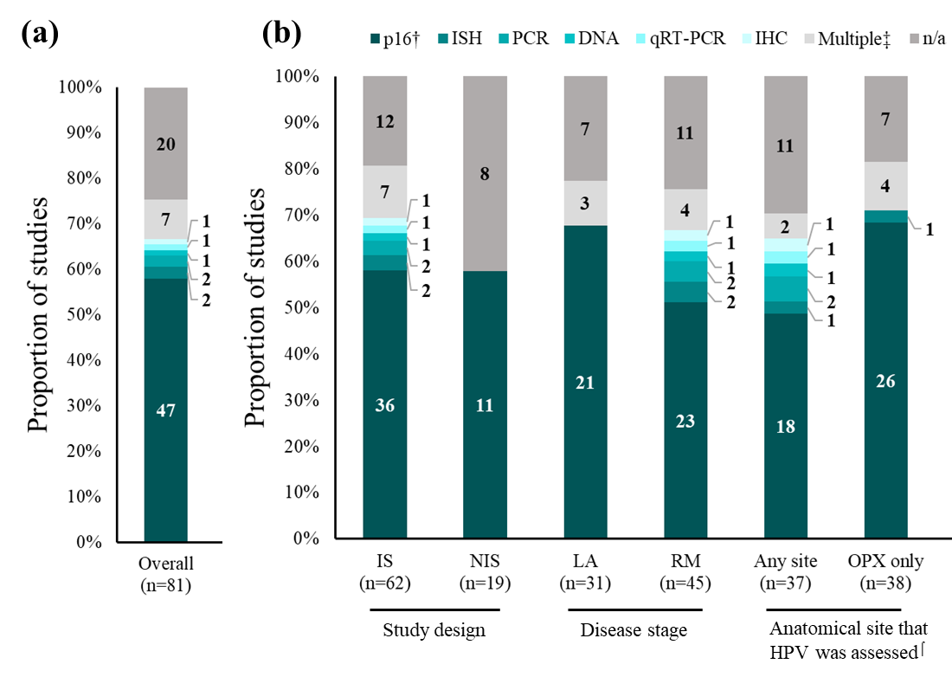
Abbreviations: DNA, deoxyribonucleic acid; HNC, head and neck cancer; HPV, human papilloma virus; IHC, immunohistochemistry; ISH, in situ hybridization; LA, locally-regionally advanced; n, number of studies; n/a, not available; OPX, oropharynx; p16, p16^{INK4A} protein; PCR, polymerase chain reaction; qRT-PCR, quantitative reverse transcription PCR; RM, recurrent and/or metastatic.
The distribution of studies per HPV detection methodology is shown overall (a) and in each subgroup (b). Numbers inside bars indicate number of studies. † Including studies where initial screening for HPV was performed by p16 detection and further confirmation of positivity was performed using other methods as well. ‡ Multiple refers to the number of assays reported in each study without necessarily referring to a combined approach per subject. ⌠ Studies were grouped by anatomical site that HPV was assessed into “Any site” meaning that any head and neck sub-sites enrolled, including OPX, were tested for HPV status, and “OPX only” representing studies where HPV status was tested only in OPX, in which case HPV positivity is available from OPC patients only, even though patients with HNC in other head and neck sub-sites had also been enrolled in the study.

