Additional file 4. Summary of HPV prevalence in LA and RM HNC and OPC per geographic region
Supplementary file 4. Summary of HPV prevalence in LA and RM (a) HNC and (b) OPC per geographic region
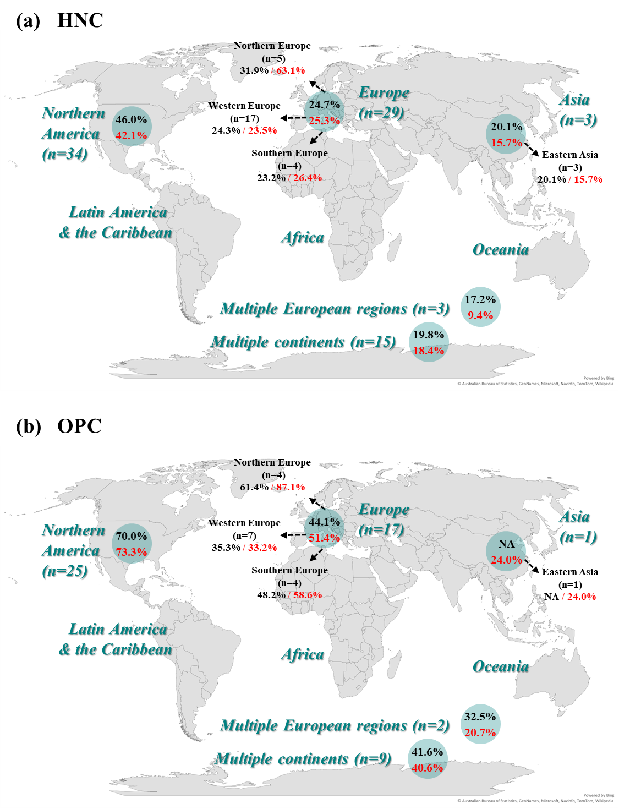
Abbreviations: HNC, head and neck cancer; HPV, human papilloma virus; n, number of studies; NA, not applicable; OPC, oropharyngeal cancer.
HPV prevalence per region is provided as mean and pooled HPV prevalence across studies shown in black and red, respectively. The category of Multiple European regions includes multi-country studies conducted in Europe; these studies were conducted in Western, Central/Eastern, and Southern Europe for HNC, and Southern and Western Europe for OPC.

