Additional file 5. HPV prevalence in LA and RM HNC and OPC per region and disease stage
Supplementary file 5. HPV prevalence in LA and RM (a) HNC and (b) OPC per region and disease stage
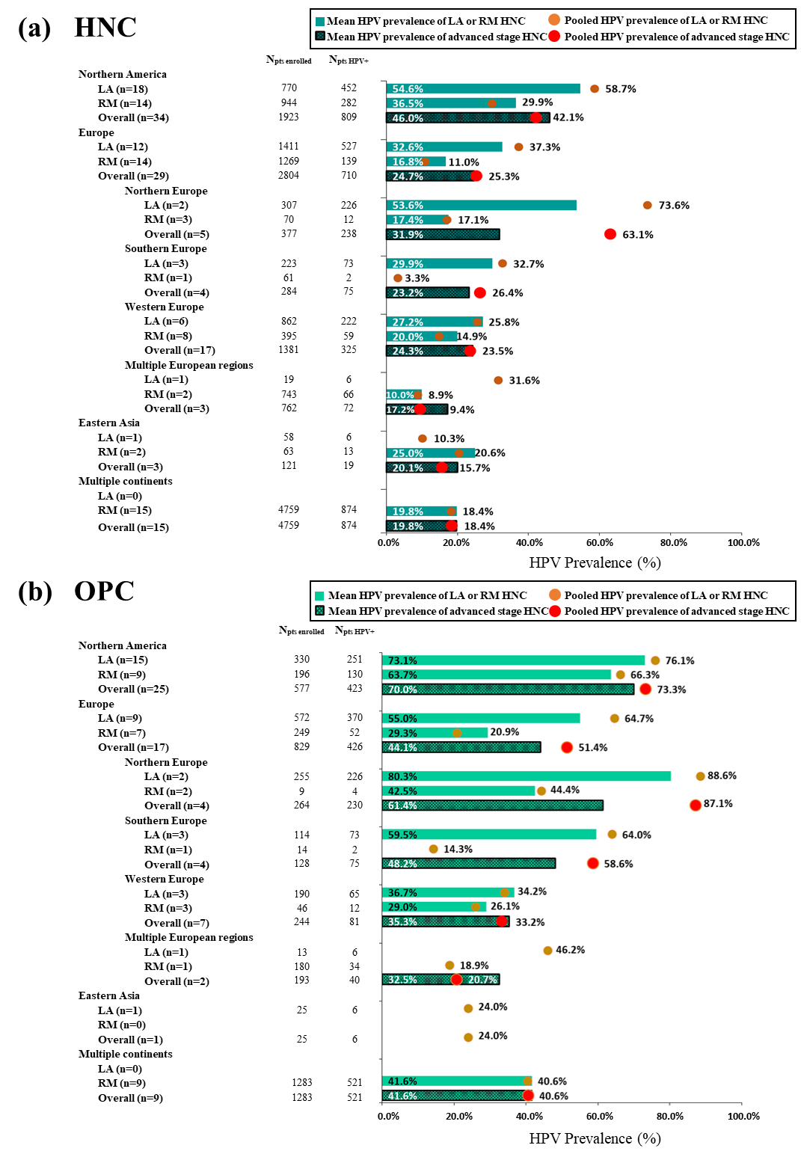
Abbreviations: HPV, human papilloma virus; LA, locally-regionally advanced; N, number of patients; n, number of studies; OPC, oropharyngeal cancer; RM, recurrent and/or metastatic.
HPV prevalence is provided as mean (bar) and pooled (circle) HPV prevalence across studies in each subgroup. LA and/or RM HNC includes LA, RM, as well as advanced stage as defined by the author or both LA and RM.

