Additional file 7. HPV prevalence in advanced OPC tested for HPV positivity using solely a p16-based assay
Supplementary file 7. HPV prevalence in advanced OPC tested for HPV positivity using solely a p16-based assay
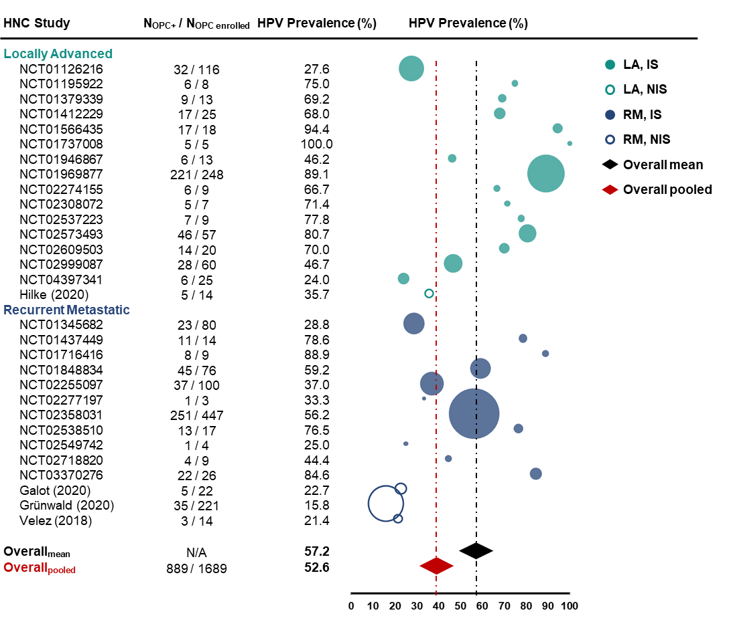
Abbreviations: HNC, head and neck cancer; HPV, human papilloma virus; IS, interventional studies; LA, locally-regionally advanced; N, number of patients; N/A, not applicable; NIS, non-interventional studies; OPC, oropharyngeal cancer; p16, p16^{INK4A} protein; RM, recurrent and/or metastatic.
Circle size corresponds to number of patients included in the study indicated, ranging from 3 to 447 patients across 30 studies in OPC. Overall HPV prevalence is provided as mean and pooled HPV prevalence across studies and depicted as a black and red diamond, respectively.

