Supporting Information for
Intensification of the lacustrine methane cycle during the Toarcian Oceanic Anoxic Event

Yizhou Huang¹, Xin Jin², Richard D. Pancost¹, David B. Kemp³, and B. David A. Naafs^{1,*}

Corresponding author: B. David A. Naafs
Email: david.naafs@bristol.ac.uk

This supporting information includes:

Figures S1 to S4
Tables S1
SI References

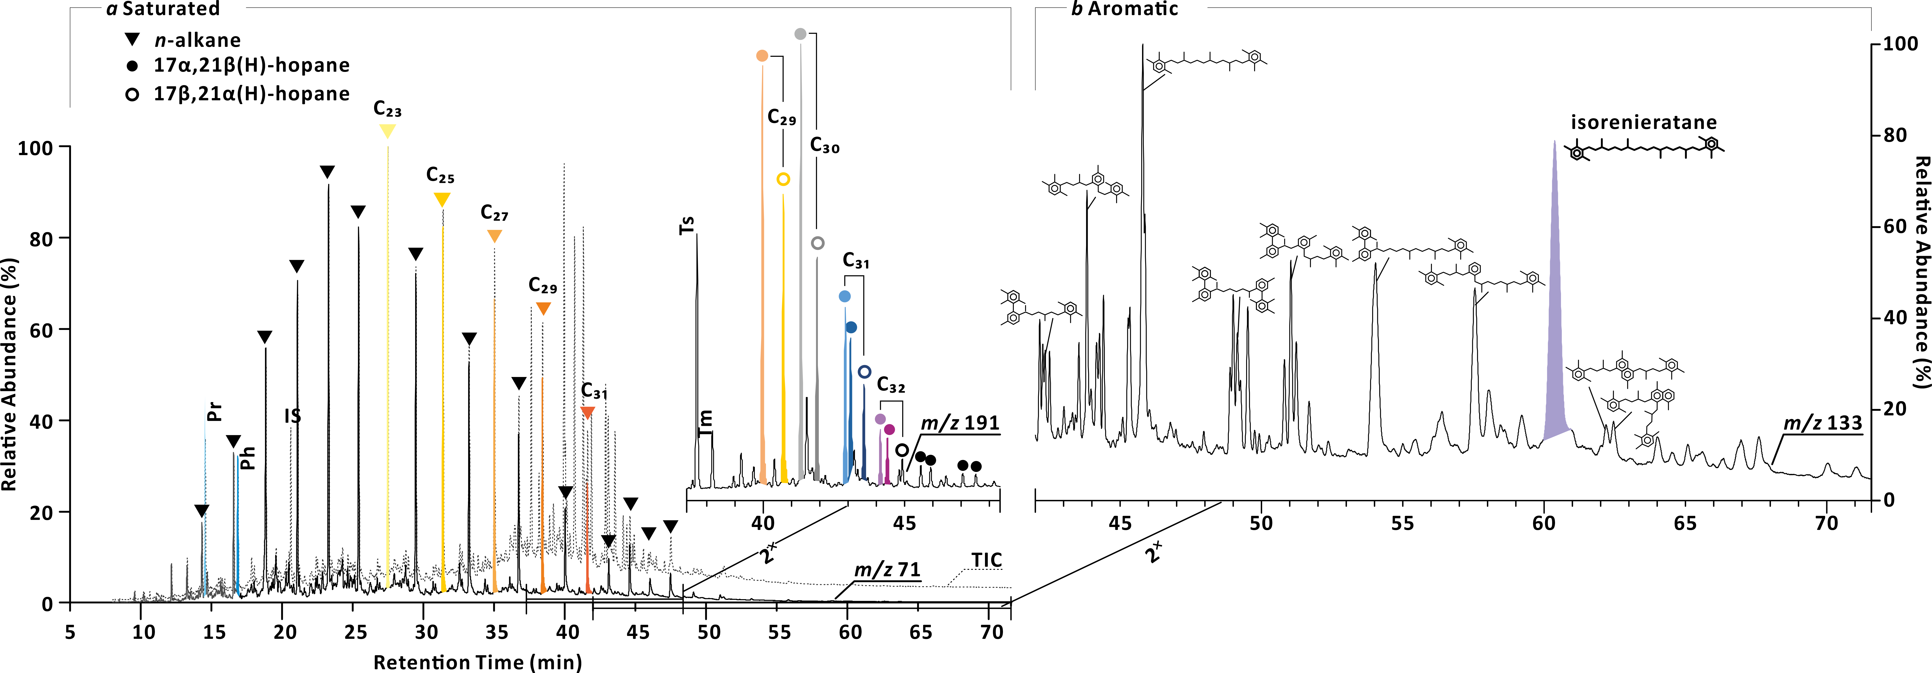

Fig. S1. Biomarkers in T-OAE sediments

Chromatography (a) of TIC, m/z 71 and m/z 191 of the saturated fraction of sample NAY-17; (b) of m/z 133 of the aromatic fraction of sample NAY-83 that contains isorenieratane.

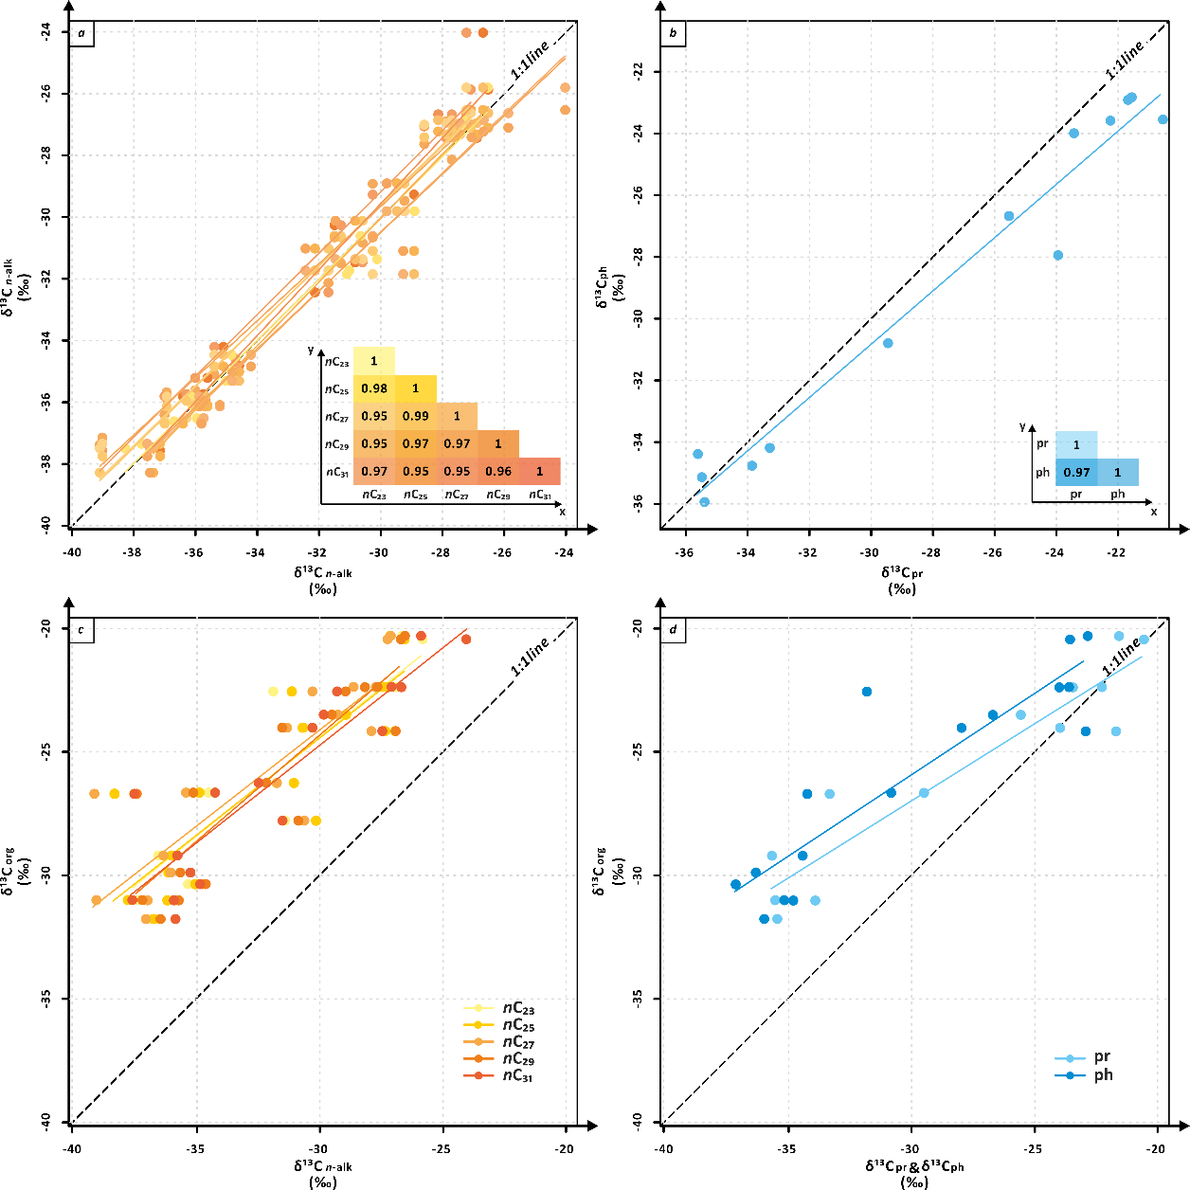

Fig. S2. The correlations between δ¹³C values of n-alkanes and pristane and phytane

(a) various n-alkanes and (b) pristane and phytane, and the r² (coefficient of determination). (c) and (d) are correlations between (c) n-alkanes δ¹³C and (d) pristane and phytane δ¹³C versus bulk δ¹³C_{org}.

Fig. S3. The correlations of δ¹³C values of hopanoids

Showing data for C₂₉-C₃₂ αβ hopanes and the r² (coefficient of determination).

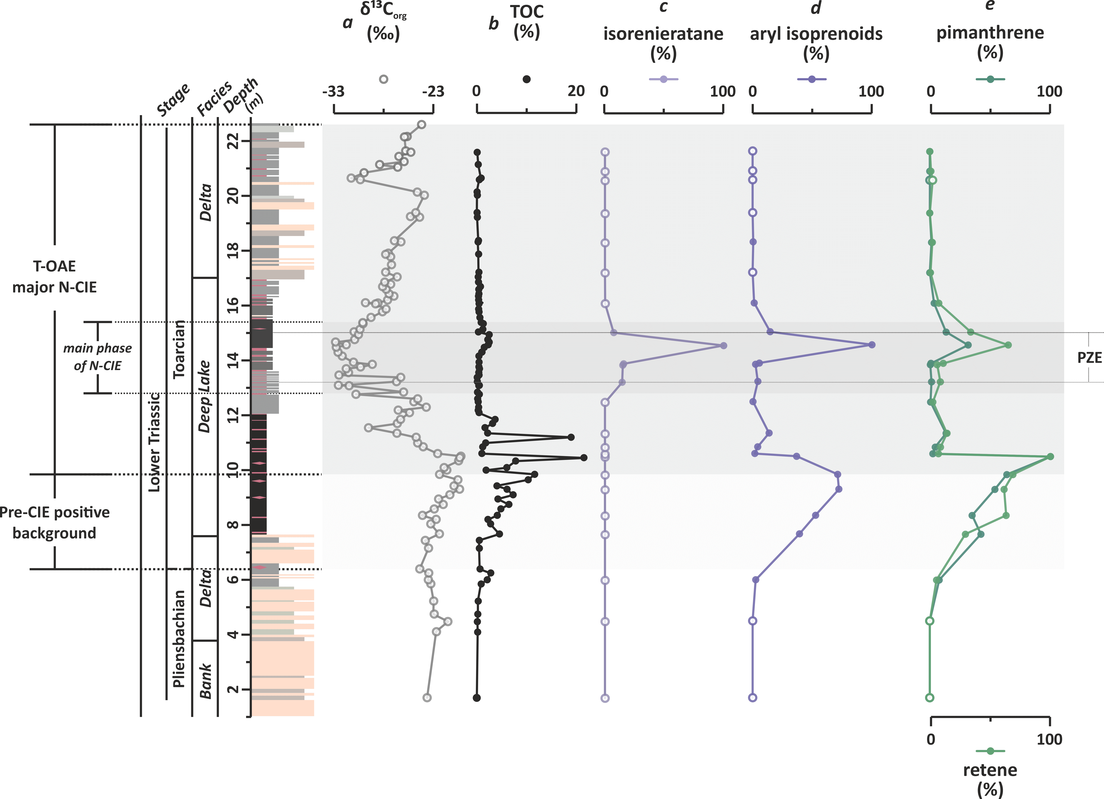

Fig. S4. Additional biomarker data from the Ordos Basin.

(a) δ¹³C_{org} and (b) TOC contents are from Jin et al. (2020; 2022). The relative abundance of (c) isorenieratane and (d) aryl isoprenoids. (e) is the relative abundance of pimanthrene (top) and retene (bottom).

Table S1. Table S1. Source data and corresponding references of Fig. 3.
Δ¹³C_{carb} | Δ¹³C_{org} | Δ¹³C_{alk} | Δ¹³C_{pr} & Δ¹³C_{ph} | Setting | OM  type | Section | References
 | -12.50 | -10.58 | -13.14 | L | T | Anya, Ordos Basin | This study
 | -6.17 | -3.70 |  | L | Mx | Core A, Sichuan | Xu et al., 2017
 | -1.70 |  |  | L | T | ZK01, Jinyang | Liu et al., 2020
-2.07 | -4.72 |  |  | M | T | Amellago | Bodin et al., 2010; 2016
 | -4.33 |  |  | M | Mx | Anabar Bay | Suan et al., 2011
 | -7.00 |  | -3.40 | M | n/d | ANDRA Core HTM, Paris Basin | van Breugel et al., 2006
 | -3.70 |  |  | M | T | Arroyo Lapa North | Al-Suwaidi et al., 2016
 | -8.63 |  |  | M | Mx | Arroyo Lapa South | Al-Suwaidi et al., 2010; 2016
 |  |  |  | M | n/d | Arroyo Serrucho | Al-Suwaidi et al., 2016
 |  |  |  | M | n/d | Asientos | Fantasia et al., 2018b
-3.67 | -2.59 |  |  | M | M | Bilong Co | Fu et al., 2016
 | -5.23 |  |  | M | Mx | Bilong Co | Xia et al., 2021
 | -6.66 |  |  | M | T | Bornholm | Hesselbo et al., 2000
-4.62 | -4.07 |  |  | M | T | Boumardoul n´Imazighn | Bodin et al., 2016
-1.40 |  |  |  | M | n/d | Breggia | Fantasia et al., 2018a; 2019b
 | -7.60 |  |  | M | T | Brody-Lubienia | Hesselbo and Pienkowski, 2011
-2.27 | -2.45 |  |  | M | M | Creux de l'Ours (Fantasia) | Fantasia et al., 2018a; 2019b
 | -5.22 |  |  | M | Mx | dormettingen | Galasso et al., 2021
3.88 |  |  |  | M | n/d | Doset | Jenkynes & Clayton, 1997
-4.00 | -4.00 |  |  | M | Mx | Dotternhausen | Röhl et al., 2001
 | -5.51 | -3.00 | -3.90 | M | M | Dotternhausen | Dickson et al., 2017 (δ¹³C_{org}); Schouten et al., 2000 (CSI)
-5.99 | -5.98 |  |  | M | M | Dotternhausen | Röhl et al., 2001
 | -1.52 |  |  | M | n/d | Dotternhausen | van de Schootbrugge et al., 2005
 | -3.29 |  |  | M | M | East Tributary, Alberta | Them et al., 2017
-5.21 | -4.35 |  |  | M | Mx | El Peñon | Fantasia et al., 2018b
-1.48 |  |  |  | M | n/d | Es Cosconar | Rosales et al., 2018
-0.97 | -6.48 |  |  | M | n/d | Foum Tillich | Bodin et al., 2016
 | -2.00 |  |  | M | T | Fuente Vidriera | Rodrigues et al., 2019
-1.88 |  |  |  | M | n/d | Gornje | Sabatino et al., 2013
 | -6.61 |  |  | M | T | Gorzow Wielkpolski | Hesselbo and Pienkowski, 2011
 | -7.18 |  |  | M | T | Haida Gwaii, British Columbia | Caruthers et al., 2011
-6.00 | -6.56 |  |  | M | M | Kastelli | Kafousia et al., 2011
 | -4.78 |  |  | M | M | Katsuyama | Gröcke et al., 2011
 | -6.57 |  |  | M | T | Kelimyar River | Suan et al., 2011
0.00 | -2.20 |  |  | M | n/d | Kovk Section | Ettinger et al., 2021
 | -3.99 |  |  | M | T | Kozlowice | Hesselbo and Pienkowski, 2011
 | -0.83 |  |  | M | T | La Cerradura | Rodrigues et al., 2019
-1.20 | -3.40 |  |  | M | n/d | La Cerradura | Ruebsam et al., 2020
-2.28 | -2.58 | -3.70 |  | M | n/d | La Cerradura | Reolid et al., 2014; Ruebsam et al., 2020 (δ¹³C_{org} & CSI)
-2.13 | -5.96 |  |  | M | M | Livartzki | Kafousia et al., 2011
 | -5.76 |  |  | M | T | Mechowo IG-1 | Hesselbo and Pienkowski, 2011
-3.77 |  |  |  | M | n/d | Mellala (Baghli) | Baghli et al., 2020
 | -6.58 |  |  | M | Mx | Mochras borehole | Xu et al., 2018
-5.50 | -5.80 |  |  | M | n/d | Monte Sorgenza | Woodfine et al., 2008 (δ¹³C_{carb}); Trecalli et al., 2012 (δ¹³C_{org})
-2.30 | -2.18 |  |  | M | n/d | Niandou | Han et al., 2018
 | -3.01 |  |  | M | T | Parkoszowice | Hesselbo and Pienkowski, 2011
 | -6.85 |  |  | M | T | Peniche | Fantasia et al., 2019b
-4.81 | -7.51 |  |  | M | T | Peniche | Hesselbo et al., 2007
-0.86 | -4.47 |  |  | M | M | Petousi | Kafousia et al., 2014
 | -4.45 |  |  | M | Mx | Polovinnaya River | Suan et al., 2011
-2.66 |  |  |  | M | n/d | Rabacal | Pittet et al., 2014
 | -3.44 |  |  | M | M | Réka Valley | Müller et al., 2017
-2.44 | -4.65 |  |  | M | M | Rietheim | Montero-Serrano et al., 2015
 | -2.49 |  |  | M | M | Sakahogi | Ikeda et al., 2018
 | -3.58 |  |  | M | T | Sakuraguchi-dani Valley | Izumi et al., 2012
-5.45 | -7.60 |  |  | M | Mx | Sancerre Core borehole | Hermoso et al., 2009 (δ¹³C_{carb}); Hermoso et al., 2012 (δ¹³C_{org})
2.23 |  |  |  | M | n/d | Somerset | Jenkynes & Clayton, 1997
 | -5.77 |  |  | M | T | Suliszowice | Hesselbo and Pienkowski, 2011
-3.29 | -7.70 |  |  | M | M | Toka | Kafousia et al., 2014
-2.00 |  |  |  | M | n/d | Trento platform | Woodfine et al., 2008
-3.00 | -6.47 |  |  | M | M | Valdorbia | Sabatino et al., 2009
-1.45 |  |  |  | M | n/d | Varbanchovets | Metodiev et al., 2014
-2.37 |  |  |  | M | n/d | Velebit-A | Sabatino et al., 2013
-3.63 |  |  |  | M | n/d | Velebit-B | Sabatino et al., 2013
 | -0.79 |  |  | M | n/d | Wolong | Han et al., 2018
-0.58 | -6.23 | -5.30 |  | M | M | Yorkshire | McArthur et al., 2000 (δ¹³C_{carb}); Cohen et al., 2004 (δ¹³C_{org})
 | -7.45 | -3.50 | -1.75 | M | M | Yorkshire | Thibault et al., 2017 (δ¹³C_{org}); French et al., 2014 (CSI)
 |  |  |  | M | M | Zázrivá | Suan et al., 2018

Dataset S1 (separate file).

SI References

Sample References:

- Al-Suwaidi, A.H. et al. (2010) ‘First record of the Early Toarcian Oceanic Anoxic Event from the Southern Hemisphere, Neuquén Basin, Argentina’, Journal of the Geological Society, 167(4), pp. 633–636. Available at: https://doi.org/10.1144/0016-76492010-025.
- Al-Suwaidi, A.H. et al. (2016) ‘The toarcian oceanic anoxic event (Early Jurassic) in the Neuquén Basin, Argentina: A reassessment of age and carbon isotope stratigraphy’, Journal of Geology, 124(2), pp. 171–193. Available at: https://doi.org/10.1086/684831/ASSET/IMAGES/LARGE/FG11.JPEG.
- Baghli, H. et al. (2020) ‘Early Jurassic climatic trends in the south-Tethyan margin’, Gondwana Research, 77, pp. 67–81. Available at: https://doi.org/10.1016/j.gr.2019.06.016.
- Bodin, K. et al. (2010) ‘Antibodies to human serum amyloid P component eliminate visceral amyloid deposits’, Nature, 468(7320), pp. 93–97. Available at: https://doi.org/10.1038/nature09494.
- Bodin, S. et al. (2016) ‘Perturbation of the carbon cycle during the late Pliensbachian – early Toarcian: New insight from high-resolution carbon isotope records in Morocco’, Journal of African Earth Sciences, 116, pp. 89–104. Available at: https://doi.org/10.1016/j.jafrearsci.2015.12.018.
- van Breugel, Y. et al. (2006) ‘Isorenieratane record in black shales from the Paris Basin, France: Constraints on recycling of respired CO₂ as a mechanism for negative carbon isotope shifts during the Toarcian oceanic anoxic event’, Paleoceanography, 21(4). Available at: https://doi.org/10.1029/2006PA001305.
- Caruthers, A.H., Gröcke, D.R. and Smith, P.L. (2011) ‘The significance of an Early Jurassic (Toarcian) carbon-isotope excursion in Haida Gwaii (Queen Charlotte Islands), British Columbia, Canada’, Earth and Planetary Science Letters, 307(1–2), pp. 19–26. Available at: https://doi.org/10.1016/j.epsl.2011.04.013.
- Cohen, A.S. et al. (2004) ‘Osmium isotope evidence for the regulation of atmospheric CO₂ by continental weathering’, Geology, 32(2), pp. 157–160. Available at: https://doi.org/10.1130/G20158.1.
- Dickson, A.J. et al. (2017) ‘Molybdenum‐isotope chemostratigraphy and paleoceanography of the Toarcian Oceanic Anoxic Event (Early Jurassic)’, Paleoceanography, 32(8), pp. 813–829. Available at: https://doi.org/10.1002/2016PA003048.
- Ettinger, N.P. et al. (2021) ‘Ocean acidification and photic‐zone anoxia at the Toarcian Oceanic Anoxic Event: Insights from the Adriatic Carbonate Platform’, Sedimentology. Edited by G. Eberli, 68(1), pp. 63–107. Available at: https://doi.org/10.1111/sed.12786.
- Fantasia, A., Föllmi, Karl B., et al. (2018a) ‘The Early Toarcian oceanic anoxic event: Paleoenvironmental and paleoclimatic change across the Alpine Tethys (Switzerland)’, Global and Planetary Change, 162, pp. 53–68. Available at: https://doi.org/10.1016/J.GLOPLACHA.2018.01.008.
- Fantasia, A., Föllmi, Karl B, et al. (2018b) ‘The Toarcian Oceanic Anoxic Event in southwestern Gondwana: an example from the Andean Basin, northern Chile’. Available at: https://doi.org/10.6084/m9.figshare.c.4133687.
- Fantasia, A., Adatte, T., et al. (2019a) ‘Global versus local processes during the Pliensbachian–Toarcian transition at the Peniche GSSP, Portugal: A multi-proxy record’, Earth-Science Reviews, 198, p. 102932. Available at: https://doi.org/10.1016/j.earscirev.2019.102932.
- Fantasia, A., Föllmi, K.B., et al. (2019b) ‘Expression of the Toarcian Oceanic Anoxic Event: New insights from a Swiss transect’, Sedimentology. Edited by J. Reijmer, 66(1), pp. 262–284. Available at: https://doi.org/10.1111/sed.12527.
- French, K.L. et al. (2014) ‘Organic geochemistry of the early Toarcian oceanic anoxic event in Hawsker Bottoms, Yorkshire, England’, Earth and Planetary Science Letters, 390, pp. 116–127. Available at: https://doi.org/10.1016/j.epsl.2013.12.033.
- Fu, X. et al. (2016) ‘Mineralogical composition of and trace-element accumulation in lower Toarcian anoxic sediments: a case study from the Bilong Co. oil shale, eastern Tethys’, Geological Magazine, 153(4), pp. 618–634. Available at: https://doi.org/10.1017/S0016756815000758.
- Galasso, F. et al. (2021) ‘Changes in organic matter composition during the Toarcian Oceanic Anoxic Event (T-OAE) in the Posidonia Shale Formation from Dormettingen (SW-Germany)’, Palaeogeography, Palaeoclimatology, Palaeoecology, 569, p. 110327. Available at: https://doi.org/10.1016/J.PALAEO.2021.110327.
- Gröcke, D.R. et al. (2011) ‘An open ocean record of the Toarcian oceanic anoxic event’, Solid Earth, 2(2), pp. 245–257. Available at: https://doi.org/10.5194/se-2-245-2011.
- Han, Z. et al. (2018) ‘Carbonate-platform response to the Toarcian Oceanic Anoxic Event in the southern hemisphere: Implications for climatic change and biotic platform demise’, Earth and Planetary Science Letters, 489, pp. 59–71. Available at: https://doi.org/10.1016/J.EPSL.2018.02.017.
- Hermoso, M. et al. (2009) ‘Expression of the Early Toarcian negative carbon-isotope excursion in separated carbonate microfractions (Jurassic, Paris Basin)’, Earth and Planetary Science Letters, 277(1–2), pp. 194–203. Available at: https://doi.org/10.1016/j.epsl.2008.10.013.
- Hermoso, M. et al. (2012) ‘Dynamics of a stepped carbon-isotope excursion: Ultra high-resolution study of Early Toarcian environmental change’, Earth and Planetary Science Letters, 319–320, pp. 45–54. Available at: https://doi.org/10.1016/j.epsl.2011.12.021.
- Hesselbo, S.P. et al. (2000) ‘Massive dissociation of gas hydrate during a Jurassic oceanic anoxic event’, Nature 2000 406:6794, 406(6794), pp. 392–395. Available at: https://doi.org/10.1038/35019044.
- Hesselbo, S.P. et al. (2007) ‘Carbon-isotope record of the Early Jurassic (Toarcian) Oceanic Anoxic Event from fossil wood and marine carbonate (Lusitanian Basin, Portugal)’, Earth and Planetary Science Letters, 253(3–4), pp. 455–470. Available at: https://doi.org/10.1016/j.epsl.2006.11.009.
- Hesselbo, S.P. and Pieńkowski, G. (2011) ‘Stepwise atmospheric carbon-isotope excursion during the Toarcian Oceanic Anoxic Event (Early Jurassic, Polish Basin)’, Earth and Planetary Science Letters, 301(1–2), pp. 365–372. Available at: https://doi.org/10.1016/j.epsl.2010.11.021.
- Ikeda, M. et al. (2018) ‘Carbon cycle dynamics linked with Karoo-Ferrar volcanism and astronomical cycles during Pliensbachian-Toarcian (Early Jurassic)’, Global and Planetary Change, 170, pp. 163–171. Available at: https://doi.org/10.1016/j.gloplacha.2018.08.012.
- Izumi, K., Miyaji, T. and Tanabe, K. (2012) ‘Early Toarcian (Early Jurassic) oceanic anoxic event recorded in the shelf deposits in the northwestern Panthalassa: Evidence from the Nishinakayama Formation in the Toyora area, west Japan’, Palaeogeography, Palaeoclimatology, Palaeoecology, 315–316, pp. 100–108. Available at: https://doi.org/10.1016/J.PALAEO.2011.11.016.
- Jenkyns, H.C. and Clayton, C. (1997) ‘Lower Jurassic epicontinental carbonates and mudstones from England and Wales: chemostratigraphic signals and the early Toarcian anoxic event’, Sedimentology, 44(4), pp. 687–706. Available at: https://doi.org/10.1046/j.1365-3091.1997.d01-43.x.
- Jin, X. et al. (2020) ‘The Jenkyns Event (early Toarcian OAE) in the Ordos Basin, North China’, Global and Planetary Change, 193(April), p. 103273. Available at: https://doi.org/10.1016/j.gloplacha.2020.103273.
- Jin, X. et al. (2022) ‘Early Jurassic massive release of terrestrial mercury linked to floral crisis’, Earth and Planetary Science Letters, p. 598. Available at: https://doi.org/10.1016/j.epsl.2022.117842.
- Kafousia, N. et al. (2011) ‘A global event with a regional character: the Early Toarcian Oceanic Anoxic Event in the Pindos Ocean (northern Peloponnese, Greece)’, Geological Magazine, 148(4), pp. 619–631. Available at: https://doi.org/10.1017/S0016756811000082.
- Kafousia, N. et al. (2014) ‘The Toarcian Oceanic Anoxic Event in the Ionian Zone, Greece’, Palaeogeography, Palaeoclimatology, Palaeoecology, 393, pp. 135–145. Available at: https://doi.org/10.1016/j.palaeo.2013.11.013.
- Liu, M. et al. (2020) ‘Organic geochemistry of a lacustrine shale across the Toarcian Oceanic Anoxic Event (Early Jurassic) from NE China’, Global and Planetary Change, 191(September 2019), p. 103214. Available at: https://doi.org/10.1016/j.gloplacha.2020.103214.
- McArthur, J.M. et al. (2000) ‘Strontium isotope profile of the early Toarcian (Jurassic) oceanic anoxic event, the duration of ammonite biozones, and belemnite palaeotemperatures’, Earth and Planetary Science Letters, 179(2), pp. 269–285. Available at: https://doi.org/10.1016/S0012-821X(00)00111-4.
- Metodiev, L.S. et al. (2014) ‘Paleoenvironmental conditions recorded by 87Sr/86Sr, δ13C and δ18O in late Pliensbachian–Toarcian (Jurassic) belemnites from Bulgaria’, Palaeogeography, Palaeoclimatology, Palaeoecology, 409, pp. 98–113. Available at: https://doi.org/10.1016/j.palaeo.2014.04.025.
- Montero-Serrano, J.C. et al. (2015) ‘Continental weathering and redox conditions during the early Toarcian Oceanic Anoxic Event in the northwestern Tethys: Insight from the Posidonia Shale section in the Swiss Jura Mountains’, Palaeogeography, Palaeoclimatology, Palaeoecology, 429, pp. 83–99. Available at: https://doi.org/10.1016/J.PALAEO.2015.03.043.
- Müller, T. et al. (2017) ‘New multiproxy record of the Jenkyns Event (also known as the Toarcian Oceanic Anoxic Event) from the Mecsek Mountains (Hungary): Differences, duration and drivers’, Sedimentology. Edited by S. Hesselbo, 64(1), pp. 66–86. Available at: https://doi.org/10.1111/sed.12332.
- Pittet, B. et al. (2014) ‘Carbon isotope evidence for sedimentary discontinuities in the lower Toarcian of the Lusitanian Basin (Portugal): Sea level change at the onset of the Oceanic Anoxic Event’, Sedimentary Geology, 303, pp. 1–14. Available at: https://doi.org/10.1016/j.sedgeo.2014.01.001.
- Reolid, M. et al. (2014) ‘The Early Toarcian Oceanic Anoxic Event in the External Subbetic (Southiberian Palaeomargin, Westernmost Tethys): Geochemistry, nannofossils and ichnology’, Palaeogeography, Palaeoclimatology, Palaeoecology, 411, pp. 79–94. Available at: https://doi.org/10.1016/j.palaeo.2014.06.023.
- Rodrigues, B. et al. (2019) ‘Sedimentary organic matter and δ¹³C_{Kerogen} variation on the southern Iberian palaeomargin (Betic Cordillera, SE Spain) during the latest Pliensbachian–Early Toarcian’, Palaeogeography, Palaeoclimatology, Palaeoecology, 534, p. 109342. Available at: https://doi.org/10.1016/j.palaeo.2019.109342.
- Röhl, H.-J. et al. (2001) ‘The Posidonia Shale (Lower Toarcian) of SW-Germany: an oxygen-depleted ecosystem controlled by sea level and palaeoclimate’, Palaeogeography, Palaeoclimatology, Palaeoecology, 165(1–2), pp. 27–52. Available at: https://doi.org/10.1016/S0031-0182(00)00152-8.
- Rosales, I. et al. (2018) ‘Isotope records (C-O-Sr) of late Pliensbachian-early Toarcian environmental perturbations in the westernmost Tethys (Majorca Island, Spain)’, Palaeogeography, Palaeoclimatology, Palaeoecology, 497, pp. 168–185. Available at: https://doi.org/10.1016/j.palaeo.2018.02.016.
- Ruebsam, W., Reolid, M. and Schwark, L. (2020) ‘δ¹³C of terrestrial vegetation records Toarcian CO₂ and climate gradients’, Scientific Reports, 10(1), p. 117. Available at: https://doi.org/10.1038/s41598-019-56710-6.
- Sabatino, N. et al. (2009) ‘Carbon-isotope records of the Early Jurassic (Toarcian) oceanic anoxic event from the Valdorbia (Umbria–Marche Apennines) and Monte Mangart (Julian Alps) sections: palaeoceanographic and stratigraphic implications’, Sedimentology, 56(5), pp. 1307–1328. Available at: https://doi.org/10.1111/J.1365-3091.2008.01035.X.
- Sabatino, N. et al. (2013) ‘Carbon-isotope record and palaeoenvironmental changes during the early Toarcian oceanic anoxic event in shallow-marine carbonates of the Adriatic Carbonate Platform in Croatia’, Geological Magazine, 150(6), pp. 1085–1102. Available at: https://doi.org/10.1017/S0016756813000083.
- van de Schootbrugge, B. et al. (2005) ‘Toarcian oceanic anoxic event: An assessment of global causes using belemnite C isotope records’, Paleoceanography, 20(3), p. n/a-n/a. Available at: https://doi.org/10.1029/2004PA001102.
- Schouten, S. (2000) ‘Effects of an oceanic anoxic event on the stable carbon isotopic composition of early Toarcian carbon’, American Journal of Science, 300(1), pp. 1–22. Available at: https://doi.org/10.2475/ajs.300.1.1.
- Suan, G. et al. (2011) ‘Polar record of Early Jurassic massive carbon injection’, Earth and Planetary Science Letters, 312(1–2), pp. 102–113. Available at: https://doi.org/10.1016/j.epsl.2011.09.050.
- Suan, G. et al. (2018) ‘Euxinic conditions and high sulfur burial near the European shelf margin (Pieniny Klippen Belt, Slovakia) during the Toarcian oceanic anoxic event’, Global and Planetary Change, 170, pp. 246–259. Available at: https://doi.org/10.1016/J.GLOPLACHA.2018.09.003.
- Them, T.R. et al. (2017) ‘High-resolution carbon isotope records of the Toarcian Oceanic Anoxic Event (Early Jurassic) from North America and implications for the global drivers of the Toarcian carbon cycle’, Earth and Planetary Science Letters, 459, pp. 118–126. Available at: https://doi.org/10.1016/j.epsl.2016.11.021.
- Thibault, N. et al. (2017) ‘The wider context of the Lower Jurassic Toarcian oceanic anoxic event in Yorkshire coastal outcrops, UK’. Available at: https://doi.org/10.1016/j.pgeola.2017.10.007.
- Trecalli, A. et al. (2012) ‘Carbonate platform evidence of ocean acidification at the onset of the early Toarcian oceanic anoxic event’, Earth and Planetary Science Letters, 357–358, pp. 214–225. Available at: https://doi.org/10.1016/j.epsl.2012.09.043.
- Woodfine, R.G. et al. (2008) ‘The response of two Tethyan carbonate platforms to the early Toarcian (Jurassic) oceanic anoxic event: environmental change and differential subsidence’, Sedimentology, 55(4), pp. 1011–1028. Available at: https://doi.org/10.1111/j.1365-3091.2007.00934.x.
- Xia, G. et al. (2021) ‘Depositional paleoenvironment and source rock characterization across the Toarcian Oceanic Anoxic Event from the eastern Tethys, Tibet, SW China’, International Journal of Coal Geology, 243, p. 103780. Available at: https://doi.org/10.1016/j.coal.2021.103780.
- Xu, W. et al. (2017) ‘Carbon sequestration in an expanded lake system during the Toarcian oceanic anoxic event’, Nature Geoscience, 10(2), pp. 129–134. Available at: https://doi.org/10.1038/ngeo2871.
- Xu, W. et al. (2018) ‘Magnetostratigraphy of the Toarcian Stage (Lower Jurassic) of the Llanbedr (Mochras Farm) Borehole, Wales: basis for a global standard and implications for volcanic forcing of palaeoenvironmental change’, Journal of the Geological Society, 175(4), pp. 594–604. Available at: https://doi.org/10.1144/jgs2017-120.

