Appendix: Tables and Figures
Table A1. Relationship between mobility and excess mortality, across waves
 | (1) | (2) | (3)
 | exmo | pscore | adj_pscore
stay_put | 2231.3554** | 198.1791*** | 445.8309**
 | (1009.91) | (43.88) | (212.65)
Wave=1 # L.stay_put | -856.72 | -29.981 | -173.34
 | (666.69) | (39.61) | (135.97)
Wave=2 # L.stay_put | -443.08 | 18.4884 | -72.531
 | (605.38) | (49.35) | (123.73)
Wave=3 # L.stay_put | -739.12 | -59.942 | -142.94
 | (786.40) | (51.79) | (159.97)
Wave=4 # L.stay_put | -900.26 | -1.7565 | -164.88
 | (855.03) | (45.58) | (163.79)
Lag outcome | 0.3234** | 0.2908*** | 0.2988***
 | (0.13) | (0.08) | (0.08)
Observations | 1617 | 1617 | 1617
R-squared | 0.2493 | 0.3955 | 0.251
Province FE | Yes | Yes | Yes
Monthyear FE | Yes | Yes | Yes
Note: This table presents results from a linear ARDL model with one lag of dependent and explanatory variable. The categorical variable `wave’ captures the four waves of the pandemic as described in Figure 1. We cluster standard errors at the province level and include month-year and province fixed effects. Level of significance: *** 0.01 ** 0.05 * 0.1
Figure A1. Callaway and Sant’Anna (2021) staggered DiD estimates
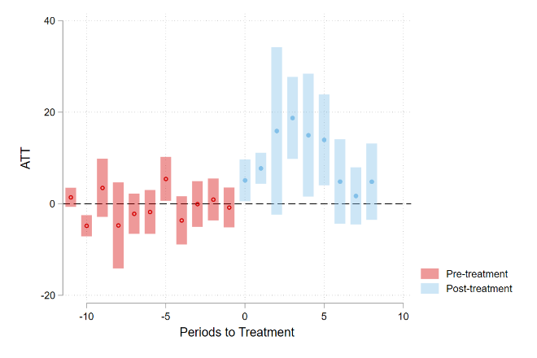
Note: The above figure is implemented using csdid command in STATA. Sample is restricted between December 2020 and Decmeber 2021, when the color codes were introduced by the government. This estimator compares first-time swtichers to not yet treated provinces.

