Supporting Information
Zn-MOF hydrogel: Regulation of ROS-mediated inflammatory microenvironment for treatment of atopic dermatitis

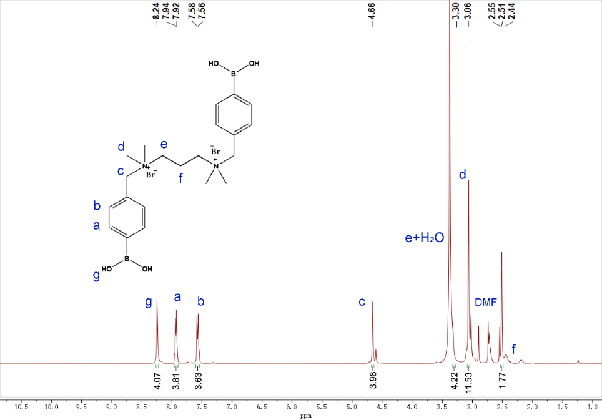
Fig. S1. ¹H-NMR (400 MHz, in DMSO) spectrum of TSPBA.
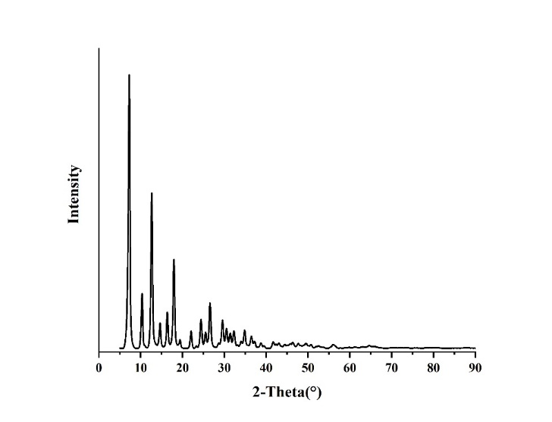
Fig. S2. XRD patterns of the ZIF-8 collected after reaction.

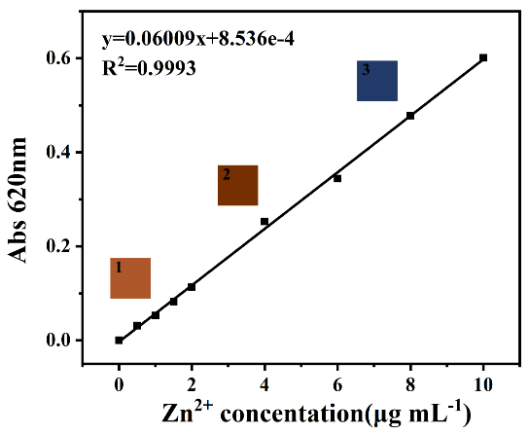
Fig. S3. A Zn²⁺ standard curve measured by a spectrophotometric method.

