Title
Comprehensive Bioinformatics analysis of angiotensin-converting enzyme 2 (ACE2)

Author list and affiliations
Shanshan Zhang,^{1,2} Yongtao Zhang,^{1,2} Pengchao Liu,^{1,2} Wei Yang,^{1,2} Xianxian Li,^{1,2} Chao Zhang,^{1,2} Dan Yang,^{1,2} Wei Zhi,^{1,2} Jinxiang Han,^{1,2*} Yanqin Lu^{1,2*}

¹ Key Laboratory for Biotech-Drugs of National Health Commission, Key Laboratory for Rare & Uncommon Diseases of Shandong Province, Biomedical Sciences College & Shandong Medicinal Biotechnology Centre, Shandong First Medical University & Shandong Academy of Medical Sciences, Ji’nan, Shandong 250014, China.
² Department of Endocrinology and Metabology, The First Affiliated Hospital of Shandong First Medical University & Shandong Provincial Qianfoshan Hospital, Ji’nan, Shandong 250014, China.

Corresponding authors
Jinxiang Han, Yanqin Lu
Address: # 6699 Qingdao Road, Jinan, Jinan 250117 China. The First Affiliated Hospital of Shandong First Medical University
E-mail: jxhan@sdfmu.edu.cn yqlu@sdfmu.edu.cn
Tel: 86-531-59567333

Supplemental Figures
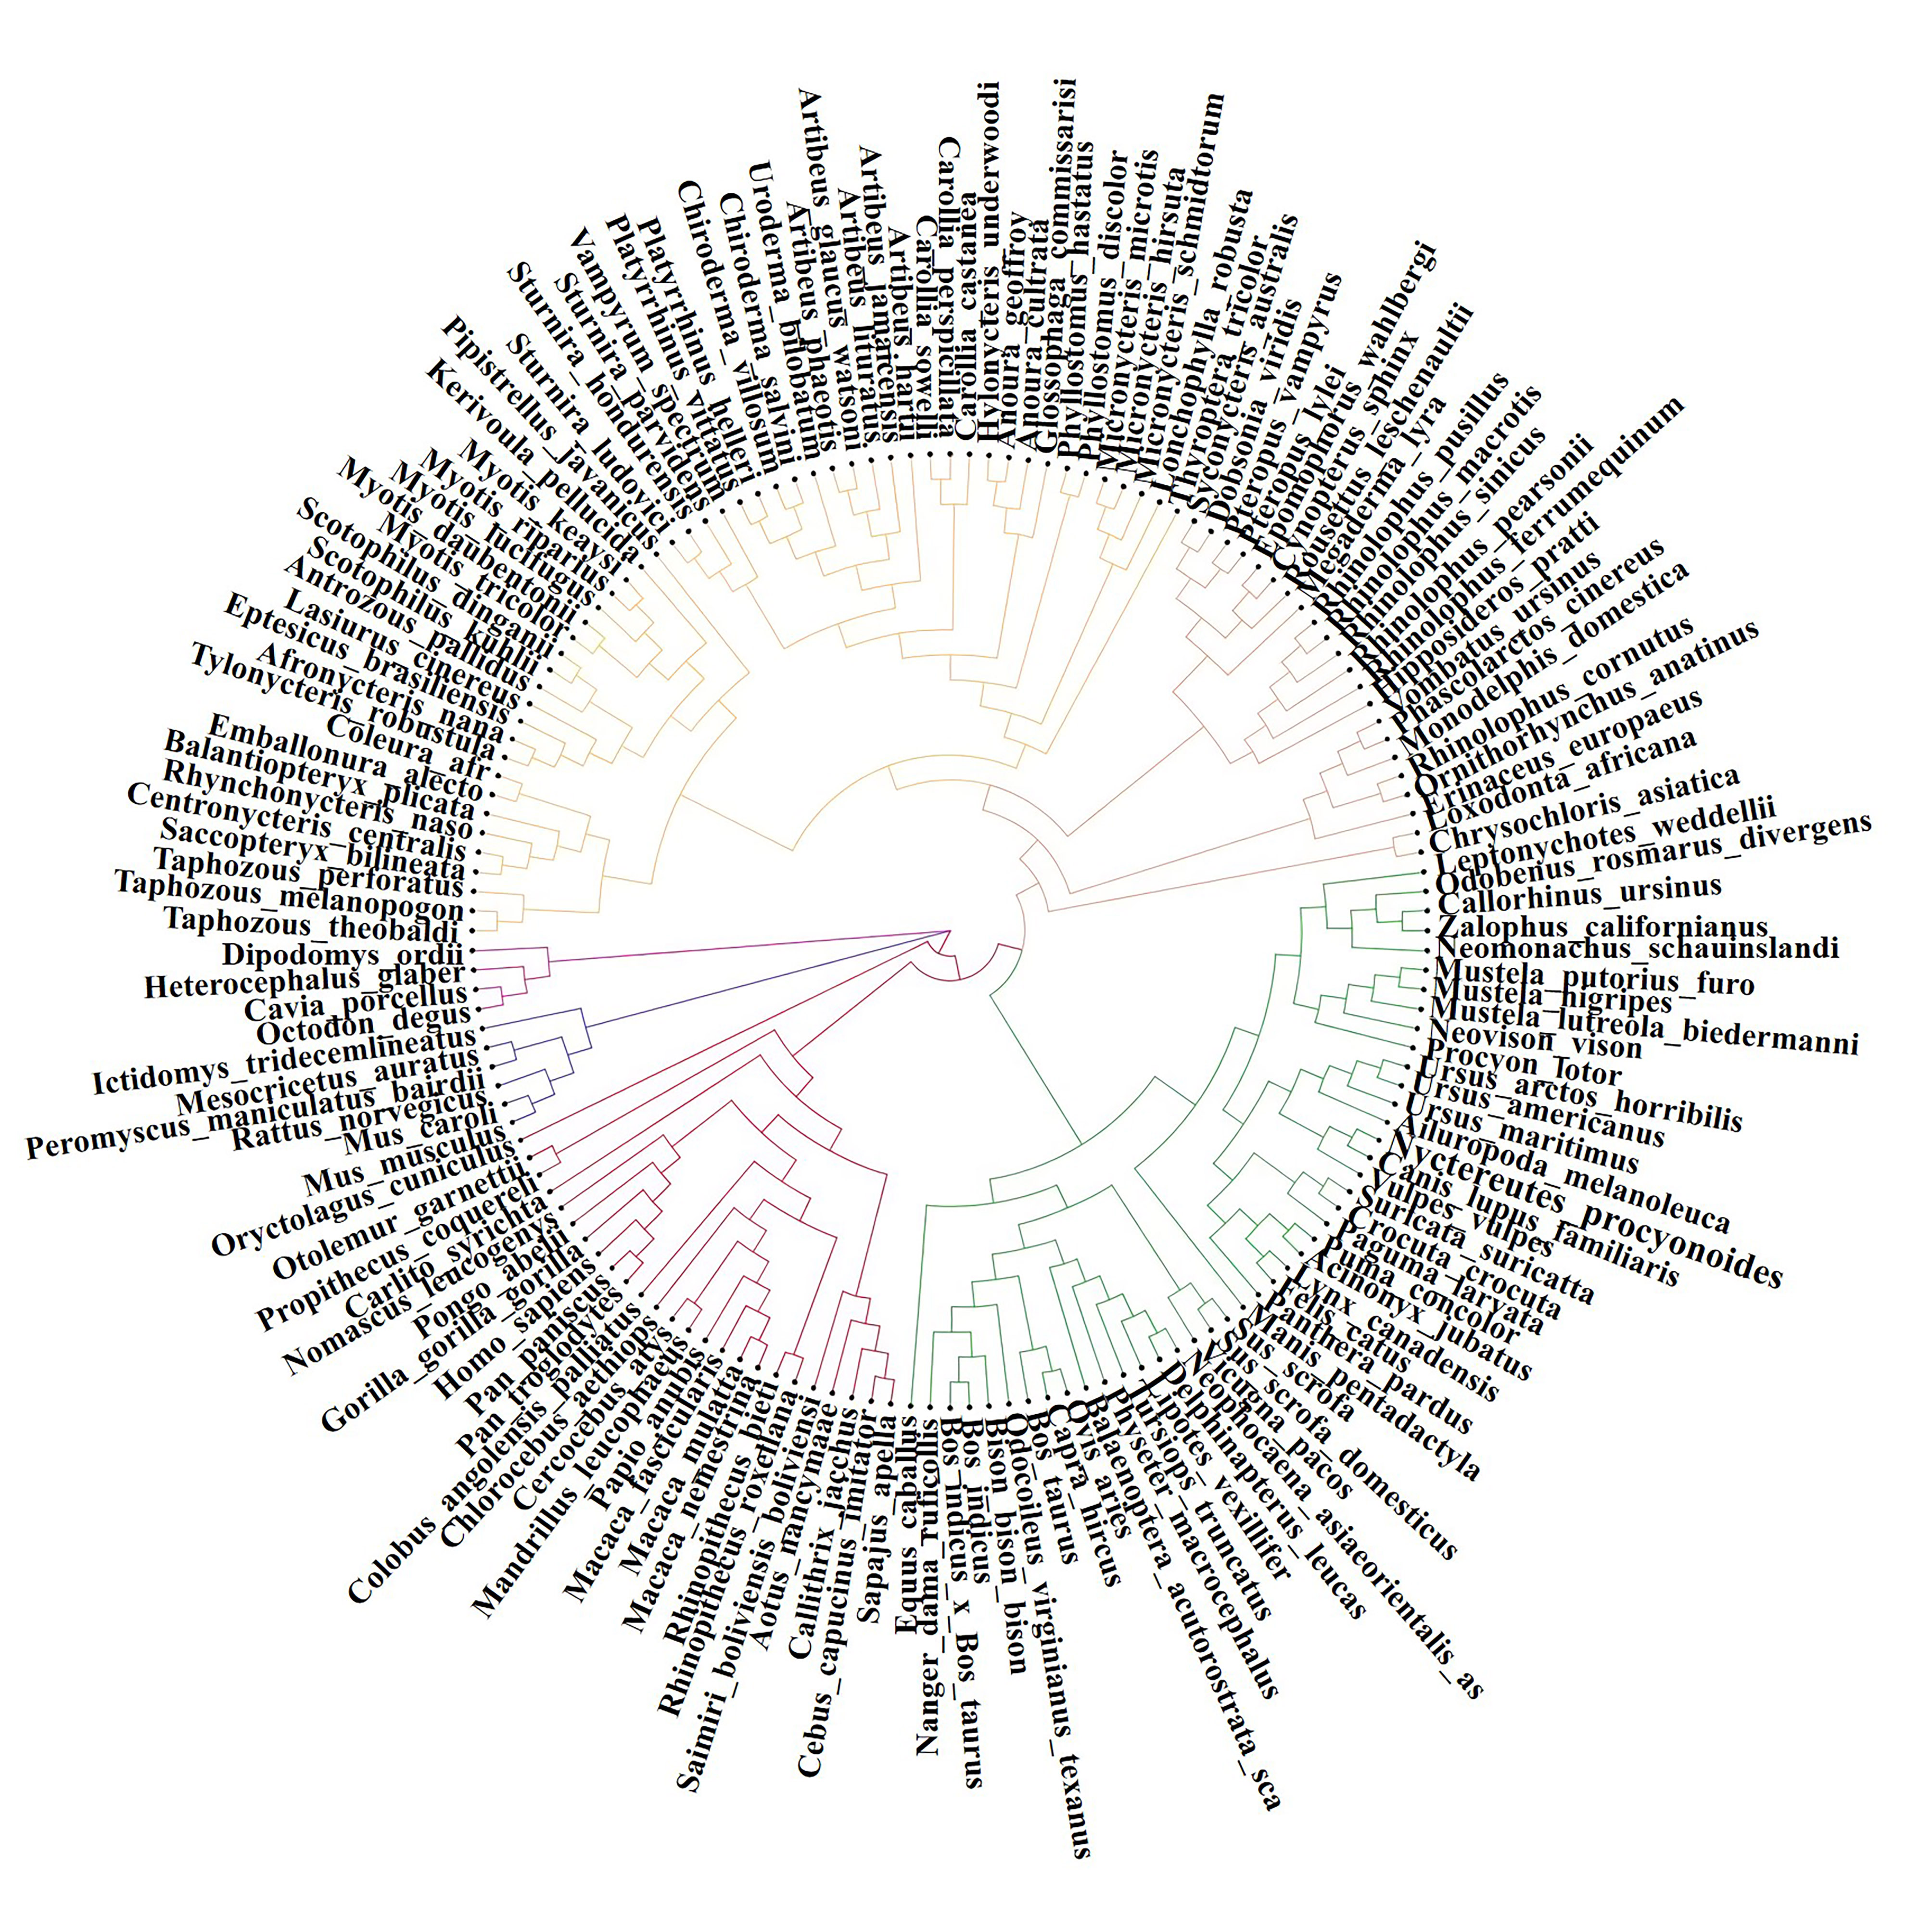
Figure S1. Phylogenetic analysis of ACE2.
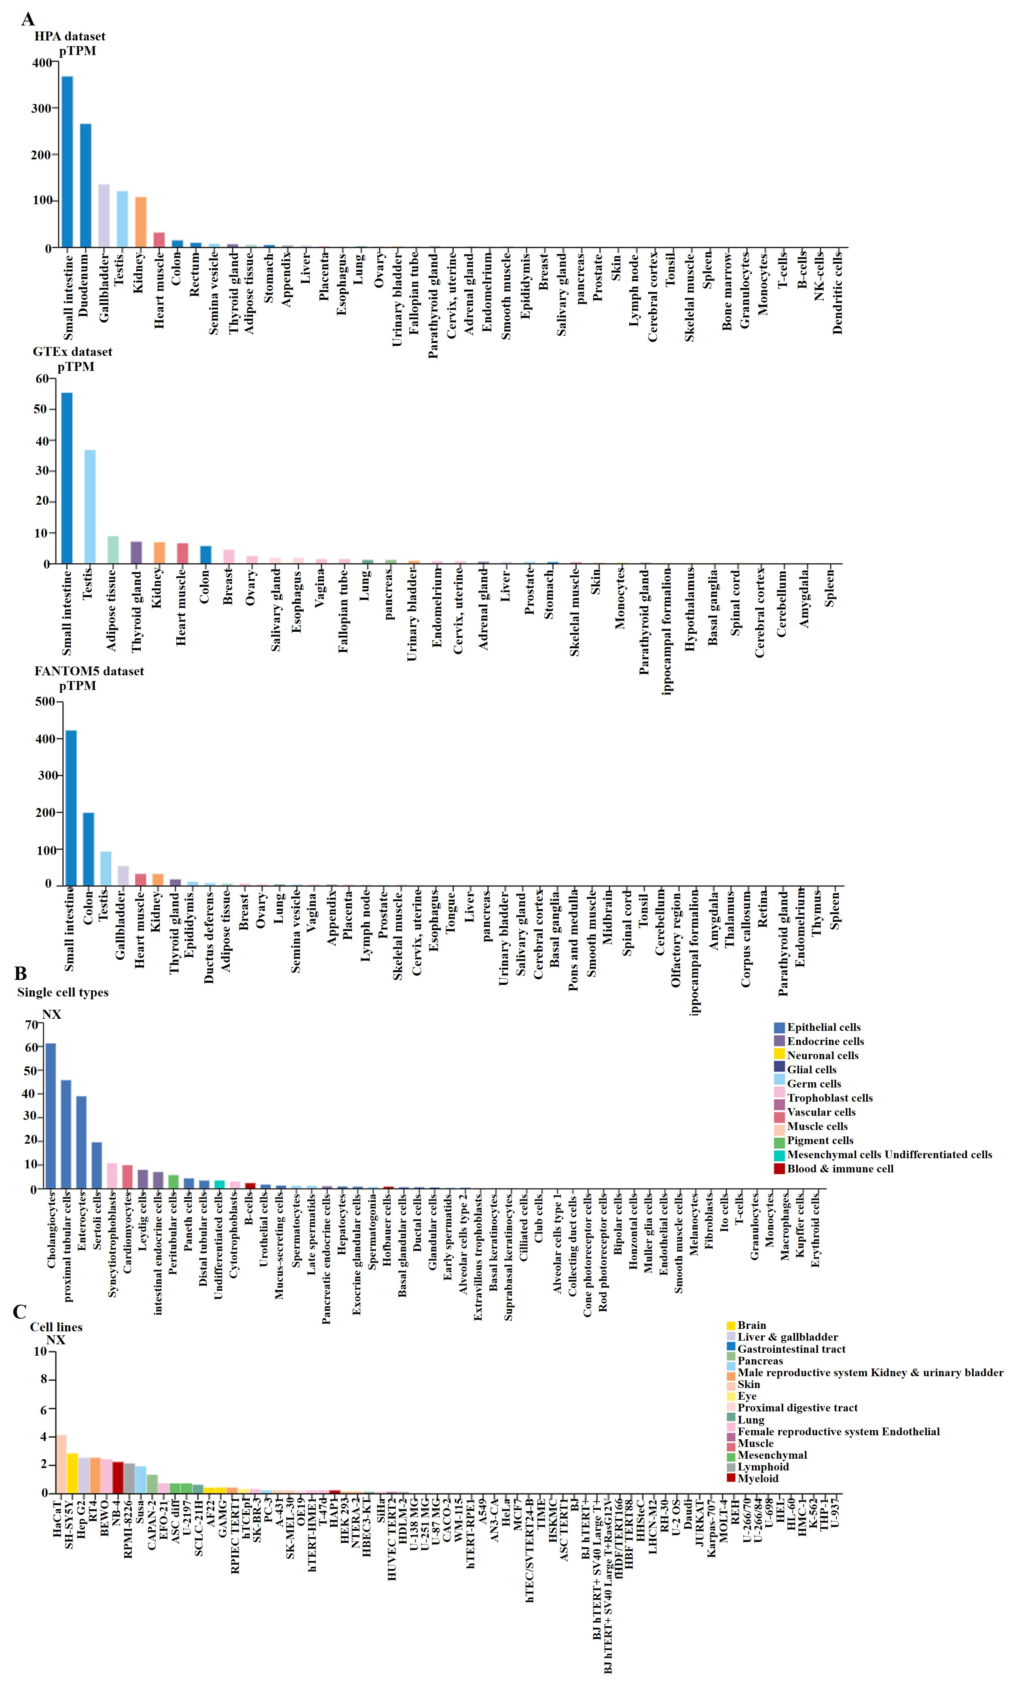
Figure S2. Expression data of ACE2. (A) Expression data of ACE2 in human tissues with HPA, GTEx and FANTOM5 transcriptomics datasets (B) Single cell expression data of ACE2 (C) Cell line expression data of ACE2

