Supplementary material
Association between exposure to specific PM_{2.5} constituents and environment, lifestyle, and clinical parameters in patients with COPD

Methods
Questionnaires on the living environment and daily life behaviors of the study participants
The participants completed questionnaires on their indoor/outdoor living environments and lifestyle. The living environment assessments included the distance from their home to the road, average traffic volume, width of the road near the home, floor level of the residence, presence of an indoor ventilating system, and presence of certain household appliances including an air purifier. The distance from the patient’s home to the nearest main road was considered short or long based on a 100-meter benchmark. The width of the road was checked to determine whether it had 1, 2, 4, 6, 8 lanes or more. The level of traffic in the vicinity of the patients’ residences was classified as low- or high-volume. Questions regarding lifestyle included the methods and durations of indoor ventilation, air purifier operation times, and methods and frequency of cleaning. Ventilation times were represented as mean hours per week. Air purifier operation times were separately calculated on days with low, moderate, and heavy dust also as mean hours per week. The frequencies of cleaning the kitchen ventilator and vacuum cleaner use were represented as mean numbers per week.

Figure S1. Correlation matrix of the correlation coefficients between constituents of PM_{2.5}.
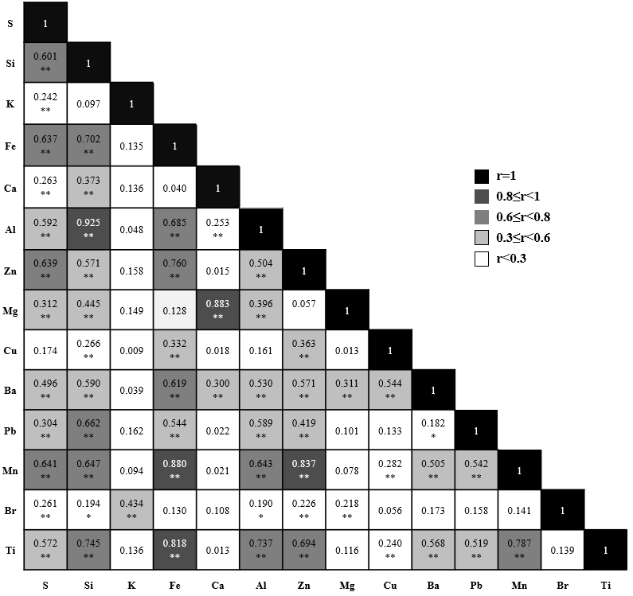 *P<0.10, **P<0.05.
Abbreviations: PM_{2.5}, particulate matter sized less than 2.5 micrometers in diameter; S, sulfur;
Si, silicon; K, potassium; Fe, iron; Ca, calcium; Al, aluminum; Zn, zinc; Mg, magnesium; Cu, copper; Ba, barium; Pb, lead; Mn, manganese; Br, bromine; Ti, titanium.
Figure S2. Relationship between air purifier operation times and X5 (% of the predicted value) according to the Mn concentration.
The Mn exposure concentration for each patient was classified as high or low based on the median value (0.02 μg/m³) and the relationships between X5 (%pred.) and air purifier operation times are shown as a scatter plot, according to the Mn concentration. The X5 (%pred.) and air purifier operation time tended showed a negative correlation in the low Mn concentration group (r=-0.314, P=0.071).
Abbreviations: %pred., percent of the predicted value; Mn, manganese.

