Supplementary information

Supplementary Data
- Supplementary Data S1: Diurnal patterns of light absorption and photosynthetic gain of grapevine canopy at five representative sites
- Supplementary Data S2: Cumulative photosynthetic gain of grapevine canopy during growth period at 1,266 sites

Supplementary Figures
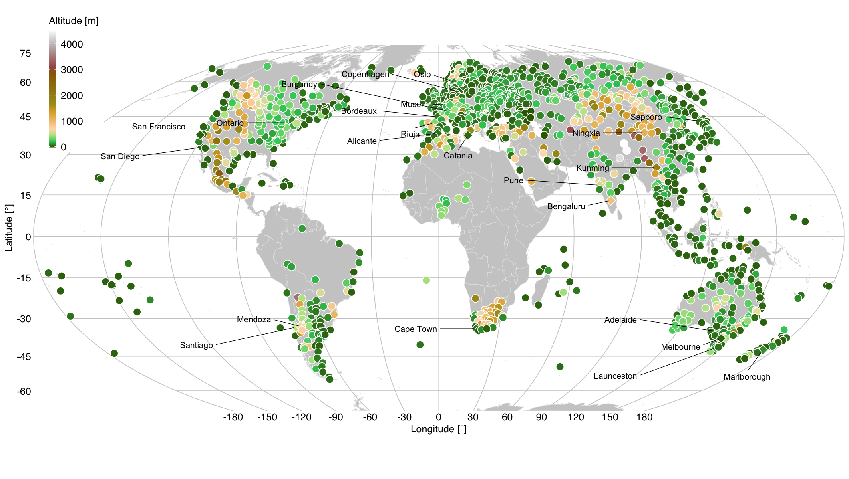
Figure S1: Location of sites subjected to the present analysis. Site elevations are indicated by the color of the symbols (n = 1,266).

Figure S2: Schematic representation of a hedge-row vineyard light simulation model. Perspective views of (a, b) EW- and (c, d) NS-hedges with (a, c) and without (b, d) shade by the neighboring hedges. See the method for further details.

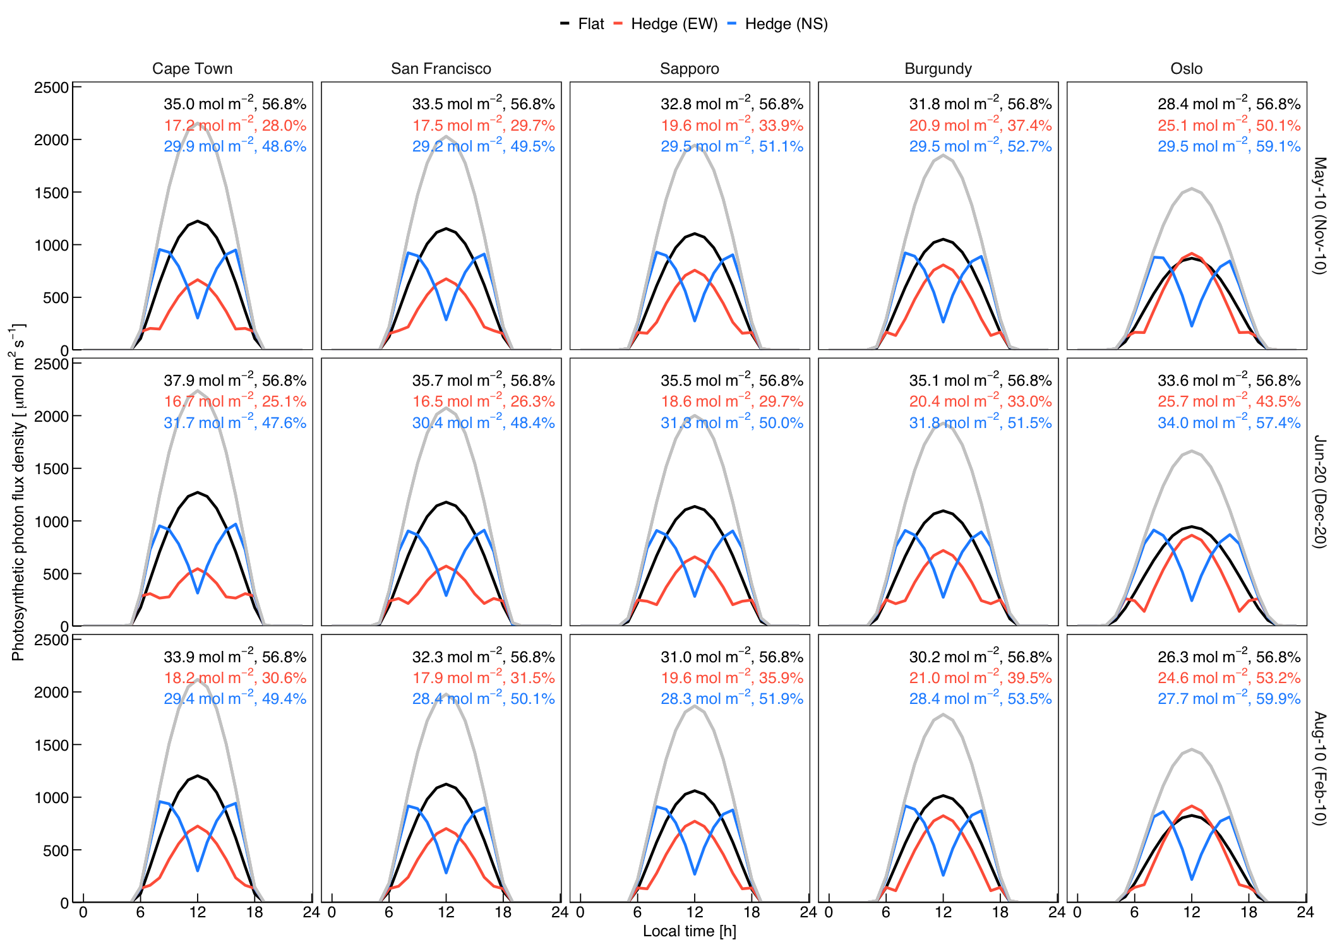
Figure S3: Diurnal patterns of canopy light absorption. Hourly values of leaf photon absorption per unit ground area of a flat canopy, East-West hedges and North-South hedges (black, red, and blue lines, respectively) of five representative sites and three timeframes are shown. Numbers at the top of panels are daily integral absorption and absorbed fractions relative to incident radiation on horizontal surface (gray lines).

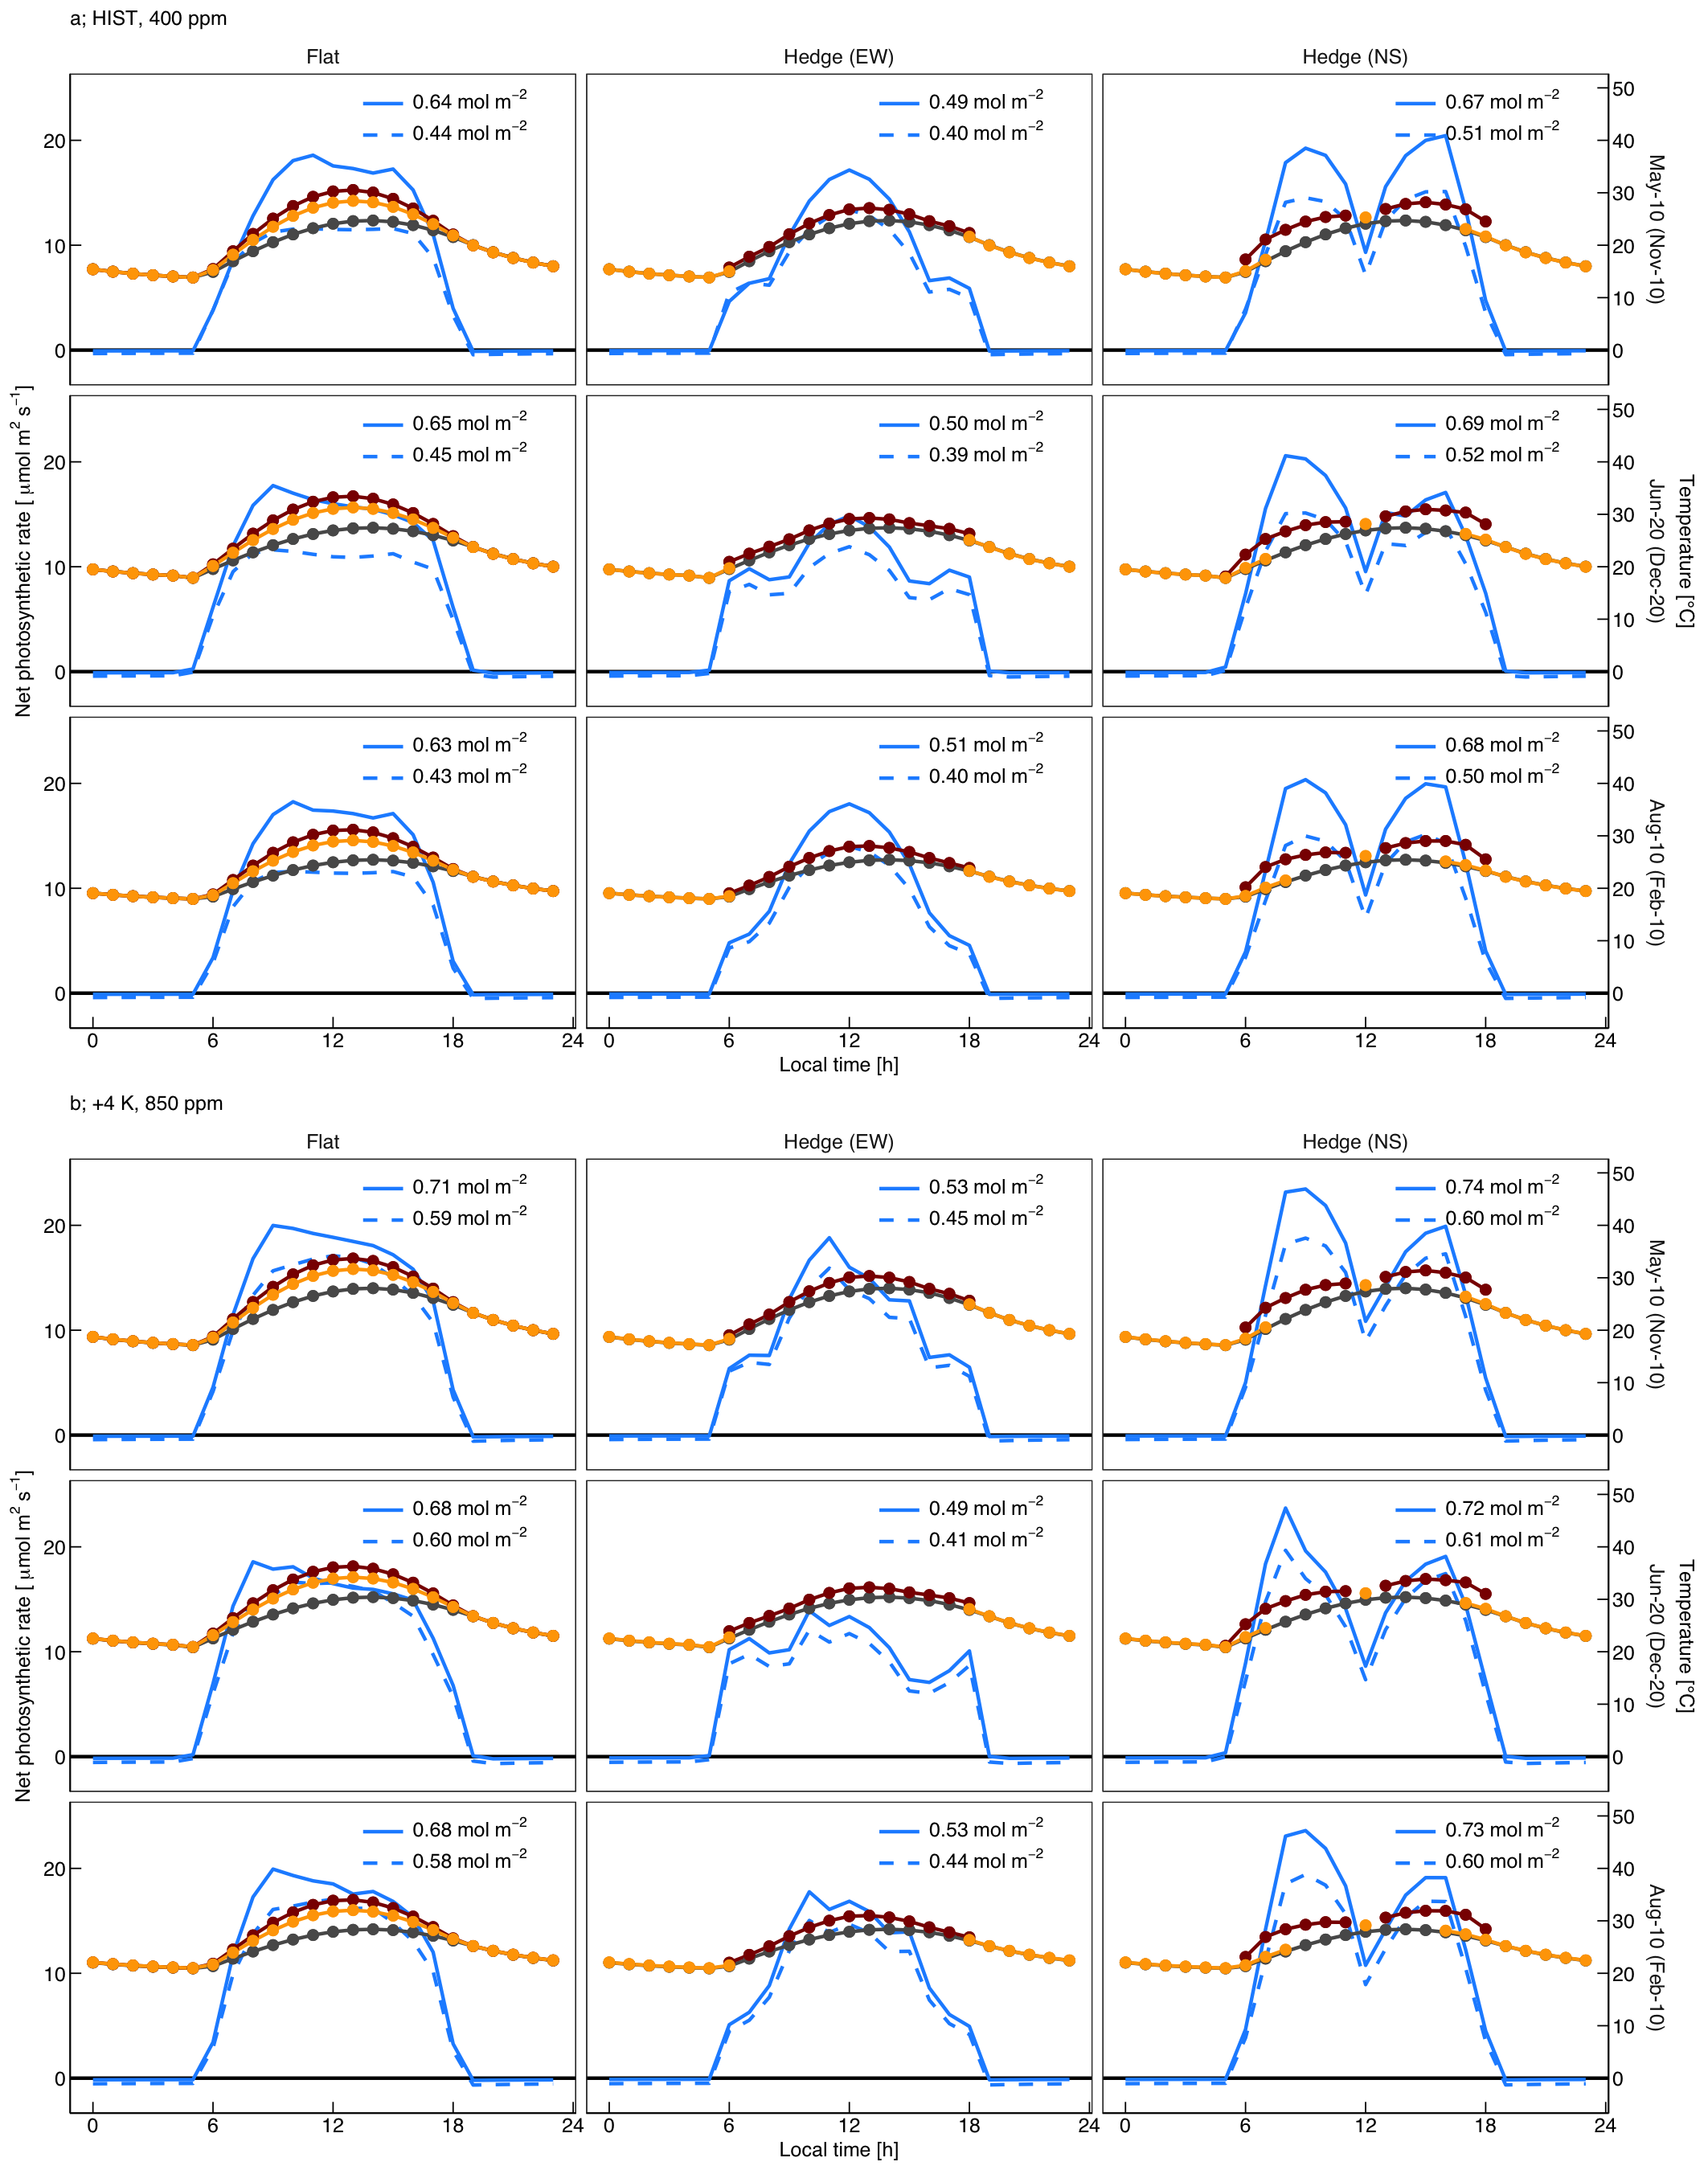
Figure S4: Diurnal patterns of canopy photosynthesis and temperatures at Cape Town, South Africa (33.97°S). Hourly values of net canopy photosynthetic rates based on two photosynthesis models (blue lines, solid lines based on Schultz and dashed lines based on Prieto et al.), temperatures of leaves exposed to direct radiation or shaded by the neighboring hedge (darkred and orange lines, respectively), and air temperature (gray lines) of a flat canopy, East-West hedges and North-South hedges in three timeframes under (a) the present climate and (b) the future climate are shown. Numbers at the top of panels are daily integral photosynthetic gains per unit ground area.

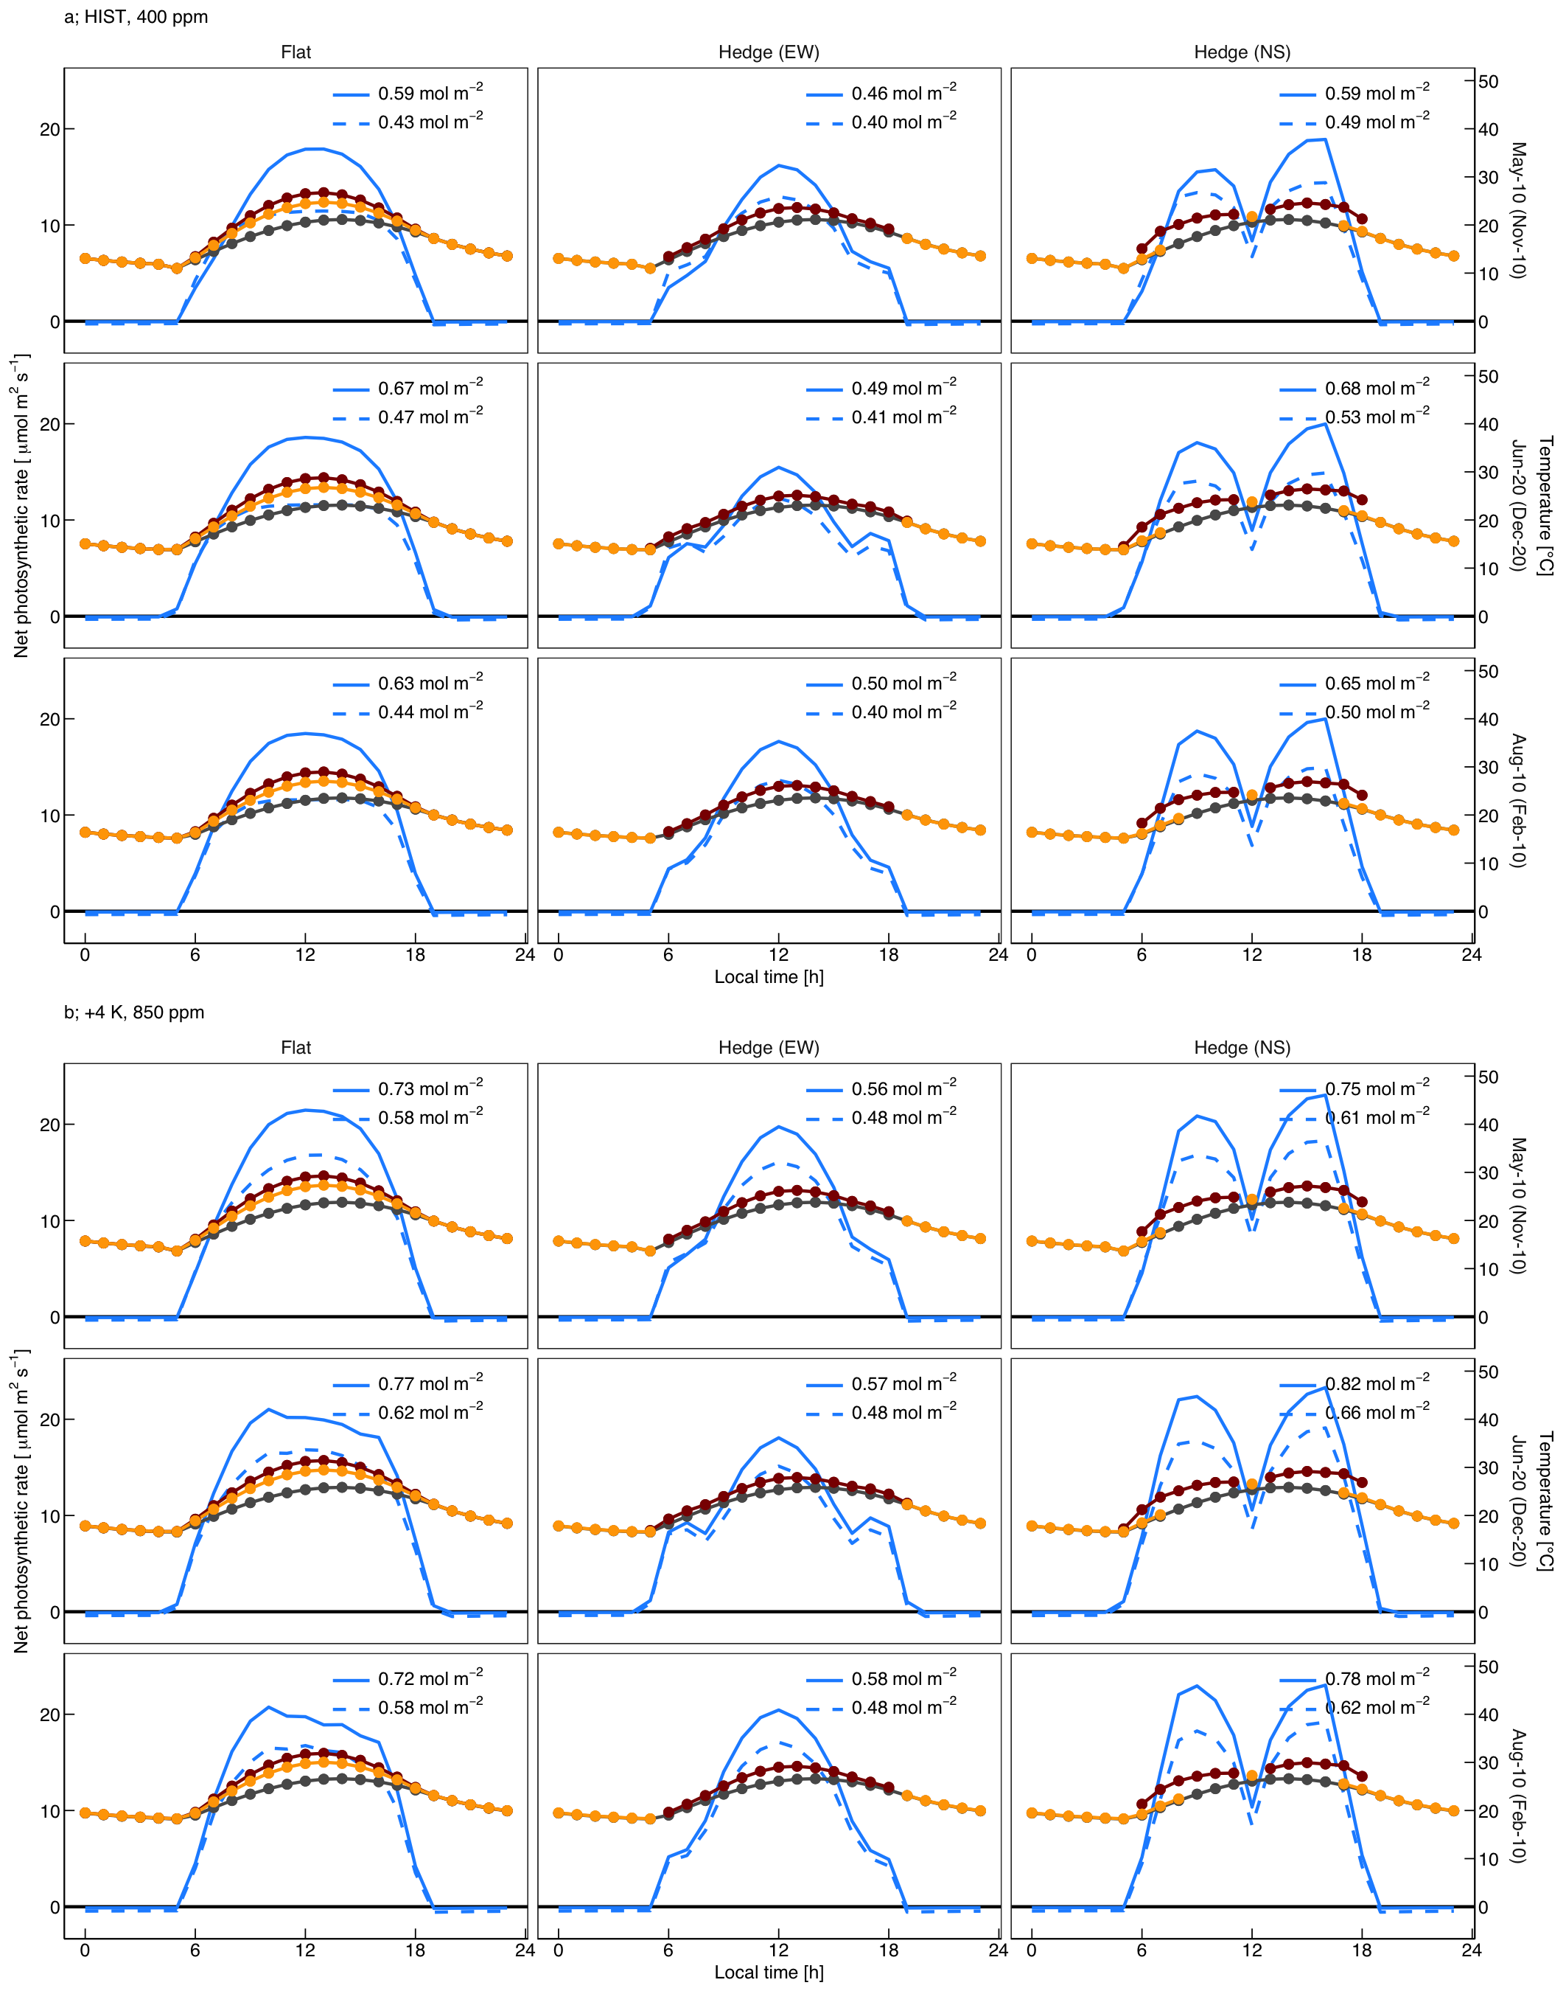
Figure S5: Same as Figure S4, but for San Francisco, USA (37.62°N)

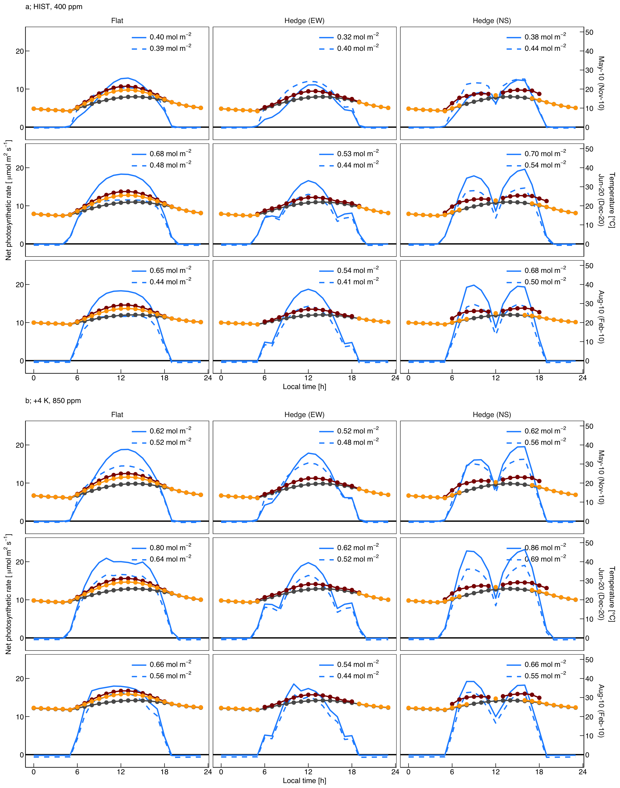
Figure S6: Same as Figure S4, but for Sapporo, Japan (43.05°N).

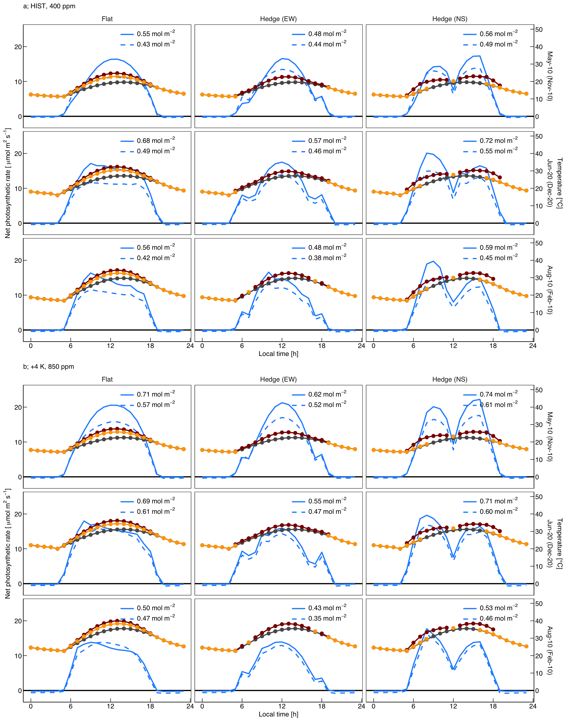
Figure S7: Same as Figure S4, but for Burgundy, France (47.27°N).

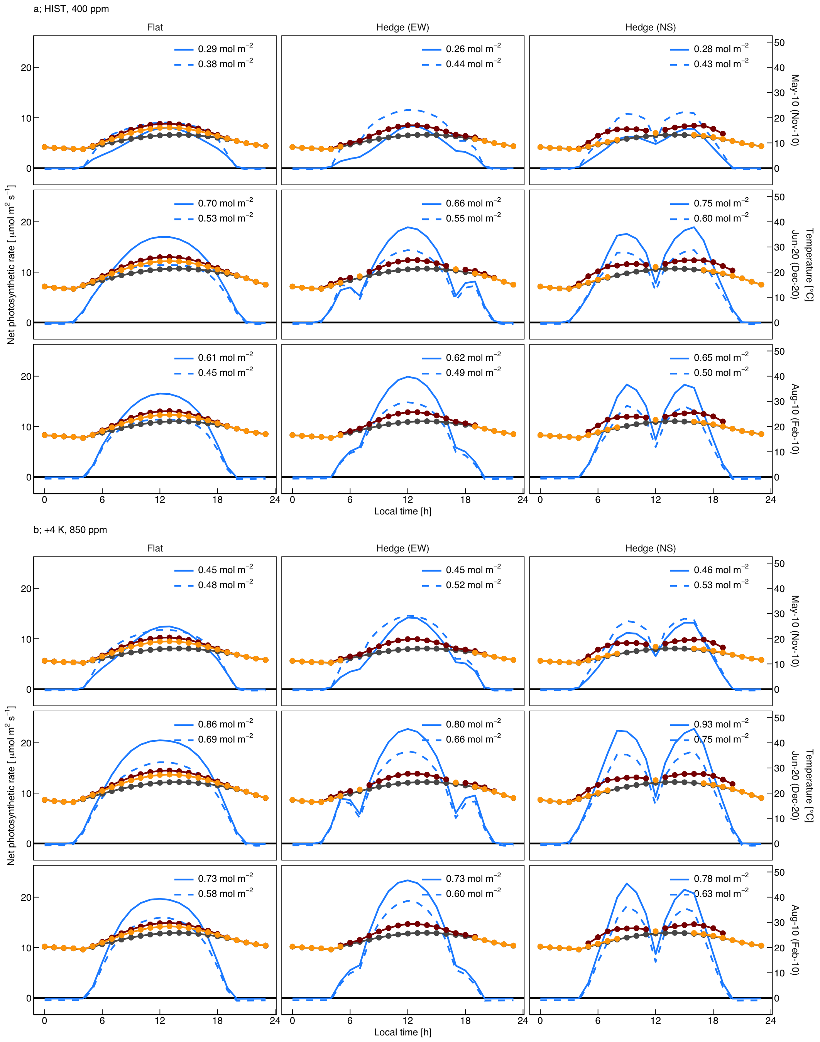
Figure S8: Same as Figure S4, but for Oslo, Norway (59.93°N).

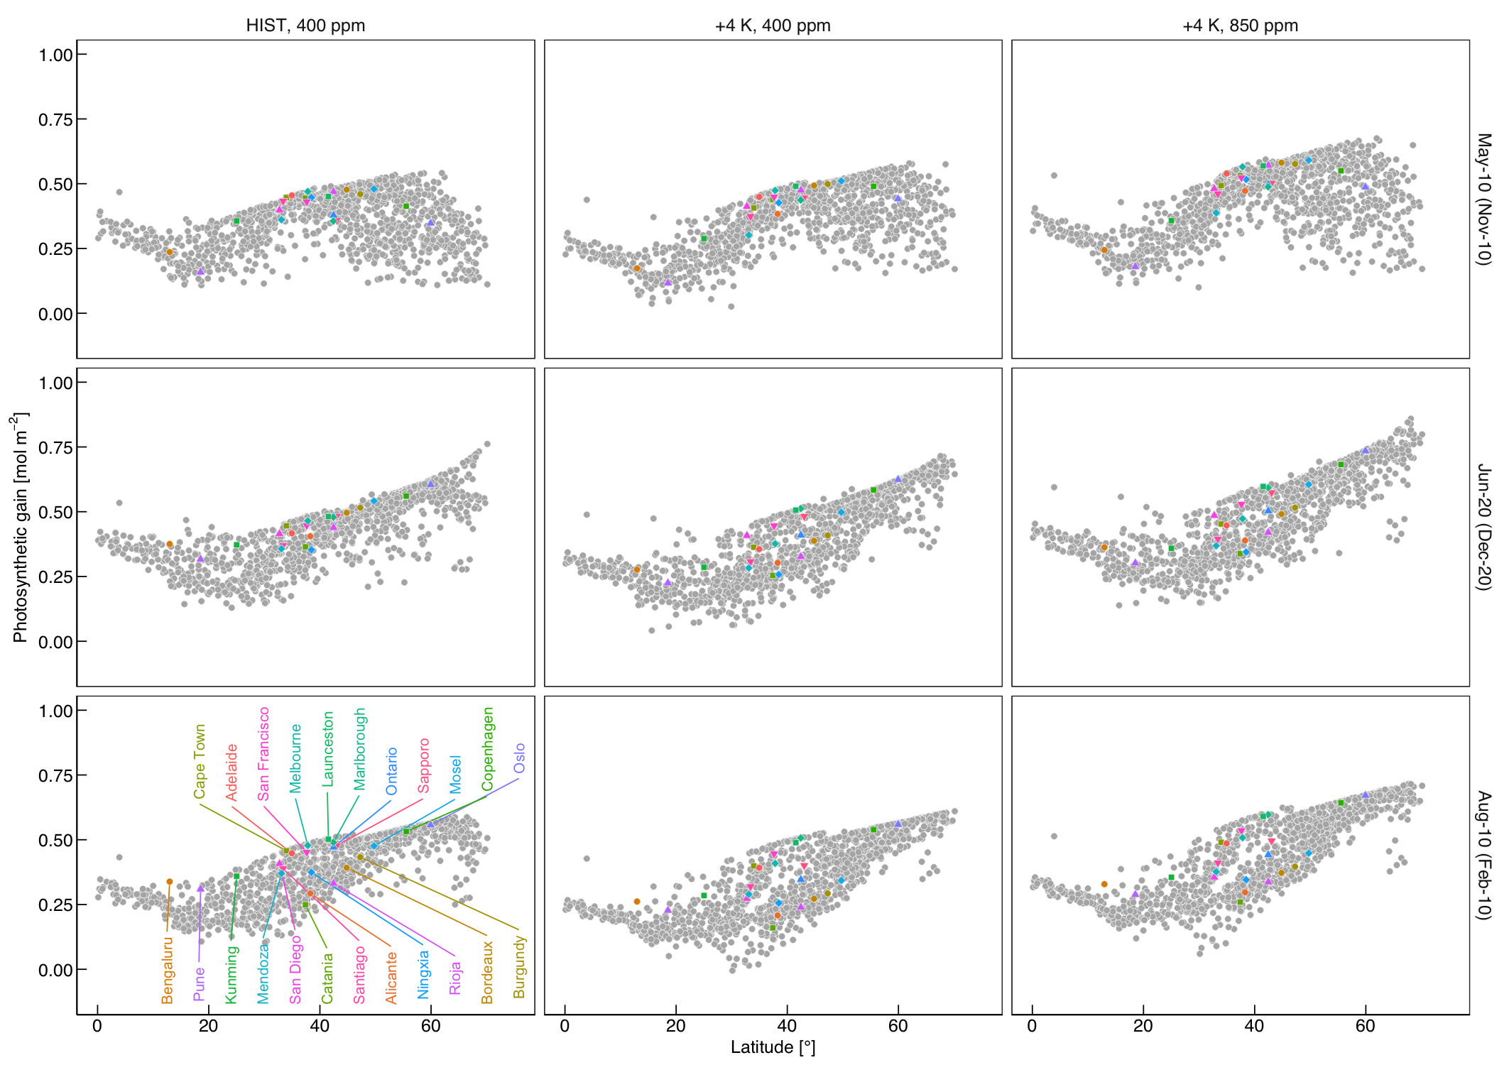
Figure S9: Same as Figure 2, but for East-West hedges.

Figure S10: Projected rise in growth season temperature. Differences in mean values of air temperatures at a height of 2 m between the present and +4-K climate scenarios from April to October for the Northern Hemisphere and from November to March for the Southern Hemisphere, sourced from d4PDF, are shown.

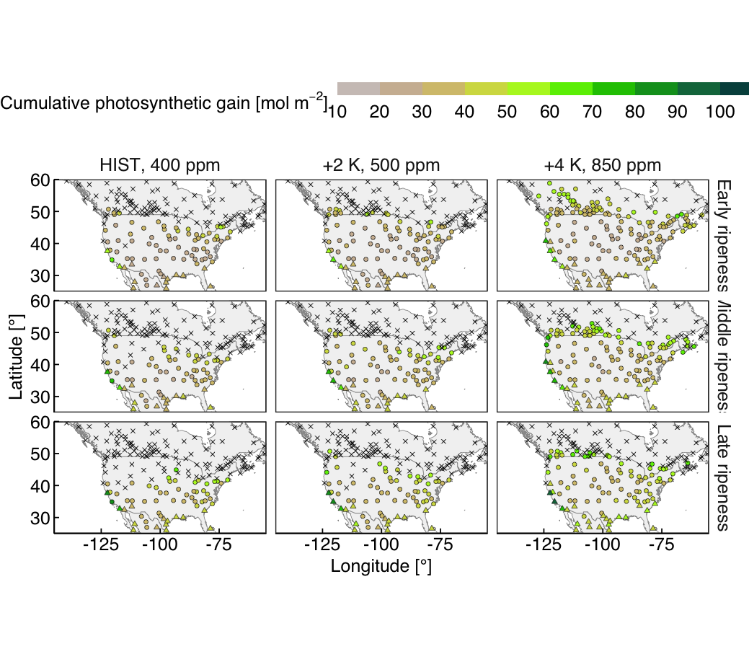
Figure S11: Same as Figure 3, but for the North American region.

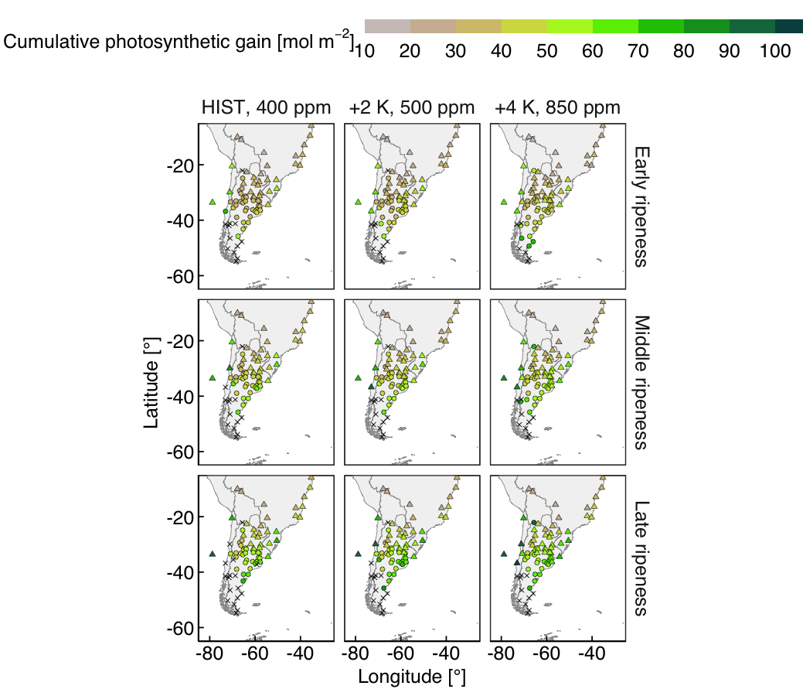
Figure S12: Same as Figure 3, but for the South American region.

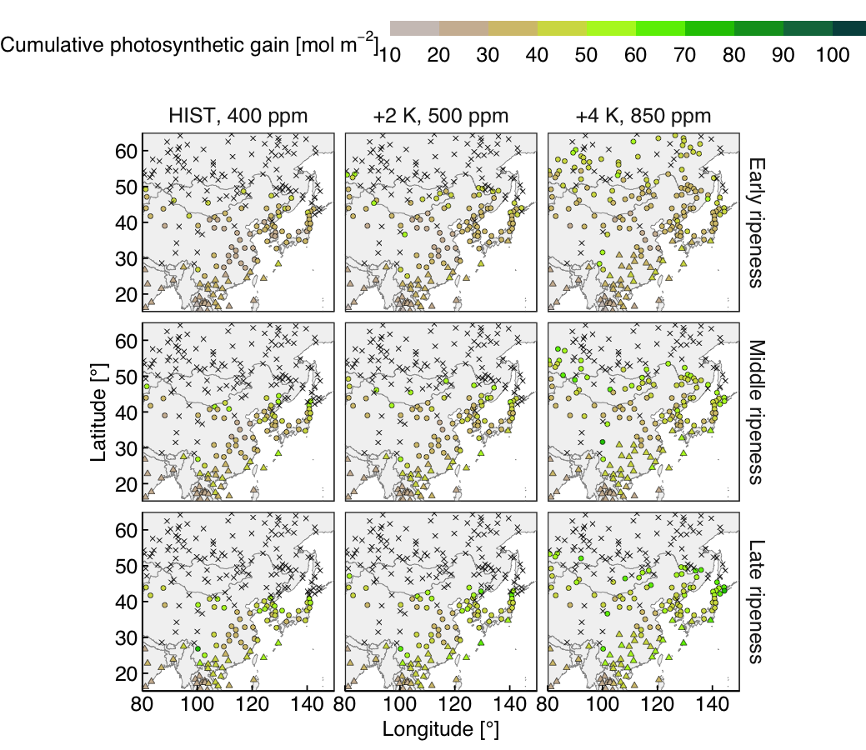
Figure S13: Same as Figure 3, but for the Asian region.

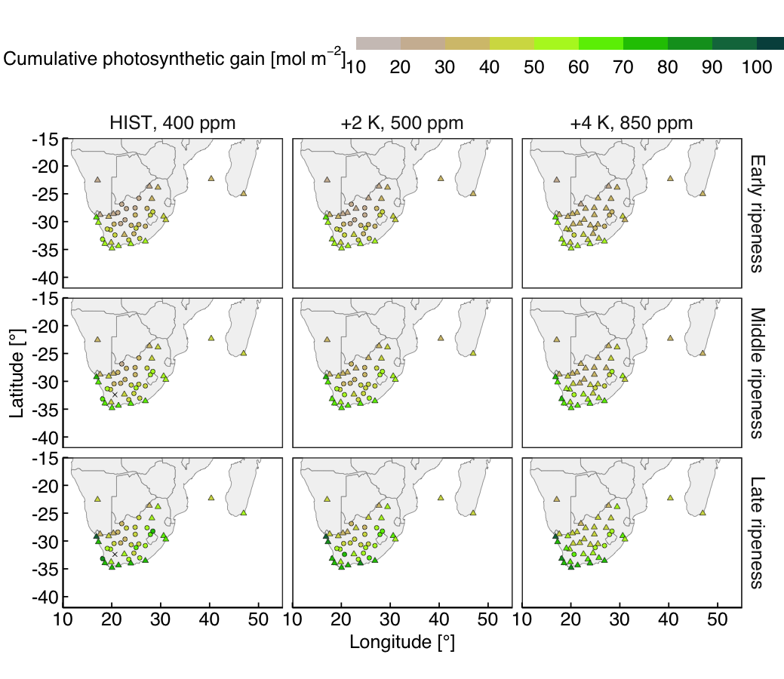
Figure S14: Same as Figure 3, but for the South African region

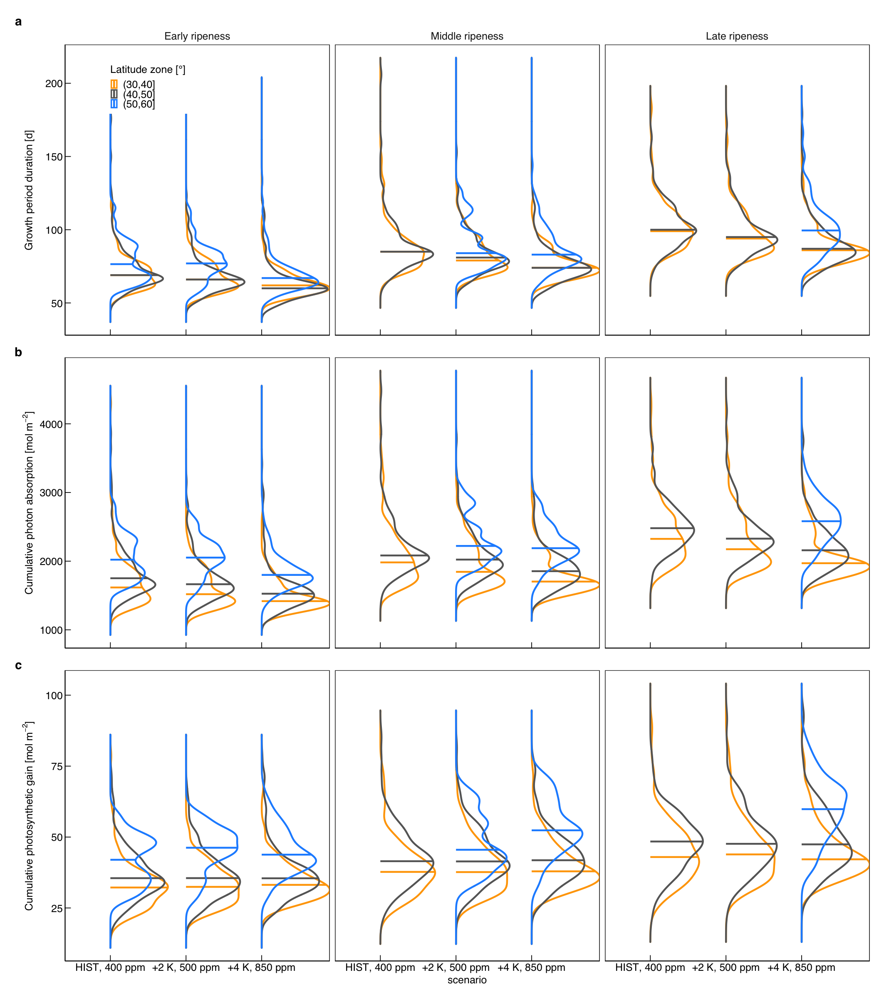
Figure S15: Probability densities of cumulative canopy photosynthetic and related components. Densities of (a) growth period duration, (b) cumulative photon absorption, and (c) cumulative photosynthetic gain of sites that meet both heat and chilling requirements are shown. The densities are shown when sufficient data are available (n > 20).

Supplementary Tables
Table S1: Effects of climate change on the number of suitable sites for viticulture.

Table S2: List of parameters used in the present model.
Table S3: Temperature dependency of the photosynthetic parameters.

Supplementary Equation S1
The global solar radiation on the horizontal surface (R_{n}; W m⁻²) was estimated and separated into direct and diffuse components as follows:
$$R_{\text{n}}=R_{\text{dir}}+R_{\text{dif}}, \left(2\right)$$
where R_{dir} is the cosine corrected direct irradiance (W m⁻²) and R_{dif} is the diffuse irradiance (W m⁻²) per unit area of horizontal ground. These two components were simulated from the site latitude, day of year, vapor pressure, atmospheric turbidity coefficient, and surface albedo around the site⁶⁶. As the radiation model incorporated the attenuation of solar radiation due to water vapor, the simulated quantities were slightly smaller in the future experiments than those in the historical experiment.
The lengths of the vertical parts of the canopy directly illuminated and shaded by a neighboring hedge (L_{light} and L_{shade}; m) were calculated from the path of direct sunlight (see Figure S2). L is the hedge height (m), D is the distance between the centers of the neighboring hedges (m), W is the hedge width (m), $ϕ$ is the solar azimuth angle (°), $α$ is the angle of the vineyard slope fixed at 5°. For simplicity, we considered vineyards on south- and north-facing slopes in the Northern and Southern Hemispheres, respectively. L_{light} equals 0 when the solar azimuth is parallel to the hedge rows.
By assuming that leaves in the light part absorb incident radiation uniformly, irradiance per unit leaf area brought about by direct radiation (I_{dir,light}; W m⁻²) was calculated as follows:
$$I_{\text{light,dir}}=ϵ\frac{f_{\text{cover}}⋅D⋅R_{\text{dir}}}{ρL_{\text{light}}} \left(3\right)$$
where f_{cover} is the fraction of hedge shades covering surface (%), $ϵ$ is the leaf absorptance fixed at 85 % (adopted from a reported value of a single mature leaf⁶⁷), and $ρ$ is the leaf area in a hedge 1 m height and 1 m width fixed at 2.0 m². The value of $ρ$ was approximated from a grapevine trained to a horizontal single-cordon system with a shoot spacing of 10 cm, internode distance of 10 cm, and leaf area of 200 cm². Reflected and transmitted radiation were not considered in this model.
Diffuse radiation on the light and shade leaves was estimated separately⁶⁸. The hemispherical sky was divided into small sections defined by 20 elevation-angle classes and 32 azimuth classes. The light and shade leaves receive diffuse radiation from the sky sections if the light paths are not intercepted by the neighboring hedges. Centroids of light and shade leaves were regarded as representatives of the two parts to reduce the computational cost. The irradiance on a unit vertical surface area caused by diffuse radiation was calculated by integrating the radiation from sky sections that were not intercepted by neighboring hedges as follows:
Idif=i​Kcoshi Ωi 4
where K is the radiant emittance uniform over the sky (W m⁻²), and $h_{i}$ (°) and $Ω_{i}$ (m²) are the elevation angle and area of the section i, respectively. K was determined by solving the following equation for the diffuse radiation on the horizontal ground surface:
Rdif=i​Ksinhi Ωi. 5
The diffuse irradiance per unit leaf area on the light and shade leaves (I_{dif,light} and I_{dif,shade}; W m⁻²) was then calculated as
$$I_{\text{light,dif}}=\frac{I_{\text{dif,light}}}{ρ} \left(6\right)$$
and
$$I_{\text{shade,dif}}=\frac{I_{\text{dif,shade}}}{ρ}. \left(7\right)$$
Radiation absorbed by light and shade leaves attributed to light penetrating from the canopy top was calculated according to Beer’s law:
$$I_{\text{light,top}}=\frac{R_{\text{n}}W\left(1-e^{-ρk⋅L_{\text{light}}}\right)}{ρL_{\text{light}}} \left(8\right)$$
and
$$I_{\text{shade,top}}=\frac{R_{\text{n}}W\left(\left(1-e^{-ρk\left(L_{\text{light}}+L_{\text{shade}}\right)}\right)-\left(1-e^{-ρkL_{\text{light}}}\right)\right)}{ρL_{\text{shade}}}=\frac{R_{\text{n}}W\left(e^{-ρkL_{\text{light}}}-e^{-ρkL}\right)}{ρL_{\text{shade}}}, \left(9\right)$$
where k is the light extinction coefficient fixed at 0.7.
The total irradiance per unit leaf area on the light leaves (I_{light}, W m⁻²) corresponds to I_{light,dir} + I_{light,dif} + I_{light,top} and that on the shade leaves (I_{shade}, W m⁻²) corresponds to I_{shade,dif} + I_{shade,top}. These energy-based quantities were converted into photon-based quantities by multiplying them with a coefficient of 2.15. This coefficient was obtained by assuming that 47 % of the total irradiance was photosynthetically active (i.e. 400–700 nm) and that photosynthetic photon flux density (PPFD) per irradiance in this waveband was 4.57 for daylight⁶⁹. These leaf-area-based quantities were converted into ground-area based quantities by dividing D.
For comparison, light absorption and photosynthetic gain of a horizontally uniform flat canopy were also estimated. The upper and lower halves were considered as light and shade leaves, respectively. The irradiance per unit leaf area on light and shade leaves is expressed as follows:
$$I_{\text{light}}=\frac{R_{\text{n}}\left(1-e^{-0.5kLAI}\right)}{0.5LAI}, \left(10\right)$$
and
$$I_{\text{shade}}=\frac{R_{\text{n}}\left(1-e^{-kLAI}\right)}{0.5LAI}-I_{\text{light}}, \left(11\right)$$
where LAI is the leaf area index (m² m⁻²) and is equals to $ρL/D$.

Supplementary Equation S2
Leaf photosynthetic rate per unit leaf area was estimated according to the Farquhar-von Caemmerer-Berry C₃ photosynthesis model⁶².
$$A=V_{\text{C}}-0.5V_{\text{O}}-R_{\text{d}}=V_{\text{C}}\left(1-\frac{Γ^{*}}{C_{\text{i}}}\right)-R_{\text{d}}, \left(12\right)$$
where V_{C} and V_{O} are the rates of carboxylation and oxygenation of Rubisco, C_{i} is the CO₂ partial pressure in intercellular spaces, R_{d} is the rate of CO₂ evolution in the light (day respiration), and $Γ^{*}$ is the compensation point for CO₂ in the absence of day respiration.
V_{C} is assumed to be limited by one of three factors: (1) the quantity, kinetic properties, and activation state of Rubisco (W_{c}); (2) ribulose-1,5-bisphosphate (RuBP) regeneration in the Calvin cycle (W_{j}); and (3) the availability of inorganic phosphate (W_{p}) or
$$V_{\text{C}}=min\left\{W_{\text{c}},W_{\text{j}},W_{\text{p}}\right\}. \left(13\right)$$
$$W_{\text{c}}=\frac{V_{\text{cmax}}C_{\text{i}}}{C_{\text{i}}+K_{\text{C}}\left(1+\frac{O}{K_{\text{O}}}\right)}, \left(14\right)$$
$$W_{\text{j}}=\frac{JC_{\text{i}}}{4\left(C_{\text{i}}+2Γ^{*}\right)}, \left(15\right)$$
and
$$W_{\text{p}}=3\text{TPU}+\frac{V_{\text{C}}Γ^{*}}{C_{\text{i}}}, \left(16\right)$$
where V_{cmax} is the maximum rate of carboxylation, K_{C} and K_{O} are the Michaelis-Menten constants for carboxylation and oxygenation, respectively, J is the rate of electron transport through photosystem II, and TPU is the rate of triose-phosphate utilization. The response of J to the incident PPFD (Q) is modeled with the following rectangular hyperbola⁷⁰:
$$J=\frac{ΦQ}{\sqrt{1+\frac{Φ^{2}Q^{2}}{{J_{\text{max}}}^{2}}}}, \left(17\right)$$
where $Φ$ is the efficiency of light conversion related to the incident photons and J_{max} is the maximum rate of electron transport.
The temperature dependencies of $Φ$, K_{C}, K_{O}, V_{cmax}, J_{max}, and TPU were simulated according to two studies^{17,63} as listed in Table S3.
$$\{K_{\text{O}},K_{\text{O}}\}=P_{25}×exp\frac{c-ΔH_{\text{a}}}{R_{\text{gas}}\left(T_{\text{leaf}}+273.15\right)}, \left(18\right)$$
and
$$\{V_{\text{cmax}},J_{\text{max}},\text{TPU}\}=P_{25}×\frac{exp\left(c-\frac{ΔH_{\text{a}}}{R_{\text{gas}}\left(T_{\text{leaf}}+273.15\right)}\right)}{1+exp\frac{ΔS\left(T_{\text{leaf}}+273.15\right)-ΔH_{\text{d}}}{R_{\text{gas}}\left(T_{\text{leaf}}+273.15\right)}}, \left(19\right)$$
where P₂₅ is the parameter at 25 °C (µmol m⁻² s⁻¹), c is the scaling constant, $Δ$H_{a} is the activation energy (kJ mol⁻¹), $Δ$H_{d} is the de-activation energy (kJ mol⁻¹), $Δ$S is the entropy term (kJ mol⁻¹), R_{gas} is the gas constant (0.00831 kJ K⁻¹ mol⁻¹), and T_{leaf} is the leaf temperature (°C) calculated based on the leaf energy balance.
The temperature dependencies of R_{d} and $Γ^{*}$ are expressed differently in the models of Schultz¹⁷ and Prieto et al.⁶³. Schultz¹⁷ adopted the following polynomial correction
$$R_{\text{d}}=d_{0}\left(1+d_{1}\left(T_{\text{leaf}}-27.1\right)+d_{2}{\left(T_{\text{leaf}}-27.1\right)}^{2}\right),$$
$$Γ^{*}=e_{0}+e_{1}\left(T_{\text{leaf}}-27.1\right)+e_{2}{\left(T_{\text{leaf}}-27.1\right)}^{2}, \left(20\right)$$
where d₀, d₁, d₂, e₀, e₁, and e₂ are empirical coefficients. Prieto et al.⁶² adopted the Arrhenius equation (Equation 18).
Down-regulation of V_{cmax}, J_{max}, and R_{d} was corrected by multiplying the empirical scaling factors adopted from the latest meta-analysis³⁹. Assuming that the parameters of the two studies were obtained at atmospheric CO₂ concentration of 400 ppm, V_{cmax}, J_{max}, and R_{d} under 500 and 850 ppm conditions were estimated as follows:
$$V_{\text{cmax, 500}}=0.981V_{\text{cmax, 400}},$$
$$V_{\text{cmax, 850}}=0.912V_{\text{cmax, 400}},$$
$$J_{\text{max, 550}}=0.993J_{\text{max, 400}},$$
$$J_{\text{max, 850}}=0.967J_{\text{max, 400}},$$
$$R_{\text{d, 550}}=1.019R_{\text{d, 400}},$$
$$R_{\text{d, 850}}=1.062R_{\text{d, 400}}, \left(21\right)$$
where numbers in the subscripts indicate the atmospheric CO₂ concentrations.
Stomatal conductance to water vapor (g_{s}) is expressed as a function reflecting stomatal sensitivity to environmental conditions ($f_{\text{env}}$) and residual stomatal conductance (g₀), as follows:
$$g_{s}=g_{0}+f_{\text{env}}A, \left(22\right)$$
The sensitivity functions adopted by Schultz’s and Prieto’s models are
$$f_{\text{env}}=\frac{g_{1}\text{RH}}{C_{\text{a}}} \left(23\right)$$
and
$$f_{\text{env}}=\frac{a_{1}}{\left(1+\frac{\text{VPD}}{D_{0}}\right)\left(C_{\text{a}}-\frac{A}{g_{b}}-Γ\right)}, \left(24\right)$$
respectively, where g₁, a₁, and D₀ are empirical factors; RH is the relative humidity (%); VPD is the vapor pressure deficit (kPa); g_{b} is the boundary layer conductance; C_{a} is the atmospheric CO₂ concentration (µmol mol⁻¹); and $Γ$ is the CO₂ compensation point (µmol mol⁻¹). a₁ was fixed at 6.25 µmol mol⁻¹, D₀ at 26 kPa, and $Γ$ at 40 µmol mol⁻¹, and the boundary layer resistance was ignored (i.e., A/g_{b} = zero).
The intercellular CO₂ concentration was calculated from stomatal conductance and atmospheric CO₂ concentration using the following equation:
$$C_{\text{i}}=C_{\text{a}}-1.6\frac{A}{g_{\text{s}}}, \left(25\right)$$
where 1.6 is a factor that corrects for the difference in the diffusivity between CO₂ and H₂O.
Equations of assimilation demand (Equation 12–Equation 17) and stomatal supply (Equation 22–Equation 25) were solved using the Photosyn function in the R package plantecophys⁶¹.

