Supplementary Table 1. Study areas of 16 provinces and 137 district-level regions for PM₁₀ exposure data
Province | Districts | Study population (n) | Area (㎡)
Seoul | Jongno-gu | 6,271 | 23,912,936
 | Jung-gu | 5,149 | 9,960,262
 | Yongsan-gu | 8,887 | 21,866,145
 | Seongdong-gu | 11,226 | 16,859,899
 | Dongdaemun-gu | 14,887 | 14,215,806
 | Jungnang-gu | 14,309 | 18,495,584
 | Seongbuk-gu | 16,010 | 24,576,989
 | Gangbuk-gu | 13,831 | 23,600,441
 | Dobong-gu | 14,259 | 20,651,004
 | Nowon-gu | 17,938 | 35,439,209
 | Eunpyeng-gu | 16,655 | 29,710,522
 | Seodaemun-gu | 12,832 | 17,626,389
 | Mapo-gu | 13,541 | 23,850,081
 | Yangcheon-gu | 12,650 | 17,405,693
 | Gangseo-gu | 14,969 | 41,452,201
 | Guro-gu | 12,839 | 20,119,104
 | Gumcheon-gu | 7,841 | 13,020,482
 | Yeongdeungpo-gu | 13,352 | 24,548,211
 | Dongjak-gu | 14,392 | 16,355,018
 | Gwanak-gu | 17,477 | 29,568,314
 | Seocho-gu | 9,498 | 46,981,621
 | Gangnam-gu | 11,651 | 39,497,507
 | Songpa-gu | 15,648 | 33,877,057
 | Gangdong-gu | 11,577 | 24,590,492
Busan | Jung-gu | 2,846 | 2,829,149
 | Yeongdo-gu | 8,699 | 14,199,917
 | Busanjin-gu | 18,236 | 29,667,096
 | Dongnae-gu | 10,868 | 16,631,810
 | Nam-gu | 13,302 | 26,820,380
 | Buk-gu | 9,572 | 39,373,195
 | Haeundae-gu | 15,237 | 51,540,907
 | Saha-gu | 12,027 | 41,770,659
 | Geumjeong-gu | 10,310 | 65,277,383
 | Gangseo-gu | 2,779 | 181,500,580
 | Yeonje-gu | 9,200 | 12,102,001
 | Suyeong-gu | 8,338 | 10,218,180
 | Sasang-gu | 8,028 | 36,104,593
 | Gijang-gun | 4,515 | 218,316,025
Daegu | Jung-gu | 4,090 | 7,056,240
 | Dong-gu | 15,003 | 182,150,280
 | Seo-gu | 9,456 | 17,319,408
 | Nam-gu | 8,415 | 17,431,453
 | Buk-gu | 14,832 | 93,987,602
 | Suseong-gu | 15,556 | 76,535,524
 | Dalseong-gun | 7,305 | 426,865,105
Incheon | Jung-gu | 3,126 | 140,365,958
 | Dong-gu | 3,048 | 7,197,170
 | Yeonsu-gu | 5,943 | 56,192,485
 | Namdong-gu | 10,796 | 57,449,150
 | Bupyeong-gu | 15,020 | 32,004,527
 | Gyeyang-gu | 7,426 | 45,567,499
 | Seo-gu | 8,544 | 118,489,132
 | Ganghwa-gun | 6,535 | 411,420,329
Gwangju | Dong-gu | 5,971 | 49,314,065
 | Seo-gu | 9,645 | 47,755,979
 | Nam-gu | 8,715 | 60,990,032
 | Buk-gu | 15,801 | 120,270,544
 | Gwangsan-gu | 8,417 | 222,782,562
Daejeon | Dong-gu | 10,792 | 136,670,767
 | Jung-gu | 12,057 | 62,178,952
 | Seo-gu | 15,405 | 95,318,145
 | Yuseong-gu | 6,512 | 176,605,773
 | Daedeok-gu | 6,575 | 68,729,951
Ulsan | Jung-gu | 5,235 | 37,006,962
 | Nam-gu | 6,267 | 73,512,354
 | Dong-gu | 2,611 | 36,074,153
 | Buk-gu | 2,662 | 157,361,696
 | Ulju-gun | 7,939 | 758,372,513
Gyeonggi-do | Suwon Jangan-gu | 6,573 | 33,342,085
 | Suwon Gwonseon-gu | 6,278 | 47,179,157
 | Suwon Paldal-gu | 5,860 | 12,856,945
 | Seongnam Sujeong-gu | 7,830 | 45,453,256
 | Seongnam Jungwon-gu | 7,139 | 26,412,623
 | Seongnam Bundang-gu | 12,006 | 69,759,501
 | Uijeongbu-si | 13,151 | 81,547,881
 | Anyang Manan-gu | 8,076 | 36,545,855
 | Anyang Dongan-gu | 8,683 | 21,938,176
 | Bucheon-si | 20,596 | 53,453,519
 | Gwangmyeong-si | 9,034 | 38,529,060
 | Pyeongtaek-si | 13,388 | 458,255,093
 | Dongducheon-si | 3,589 | 95,667,273
 | Ansan Sangnok-gu | 7,094 | 57,991,984
 | Ansan Danwon-gu | 5,790 | 98,417,756
 | Goyang Deogyang-gu | 11,508 | 165,591,578
 | Goyang Ilsan-gu | 15,698 | 102,520,602
 | Gwacheon-si | 1,733 | 35,870,116
 | Guri-si | 5,408 | 33,332,882
 | Namyangju-si | 17,387 | 458,144,214
 | Osan-si | 2,965 | 42,706,071
 | Siheung-si | 7,435 | 139,683,554
 | Gunpo-si | 7,398 | 36,416,592
 | Uiwang-si | 3,649 | 54,034,758
 | Hanam-si | 4,197 | 92,987,872
 | Yongin-si | 25,328 | 591,235,776
 | Paju-si | 13,702 | 673,880,294
 | Icheon-si | 7,743 | 461,470,642
 | Anseong-si | 7,917 | 553,465,426
 | Gimpo-si | 7,973 | 276,601,527
 | Hwaseong-si | 12,481 | 699,411,815
 | Yangju-si | 6,524 | 310,469,902
 | Pocheon-si | 7,897 | 826,986,435
Gangwon-do | Chuncheon-si | 12,879 | 1,116,417,910
 | Wonju-si | 14,369 | 868,251,130
 | Gangneung-si | 13,192 | 1,040,753,600
 | Donghae-si | 4,610 | 180,304,698
 | Samcheok-si | 5,470 | 1,187,805,137
Chungcheongbuk-do | Cheongju-si | 30,939 | 940,995,451
 | Chungju-si | 11,502 | 983,618,696
 | Jecheon-si | 8,248 | 882,766,071
Chungcheongnam-do | Cheonan-si | 14,960 | 636,150,973
 | Asan-si | 8,937 | 542,776,132
 | Seosan-si | 9,333 | 742,179,548
 | Dangjin-si | 10,875 | 705,528,041
Jeollabuk-do | Jeonju-si | 23,846 | 206,016,741
 | Gunsan-si | 12,415 | 397,454,458
 | Iksan-si | 15,082 | 506,574,852
 | Jeongeup-si | 9,967 | 693,097,194
 | Namwon-si | 7,740 | 752,183,179
Jeollanam-do | Mokpo-si | 8,885 | 51,656,909
 | Yeosu-si | 13,542 | 512,259,113
 | Suncheon-si | 12,019 | 910,948,821
 | Gwangyang-si | 6,045 | 464,134,692
 | Yeongam-gun | 5,608 | 612,484,981
Gyeongsangbuk-do | Pohang Nam-gu | 8,520 | 393,994,642
 | Pohang Buk-gu | 10,089 | 736,573,142
 | Gyeongju-si | 17,468 | 1,324,890,516
 | Gimcheon-si | 11,305 | 1,009,918,173
 | Andong-si | 12,657 | 1,522,125,408
 | Gumi-si | 9,646 | 615,305,568
 | Yeongju-si | 9,380 | 670,101,796
Gyeongsangnam-do | Changwon-si | 29,623 | 749,030,515
 | Jinju-si | 14,134 | 712,903,526
 | Gimhae-si | 11,866 | 463,522,923
 | Yangsan-si | 7,613 | 485,617,219
 | Hadong-gun | 6,427 | 674,910,207
Jeju | Jeju-si | 15,275 | 978,721,709
 | Seogwipo-si | 8,520 | 871,557,015

Supplementary Table 2. Definition of comorbidities
Comorbidities (ICD-10)
Depression | F32, F33
Traumatic brain injury | S020, S021, S027, S029, S060–S069
Hypertension | I10-I13, I15
Diabetes mellitus | E10–E14
Hyperlipidemia | E780–E785
Coronary artery disease | I20–I25
Cerebrovascular disease | G45, G46, I60–I69, I71
Atrial fibrillation | I48
Peripheral vascular disease | I739, I790, R02, Z958, Z959
Myocardial infarction | I21, I22
Stroke | G45, H341, I60–I64
COPD | J41-J44
Chronic liver disease | B15-B19, C22, K70, K73, K74
Chronic pulmonary disease | J40-J47, J60–J67, J684, J701, J703, J841, J920, J961, J982, J983
COPD, chronic obstructive pulmonary disease

Supplementary Table 3. Air pollutants and hazard ratio of Alzheimer’s disease and vascular dementia
Model |  | HR* |  | 95% CI |  | AIC
Alzheimer’s disease
PM₁₀ |  | 0.989 |  | (0.980, 0.997) |  | 3644062.1
SO₂ |  | 0.979 |  | (0.975, 0.983) |  | 3594718.8
NO₂ |  | 0.925 |  | (0.914, 0.936) |  | 3644382.8
O₃ |  | 1.092 |  | (1.075, 1.109) |  | 3646367.8
CO |  | 0.963 |  | (0.957, 0.970) |  | 3588291.1
PM₁₀ + SO₂ |  | 0.995 |  | (0.986, 1.004) |  | 3588850.2
PM₁₀ + SO₂ + NO₂ |  | 0.997 |  | (0.988, 1.006) |  | 3583356.8
PM₁₀ + SO₂ + NO₂ + O₃ |  | 0.998 |  | (0.989, 1.007) |  | 3579883.4
PM₁₀ + SO₂ + NO₂ + O₃ + CO |  | 0.998 |  | (0.989, 1.007) |  | 3572166.7
Vascular dementia
PM₁₀ |  | 1.050 |  | (1.021, 1.079) |  | 330431.5
SO₂ |  | 0.950 |  | (0.936, 0.964) |  | 327612.1
NO₂ |  | 0.882 |  | (0.849, 0.916) |  | 330371.4
O3 |  | 1.178 |  | (1.119, 1.240) |  | 330266.2
CO |  | 1.018 |  | (0.997, 1.039) |  | 327549.9
PM₁₀ + SO₂ |  | 1.067 |  | (1.037, 1.098) |  | 327483.0
PM₁₀ + SO₂ + NO₂ |  | 1.067 |  | (1.038, 1.098) |  | 327316.0
PM₁₀ + SO₂ + NO₂ + O₃ |  | 1.070 |  | (1.040, 1.100) |  | 327051.8
PM₁₀ + SO₂ + NO₂ + O₃ + CO |  | 1.066 |  | (1.036, 1.096) |  | 326809.2
Units were 10㎍/㎥ for PM₁₀; 10ppb for NO₂ and O₃, 1ppb for SO₂; and 0.1ppm for CO.
*Adjusted for sex, age as a time-varying covariate, BMI, smoking, physical activity, insurance premium, comorbidities including depression, traumatic brain injury, stroke, diabetes mellitus, CCI, proportion of basic livelihood security recipients, and proportion of people without a high school diploma.

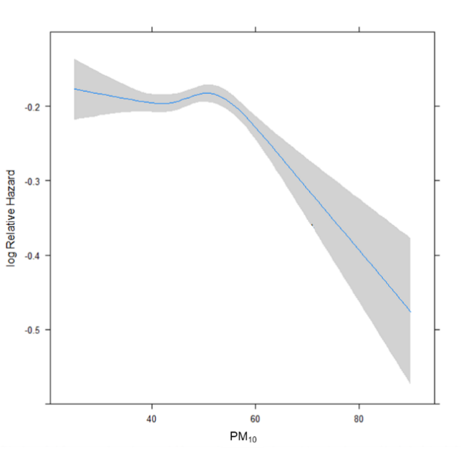 | 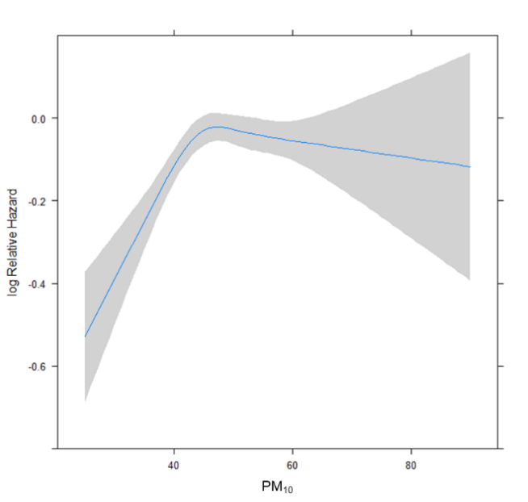
<Alzheimer’s Disease> | <Vascular Dementia>
Supplementary Figure 1. Exposure-response relationship between PM₁₀ and dementia type

