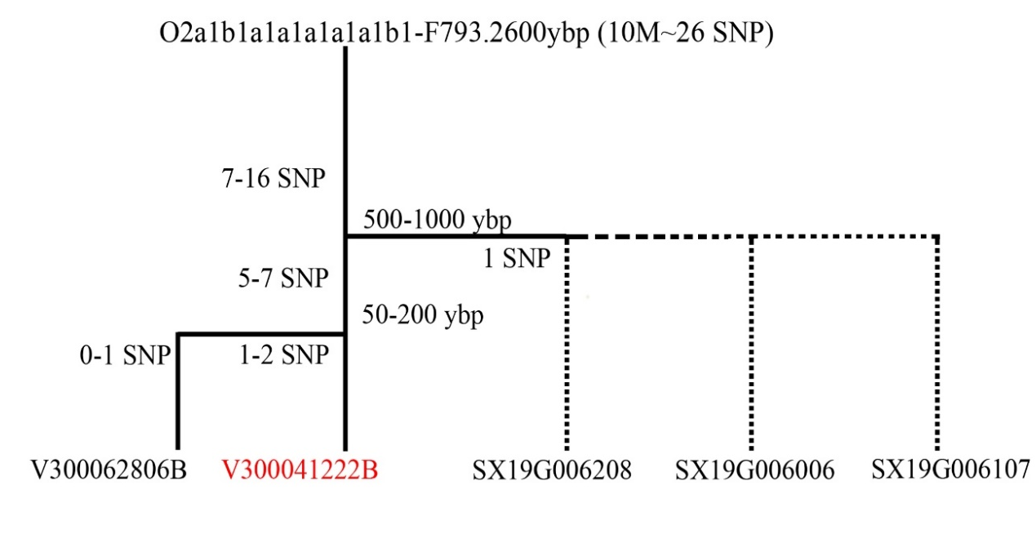
Fig.S1 The procedure of how to deduce coancestry by differentiated SNP sites

