Supplementary Figure 1
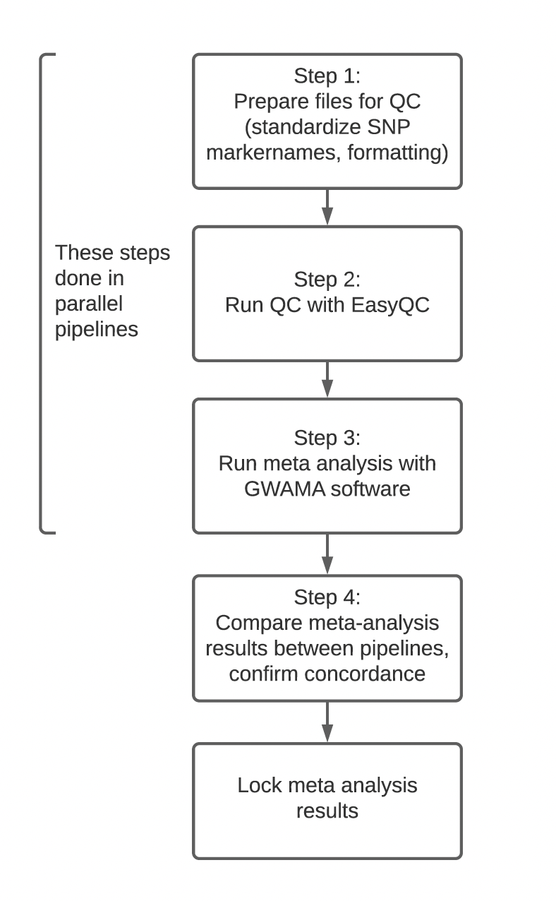

Steps of analysis performed, as described in methods section.

Supplemental Figure 2
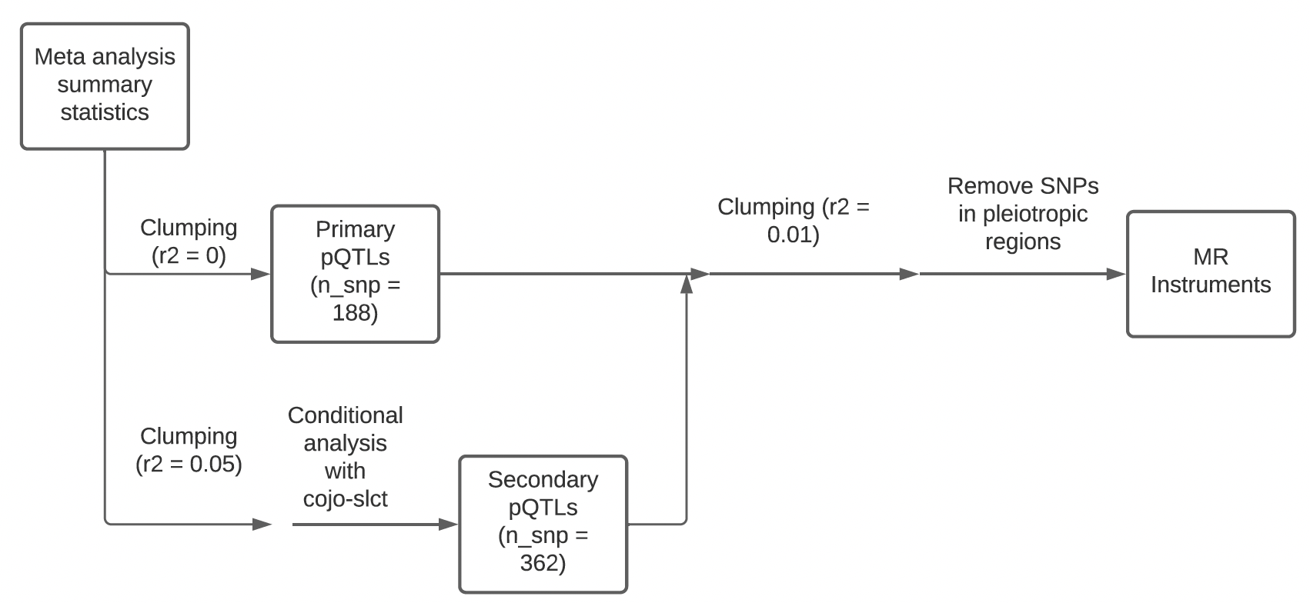

Meta-analysis methods and determination of primary and secondary pQTLs and Mendelian randomization instruments.

Supplementary Figure 3

Phenotypic correlation matrix across all proteins analyzed.

Supplementary Figure 4

Genotypic correlation matrix across all proteins analyzed.

