Supplementary tables

Supplementary table 1: Fit of tested models
Model | df | AIC
Ancestral chromosome LM | 28 | 3237.31
Simple chromosome LM | 25 | 3319.60
Interacting chromosome LM | 53 | 3079.848
Ancestral chromosome LMM | 29 | 3182.88
Simple chromosome LMM | 26 | 3234.73
Interacting chromosome LMM | 54 | 2872.45
Ancestral chromosome GLM | 27 | 3107.78
Simple chromosome GLM | 24 | 3222.77
Interacting chromosome GLM | 52 | 3004.23
Ancestral chromosome GLM | 28 | 3109.78
Simple chromosome GLM | 25 | 3198.24
Interacting chromosome GLMM | 53 | 3006.22
Supplementary table 1: Test the fit of linear models with the corresponding ancestral chromosome for each partition retained as a predictor (ancestral chromosome), with the corresponding ancestral chromosome collapsed into categoris of autosome, micro-chromosome, and sex chromosome (simple chromosome), and testing for an interacting effect from species (interacting).

Supplementary table 1: Fit of tested models
Model | df | AIC
Ancestral chromosome GLM | 27 | 3107.78
Simple chromosome GLM | 24 | 3222.77
Interacting chromosome GLM | 52 | 3004.23
Ancestral chromosome GLM | 28 | 3109.78
Simple chromosome GLM | 25 | 3198.24
Interacting chromosome GLMM | 53 | 3006.22
Supplementary table 1: Test the fit of linear models with the corresponding ancestral chromosome for each partition retained as a predictor (ancestral chromosome), with the corresponding ancestral chromosome collapsed into categoris of autosome, micro-chromosome, and sex chromosome (simple chromosome), and testing for an interacting effect from species (interacting).

Supplementary table 2: Regression coefficients of retained factors in each species model
 | P. pennipes | I. elegans | P. flavescens | T. hageni
Mcfadden’s pseudo-R² | .14 | .19 | .29 | .34
Corresponding ancestral chromosome
One | - | 0.13 | -0.21 | 0.06
Two | - | -0.31 | -0.04 | 0.02
Three | - | -0.12 | -0.06 | 0.11
Four | - | 0.12 | -0.07 | 0.06
Five | - | - | -0.18 | <0.01
Six | - | -0.20 | -0.15 | 0.11
Seven | - | -0.25 | -0.22 | -0.03
Nine | - | -0.30 | -0.18 | -0.18
Ten | - | -0.34 | -0.16 | -0.15
Eleven | - | -0.35 | -0.32 | -0.32
m | - | -19.02 | - | -2.66
X | - | -0.69 | -0.93 | -0.75
Chromosome classification
Micro | -17.93 | - | † | -
Sex | -0.37 | - | - | -
Relative proportions
CDS content | 35.65 | 10.37 | 30.35 | 42.08
Retroelements | - | -6.57 | - | -5.05
Transposons | 0 | -13.48 | - | -
Unclassified repetitive elements | -1.40 | 7.38 | - | -
Other repetitive elements | -37.88 | -18.76 | - | -
Other factors
GC content | - | - | - | -10.48
Relative position | - | -0.02 | -0.06 | -
Table one: Regression coefficients of generalized linear models using chromosome classification (sex chromosome, micro chromosome, or autosome), corresponding ancestral chromosome, chromosome state change (fusion, fission, or none),CDS content, GC content, relative position of the partition on the chromosome, and the proportion of unclassified repeats, retroelements, transposons and other repetitive elements influenced the number of syntenic blocks in chromosome partitions for T. hageni, P. flavescens, I. elegans, and P. pennipes. Factors not included in the final model for each species are denoted with a single “-”
†Not available to be retained in species model
Note: chromosome state change was not retained in any model.

Supplementary table 3: Regression coefficients of retained factors in retroelement models
 | I. elegans | T. hageni
Mcfadden’s pseudo-R² | .21 | .35
Corresponding ancestral chromosome
One | 0.24 | 0.06
Two | -0.32 | 0.01
Three | -0.10 | 0.10
Four | 0.15 | 0.06
Five | - | <0.01
Six | -0.25 | 0.10
Seven | -0.22 | -0.03
Nine | -0.27 | .21
Ten | -0.31 | .01
Eleven | -0.36 | -0.15
m | -19.00 | -2.70
X | -0.78 | -0.80
Relative proportions
CDS content | 9.07 | 42.00
Long interspersed nuclear elements | -7.56 | -5.57
Short interspersed nuclear elementns | 292.12 | -
Transposons | -13.48 | -
Unclassified repetitive elements | 5.28 | -
Other repetitive elements | -23.34 | -
Other factors
GC content | - | -10.53
Relative position | -0.02 | -
Table one: Regression coefficients of generalized linear models using retained factors from original models, with retroelements broken down into the relative proportion of long interspersed nuclear elements, short interspersed nuclear elements, and long terminal repetitive elements, for species where retroelements were retained in the original model.
Note: Long terminal repats were not retained in either model.
x=retained in model. Factors not included in the final model for each species are denoted with a single “-”
Note: chromosome state change was not retained in any model.

Supplementary figures

Figure S1: Repetitive content of publicly available Odonata genomes
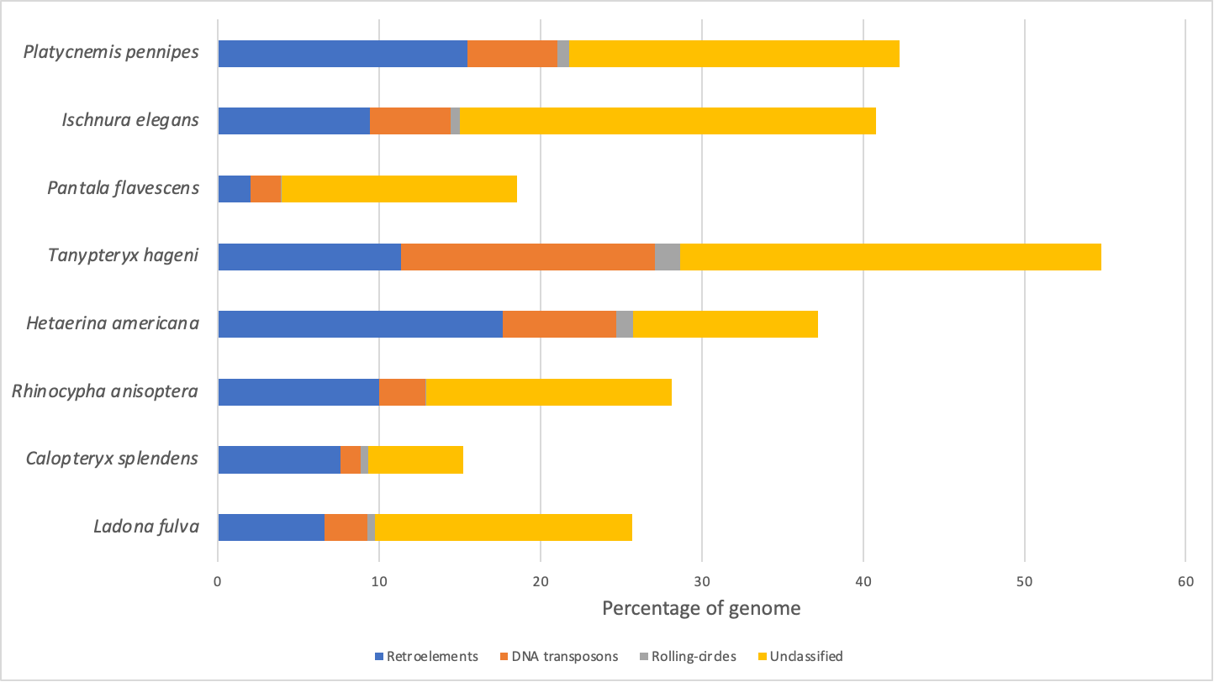
Figure S1: Data on repetitive content of eight Odonata genomes. The first four species (Tanypteryx hageni, Pantala flavescens, Ischnura elegans and Platycnemis pennipes) all have chromosome-level assemblies and are the focus of this work. The other species (Hetaerina americana, Rhinocypha anisoptera, Calopteryx splendens and Ladona fulva) are also publicly available genome assemblies of differing qualities. The relative proportion of retroelements, DNA transposons, rolling-circles and unclassified repetitive elements are compared.

Supplementary figure S2: Retroelement composition of Odonata Genomes
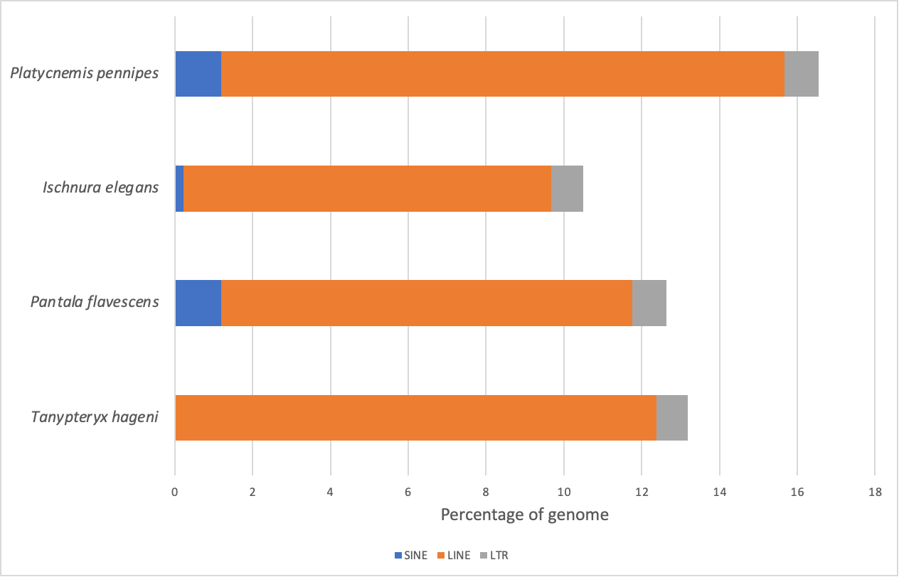
Supplementary figure S2: Shows the relative proportion of different classes of retroelements in the genomes of P. pennipes, I. elegans, P. flavescens and T. hageni. Classes shown are short interspersed nuclear elements (SINEs), long interspersed nuclear elements (LINEs), and long terminal repeats (LTRs). Classes of retroelements were identified using RepeatMasker³⁵.

