Supplementary information

Same same, but different: exploring the enigmatic role of the pituitary adenylate cyclase-activating polypeptide (PACAP) in invertebrate physiology

¹Zsolt Pirger, ²Péter Urbán, ²Bence Gálik, ³László Márk, ⁴Gábor K. Tóth, ⁵Joris M. Koene, ⁶György Kemenes, ⁷Dóra Reglődi, ¹Tibor Kiss, and ¹István Fodor*

¹Ecophysiological and Environmental Toxicological Research Group, Balaton Limnological Research Institute, Eötvös Loránd Research Network, Tihany, Hungary
²Genomics and Bioinformatics Core Facilities, Szentágothai Research Centre, University of Pécs, 7624 Pécs, Hungary
³Institute of Biochemistry and Medical Chemistry, Medical School, University of Pécs, 7624 Pécs, Hungary
⁴ Department of Medical Chemistry, University of Szeged, Szeged, Hungary
⁵Ecology & Evolution, Amsterdam Institute for Life and Environment, Faculty of Science, Vrije Universiteit, Amsterdam, the Netherlands
⁶Sussex Neuroscience, School of Life Sciences, University of Sussex, Brighton, BN1 9QG, UK
⁷Department of Anatomy, ELKH-PTE PACAP Research Team, Centre for Neuroscience, Medical School, University of Pecs, 7624, Pecs, Hungary

*Corresponding author; E-mail: fodor.istvan@blki.hu (I Fodor)

Supplementary Table 1. Members of the Secretin neuropeptide superfamily (based on the Cardoso et al. 2020 review¹).
Secretin peptide family
Secretin
Vasoactive Intestinal Peptide (VIP)
Peptide Histidine Isoleucine (PHI)
PACAP
PACAP-Related Peptide (PRP)
Growth Hormone-Releasing Hormone (GHRH)
Glucagon peptide family
Glucagon (GCG)
Glucagon-Like Peptide 1 (GLP1)
Glucagon-Like Peptide 2 (GLP2)
Glucosedependent Insulinotropic Peptide (GIP)

Supplementary Table 2. Data on the presence and function of PACAP peptides and their receptors in protozoan, non-bilaterian, and protostome species. The relevant L. stagnalis data are highlighted with red color. Abbreviations: MS – mass spectrometry, IHC – immunohistochemistry, WB – Western blotting, CNS – central nervous system, PKA – protein kinase A, PKC – protein kinase C, AC –adenylyl cyclase
Taxon  (Species) | Gene for prepropeptide or receptor | cDNA for prepropeptide or receptor | MS | IHC | WB | Effect of PACAP-27/38 on cAMP synthesis | Effect of PACAP-27/38  on physiology | Effect of antagonists | Effect of other inhibitors | Reference(s)
Protozoa  Tetrahymena thermophila | not found | not found | not investigated | not investigated | not investigated | increased by PACAP-38 | chemorepulsion by human PACAP-38 | receptor activation | not investigated | ¹⁻³
Porifera | not found | not found | not investigated | not investigated | not investigated | not investigated | not investigated | not investigated | not investigated | ¹
Placozoa | not found | not found | not investigated | not investigated | not investigated | not investigated | not investigated | not investigated | not investigated | ¹
Cnetophora | not found | not found | not investigated | not investigated | not investigated | not investigated | not investigated | not investigated | not investigated | ¹
Cnidaria  Hydra magnipapillata | not found | a partial sequence for PACAP-38 but later studies failed to verify it | not investigated | not investigated | not investigated | not investigated | not investigated | not investigated | not investigated | ^{1,4,5}
Planaria  Dugesia japonica | not found | a partial sequence for PACAP-38 but later studies failed to verify it | not investigated | not investigated | not investigated | not investigated | not investigated | not investigated | not investigated | ^{1,4,5}
Annelida  Lumbricus terrestris | not  investigated | not found | not investigated | positive signal with mammalian antibodies for PACAP-27 and PACAP-38 | not investigated | not investigated | not investigated | not investigated | not investigated | ^{6,7}
Annelida  Lumbricus  polyphemus | not  investigated | not  investigated | not investigated | positive signal with a mammalian antibody for PACAP-38 | not investigated | not investigated | not investigated | not investigated | not investigated | ⁶
Annelida  Eisenia fetida | not found | not found | not investigated | positive signal with mammalian and fish antibodies for PACAP-27, PACAP-38, and PAC₁ | positive signal with mammalian antibodies for PACAP-38 and PAC₁ | not investigated | not investigated | not investigated | not investigated | ⁷⁻¹²
Cephalopoda  Sepioteuthis lessoniana | not found | a partial sequence for PACAP-38 but later studies failed to verify it | not investigated | not investigated | not investigated | not investigated | not investigated | not investigated | not investigated | ^{1,4,5}
Gastropoda  Helix pomatia | not investigated | not investigated | identified PACAP-like peptide fragments in the CNS | positive signal with mammalian antibodies for PACAP-27, PACAP-38, and PAC₁ | positive signal with mammalian antibodies for PACAP-27, PACAP-38, and PAC₁ | increased by PACAP-38 in the homogenate of salivary gland | extracellular application of human PACAP-27/38 transiently depolarized or increased postsynaptic  activity of neurons or elicited a long-lasting hyperpolarization; anti-apoptotic effect in the salivary gland; pretreating the flexor muscle in the posterior tentacle with human PACAP-27 enhanced the nerve-evoked contraction (presynaptic effect on the nicotinic neuromuscular contact); pretreating the flexor muscle with human PACAP-27 enhanced the ACh-evoked contraction (postsynaptic effect) | PACAP-6/27 blocked both presynaptic and postsynaptic effects | DMDA (ACh-R antagonist) or H-7 (PKA and PKC blocker) blocked the presynaptic effect; M65 (PAC₁ antagonist) or H-7 or ChelCl (PKC blocker) blocked the postsynaptic effect | ¹³⁻¹⁵
Gastropoda  Lymnaea stagnalis | not found  (this study) | not found  (this study) | identified PACAP-like peptide fragments in the CNS | positive signal with mammalian antibodies for PACAP-38 in the CNS and PAC₁ in the heart (latter: this study) | positive signal with mammalian antibodies for PACAP-38  (this study) | increased by PACAP-38 in the homogenate of CNS | PACAP is necessary and instructive for the formation of associative memory; systematic application of human PACAP-38 reversed age-related memory impairment; systematic application of human PACAP-38 has a neuroprotective function in dopamine-based neurodegeneration developed in the Lymnaea parkinsonian model | PACAP-6/38 reduced the cAMP-increasing effect; PACAP-6/38 blocked the formation of associative memory; PACAP-6/38 blocked the memory-boosting effect | actinomycin-D (transcription inhibitor) blocked the memory-boosting effect | ¹⁶⁻¹⁹
Insecta  Drosophila melanogaster | not found | not found | not investigated | positive signal with a mammalian antibody | positive signal with a mammalian antibody | not investigated but AC activity increased by PACAP-38 | focal application of human PACAP-38 to the neuromuscular junction region caused an immediate depolarization and a late, large enhancement of K+ current in muscles;  exposure of  larval neuromuscular preparation to human PACAP-38 enhanced the K+ current; exposure of larval muscle to human PACAP-38 modified calcium  ion transport | PACAP-6/38 abolished the calcium transport effect | 2',5'-dideoxyadenosine (AC inhibitor) abolished the effect on calcium transport;  H-89 (PKA inhibitor) abolished the effect on calcium transport | ²⁰⁻²²
Insecta Periplaneta  americana | not found | a partial sequence for PACAP-38 but later studies failed to verify it | not investigated | not investigated | not investigated | not investigated | not investigated | not investigated | not investigated | ^{1,4,5}
Crustacea  Eriocheir japonica | not investigated | a partial sequence for PACAP-38 | not investigated | not investigated | not investigated | not investigated | not investigated | not investigated | not investigated | ^{1,4,5}
Crustacea  Litopenaeus vannamei | not investigated | a partial sequence for PACAP-38 | not investigated | not investigated | not investigated | not investigated | shrimp PACAP-38 in the water boosted innate immunity of the animals (increased hemocyte count, superoxide  dismutase activity, lectins and nitric oxide synthase derived metabolites, total protein concentration, growth) | not investigated | not investigated | ²³

Supplementary Figure 1. Schematic representation of L. stagnalis showing the position of the heart (consisting of an auricle [A] and ventricle [V]) next to the kidney (K) (A) – modified after²⁴. Dissected heart from L. stagnalis showing the auricle and ventricle. Scale bar = 2 mm (B). Abbreviations: LN – lip nerves; CNS – central nervous system; BM – buccal mass; LN – lip nerve; LPN and RPN – left and right parietal nerves; IN – intestinal nerve; AA – anterior aorta; PA – posterior aorta
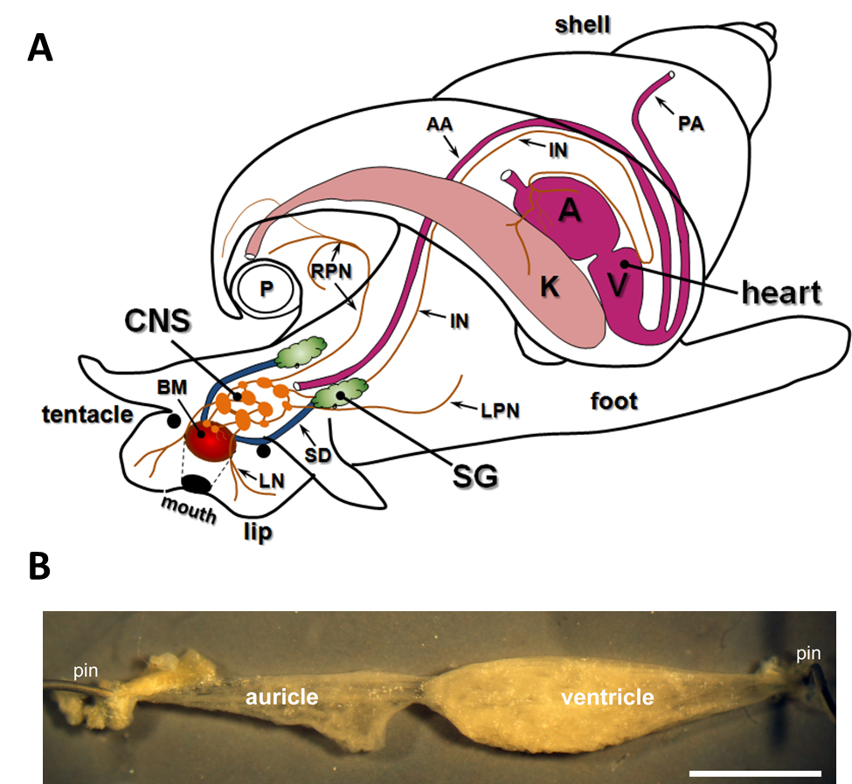

Supplementary Table 3. In silico predicted fragments of the human PACAP-38 peptide. Although the masses of some fragments obtained from the bands (see Figure 2b in the main text) apparently match the in silico predicted fragments (indicated with gray color), the fragment sequence searches did not show identity or similarity. Hence, the presence of vertebrate PACAP-38 can be excluded in L. stagnalis.
Number | Range | Mono MH⁺ | Partials | Sequence | Composition
1 | [ 1- 12] | 1384.613 | 0 | HSDGIFTDSYSR | C59H85N17O22
2 | [ 1- 14] | 1703.777 | 1 | HSDGIFTDSYSRYR | C74H106N22O25
3 | [ 1- 15] | 1831.872 | 2 | HSDGIFTDSYSRYRK | C80H118N24O26
4 | [13- 14] | 338.182 | 0 | YR | C15H23N5O4
5 | [13- 15] | 466.277 | 1 | YRK | C21H35N7O5
6 | [13- 20] | 1023.577 | 2 | YRKQMAVK | C45H78N14O11S1
8 | [15- 20] | 704.412 | 1 | KQMAVK | C30H57N9O8S1
9 | [15- 21] | 832.507 | 2 | KQMAVKK | C36H69N11O9S1
10 | [16- 20] | 576.317 | 0 | QMAVK | C24H45N7O7S1
11 | [16- 21] | 704.412 | 1 | QMAVKK | C30H57N9O8S1
12 | [16- 29] | 1519.903 | 2 | QMAVKKYLAAVLGK | C70H122N18O17S1
14 | [21- 29] | 962.603 | 1 | KYLAAVLGK | C46H79N11O11
15 | [21- 30] | 1118.704 | 2 | KYLAAVLGKR | C52H91N15O12
16 | [22- 29] | 834.508 | 0 | YLAAVLGK | C40H67N9O10
17 | [22- 30] | 990.609 | 1 | YLAAVLGKR | C46H79N13O11
18 | [22- 32] | 1281.768 | 2 | YLAAVLGKRYK | C61H100N16O14
20 | [30- 32] | 466.277 | 1 | RYK | C21H35N7O5
21 | [30- 34] | 750.437 | 2 | RYKQR | C32H55N13O8
22 | [31- 32] | 310.176 | 0 | YK | C15H23N3O4
23 | [31- 34] | 594.336 | 1 | YKQR | C26H43N9O7
24 | [31- 36] | 821.499 | 2 | YKQRVK | C37H64N12O9
25 | [33- 34] | 303.178 | 0 | QR | C11H22N6O4
26 | [33- 36] | 530.341 | 1 | QRVK | C22H43N9O6
27 | [33- 38] | 772.479 | 2 | QRVKNK | C32H61N13O9
28 | [35- 36] | 246.181 | 0 | VK | C11H23N3O3
29 | [35- 38] | 488.319 | 1 | VKNK | C21H41N7O6
30 | [37- 38] | 261.156 | 0 | NK | C10H20N4O4

Supplementary Figure 2. Generalized sequence conservation of the described invertebrate and vertebrate PACAP mature peptides. Conserved amino acids are indicated with asterisk.

*:********************************..:*
Human: HSDGIFTDSYSRYRKQMAVKKYLAAVLGKRYKQRVKNK
Rat: HSDGIFTDSYSRYRKQMAVKKYLAAVLGKRYKQRVKNK
Chicken: HIDGIFTDSYSRYRKQMAVKKYLAAVLGKRYKQRVKNK
Frog: HSDGIFTDSYSRYRKQMAVKKYLAAVLGKRYKQRIKNK
Fish: HSDGIFTDSYSRYRKQMAVKKYLAAVLGKRYRQRYRSK
Insect: HSDGIFTDSYSRYRKQMAVKKYLAAVLGKRYRQRYRSK
Mollusk: HSDGIFTDSYSRYRKQMAVKKYLAAVLGKRYRQRYRNK
Cnidaria: HSDGIFTDSYSRYRKQMAVKKYLAAVLGKRYRQRYRNK

References
1 Cardoso, J. C. R., Garcia, M. G. & Power, D. M. Tracing the Origins of the Pituitary Adenylate-Cyclase Activating Polypeptide (PACAP). Front. Neurosci. 14, 366, doi:10.3389/fnins.2020.00366 (2020).
2 Hassenzahl, D. L. et al. Chemorepellent signaling through the PACAP/lysozyme receptor is mediated through cAMP and PKC in Tetrahymena thermophila. J. Comp. Physiol. A. 187, 171-176, doi:10.1007/s003590100185 (2001).
3 Keedy, M. et al. Pharmacological evidence suggests that the lysozyme/PACAP receptor of Tetrahymena thermophila is a polycation receptor. Acta. Protozoo.l 42, 11-17 (2003).
4 Kiss, T. & Pirger, Z. Multifunctional role of PACAP-like peptides in molluscs. Protein Pept. Lett. 20, 628-635, doi:10.2174/0929866511320060003 (2013).
5 Pirger, Z., Krajcs, N. & Kiss, T. Occurrence, Distribution, and Physiological Function of Pituitary Adenylyl Cyclase-Activating Polypeptide in Invertebrate Species. in Pituitary Adenylate Cyclase Activating Polypeptide — PACAP (eds D. Reglodi & A. Tamas), Current Topics in Neurotoxicity Vol. 11 (Springer Nature, New York, 2016).
6 Reglodi, D., Lengvari, I., Szelier, M., Vigh, S. & Arimura, A. Distribution of PACAP-like immunoreactivity in the nervous system of oligochaeta. Peptides 21, 183-188, doi:10.1016/s0196-9781(99)00201-6 (2000).
7 Molnar, L. et al. Comparative anatomy of PACAP-immunoreactive structures in the ventral nerve cord ganglia of lumbricid oligochaetes. Ann. N. Y. Acad. Sci. 1070, 427-430, doi:10.1196/annals.1317.056 (2006).
8 Boros, A. et al. Changes in the expression of PACAP-like compounds during the embryonic development of the earthworm Eisenia fetida. J. Mol. Neurosci. 36, 157-165, doi:10.1007/s12031-008-9102-6 (2008).
9 Varhalmi, E. et al. Expression of PACAP-like compounds during the caudal regeneration of the earthworm Eisenia fetida. J. Mol. Neurosci. 36, 166-174, doi:10.1007/s12031-008-9125-z (2008).
10 Molnar, L. et al. PAC1 receptor localization in a model nervous system: light and electron microscopic immunocytochemistry on the earthworm ventral nerve cord ganglia. Regul. Pept. 145, 96-104, doi:10.1016/j.regpep.2007.09.014 (2008).
11 Boros, A. et al. Pituitary adenylate cyclase-activating polypeptide type 1 (PAC1) receptor is expressed during embryonic development of the earthworm. Cell Tissue Res. 339, 649-653, doi:10.1007/s00441-009-0909-4 (2010).
12 Somogyi, I. et al. Pituitary adenylate cyclase-activating polypeptide-like compounds could modulate the activity of coelomocytes in the earthworm. Ann. N. Y. Acad. Res. 1163, 521-523, doi:10.1111/j.1749-6632.2009.04431.x (2009).
13 Pirger, Z. et al. PACAP has anti-apoptotic effect in the salivary gland of an invertebrate species, Helix pomatia. J. Mol. Neurosci. 36, 105-114, doi:10.1007/s12031-008-9070-x (2008).
14 Krajcs, N. et al. PACAP Modulates Acetylcholine-Elicited Contractions at Nicotinic Neuromuscular Contacts of the Land Snail. J. Mol. Neurosci. 57, 492-500, doi:10.1007/s12031-015-0605-7 (2015).
15 Hernadi, L. et al. The presence and distribution of pituitary adenylate cyclase activating polypeptide and its receptor in the snail Helix pomatia. Neuroscience 155, 387-402, doi:10.1016/j.neuroscience.2008.05.003 (2008).
16 Pirger, Z. et al. A homolog of the vertebrate pituitary adenylate cyclase-activating polypeptide is both necessary and instructive for the rapid formation of associative memory in an invertebrate. J. Neurosci. 30, 13766-13773, doi:10.1523/JNEUROSCI.2577-10.2010 (2010).
17 Pirger, Z. et al. Pituitary adenylate cyclase activating polypeptide (PACAP) and its receptors are present and biochemically active in the central nervous system of the pond snail Lymnaea stagnalis. J. Mol. Neurosci. 42, 464-471, doi:10.1007/s12031-010-9361-x (2010).
18 Pirger, Z. et al. Reversal of Age-Related Learning Deficiency by the Vertebrate PACAP and IGF-1 in a Novel Invertebrate Model of Aging: The Pond Snail (Lymnaea stagnalis). J. Gerontol. A. Biol. 69, 1331-1338, doi:10.1093/gerona/glu068 (2014).
19 Maasz, G. et al. Pituitary adenylate cyclase-activating polypeptide (PACAP) has a neuroprotective function in dopamine-based neurodegeneration in rat and snail parkinsonian models. Dis. Model. Mech. 10, 127-139, doi:10.1242/dmm.027185 (2017).
20 Zhong, Y. Mediation of PACAP-like neuropeptide transmission by coactivation of Ras/Raf and cAMP signal transduction pathways in Drosophila. Nature 375, 588-592, doi:10.1038/375588a0 (1995).
21 Bhattacharya, A., Lakhman, S. S. & Singh, S. Modulation of L-type calcium channels in Drosophila via a pituitary adenylyl cyclase-activating polypeptide (PACAP)-mediated pathway. J. Biol. Chem. 279, 37291-37297, doi:10.1074/jbc.M403819200 (2004).
22 Zhong, Y. & Pena, L. A. A novel synaptic transmission mediated by a PACAP-like neuropeptide in Drosophila. Neuron 14, 527-536, doi:10.1016/0896-6273(95)90309-7 (1995).
23 Lugo, J. M. et al. First report of the pituitary adenylate cyclase activating polypeptide (PACAP) in crustaceans: conservation of its functions as growth promoting factor and immunomodulator in the white shrimp Litopenaeus vannamei. Fish Shellfish Immunol. 35, 1788-1796, doi:10.1016/j.fsi.2013.08.028 (2013).
24 Kerkhoven, R. M. et al. Axonal mapping of the giant peptidergic neurons VD1 and RPD2 located in the CNS of the pond snail Lymnaea stagnalis, with particular reference to the innervation of the auricle of the heart. Brain Res. 565, 8-16, doi:10.1016/0006-8993(91)91730-o (1991).

