ECONOMIC EVALUATION OF CEFIDEROCOL FOR THE TREATMENT OF CARBAPENEM-RESISTANT INFECTIONS IN ITALY
Authors: Matteo Bassetti¹, Andrea Pitrelli², Maria Laura Notarianni², Will Green³, Amy Dymond³, Karan Gill².
Affiliations and addresses:
¹ Clinica Malatttie Infettive, Università di Genova Ospedale Policlinico San Martino-IST Genova, Italy
² Shionogi B.V. UK, London, UK
³ York Health Economics Consortium, York, United Kingdom
Table S.1: Time on treatment
Infection type | Treatment | Time on initial therapy if response (days) | Time to salvage therapy if no response (days) | Time to death (days)
cUTI | Cefiderocol | 9.6 [1] | 7.4 [2] | 7.4 (Assumed equal to time to salvage: no response)
cUTI | Colistin | 9.5 [3] | 12.6 [2] (Assumed equal to best alternative therapy arm) | 12.6 (Assumed equal to time to salvage: no response)
cUTI | Ceftazidime/avibactam | 7.5 [3] | 12.6 [2] (Assumed equal to best alternative therapy arm) | 19 [4]
cUTI | Carbapenems | 9.7 [1] | 12.6 [2] (Assumed equal to best alternative therapy arm) | 12.6 (Assumed equal to time to salvage: no response)
Pneumonia | Cefiderocol | 10.4 [5] | 12.6 [2] (Assumed equal to best alternative therapy arm) | 12.6 (Assumed equal to time to salvage: no response)
Pneumonia | Colistin | 12.9 [16] | 12.6 [2] (Assumed equal to best alternative therapy arm) | 12.6 (Assumed equal to time to salvage: no response)
Pneumonia | Ceftazidime/avibactam | 7.0 [6] | 12.6 [2] (Assumed equal to best alternative therapy arm) | 19 [4]
Pneumonia | Carbapenems | 10.1 [5] | 12.6 [2] (Assumed equal to best alternative therapy arm) | 12.6 (Assumed equal to time to salvage: no response)
BSI/sepsis | Cefiderocol | 11.5 [2] | 12.6 [2] (Assumed equal to best alternative therapy arm) | 12.6 (Assumed equal to time to salvage: no response)
BSI/sepsis | Colistin | 12.9 (Assumed equal to pneumonia) | 12.6 [2] (Assumed equal to best alternative therapy arm) | 12.6 (Assumed equal to time to salvage: no response)
BSI/sepsis | Ceftazidime/avibactam | 7.5 (Assumed equal to cUTI) | 12.6 [2] (Assumed equal to best alternative therapy arm) | 19 [4]
BSI/sepsis | Carbapenems | 11.5 (Assumed equal to cefiderocol) | 12.6 [2] (Assumed equal to best alternative therapy arm) | 12.6 (Assumed equal to time to salvage: no response)
Weighted infection | Cefiderocol | 10.6 | 11.1 | 11.1
Weighted infection | Colistin | 11.9 | 12.6 | 12.6
Weighted infection | Ceftazidime/avibactam | 7.3 | 12.6 | 19.0
Weighted infection | Carbapenems | 10.5 | 12.6 | 12.6
cUTI: Complicated urinary tract infection

Appendix A: Clinical Efficacy and Susceptibility (Suspected Carbapenem Resistant Population)
Despite the completion of a targeted literature review, no data were available to quantify the probability that a patient is resistant to carbapenem after previously being classified as high-risk. Therefore, a clinical expert advised that approximately 70% of high-risk patients would be classified as carbapenem resistant (CR), with the remaining 30% carbapenem susceptible (CS). Therefore, this value informed the first decision node within the model.
Pathogen susceptibility indicates the effectiveness of a specific treatment against a defined pathogen or defined class/group of pathogens and was used to determine if the initial treatment received within the suspected CR population scenario was appropriate or inappropriate. The susceptibility data of cefiderocol and ceftazidime/avibactam was informed by Shionogi (data on file).
The treatment effectiveness of cefiderocol as initial therapy is populated from the Phase III APEKS clinical trial for complicated urinary tract infection (cUTI) and pneumonia. Treatment effectiveness data for bloodstream infection (BSI)/sepsis were not available from the APEKS trial and, therefore, a pooled analysis from the patients with bacteriemia included in APEKS cUTI and pneumonia trials was used to populate the effectiveness of cefiderocol in this infection site.
The treatment effectiveness of cefiderocol as initial therapy was populated from the Phase III APEKS clinical trial for cUTI and pneumonia [1, 5]. Data to inform the treatment effectiveness of ceftazidime/avibactam within the cUTI and pneumonia populations was obtained from two large-scale phase III randomised controlled trials, which were considered to have the most robust study design out of those obtained from a targeted literature search [7, 8]. The treatment effectiveness of ceftazidime/avibactam within the BSI/sepsis population was estimated using an average of the cUTI and pneumonia populations due to a lack of alternative information.
The treatment effectiveness of colistin as a salvage treatment colistin within the suspected CR population was also obtained from the clinical cure at the end of treatment within the CREDIBLE Phase III randomised controlled trial [2].
Appropriate vs Inappropriate Treatment
Following clinical consultation, it was assumed that 70% and 95% of patients with a CR and CS infection, respectively, receiving appropriate treatment upon entry to the model would qualify for treatment de-escalation. A network-meta analysis was identified that estimated the increased risk of death incurred by patients that incurred a delay in receiving appropriate treatment of approximately 15 days [9]. The analysis was based upon a pooled estimate of 12 studies among patients receiving appropriate vs inappropriate antibiotics and calculated an odds ratio of 0.45 (95% confidence intervals 0.29 to 0.70), which was applied to all patients that received inappropriate therapy upon entry to the model. It was also assumed that patients receiving inappropriate therapy upon entry to the model incurred an extended hospital stay of 4.90 and 5.50 days, for patients with a CR and CS infection, respectively compared to those that received appropriate treatment [10].
Table S.2: Additional clinical parameters (suspected CR infection)
Infection type | Treatment | Susceptability data (scenario analysis only) |  |  |  |  | Source
Infection type | Treatment | Enterobacterales | Acinetobacter Baumanni | Stenotrophomonas maltophilia | Pseudomonas aeruginosa | Weighted pathogen | Source
cUTI | Cefiderocol | 83.0% | 97.1% | 100.0% | 98.8% | 88.3% | [11]
cUTI | Ceftazidime/avibactam | 73.9% | 21.0% | 50.9% | 65.4% | 66.4% | [11]
Pneumonia | Cefiderocol | 69.9% | 99.0% | 100.0% | 97.1% | 79.5% | [11]
Pneumonia | Ceftazidime/avibactam | 74.8% | 13.7% | 38.9% | 77.7% | 68.3% | [11]
BSI/sepsis | Cefiderocol | 83.3% | 94.1% | 100.0% | 98.1% | 88.1% | [11]
BSI/sepsis | Ceftazidime/avibactam | 73.8% | 11.3% | 38.7% | 62.9% | 64.4% | [11]
Weighted infection | Cefiderocol | 78.9% | 96.5% | 100.0% | 98.0% | 85.4% | [11]
Weighted infection | Ceftazidime/avibactam | 74.1% | 14.8% | 42.2% | 68.3% | 66.2% | [11]
Infection type | Treatment | Probability of sustained response from initial treatment in suspected CR population (scenario analysis only)
Infection type | Treatment | Enterobacterales | Acinetobacter Baumanni | Stenotrophomonas maltophilia | Pseudomonas aeruginosa | Weighted pathogen | Source
cUTI | Cefiderocol | 90.2% | 89.7% | 89.7% | 73.3% | 86.7% | [1]
cUTI | Ceftazidime/avibactam | 90.3% | 0.0% | 0.0% | 90.3% | 78.0% | [7]
Pneumonia | Cefiderocol | 64.2% | 52.2% | 77.2% | 66.7% | 64.3% | [5]
Pneumonia | Ceftazidime/avibactam | 68.8% | 0.0% | 0.0% | 68.8% | 59.4% | [8]
BSI/sepsis | Cefiderocol | 80.4% |  |  |  |  | Assumption
BSI/sepsis | Ceftazidime/avibactam | 79.6% | 0.0% | 0.0% | 79.6% | 68.7% | Assumption
Weighted infection | Cefiderocol | 78.8% | 74.0% | 82.0% | 74.0% | 77.70% | Calculation
Weighted infection | Ceftazidime/avibactam | 79.2% | 0.00% | 0.00% | 79.2% | 68.3% | Calculation
Treatment |  | Probability of an adverse event |  |  |  |  | Source
 |  | Renal impairment |  | Clostridium difficile infection |  |  | Source
Ceftazidime/avibactam |  | 3.2% |  | 0.0% |  |  | [12]
Carbapenems |  | 0.7% |  | 0.6% |  |  | Data on file
BSI: bloodstream infection; cUTI: complicated urinary tract infection;
Table S.3: Additional cost and utility parameters
Treatment | Unit cost |  | Units per pack |  | Units per day | Cost per day | Source
Ceftazidime/avibactam | €1,108.03 |  | 10 |  | 3 | €332.41 | [13]
Carbapenems | €119.89 |  | 10 |  | 6 | €71.93 | [13]
Mereopenem (treatment descalation) |  |  |  |  |  | €35.97 | [13]
Infection (confirmed CR) |  | Hospital cost per day (inappropriate treatment) |  | Length of stay (days)† |  | Cost per hospital stay | Source
cUTI |  | €443.29 |  | 11.8 |  | €5,230.82 | SDO2019
Pneumonia |  | €477.29 |  | 13.4 |  | €6,395.69 | SDO2019
BSI/sepsis |  | €556.33 |  | 18.2 |  | €10,125.21 | SDO2019
Weighted infection |  | €499.99 |  | 14.8 |  | €7,409.89 | SDO2019
Infection (confirmed CS) |  | Hospital cost per day (inappropriate treatment) |  | Length of stay (days) |  | Cost per hospital stay | Source
cUTI |  | €443.29 |  | 12.4 |  | €5,496.80 | SDO2019
Pneumonia |  | €477.29 |  | 14.0 |  | €6,682.06 | SDO2019
BSI/sepsis |  | €556.33 |  | 18.8 |  | €10,459.00 | SDO2019
Weighted infection |  | €499.99 |  | 15.4 |  | €7,709.29 | SDO2019
†Calculated based on increased length of stay associated with inappropriate treatment; BSI: bloodstream infection; CR: carbapenem resistant; CS: carbapenem susceptible; cUTI: complicated urinary tract infection

Appendix B: Sensitivity Analyses (scenario analysis: suspected CR population)
The results of the deterministic sensitivity analysis (DSA) are presented in Figure S.1 as a tornado diagram and show the ten parameters that most influenced the incremental net monetary benefit (based on a cost-effectiveness threshold of €40,000). In the base case analysis, the treatment sequence containing cefiderocol is cost-effective in comparison to the sequence containing ceftazidime/avibactam (with a positive net monetary benefit of €36,525). Results from the DSA show that the probability of a sustained clinical cure, associated with both treatments, influences the outcomes most. Cefiderocol remains cost-effective when all inputs were varied individually. The probability sensitivity analysis (PSA) results also showed that the treatment sequence containing cefiderocol was cost-effective in 79.4% of iterations (as displayed in Figure S.2).
Figure S.1: One-way deterministic sensitivity analysis (scenario analysis: suspected CR population)
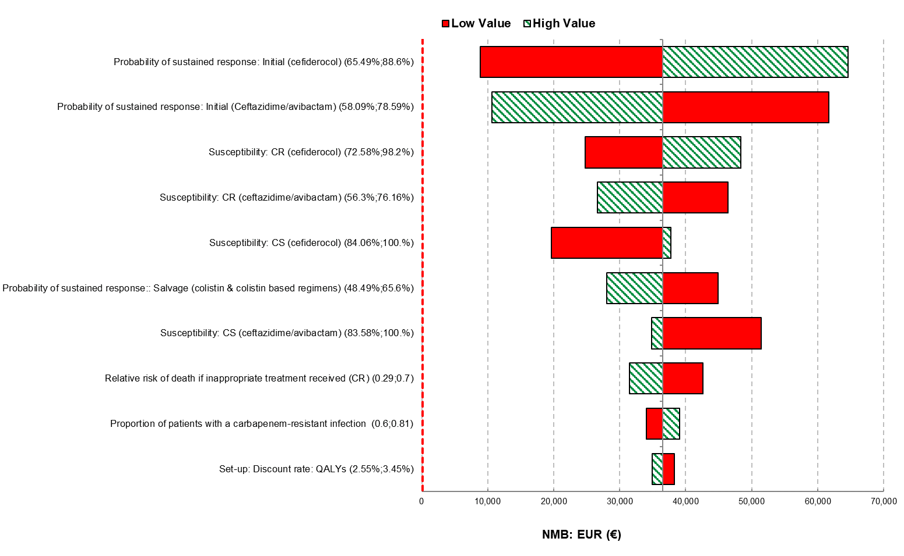
Figure S.2: Probabilistic cost-effectiveness plane (scenario analysis: suspected CR population)

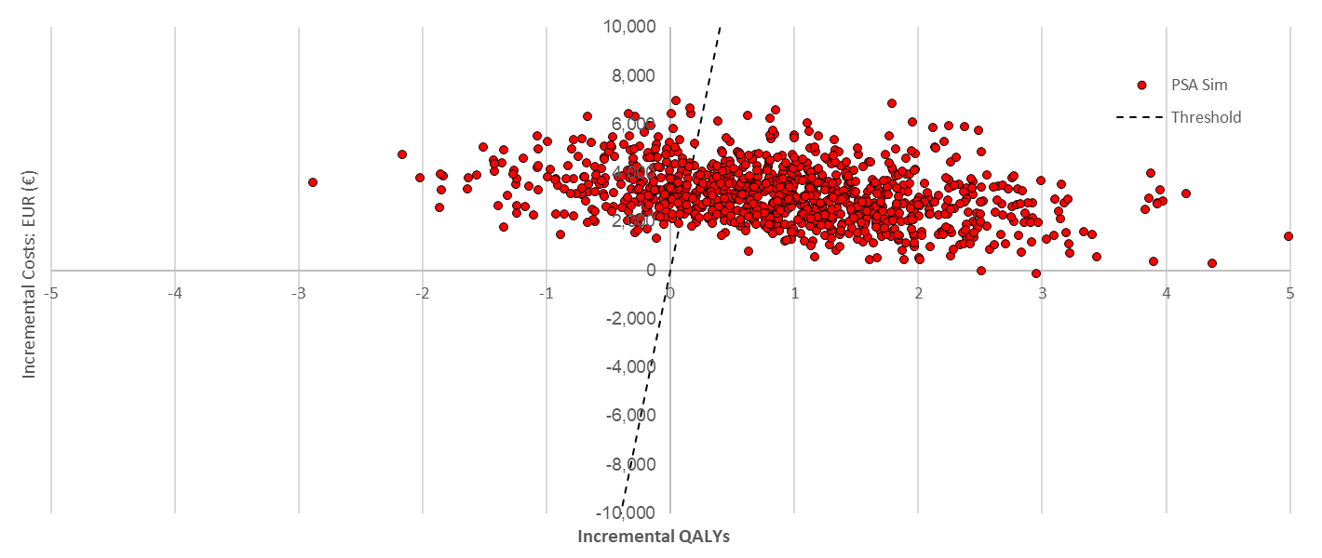

REFERENCES
1. Shionogi. A Study of Efficacy/Safety of Intravenous S-649266 Versus Imipenem/Cilastatin in Complicated Urinary Tract Infections (APEKS-cUTI). Bethesda: US National Library of Medicine: 2016 2016.
2. Bassetti M, Echols R, Matsunaga Y, Ariyasu M, Doi Y, Ferrer R, et al. Efficacy and safety of cefiderocol or best available therapy for the treatment of serious infections caused by carbapenem-resistant Gram-negative bacteria (CREDIBLE-CR): a randomised, open-label, multicentre, pathogen-focused, descriptive, phase 3 trial. The Lancet Infectious Diseases. 2021;21(2):226-40.
3. Kongnakorn T, Wagenlehner F, Falcone M, Tichy E, Di Virgilio R, Baillon-Plot N, et al. Cost-effectiveness analysis of ceftazidime/avibactam compared to imipenem as empirical treatment for complicated urinary tract infections. Int J Antimicrob Agents. 2019;54(5):633-41.
4. Temkin E, Torre-Cisneros J, Beovic B, Benito N, Giannella M, Gilarranz R, et al. Ceftazidime-avibactam as salvage therapy for infections caused by carbapenem-resistant organisms. Antimicrob Agents Chemother. 2017;61(2):e01964-16.
5. Shionogi. Clinical Study of S-649266 for the Treatment of Nosocomial Pneumonia Caused by Gram-negative Pathogens (APEKS-NP). Bethesda: US National Library of Medicine: 2017.
6. Simon MS, Sfeir MM, Calfee DP, Satlin MJ. Cost-effectiveness of ceftazidime-avibactam for treatment of carbapenem-resistant Enterobacteriaceae bacteremia and pneumonia. Antimicrob Agents Chemother. 2019
7. Wagenlehner FM, Sobel JD, Newell P, Armstrong J, Huang X, Stone GG, et al. Ceftazidime-avibactam Versus Doripenem for the Treatment of Complicated Urinary Tract Infections, Including Acute Pyelonephritis: RECAPTURE, a Phase 3 Randomized Trial Program. Clin Infect Dis. 2016;63(6):754-62.
8. Torres A, Zhong N, Pachl J, Timsit JF, Kollef M, Chen Z, et al. Ceftazidime-avibactam versus meropenem in nosocomial pneumonia, including ventilator-associated pneumonia (REPROVE): a randomised, double-blind, phase 3 non-inferiority trial. Lancet Infect Dis. 2018;18(3):285-95.
9. Consortium YHE. Systematic Review on Impact of Delay in Appropriate Therapy in Hospital for Bacterial Infections (Impact of Delay) Unpublished: 2019.
10. Bonine NG, Berger A, Altincatal A, Wang R, Bhagnani T, Gillard P, et al. Impact of Delayed Appropriate Antibiotic Therapy on Patient Outcomes by Antibiotic Resistance Status From Serious Gram-negative Bacterial Infections. Am J Med Sci. 2019;357(2):103-10.
11. Candel FJ, Henriksen AS, Longshaw C, Yamano Y, Oliver A. In vitro activity of the novel siderophore cephalosporin, cefiderocol, in Gram-negative pathogens in Europe by site of infection. Clinical Microbiology and Infection. 2021
12. Torres A, Zhong N, Pachl J, Timsit J-F, Kollef M, Chen Z, et al. Ceftazidime-avibactam versus meropenem in nosocomial pneumonia, including ventilator-associated pneumonia (REPROVE): a randomised, double-blind, phase 3 non-inferiority trial. The Lancet Infectious Diseases. 2018;18(3):285-95.
13. Ufficiale G. Serie Generale n.19 del 25-01-2021. 2021. Available from: https://www.gazzettaufficiale.it/gazzetta/serie_generale/caricaDettaglio?dataPubblicazioneGazzetta=2021-01-25&numeroGazzetta=19.

