Supporting Information (SI)

Dual Architecture and Bioenergetics of Cellulose-Graphene Oxide-Arginine Aerogel Supports Stem Cell Bioactivity for Cartilage Regeneration
Puneet Pareek¹ , Shivani Chaudhary¹, Sonu Singh¹, Aiswarya Thattaru Thodikayil², Dinesh Kalyanasundaram^{1,3}, Sachin Kumar^{1,3*}
¹Centre for Biomedical Engineering, Indian Institute of Technology Delhi, New Delhi 110016, India
²Department of Materials Science and Engineering, Indian Institute of Technology Delhi, New Delhi 110016, India
³Department of Biomedical Engineering, All India Institute of Medical Sciences, New Delhi 110029, India

*Corresponding authors: sachin.kumar@cbme.iitd.ac.in
ORCID: Sachin Kumar: 0000-0002-1898-1578

This supporting information file includes supporting figures and data
Table S1: List of synthetic, natural, and hybrid scaffold materials with their respective morphology used for cartilage regeneration.
1. Color changes during the different reaction stage for the synthesis of GO from graphite using modified Hummers
Figure S1: Digital images representing color changes (A-C) of solution during the different reaction stage for the synthesis of GO from graphite using modified Hummers and (D) Graphene oxide flake obtained after reaction by lyophilization.
2. Arginine adsorption and quantification
Figure S2: Quantification of Arginine using Bradford standard plot. (A) BSA concentration-dependent Bradford standard curve, (B) Arginine concentration-dependent Bradford standard curve, and (C) Absorbance of Arginine left in supernatant after 72 hr incubation with GO solution at different pH.
3. Porosity measurement of Aerogel
4. Aqueous stability of stage 2 Aerogel samples
Figure S3: Aquaeous stability of aeogel samples. (A) Digital images of aerogel immersed in water for 2 weeks show good stability without releasing aerogel fragments or GO flakes. (B) UV-Vis spectra of control GO, CNF solution, and aqueous solution collected from CNF and CNF-GO immersed aerogel.
5. Indirect bioactivity analysis of CNF-GO-Arg aerogel
Figure S4: Digital image showing Alican blue and Alizarin red S staining of stem cells in control and arginine treated media at day 21
6. References

Table S1: List of synthetic, natural, and hybrid scaffold materials with their respective morphology used for cartilage regeneration.
Material | Scaffold Fabrication Method | Type of material | Morphology | Citation
Collagen | Freeze drying | Natural | Micropores | [1]
Hyaluronic acid - chitosan | Wet spinning | Hybrid | Fibrous | [2]
Chitosan | Freeze drying | Natural | Micropores | [3]
Chitosan – Polyglycolide (PGA) | Freeze drying | Natural | Micropores with mesh | [4]
Fibrin | Freeze drying | Natural | Porous | [5]
Polycaprolactone (PCL) | Electrospinning | Natural | Nanofibrous | [6]
poly(l-lactide-co-ε-caprolactone) and Collagen  (PLCL) (COL) | 3D Printing | Natural | Microporous | [7]
poly(l-lactide-co-ε-caprolactone) and chitosan | Freeze drying and crosslinking | Natural | Microporous | [8]
ACI Maix (MACI) – collage type I and type III | crosslinking | Natural | Nanofibrous | [9]
Chitosan, pectin and Poly -L- Lactide | Freeze drying | Natural | Microporous | [10]
Polycaprolactone (PCL) | 3D Printing | Natural | Micropores | [11]
poly(l-lactide-co-ε-caprolactone) PLCL | Gel pressing | Hybrid | Microporous | [12]
Polyurethane | Freeze drying | Synthetic | Micropores | [13]
Poly(lactic-co-glycolic acid) (PLGA) | Electrospinning | Natural | Fibrous | [14]
Polyether sulfone (PES) | Electrospinning | Synthetic | Nanofibrous | [15]
Alginate | Microfluidic technology | Natural | Honeycomb shaped micropores | [16]

1. Graphene oxide (GO) synthesized by oxidation of graphite using modified Hummers
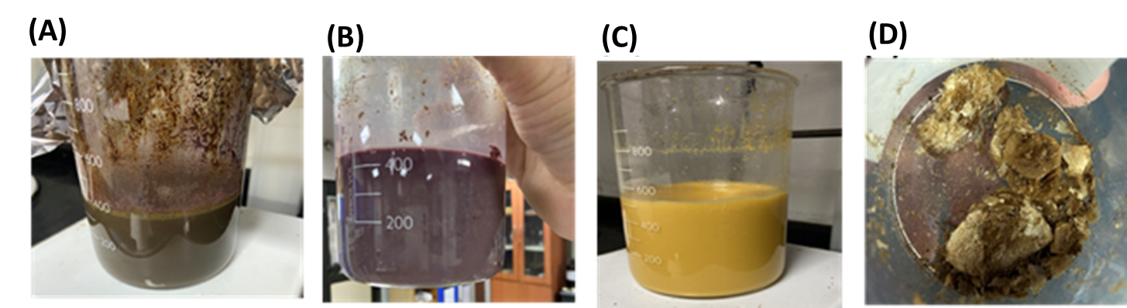
Figure S1: Digital images representing color changes (A-C) of solution during the different reaction stage for the synthesis of GO from graphite using modified Hummers and (D) Graphene oxide flake obtained after reaction by lyophilization.
2. Arginine adsorption and quantification
To quantitatively determine the amount of Arginine adsorption, Bradford protein assay was used. First, a standard curve for Bradford assay using bovine serum albumin (BSA) protein was prepared. BSA aqueous solution of different concentration (2, 1.5, 1, 0.75, 0.5, 0.25 mg/ml) were prepared and 40 µL of different concentrated BSA solutions were added in a 96 well plate in triplet. 160 µL of Bradford reagent was added to each well containing BSA solution and incubated for 10 minutes. The plate was read in a plate reader (Agilent Biotek LX multimode) at 595 nm. Similar to BSA, arginine aqueous solutions of different concentrations (100, 75, 50, 25, 10, 0 mg/ml) were prepared, and a standard curve for Arginine solution was obtained using Bradford reagent similar to BSA. Using the obtained standard Arginine plot, the amount of Arginine in the collected supernatant from GO-Arg solution was evaluated and subtracted from the main solution to measure the amount of adsorbed Arginine on the GO surface indirectly.
We used the Bradford assay to evaluate the adsorption of Arginine on GO surface. Bradford reaction primarily works on the presence of basic amino acids like Arginine in protein. Coomassie blue dye in Bradford reagent readily binds to Arginine and Lysine groups of proteins which shift the Coomassie dye color brown to the blue [17]. Using BSA protein, Arginine amino acid, and Bradford reagent, we showed how simple arginine amino acid can chemically interact with Bradford reagent similar to that of BSA protein, turning the brown color of Bradford reagent to blue. Figures S2A and S2B show concentration-dependent spectroscopic quantification for BSA and Arginine using Bradford as a standard curve. The obtained Arginine standard curve was later used to quantify the amount of Arginine on the GO surface.
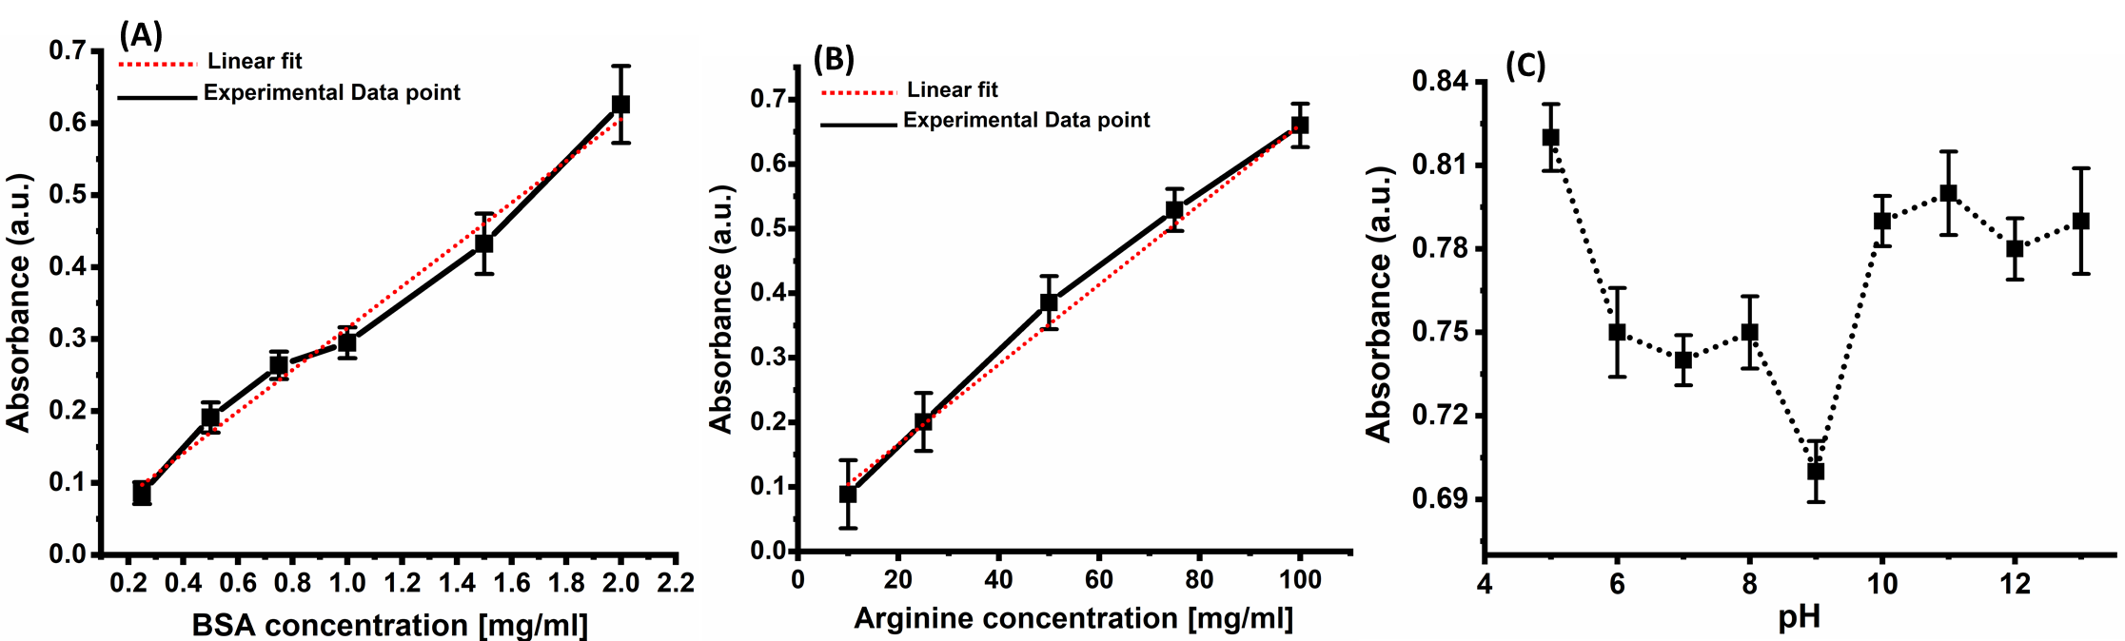
Figure S2: Quantification of Arginine using Bradford standard plot. (A) BSA concentration-dependent Bradford standard curve, (B) Arginine concentration-dependent Bradford standard curve, and (C) Absorbance of Arginine left in supernatant after 72 hr incubation with GO solution at different pH.
Figure S2C showed that supernatant collected after 72 hr incubation revealed minimum absorbance at pH ̴ 9. Minimum absorbance of Arginine at pH 9 suggested a low amount of free Arginine in the supernatant, which indirectly indicated a high amount of Arginine got coated on the GO surface leaving behind the low amount of free Arginine in the supernatant. Similarly, the amount of Arginine on the GO surface at different pH was evaluated using the standard arginine curve.
3. Porosity measurement of Aerogel
Porosity of prepared aerogels was evaluated using the liquid displacement method in accordance with reported literature [18]. In brief aerogel sample (diameter: 13 mm, height: 10 mm) was immersed in a graduate measuring cylinder containing a known volume of solvent Ethanol (V1). Porous aerogel samples were left in the small measuring cylinder for 10 min allowing ethanol to infiltrate into the pores of aerogel. Then the total volume of ethanol and the ethanol-soaked scaffold was recorded (V2). Soaked aerogel sample was then removed, and the remaining ethanol volume was measured (V3). The skeleton volume of the aerogel scaffold was represented by the volume difference (V2–V3), whereas the void volume of the scaffold was represented by the volume difference (V1–V3). The porosity (ε) of the aerogel scaffold was calculated as ε(%) = [ (V1–V3) / (V2–V3) ] * 100.

4. Aqueous stability of stage 2 Aerogel samples
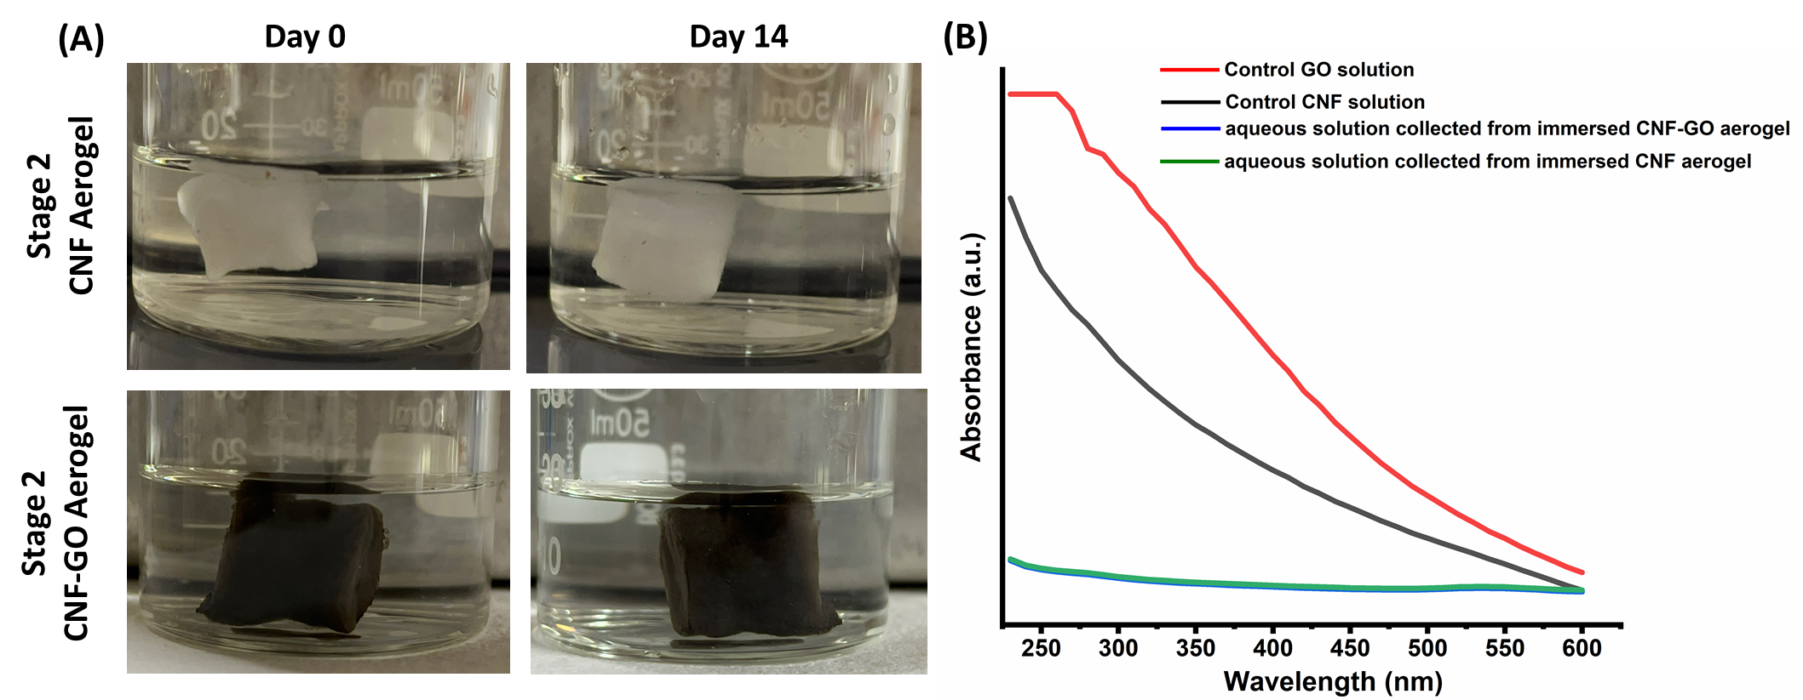
Figure S3: Aquaeous stability of aeogel samples. (A) Digital images of aerogel immersed in water for 2 weeks show good stability without releasing aerogel fragments or GO flakes. (B) UV-Vis spectra of control GO, CNF solution, and aqueous solution collected from CNF and CNF-GO immersed aerogel.
The leakage of the CNF fragment or leaching of GO flakes from the aerogel was evaluated by the appearance of aqueous solution and UV-Vis spectroscopy measurement. Aqueous solution of immersed aerogel appeared transparent even after 2 weeks (Figure S3A), suggesting no release of CNF or GO fragments from aerogel. The UV–Vis absorption spectroscopy of the control GO solution (0.05 mg/ml) exhibited a shoulder peak around 300 nm (Figure S3B) corresponding to the n → π* transition from the carbonyl (C=O) groups on the surface of GO [19]. A low concentration of CNF solution (0.1 mg/ml) did not show any clear peak or shoulder in the UV–visible wavelength range (230 – 600 nm) in the spectrum (Figure S3B). However, the presence of nanoscale cellulose fiber and GO fakes may cause absorption in the whole wavelength range due to the light scattering resulting in baseline shift for CNF and GO solution as shown in UV-Vis spectra (Figure S3B) [20]. In contrast, aqueous solution collected from CNF and CNF-GO immersed aerogel showed similar absorbance reading with an almost flat line in the entire UV–visible wavelength range, indicating the lack of any nanoscale cellulose fiber or GO flakes in the respective solution.
5. Indirect bioactivity analysis of CNF-GO-Arg aerogel
We have indirectly measured the bioactivity ability of CNF-GO-Arg aerogel to promote chondrogenic differentiation due to release of arginine. To mimic the release of arginine from CNF-GO-Arg aerogel, we added Arginine 0.4 and 0.7 mM in culture media corresponded to actual release of arginine from CNF-GO-Arg aerogel at day 14 and 21. After 21 days of culturing stem cells in control culture media (lacking arginine) and arginine treated media were stained with Alcian blue and Alizarin red S dye to evaluate their chondro and osteo differentiation respectively. Stem cells cultured in arginine treated media showed high Alcian blue staining in comparsion to Alizaring Red S, indicating presence of arginine 0.7 mM promoted more chondrogenic differentiation in comparison to osteogenic differentiation.
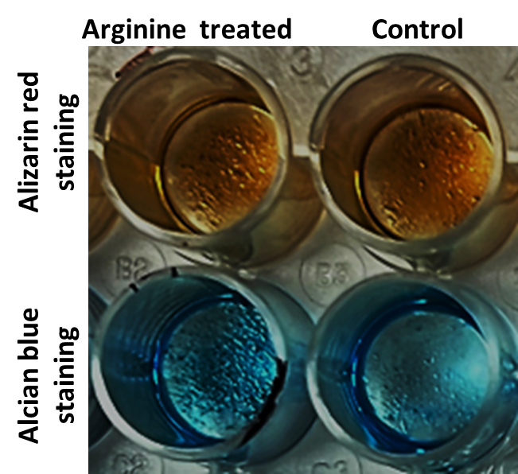
Figure S4: Digital image showing Alican blue and Alizarin red S staining of stem cells in control and arginine treated media at day 21
6. References
1. J. Glowacki, S. Mizuno, Collagen Scaffolds for Tissue Engineering. Biopolymers 89, 338-344 (2008)
2. S. Yamane, N. Iwasaki, T. Majima, T. Funakoshi, T. Masuko, K. Harada, A. Minami, K. Monde, S. Nishimura, Feasibility of Chitosan-Based Hyaluronic Acid Hybrid Biomaterial for a Novel Scaffold in Cartilage Tissue Engineering. Biomaterials 26, 611-619 (2005)
3. J. A. Gilbert, S. H. Elder, D. L. Nettles, Potential Use of Chitosan as a Cell Scaffold Material for Cartilage Tissue Engineering. Tissue Engineering 8, 7 (2002)
4. D. J. Griffon, M. R. Sedighi, D. V. Schaeffer, J. A. Eurell, A. L. Johnson, Chitosan Scaffolds: Interconnective Pore Size and Cartilage Engineering. Acta Biomater 2, 313-320 (2006)
5. V. P. Ribeiro, A. da Silva Morais, F. R. Maia, R. F. Canadas, J. B. Costa, A. L. Oliveira, J. M. Oliveira, R. L. Reis, Combinatory Approach for Developing Silk Fibroin Scaffolds for Cartilage Regeneration. Acta Biomater 72, 167-181 (2018)
6. W. J. Li, R. Tuli, C. Okafor, A. Derfoul, K. G. Danielson, D. J. Hall, R. S. Tuan, A Three-Dimensional Nanofibrous Scaffold for Cartilage Tissue Engineering Using Human Mesenchymal Stem Cells. Biomaterials 26, 599-609 (2005)
7. Y. He, W. Liu, L. Guan, J. Chen, L. Duan, Z. Jia, J. Huang, W. Li, J. Liu, J. Xiong, L. Liu, D. Wang, A 3d-Printed Plcl Scaffold Coated with Collagen Type I and Its Biocompatibility. Biomed Res Int 2018, 5147156 (2018)
8. C. Li, L. Wang, Z. Yang, G. Kim, H. Chen, Z. Ge, A Viscoelastic Chitosan-Modified Three-Dimensional Porous Poly(L-Lactide-Co-Epsilon-Caprolactone) Scaffold for Cartilage Tissue Engineering. J Biomater Sci Polym Ed 23, 405-424 (2012)
9. B. J. Huang, J. C. Hu, K. A. Athanasiou, Cell-Based Tissue Engineering Strategies Used in the Clinical Repair of Articular Cartilage. Biomaterials 98, 1-22 (2016)
10. M. Nofar, D. Sacligil, P. J. Carreau, M. R. Kamal, M. C. Heuzey, Poly (Lactic Acid) Blends: Processing, Properties and Applications. Int J Biol Macromol 125, 307-360 (2019)
11. K. Theodoridis, E. Aggelidou, T. Vavilis, M. E. Manthou, A. Tsimponis, E. C. Demiri, A. Boukla, C. Salpistis, A. Bakopoulou, A. Mihailidis, A. Kritis, Hyaline Cartilage Next Generation Implants from Adipose-Tissue-Derived Mesenchymal Stem Cells: Comparative Study on 3d-Printed Polycaprolactone Scaffold Patterns. J Tissue Eng Regen Med 13, 342-355 (2019)
12. Y. Jung, S. H. Kim, H. J. You, S. H. Kim, Y. H. Kim, B. G. Min, Application of an Elastic Biodegradable Poly(L-Lactide-Co-Epsilon-Caprolactone) Scaffold for Cartilage Tissue Regeneration. J Biomater Sci Polym Ed 19, 1073-1085 (2008)
13. M. C. Tsai, K. C. Hung, S. C. Hung, S. H. Hsu, Evaluation of Biodegradable Elastic Scaffolds Made of Anionic Polyurethane for Cartilage Tissue Engineering. Colloids Surf B Biointerfaces 125, 34-44 (2015)
14. H. J. Shin, C. H. Lee, I. H. Cho, Y. J. Kim, Y. J. Lee, I. A. Kim, K. D. Park, N. Yui, J. W. Shin, Electrospun Plga Nanofiber Scaffolds for Articular Cartilage Reconstruction: Mechanical Stability, Degradation and Cellular Responses under Mechanical Stimulation in Vitro. J Biomater Sci Polym Ed 17, 103-119 (2006)
15. H. Mahboudi, M. Soleimani, S. E. Enderami, M. Kehtari, H. Hanaee-Ahvaz, H. Ghanbarian, M. Bandehpour, S. Nojehdehi, S. Mirzaei, B. Kazemi, The Effect of Nanofibre-Based Polyethersulfone (Pes) Scaffold on the Chondrogenesis of Human Induced Pluripotent Stem Cells. Artif Cells Nanomed Biotechnol 46, 1948-1956 (2018)
16. C. C. Wang, K. C. Yang, K. H. Lin, H. C. Liu, F. H. Lin, A Highly Organized Three-Dimensional Alginate Scaffold for Cartilage Tissue Engineering Prepared by Microfluidic Technology. Biomaterials 32, 7118-7126 (2011)
17. S. J.Compton, C. G.Jones, Mechanism of Dye Response and Interference in the Bradford Protein Assay. Analytical Biochemistry 151, 5 (1985)
18. J. Shi, L. Lu, W. Guo, M. Liu, Y. Cao, On Preparation, Structure and Performance of High Porosity Bulk Cellulose Aerogel. Plastics, Rubber and Composites 44, 26-32 (2014)
19. S. Kumar, S. Raj, K. Sarkar, K. Chatterjee, Engineering a Multi-Biofunctional Composite Using Poly(Ethylenimine) Decorated Graphene Oxide for Bone Tissue Regeneration. Nanoscale 8, 6820-6836 (2016)
20. N. Yan, X.-S. Chai, T. Runge, A Simple Multi‐Wavelength Spectroscopic Method for the Determination of Carboxyl Group Content in Nanocellulose. Cellulose 28, 2805-2811 (2021)

