Personal Protective Equipment Waste Management Behavior of Undergraduates in Xi'an City: Extended Theory of Value-Identity-Personal Norm Model
Graphical Abstract | Authors
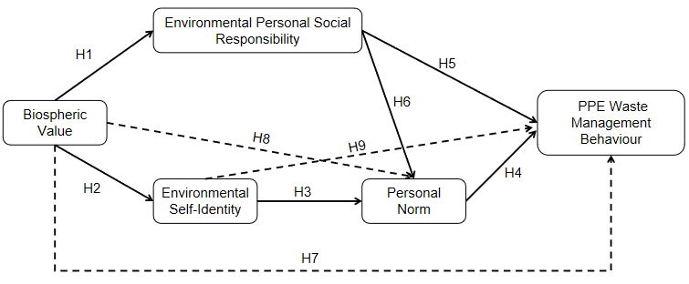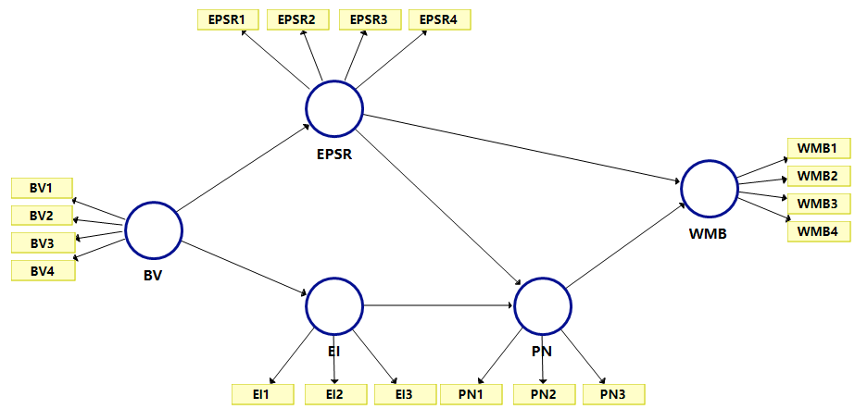  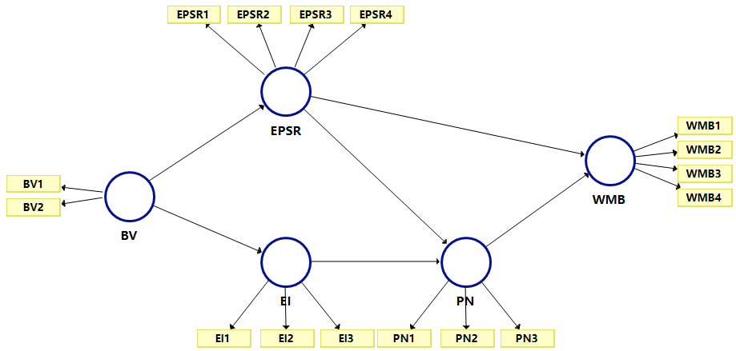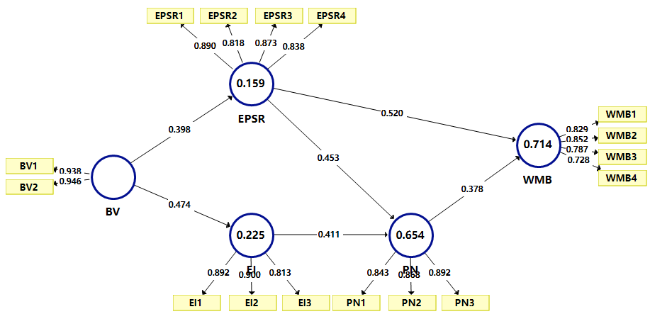 | Li Ting,, Xu Ting, Liang Yan, Luo Wei, Zhang Jin
In Brief
In this study, we used the extended Value-Identity-Personal (VIP) norm model to empirically analyze the influencing factors of pro-environmental behavior (PEB) among college students in Xi 'an, China, while considering the usage of PPE as an example of PEB. We proposed nine hypothetical questions, and the VIP model was established through the SmartPLS software to test the valid questionnaires of 414 college students. The verification results indicated that all the nine hypotheses ...

Highlights
- Pro-environmental behavior among college students in Xi 'an, China was analyzed
- Extended Value-Identity-Personal norm model was used for empirical analysis
- Factors influencing the PPE waste management behaviors were studied
- A total of 414 valid questionnaires were collected
- PPE management behavior had a low correlation with age and gender of the students

