Supplementary material

In these Supplementary Materials, we present figures that support the analysis described in the main paper, but which are not necessary to understand the main results.

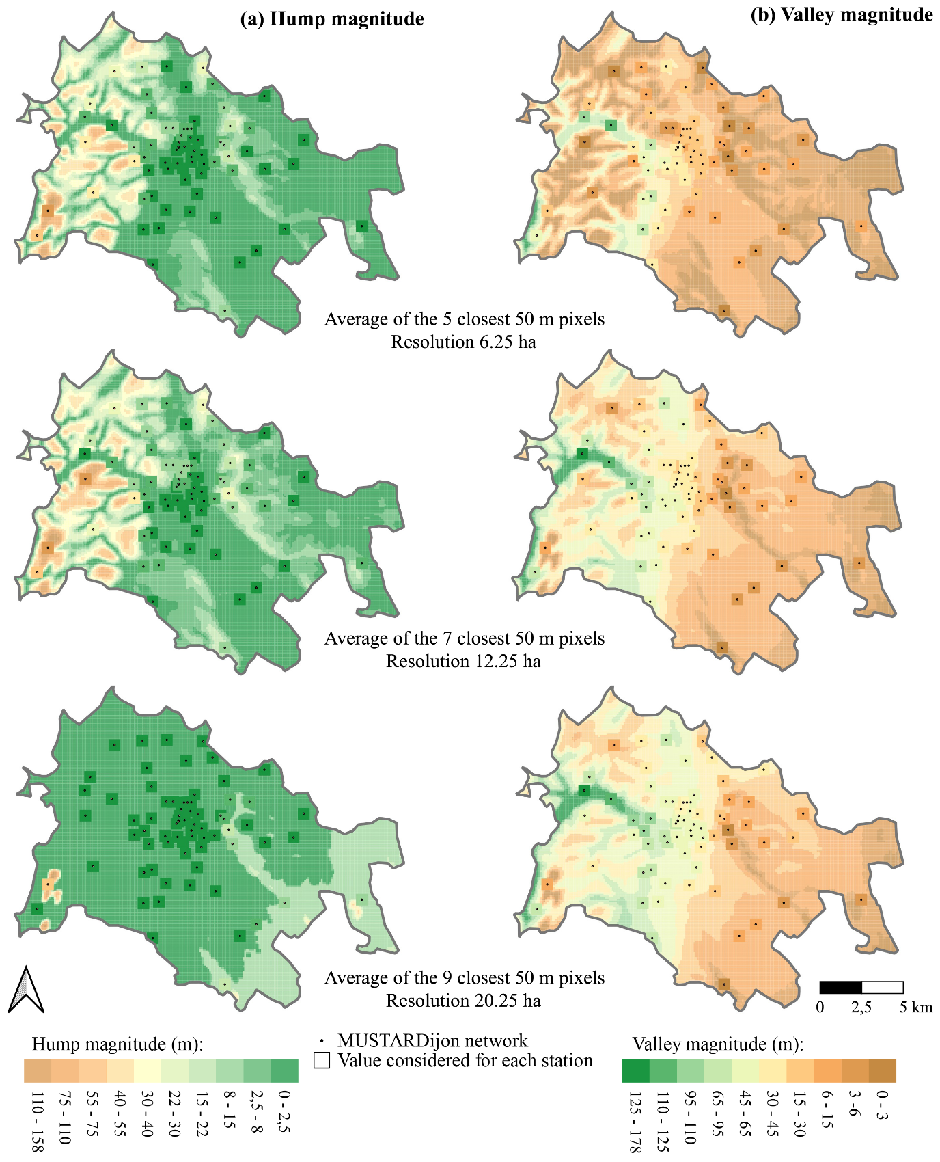

Supplementary Figure S1: Sensitivity of the (a) hump and (b) valley magnitude patterns to the number of pixels used for smoothing.

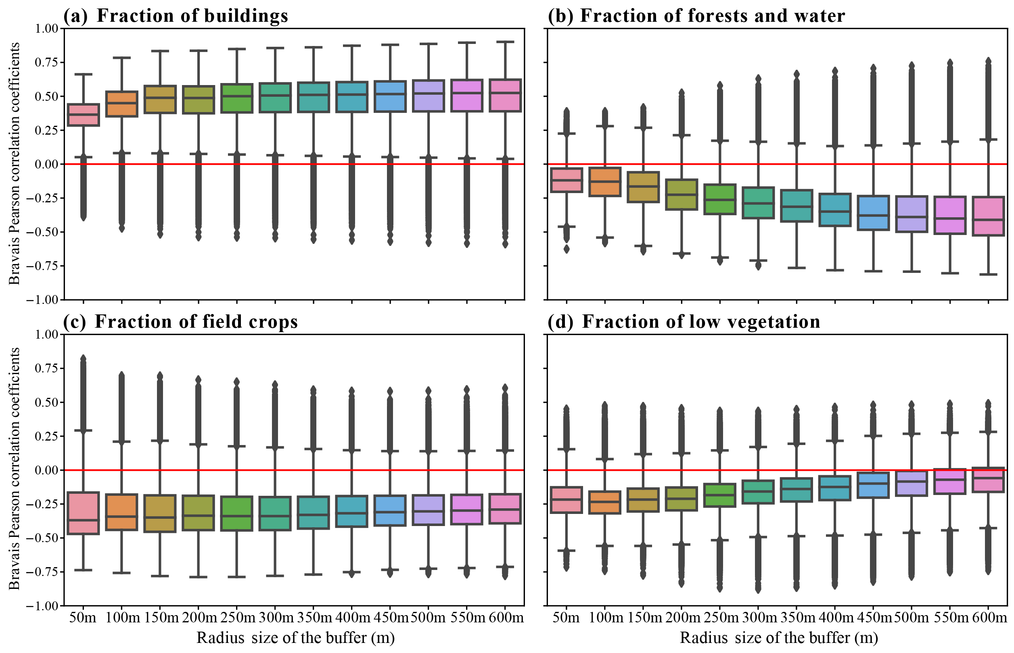

Supplementary Figure S2: Bravais Pearson correlation coefficients between hourly air temperature measured by the MUSTARDijon network and land cover descriptors computed using buffer size from 50m to 600m, every 50m, for the period 2014 – 2021.

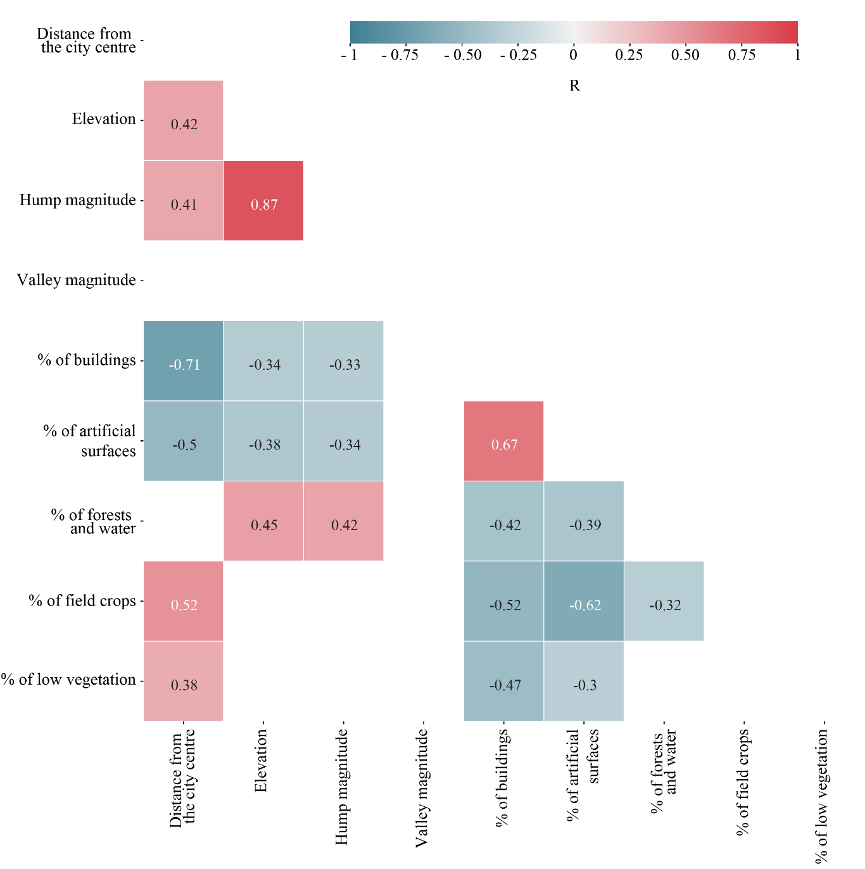

Supplementary Figure S3: Spatial collinearity between the potential predictors across the MUSTARDijon network used in the MLR models, as seen from Bravais Pearson correlations. Only correlation values exceeding the 99% confidence level are shown.

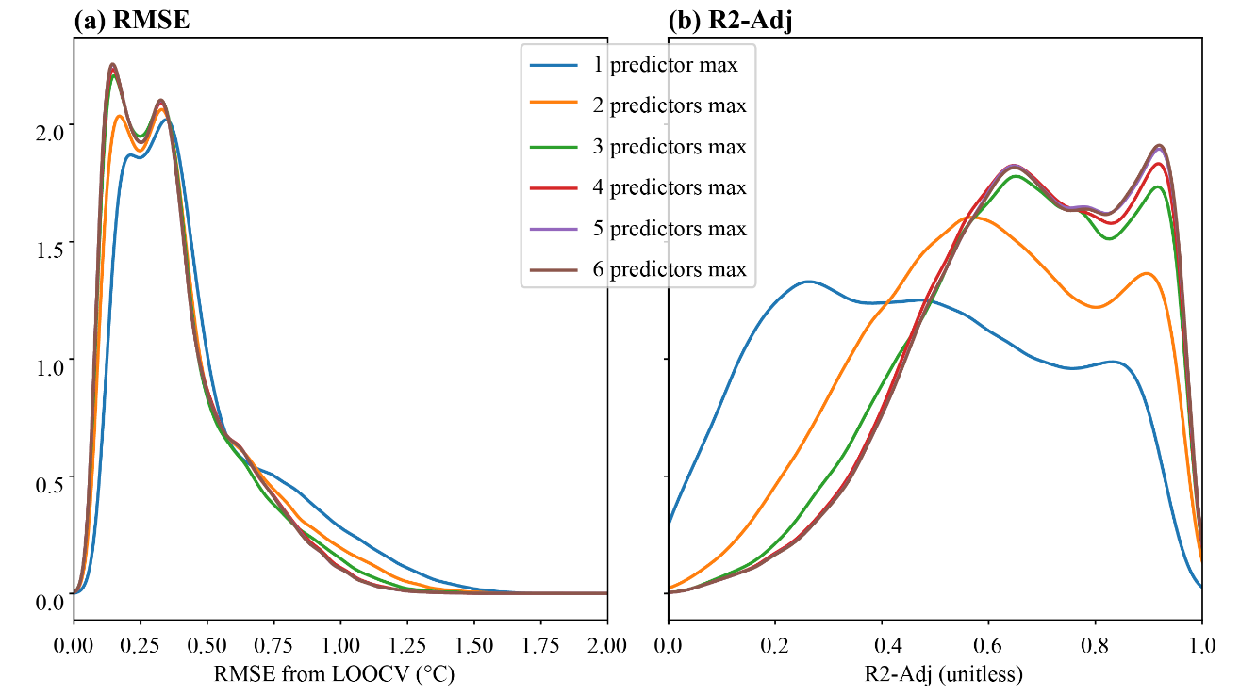

Supplementary Figure S4: Probability density function of (a) intensity and (b) spatial errors of the MLR models built with a maximum number of predictors varying between 1 and 6 (see Table 1) for the period 2014–2021. Magnitude and spatial errors are defined as the area-averaged RMSE from LOOCV and R2-Adj, respectively.

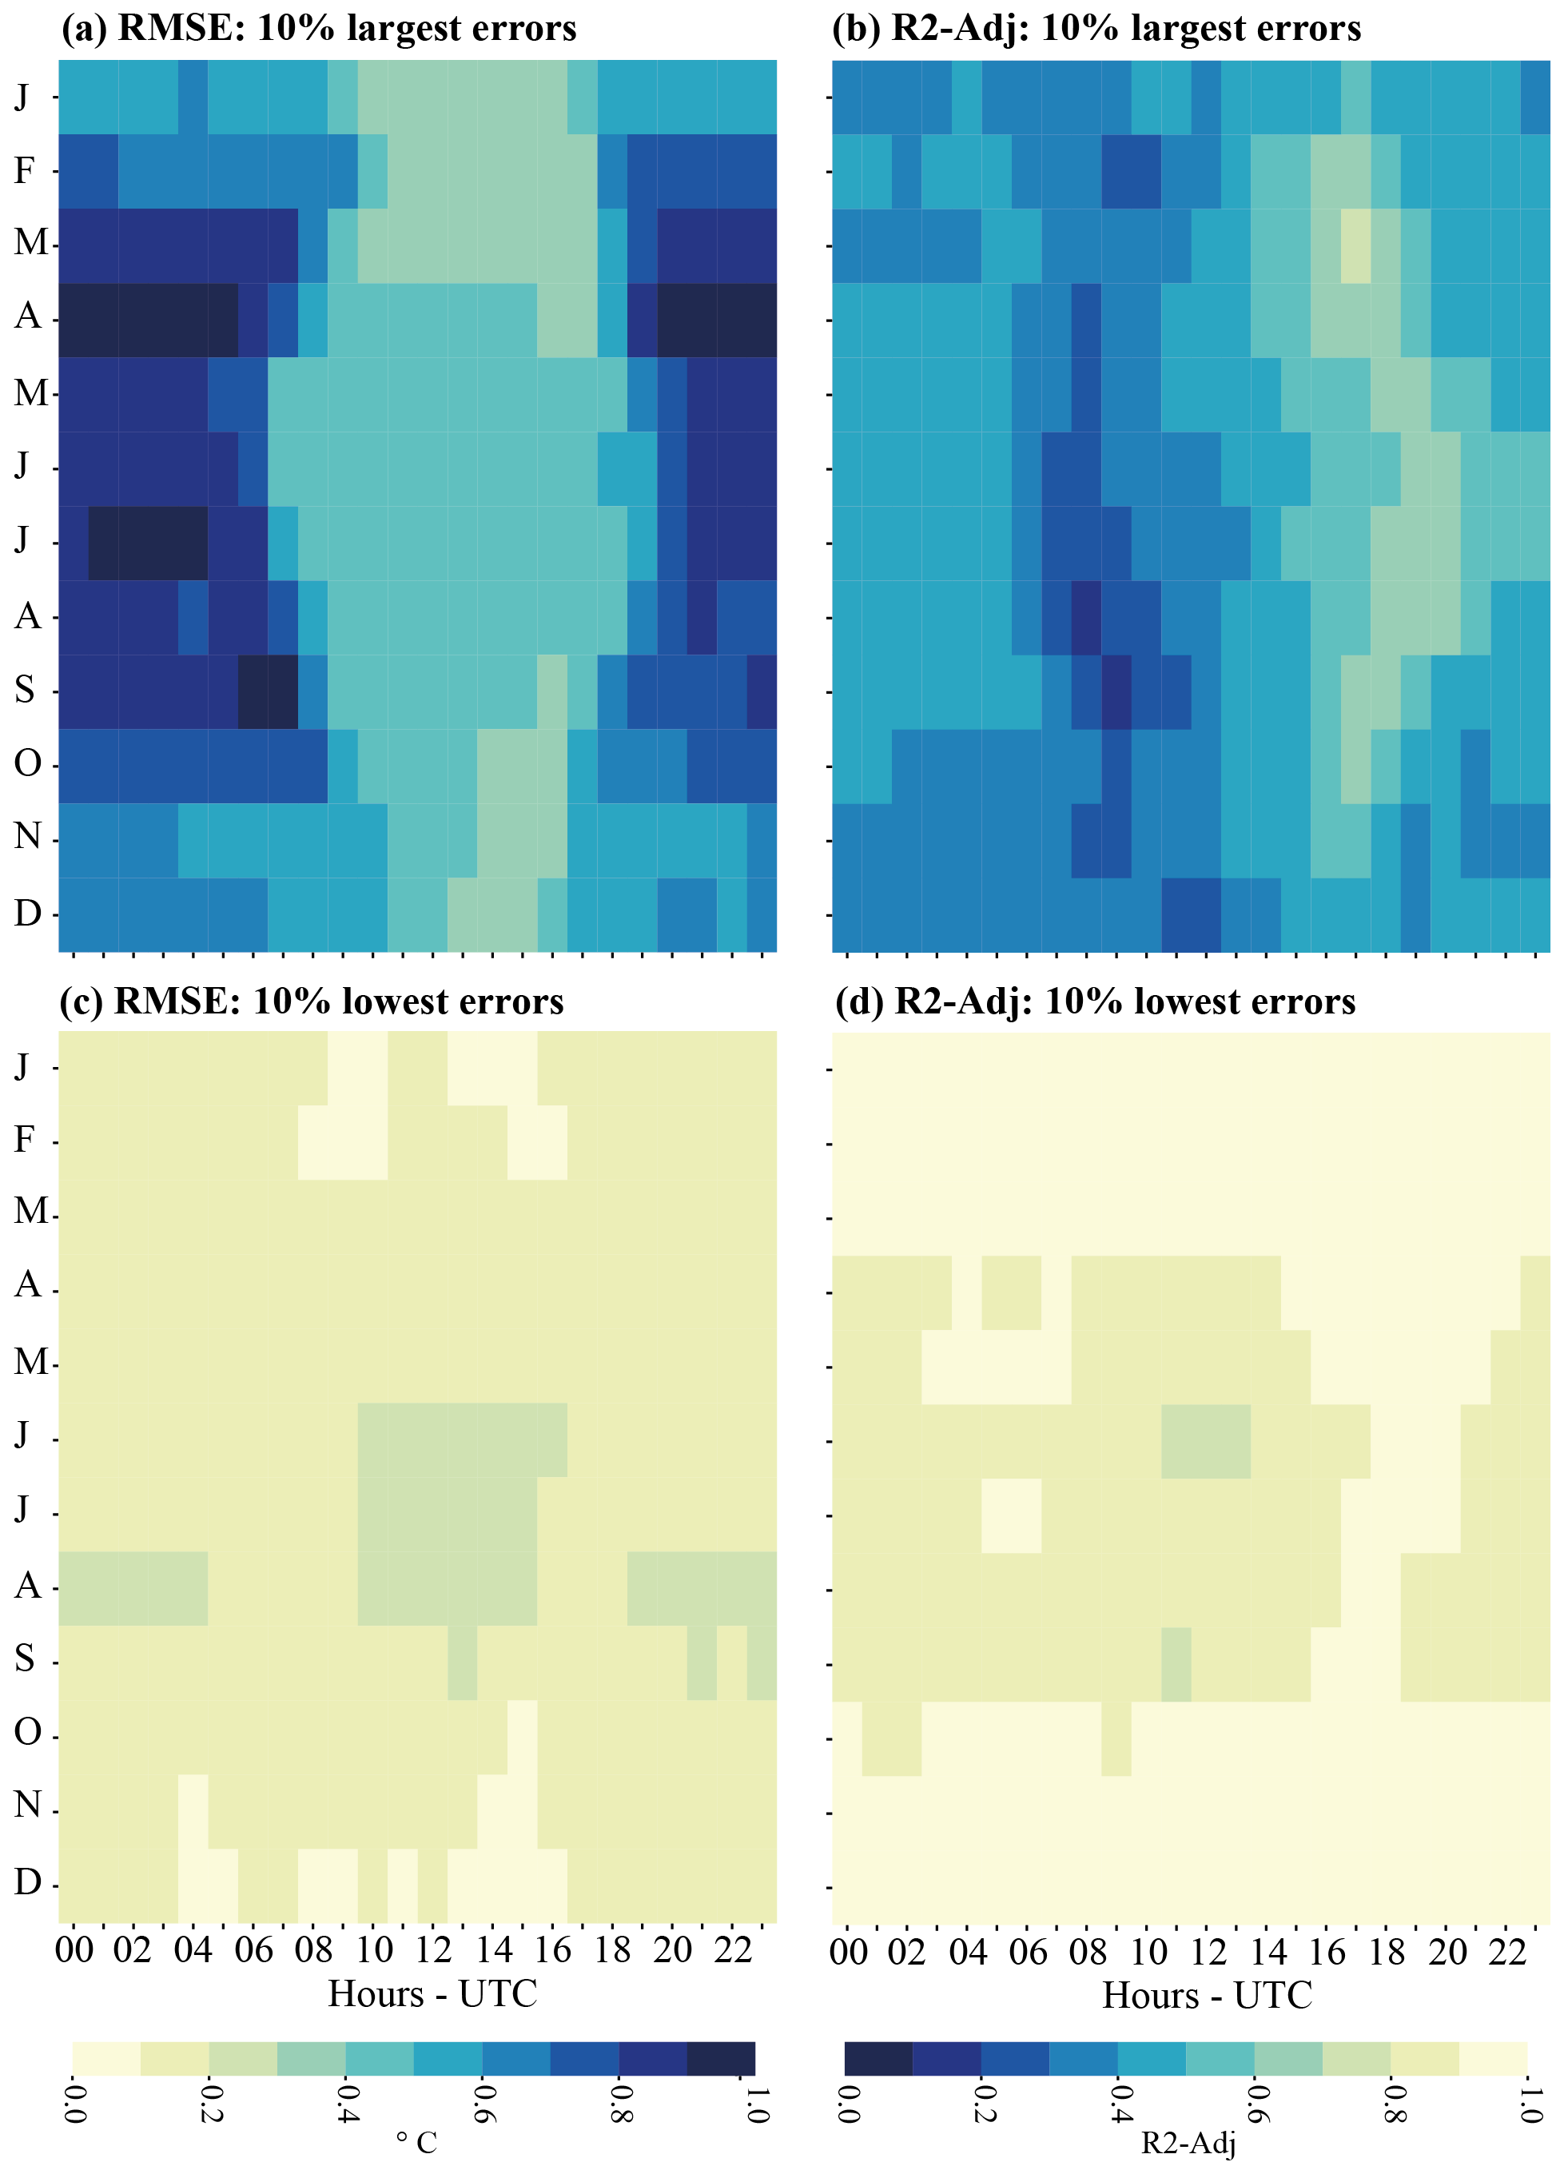
Supplementary Figure S5: Same as Fig. 8 but for (a-b) the 10% largest errors computed as the 90th percentile threshold value for RMSE and the 10th percentile threshold value for R2-Adj and (c-d). the 10% lowest errors (10th/90th percentile threshold value for RMSE/R2-Adj).

