Variability in ecological attributes of abundant species increases with taxonomic diversity: insights for assembly mechanisms of Neotropical bat communities
María A. Hurtado-Materon and Oscar E. Murillo-García
FIGURES
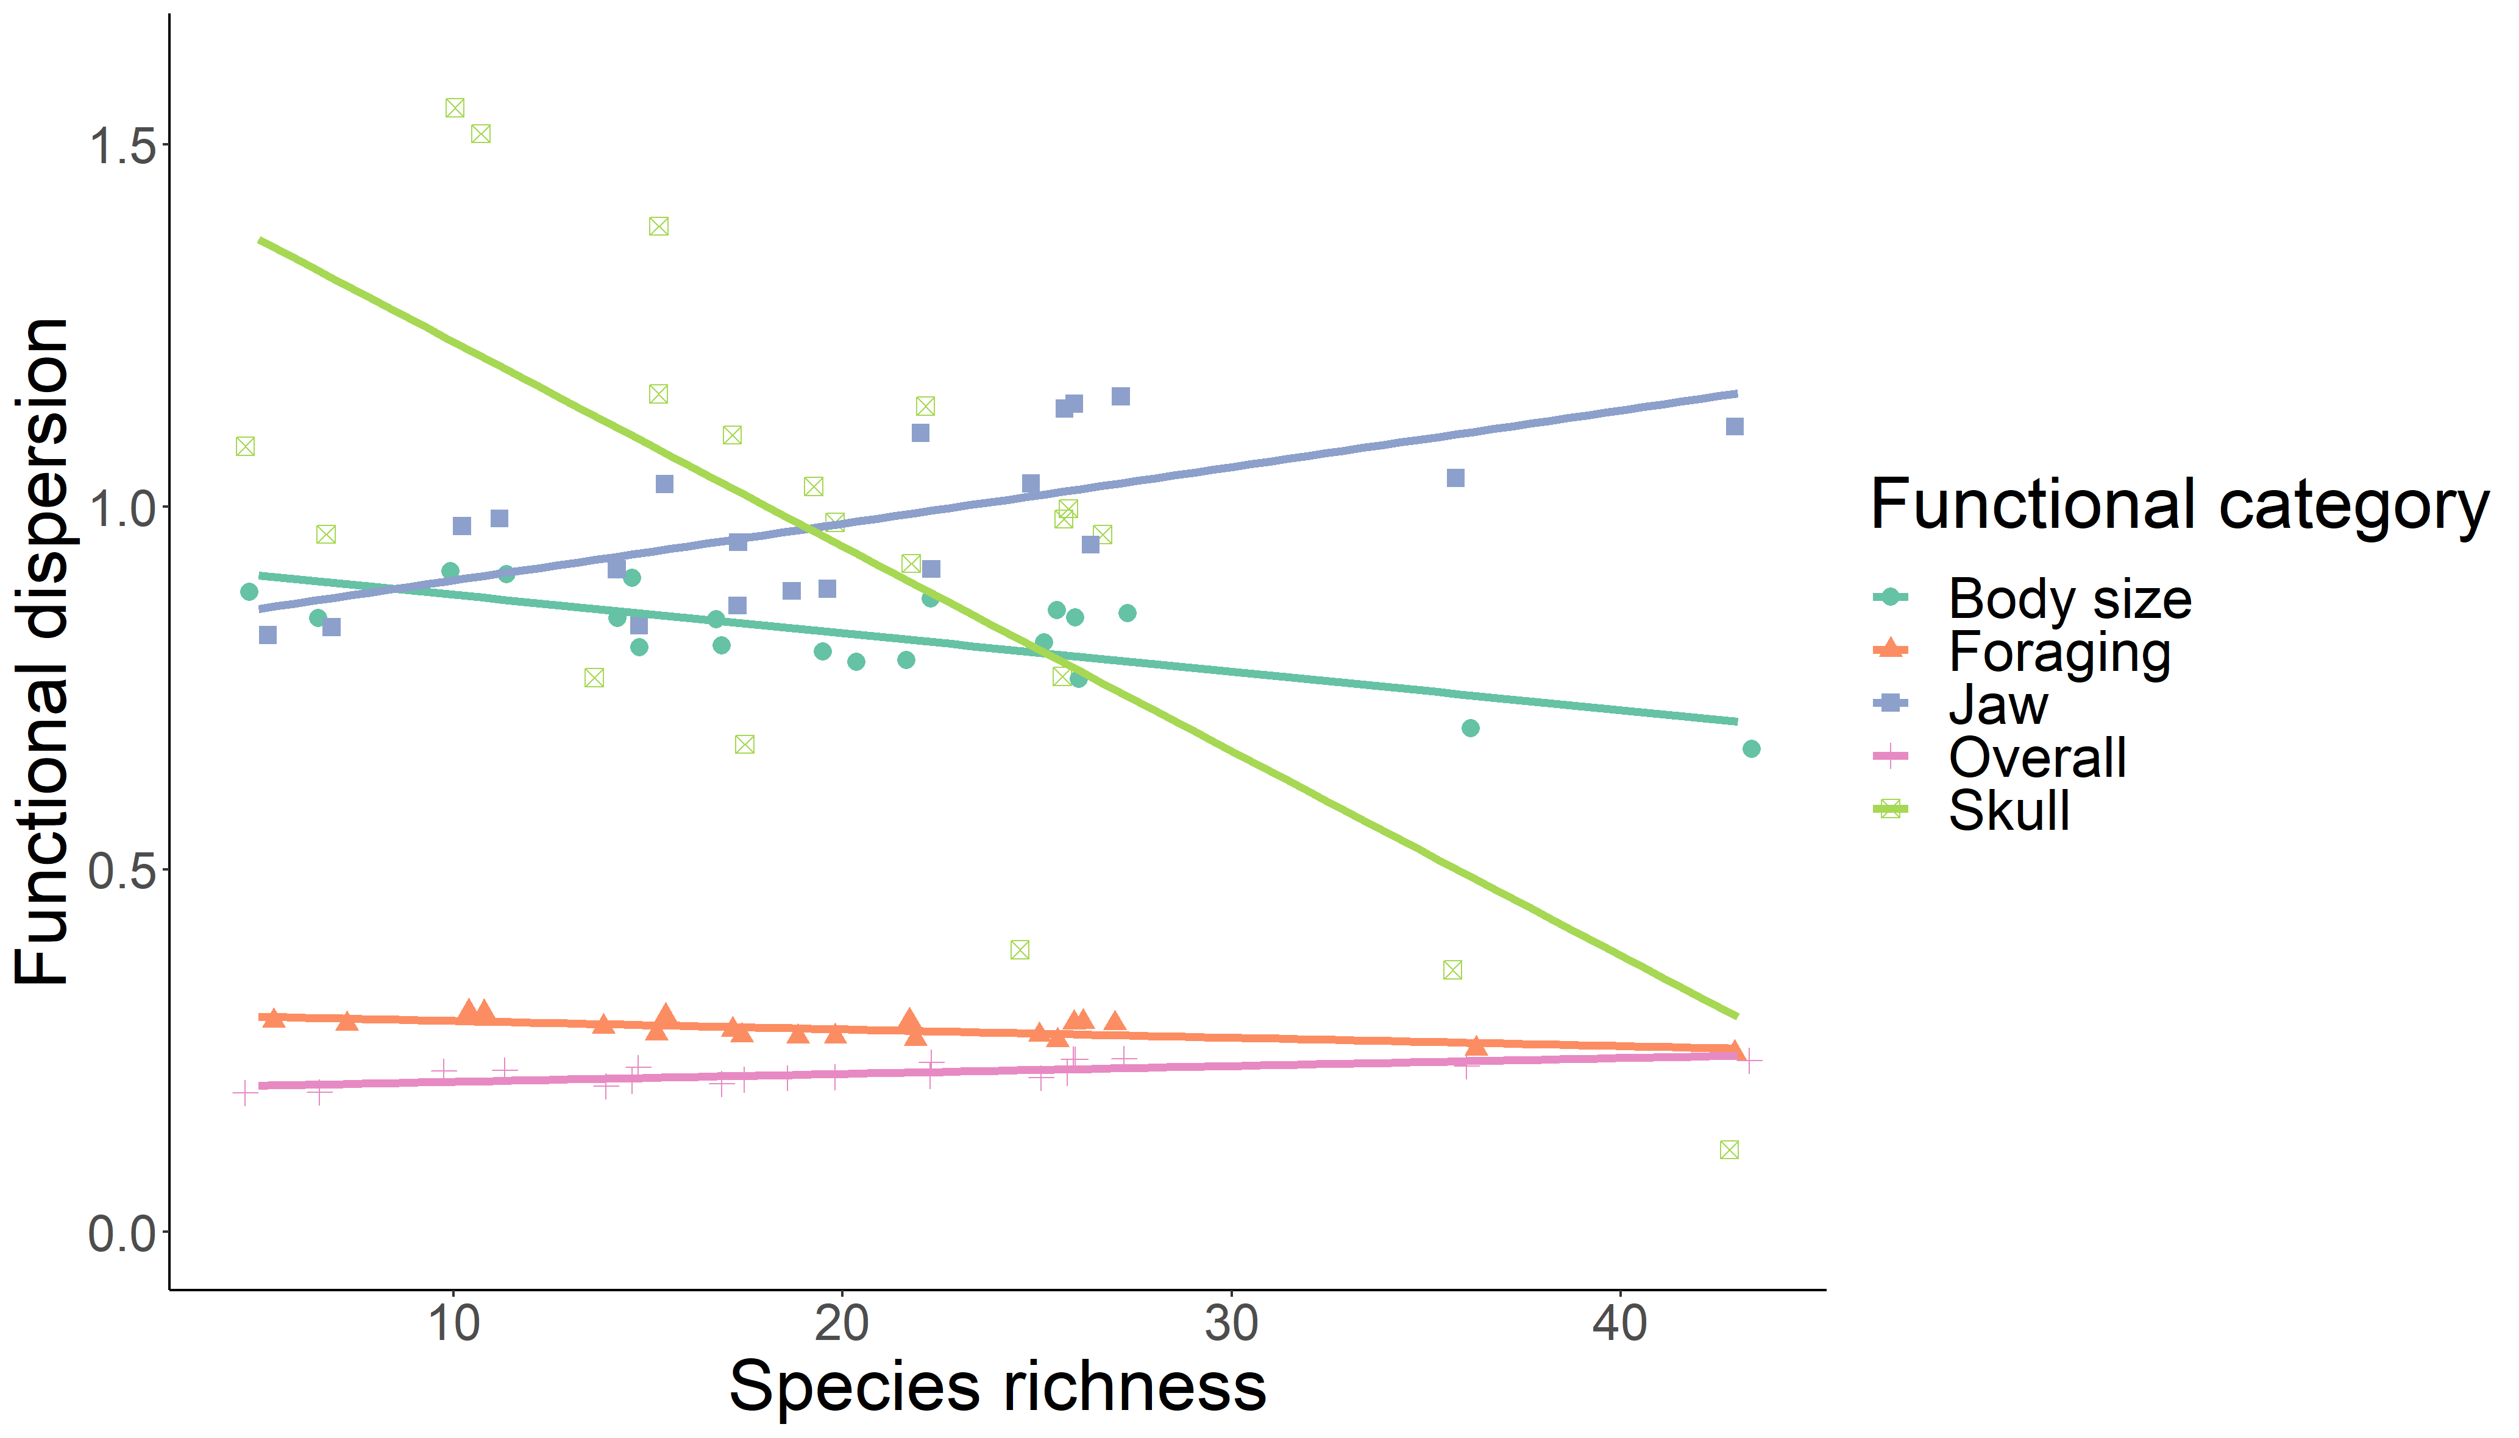
Figure S1. Variation in functional dispersion with species richness for Neotropical bat assemblages across Western and Central Mountain ranges of Colombian Andes.
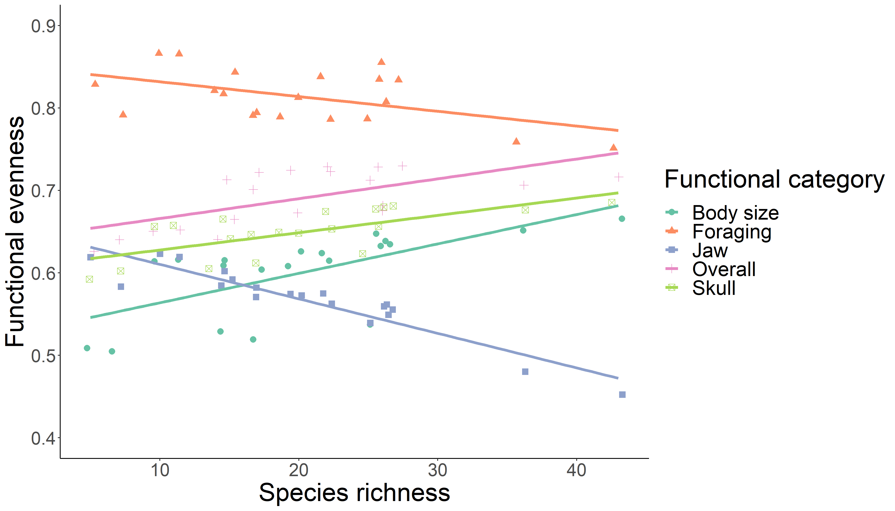
Figure S2. Variation in functional evenness with species richness for Neotropical bat assemblages across Western and Central Mountain ranges of Colombian Andes.
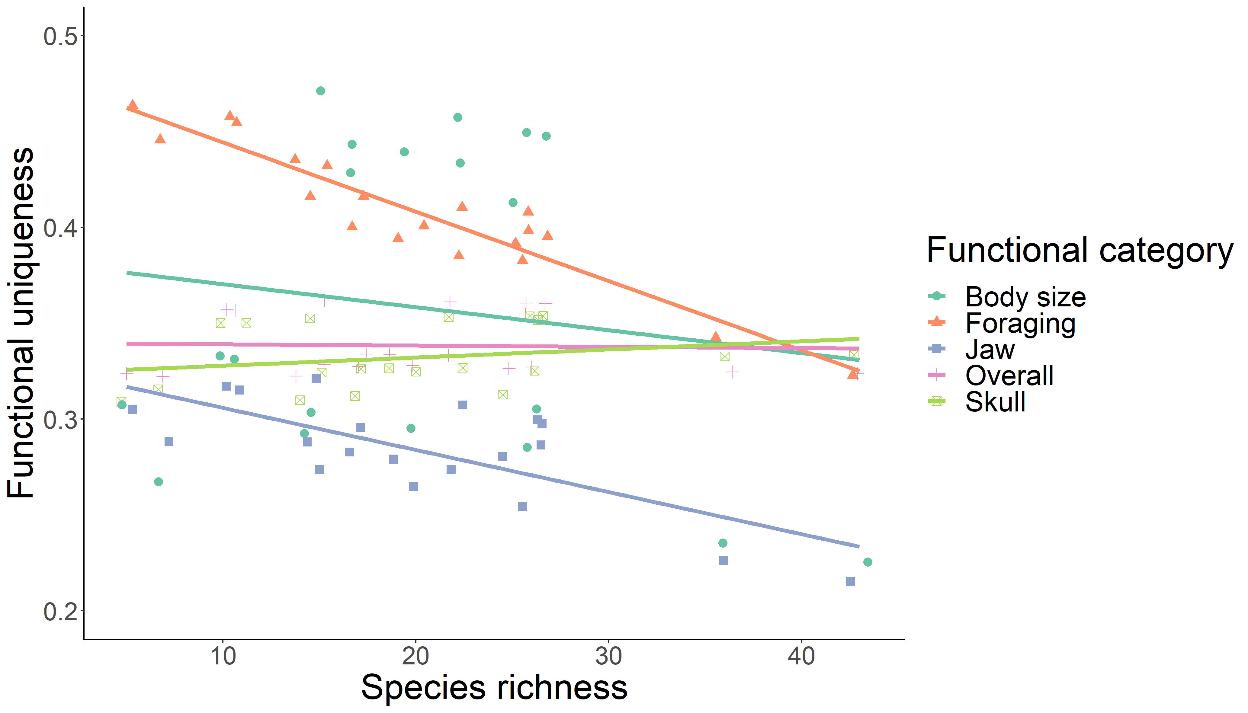
Figure S3. Variation in functional uniqueness with species richness for Neotropical bat assemblages across Western and Central Mountain ranges of Colombian Andes.

TABLES
Table S1. Result Generalized Linear Mixed Models for the relationship between species richness and both functional and phylogenetic diversity in Neotropical bat assemblages.
 | b | IC | Bayesian p-value | Lack of fit | b | IC | Bayesian p-value | Lack of fit
 | Functional divergence |  |  |  | Functional dispersion
Skull | 0.04 | [0.019, 0.063] | 0.561 | 1.167 | -0.035 | [-0.088, 0.018] | 0.455 | 1.054
Jaw | 0.035 | [0.013, 0.057] | 0.552 | 1.175 | 0.01 | [-0.004, 0.025] | 0.439 | 1.042
Size | 0.018 | [-0.007, 0.043] | 0.559 | 1.177 | -0.004 | [-0.038, 0.032] | 0.454 | 1.058
Foraging | 1.08E-05 | [-0.025, 0.026] | 0.586 | 1.236 | -0.001 | [-0.006, 0.004] | 0.448 | 1.053
Total | 0.035 | [0.015, 0.056] | 0.542 | 1.168 | 0.001 | [-0.001, 0.003] | 0.455 | 1.054
 | Functional evenness |  |  |  | Functional uniqueness
Skull | 0.006 | [-0.015, 0.026] | 0.513 | 1.124 | 0.001 | [-0.021, 0.021] | 0.504 | 1.107
Jaw | -0.016 | [-0.036, 0.003] | 0.51 | 1.124 | -0.009 | [-0.032, 0.012] | 0.573 | 1.19
Size | 0.009 | [-0.017, 0.035] | 0.544 | 1.156 | -0.008 | [-0.062, 0.044] | 0.552 | 1.18
Foraging | -0.005 | [-0.030, 0.023] | 0.523 | 1.13 | -0.013 | [-0.043, 0.019] | 0.564 | 1.191
Total | 0.007 | [-0.014, 0.028] | 0.504 | 1.115 | -0.001 | [-0.018, 0.016] | 0.456 | 1.065
 | Phylogenetic diversity
MPD | 0.306 | [0.053, 0.575] | 0.458 | 1.053
MNTD | -0.102 | [-0.355, 0.141] | 0.454 | 1.064

Table S2. Phylogenetic signal analysis results, using Pagel’s lambda ⁵⁴ for functional traits evaluated in Neotropical bat assemblages.
Variable | Lambda | logL | logL0 | p-value
Length of forearm | 1.007283326 | -233.4328652 | -252.1063089 | 9.89E-10
Mass | 1.012526458 | -267.5122578 | -274.2179726 | 0.000250096
Total length | 1.004426824 | -263.4624565 | -275.2757988 | 1.17E-06
Wing shape | 0.918217529 | 67.51144412 | 51.8516141 | 2.19E-08
Relative length of the pinna | 0.84567742 | 85.64376594 | 76.05942661 | 1.20E-05
Total skull length | 1.009112078 | -196.5644028 | -204.8975434 | 4.46E-05
Breadth of braincase | 1.00196301 | -112.1240716 | -125.4480205 | 2.44E-07
Length of maxillary toothrow | 1.015351782 | -124.1632925 | -140.6234117 | 9.60E-09
Breadth across upper molar | 1.014563149 | -124.667545 | -156.7473433 | 1.15E-15
M2 area | 1.020310458 | -136.9786198 | -162.0337683 | 1.45E-12
Meddle skull width | 0.698406934 | -128.2739207 | -133.0679473 | 0.001958475
Total dentary length | 0.990595895 | -162.4050156 | -169.5402938 | 0.000158322
Condyle-canine length | 0.985938147 | -160.9227831 | -167.8735296 | 0.000192645
Coronoid process height | 1.002440495 | -111.750743 | -127.389719 | 2.24E-08

Table S3. Localities across the Western and Central ranges of the Colombian Andes used for this study.
State | Municipality | Locality | Mountain range | Altitude, MASL |  | Ecoregion
 |  |  |  | Mín | Máx | Ecoregion
Valle del Cauca | Buenaventura | Bahía Malaga | Western | 0 | 0 | Pacific-South American Mangroves
Chocó | Bahía Solano | Ensenada de Utría | Western | 5 | 10 | Chocó-Darien wet forests
Chocó | Bajo Baudó | Piliza | Western | 0 | 100 | Chocó-Darien wet forests
Valle del Cauca | Buenaventura | Bajo Calima | Western | 40 | 400 | Chocó-Darien wet forests
Caldas | La Dorada | Guarinocito, Hacienda La Española | Central | 235 | 313 | Valle del Magdalena montane forest
Risaralda | Pueblo rico | Santa Cecilia, Volga, Alto Amurrapá | Western | 413 | 470 | Northeast of the Andes montane forest
Valle del Cauca | Buenaventura | Alto Anchicaya | Western | 230 | 660 | Chocó-Darien wet forests
Chocó | San José del Palmar |  | Western | 350 | 900 | Chocó-Darien wet forests
Chocó | San José del Palmar | Alto del oso | Western | 1000 | 1000 | Northeast of the Andes montane forest
Valle del Cauca | Buga | El Vínculo | Central | 975 | 1100 | Valle del Cauca dry forests
Risaralda | Belen de Umbría |  | Western | 1525 | 1747 | Valle del Cauca montane forest
Cauca | Cajibio | El Cofre, Finca La Herencia | Macizo | 1700 | 1700 | Valle del Cauca montane forest
Valle del Cauca | El Cairo | Quebrada Charco azul | Western | 1600 | 1800 | Northeast of the Andes montane forest
Valle-Chocó |  | Alto de Galápagos | Western | 1800 | 2000 | Northeast of the Andes montane forest
Valle del Cauca | La Cumbre | Bitaco, Chicoral | Western | 1650 | 2176 | Valle del Cauca montane forest
Risaralda | Dosquebradas | Parque Regional Natural Ucumarí, estación Piscicola "El cedral" | Central | 2130 | 2196 | Valle del Cauca montane forest
Valle del Cauca | El Cairo | Estación biológica cerro El Ingles | Western | 2000 | 2400 | Northeast of the Andes montane forest
Quindío | Salento | Boquía, Reserva Natural La Patasola, finca La Betulia | Central | 2200 | 2600 | Valle del Cauca montane forest
Quindío | Salento | Finca Bengala, otros | Central | 2740 | 3250 | Valle del Cauca montane forest
Risaralda | Pereira | Laguna de Otún, 6 km N 9 km O (El porvernir) | Central | 3150 | 3560 | Valle del Cauca montane forest

