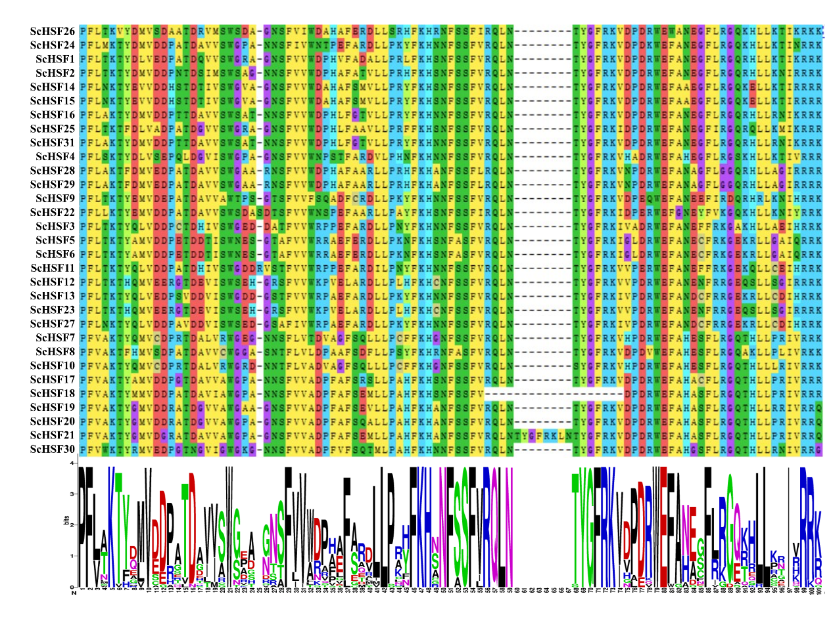
Additional file 2 Figure S1: Alignment of multiple ScHSF and select DBD domain amino acid sequences

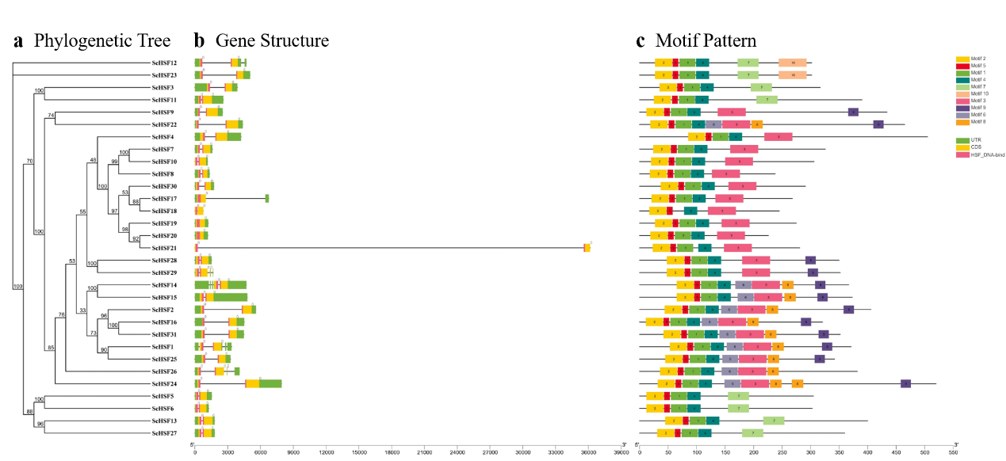
Additional file 3 Figure S2: Analysis of conserved motifs and gene structures in the phylogenetic tree of 31 ScHSF genes.

