Supplementary figure
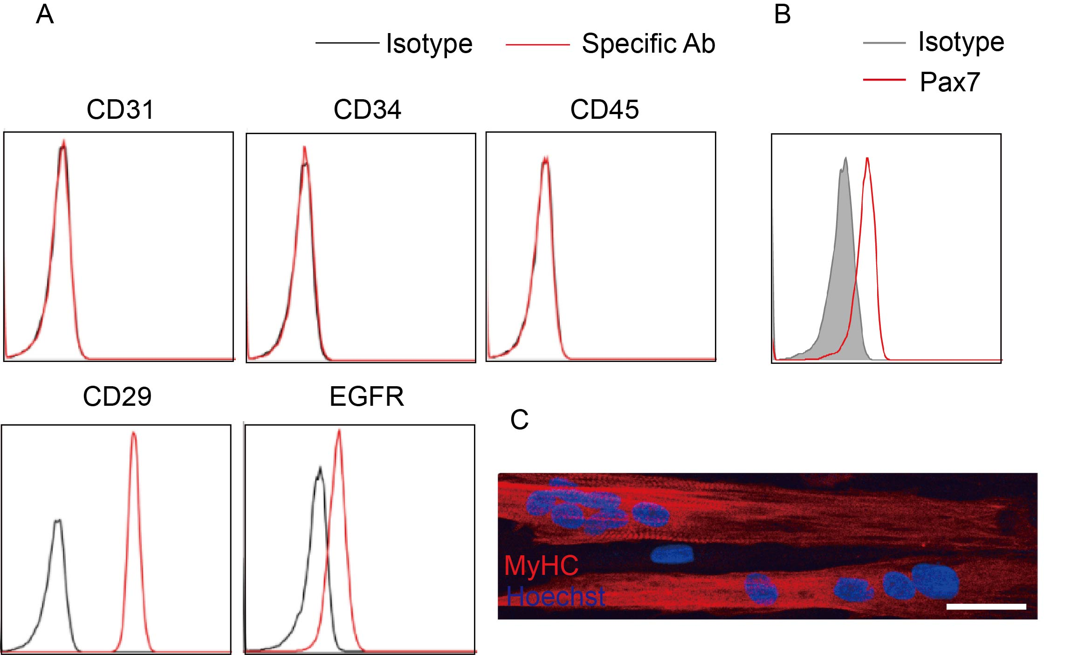
Fig. S1 Phenotypic characterization of MuSCs and their differentiation in vitro. A Characterization of cultured human MuSC surface markers by flow cytometric analysis. B Characterization of nuclear factor PAX7 in cultured human MuSCs by flow cytometric analysis. C Representative images of the differentiation potentials of cultured human MuSCs. Scale bar, 50 μm.

Supplementary table
Table S1 The primers for qRT-PCR
Gene | Classification of primers | Sequence (5’-3’)
IL4I1 | Forward primer | 5’-GCCAAGACCCCTTCGAGAAAT-3’
IL4I1 | Reverse primer | 5’-CCGATCCTGTTATCTGCCTCC-3’
TSG-6 | Forward primer | 5’-TTTCTCTTGCTATGGGAAGACAC-3’
TSG-6 | Reverse primer | 5’-GAGCTTGTATTTGCCAGACCG-3’
CYP1B1 | Forward primer | 5’-GCAAGGGCATGGGAATTGAC-3’
CYP1B1 | Reverse primer | 5’-GAGTCTCTTGGCGTCGTCAG-3’
β-ACTIN | Forward primer | 5’-TTGCCGACAGGATGCAGAAGGA-3’
β-ACTIN | Reverse primer | 5’-AGGTGGACAGCGAGGCCAGGAT-3’
Cxcl1 | Forward primer | 5’-CCCTCTCCTTCCTCATTCTTACA-3’
Cxcl1 | Reverse primer | 5’-AGTCTTGAAAGCCCATGTGAAA-3’
β-actin | Forward primer | 5’-GTGACGTTGACATCCGTAAAGA-3’
β-actin | Reverse primer | 5’-GCCGGACTCATCGTACTCC-3’
Ccl5 | Forward primer | 5’-GCTGCTTTGCCTACCTCTCC-3’
Ccl5 | Reverse primer | 5’-TCGAGTGACAAACACGACTGC-3’
Mcp1 | Forward primer | 5’-CTCCAAGCCAAAGTCCTTAGAG-3’
Mcp1 | Reverse primer | 5’-TCTCTCTTCCTCCACCACCATG-3’
Mcp1 | Reverse primer | 5’-GCGTTAACTGCATCTGGCTGA-3’
Nrf2 | Forward primer | 5’-GAAGCACGCTGAAGGCACAAT-3’
Nrf2 | Reverse primer | 5’-AGGGCCGTTCTGTTTGACAC-3’
Ho-1 | Forward primer | 5’-AGGTACACATCCAAGCCGAGA-3’
Ho-1 | Reverse primer | 5’-CATCACCAGCTTAAAGCCTTCT-3’

