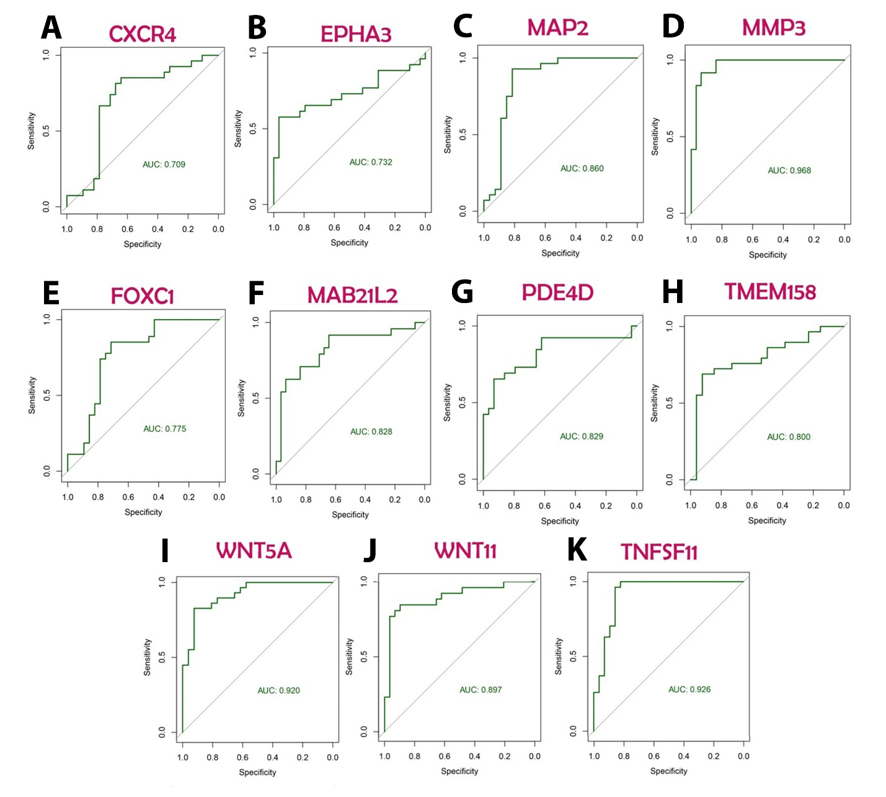

Supplementary Fig. 1. SVM method was applied to evaluate the efficiency of each gene in discriminating metastatic samples from non-metastatic ones. In this study, the area under the ROC curve (AUC)and the total accuracy were used to assess the models’ performances. ROC curves for feature genes including A) CXCR4, B) EPHA3, C) MAP2, D) MMP3, E) FOXC1, F) MAB21L2, G) PDE4D, H) TMEM158, I) WNT5a, J) WNT11, and, K) TNFSF11 is presented in this figure.

