Supplement

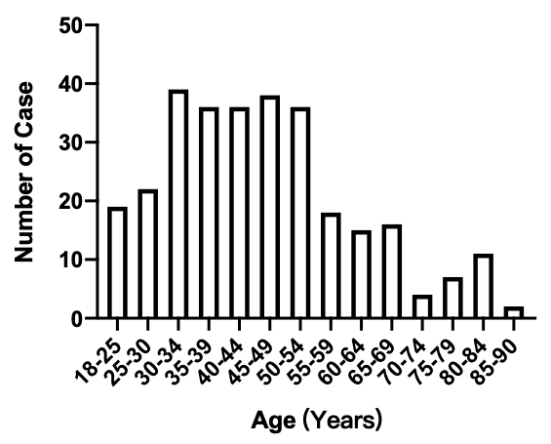
Supplement Figure 1 The distribution of patients in different age group.

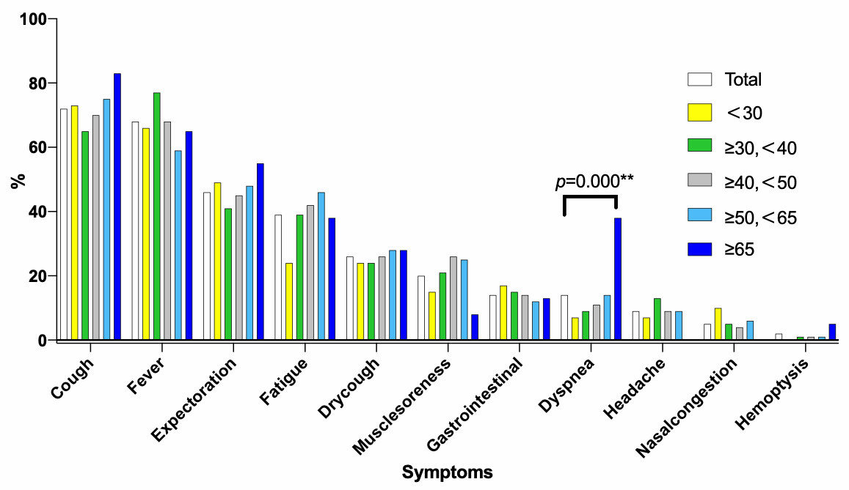
Supplement Figure 2a: Symptoms of COVID-19 according to age groups.

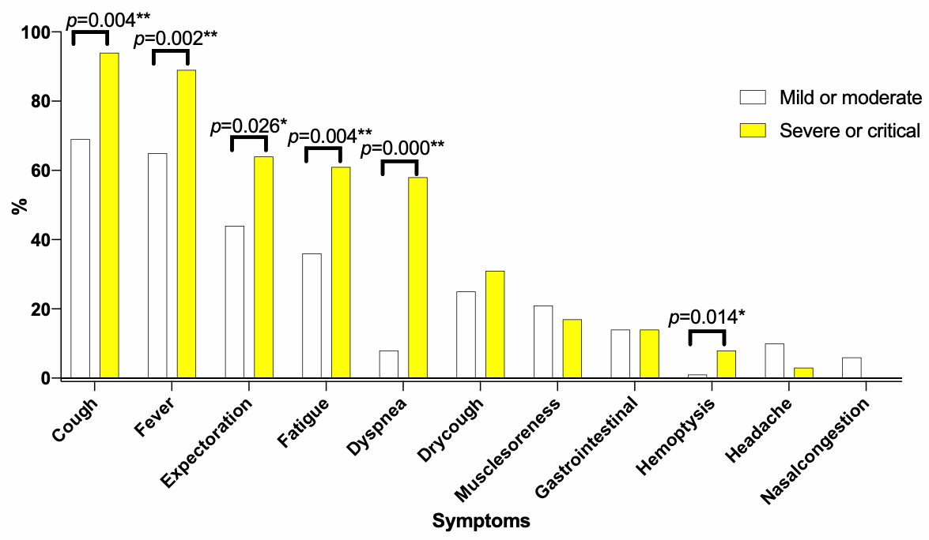

Supplement Figure 2b: Symptoms of COVID-19 according to mild/moderate and severe/critical type.

 | Total | ＜30 | ≥30,＜40 | ≥40,＜50 | ≥50,＜65 | ≥65 | P value
 | n=299 | n=41 | n=75 | n=74 | n=69 | n=40
WBC(×10*9) | 4.97(3.86,6.49) | 5.34(4.18,7.82) | 4.7(3.64,5.8) | 4.79(3.62,5.84) | 4.95(3.97,6) | 5.59(3.87,7.73) | 0.151
N% | 63.9(56,72.3) | 57.8(51.6,66.7) | 61.8(56,73.8) | 65.1(56.2,71.9) | 64.5(55.5,72.38) | 69.25(61.15,82.53) | 0.006**
N(×10*9) | 3.09(2.32,4.54) | 2.95(2.16,4.23) | 2.97(2.31,3.93) | 2.98(2.29,3.96) | 3.13(2.34,4.6) | 3.86(2.4,6.17) | 0.242
L% | 27(19.3,35) | 32.75(23.58,42.93) | 29.1(21.8,35.4) | 26.1(19.35,35.95) | 27.45(19.85,36.35) | 19.25(11.55,27.6) | 0.003**
L(×10*9) | 1.22(0.84,1.63) | 1.6(1.23,2.31) | 1.2(0.8,1.62) | 1.15(0.85,1.52) | 1.29(0.87,1.64) | 1.06(0.63,1.49) | 0.000**
Hb(g/l) | 134(123,147.5) | 146(132.25,158) | 140(129,150) | 141(129,152) | 126(119,138) | 122.5(118,131) | 0.000**
Pt(×10*9) | 206(161,253) | 245(195,273.5) | 214(172,248) | 216.5(159.25,259.25) | 184(146.5,239) | 175.5(144.75,228.75) | 0.01**
PT time(s) | 12.3(11.1,12.99) | 12.6(10.83,13.3) | 12.3(10.9,12.8) | 12.34(11,13.08) | 12.03(11.07,12.9) | 12.65(11.73,13.28) | 0.558
APTT(s) | 32.7(29.1,37.2) | 30.9(27,33.69) | 34.12(30.2,38.14) | 32.3(29.4,37.03) | 33.9(27.8,37.1) | 31.64(28.7,39.66) | 0.189
DD(mg/L ) | 0.32(0.2,0.49) | 0.29(0.13,0.4) | 0.28(0.18,0.4) | 0.31(0.2,0.44) | 0.35(0.2,0.5) | 0.66(0.4,1.46) | 0.000**
albumin(g/l) | 42.25(38.57,45.7) | 45.36(42.15,49) | 44(41.22,46.7) | 42.6(38.98,45.72) | 40.9(36.6,43.7) | 36.92(32.35,40.4) | 0.000**
ALT(U/L) | 21.6(14.95,35) | 19.25(13.08,28.9) | 22(15,38.7) | 27(16.98,43.1) | 22.4(15,34.3) | 17.85(12.58,24.85) | 0.024*
AST(U/L) | 23(18.1,30.8) | 21.85(18.25,26) | 22(17,29) | 23(19.68,32.73) | 24(18,30.9) | 25.3(19.33,39.8) | 0.122
CK(U/L) | 67.1(46.08,103) | 72(51.1,100) | 64(48.4,103) | 63.5(43.5,109.5) | 67(45.5,96.31) | 88.5(47.48,145.23) | 0.419
CKMB(U/L) | 8(2.5,11.93) | 6(2.5,9) | 9(2.5,11.93) | 8(2.5,10.63) | 8(2.5,11.8) | 11(4.85,17) | 0.088
TBIL | 11.55(8.18,18.49) | 11.95(7.4,19.78) | 11.9(8.02,18.43) | 10.2(8.25,18.6) | 13.12(9.02,18.78) | 10.24(7.12,15.23) | 0.528
K(mmol/L)) | 4.14(3.79,4.5) | 4.13(3.75,4.47) | 4.02(3.75,4.58) | 4.18(3.8,4.46) | 4.19(3.81,4.45) | 4.1(3.9,4.56) | 0.981
Na(mmol/L)) | 139.8(137.8,141.5) | 139.2(137.95,142.6) | 139.8(138.4,141) | 139.25(137.8,141.03) | 140.1(137.9,141.87) | 139.69(136.38,142.45) | 0.747
BUN(mmol/L) | 3.95(3.15,4.94) | 3.82(3.15,4.33) | 3.7(2.86,4.4) | 3.7(3.13,4.94) | 4.34(3.28,5.45) | 5.12(3.6,7.35) | 0.000**
Cr(µmoll) | 67.5(56,80) | 70.5(56.1,81.75) | 67(57.1,81.5) | 69.15(55.08,79.38) | 64.2(55.75,76.7) | 71.45(56.75,81.8) | 0.562
ESR(mm/h) | 20.45(8,44.88) | 14.5(6,39.25) | 19.3(6,40) | 17(11.25,39.75) | 20(8,44.13) | 69.8(30,85) | 0.000**
LDH(U/L) | 177.5(153,219.25) | 169(147,209.5) | 175(146.5,203.75) | 187(160.75,228.25) | 172.5(148.5,196.5) | 198(159,303) | 0.07
Mb(µg/l) | 36(30,57) | 37.35(30,43.73) | 35(30,47.9) | 33.5(30,52.89) | 39(30,61.63) | 86.25(41.15,202.95) | 0.002**
Glu(mmol/l) | 5.45(4.95,6.45) | 5.13(4.9,5.52) | 5.44(4.75,6) | 5.62(5.08,6.94) | 5.51(5.08,6.83) | 5.43(5.12,9.31) | 0.229
CRP(mg/L  ) | 5.19(5,16.6) | 5(5,13.62) | 5(2.51,11.74) | 5(3.69,18.6) | 5.6(5,16.61) | 13.9(5,48.55) | 0.003**
PCT(ng/ml) | 0.06(0.05,0.1) | 0.05(0.03,0.1) | 0.06(0.05,0.1) | 0.05(0.05,0.1) | 0.05(0.05,0.1) | 0.1(0.07,0.13) | 0.000**
Supplement Table 1: Laboratory testing profile of COVID-19 according to age groups

* p＜0.05, **p＜0.01

