Table 1: Description of the diets
Ingredients (g) | High Fat diet  D12492 | Western diet  D12079B
Casein, Lactic, 30 Mesh | 200 | 195
Methionine, DL | 0 | 3
Cystine, L | 3 | 0
Sucrose, Fine Granulated | 72.8 | 350
Startch, Corn | 0 | 50
Lodex 10 | 125 | 100
Solka Floc, FCC200 (Fiber) | 50 | 50
Butter, Anhydrous | 0 | 200
Corn oil | 0 | 10
Lard | 245 | 0
Soybean Oil, USP | 25 | 0
S10026B (Mineral) | 50 | 0
S10001A (Mineral) | 0 | 17.5
Calcium Phosphate, Dibasic (Mineral) | 0 | 17.5
Calcium Carbonate, Light, USP (Mineral) | 0 | 4
Choline Bitartrate (Vitamin) | 2 | 2
V10001C (Vitamin) | 1 | 1
Ethoxyquin (Anti-oxydant) | 0 | 0.04
Cholesterol, NF | 0 | 1.5
Dye, Blue FD&C #1 | 0.05 | 0

Table 2: Oligonucleotide primers used for quantitative real-time polymerase chain reaction
Gene name NCBI | Alias | Oligo FWD | Oligo REV | Sonde  UPL
Abcg5 | ABCG5 | cggagagttggtgttctgtg | caccgatgtcaagtccatgt | 82
Abcg8 | ABCG8 | cagatgctggctatcataggg | ctgatttcatcttgccacca | 13
Acat2 | ACAT-2 | agaagtccttcagagagccaaa | cactggcttgtcgagtagga | 50
Acaca | ACC | acagagatggtggctgatgtc | gatccccatggcaatctg | 4
Actb | Actb (control) | cccgcgagtacaaccttct | cgtcatccatggcgaact | 17
Mlxipl | ChREBP | aatcccagcccctacacc | ctgggaggagccaatgtg | 10
Gapdh | Gapdh (control) | ccctcaagattgtcagcaatg | agttgtcatggatgaccttgg | 73
Hmgcr | HMGCoAR | caaccttctacctcagcaagc | acagtgccacacacaattcg | 80
Hprt | Hprt (control) | gaccggttctgtcatgtcg | acctggttcatcatcactaatcac | 95
Ldlr | LDL-R | tgctactggccaaggacat | ctgggtggtcggtacagtg | 16
Lrp1 | LRP-1 | aatcgagggcaagatgacac | ccagtctgtccagtacatccac | 81
Pcsk9 | PCSK9 | ccagtgtccacgcttcct | gatgccatgctccttgattt | 1
Scarb1 | SR-B1 | ggtgcccatcatttaccaac | gcgagccctttttactacca | 71
Srebf2 | SREBP2 | gtgcagacagtcgctacacc | aatctgaggctgaaccagga | 62

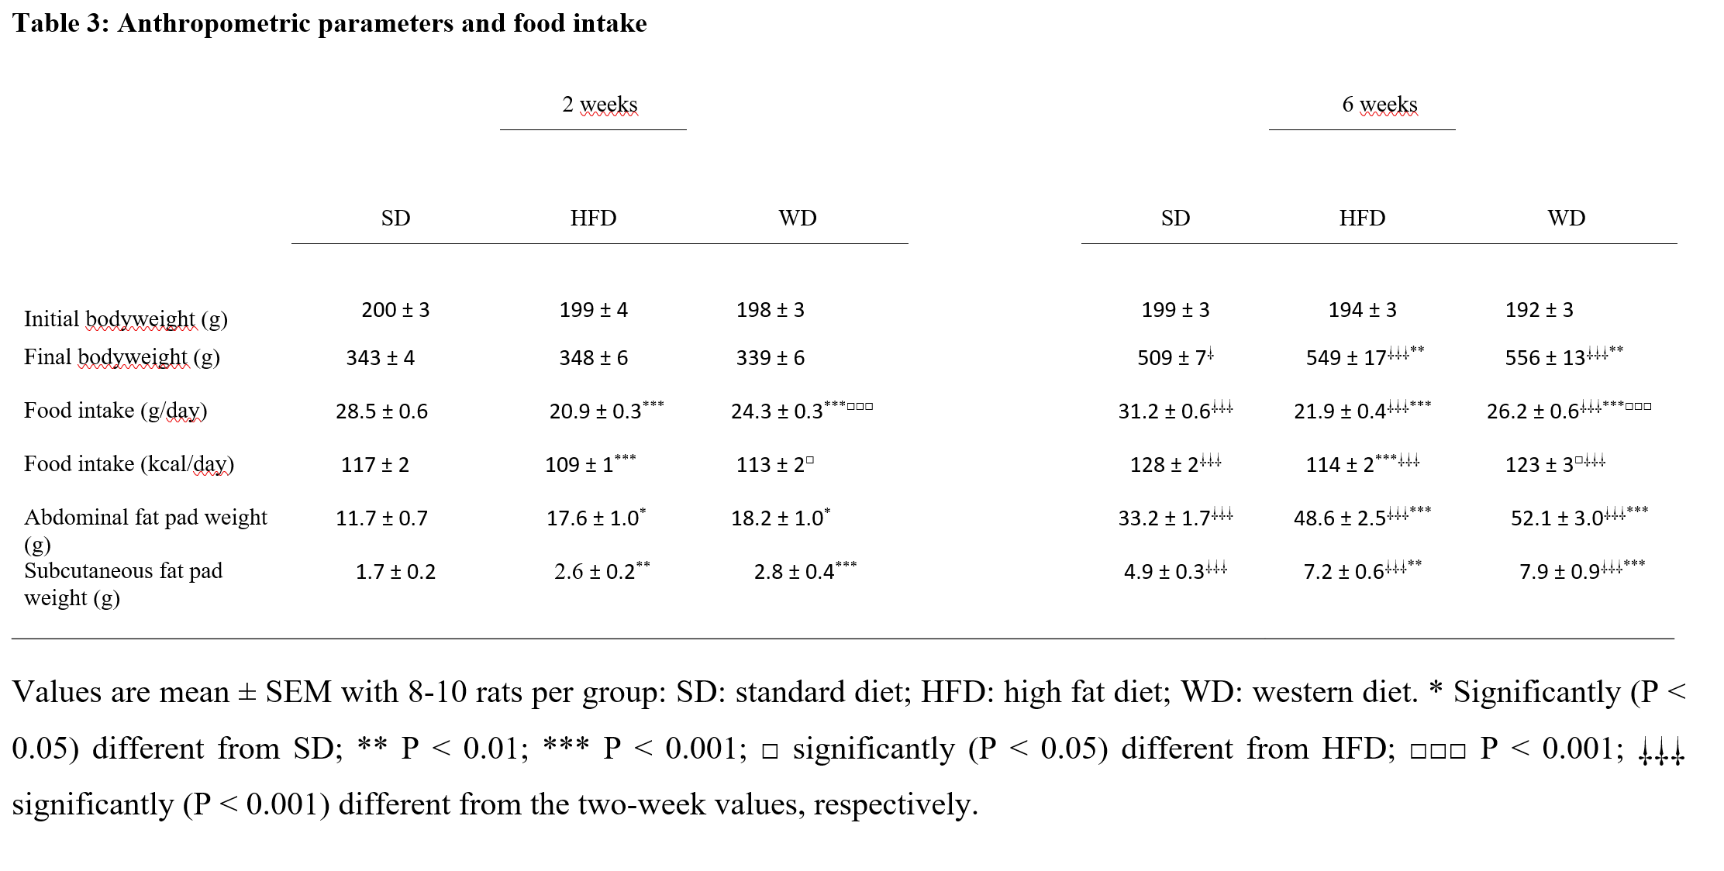
Values are mean ±SEM with

