Supplementary document of “Enhanced Design of Multiplexed Coded Masks for Fresnel Incoherent Correlation Holography”
Shivasubramanian Gopinath,¹ Andrei Bleahu,¹ Tauno Kahro,¹ Aravind Simon John Francis Rajeswary,¹ Ravi Kumar,² Kaupo Kukli,¹ Aile Tamm,¹ Joseph Rosen,^{1,3} and Vijayakumar Anand,^{1,4,*}
¹Institute of Physics, University of Tartu, W. Ostwaldi 1, 50411 Tartu, Estonia
²Department of Physics, SRM University-AP, Amaravati 522502, Andhra Pradesh, India
³School of Electrical and Computer Engineering, Ben-Gurion University of the Negev, Beer-Sheva 8410501, Israel
⁴Optical Sciences Center and ARC Training Centre in Surface Engineering for Advanced Materials (SEAM), School of Science, Computing and Engineering Technologies, Optical Sciences Center, Swinburne University of Technology, Hawthorn, Melbourne, VIC 3122, Australia
*vijayakumar.anand@ut.ee

1. Simulation results
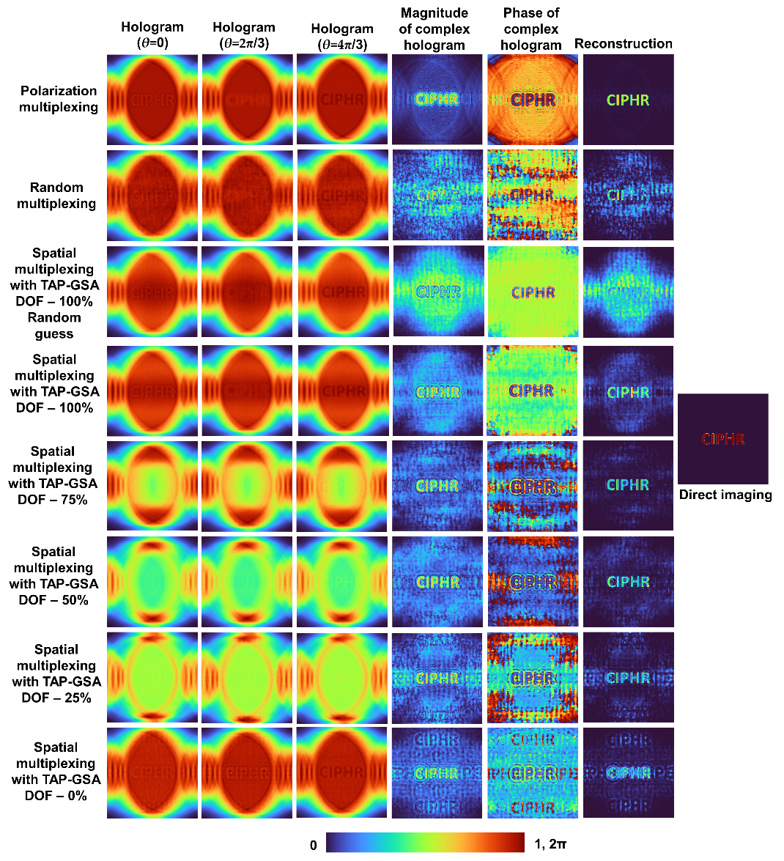
Figure S1 Simulation results of random multiplexing, polarization multiplexing and spatial multiplexing using TAP-GSA with different DOFs of 100%, 75%, 50%, 25% and 0% with the ideal initial guessed phase matrix and DOF 100% with the random guessed phase matrix.
The simulation was repeated for the simplified version of the first configuration shown in Fig. 2(a) for polarization multiplexing, random multiplexing and spatial multiplexing with DOFs of 0%, 25%, 50%, 75% and 100% with the ideal initial guessed phase matrix and random initial guess phase matrix. In this simulation, a matrix consisting of 1200×1200 pixels was used with a pixel size of 8 μm and a wavelength λ = 632.8 nm. The first configuration was simulated for z₁ = f₁ = 1000 cm, z₂ = 17.8 cm, and f₂ = 8.9 cm. Except for the case with the initial guess as a random matrix, all other cases demonstrated an SNR higher than the random multiplexing method. This behavior is different from the results shown in Figure 3.
2. Fabrication and testing of phase masks
The phase masks designed for FINCH with reduced path difference (f₁ = 14 cm and f₂ = 25 cm) were binarized with a pixel size of 8 μm and a length of 9.6 mm and converted from a bitmap file to Graphic Design System (GDSII) using the trial version of LinkCAD software [S1]. The images of the binary masks for random multiplexing and spatial multiplexing with TAP-GSA are shown in Figs. S2(a) and S2(b), respectively. The computer-aided design (CAD) of a section of the randomly multiplexed device is shown in Fig. S2(c). The thickness t of the photoresist was optimized for a wavelength of λ = 650 nm as t = λ/2(n-1), where n is the refractive index of the photoresist. The devices were fabricated using a photolithography technique, where the fabrication of masks was carried out in an ISO5 cleanroom by using a Maskless Aligner (Heidelberg Instruments, µMLA 100, Germany) with dose control of the light source at 390 nm. Positive photoresist (AR-P 3510T, Allresist, Germany) was spin coated (4000 rpm, 60 s) onto cleaned glass substrates and softly baked on a hot plate at 100° C for 60 s. To improve the adhesion of the photoresist to the glass substrates, the promoter AR 300-80 new (Allresist, Germany) was used, and AR 300-44 (Allresist, Germany) was used for developing the UV irradiated structures. The optical microscope images of the fabricated devices corresponding to Fig. S2(a) are shown in Figs. S3(a) and S3(c). The optical microscope images of the fabricated devices corresponding to Fig. S2(b) are shown in Figs. S3(b) and S3(d).
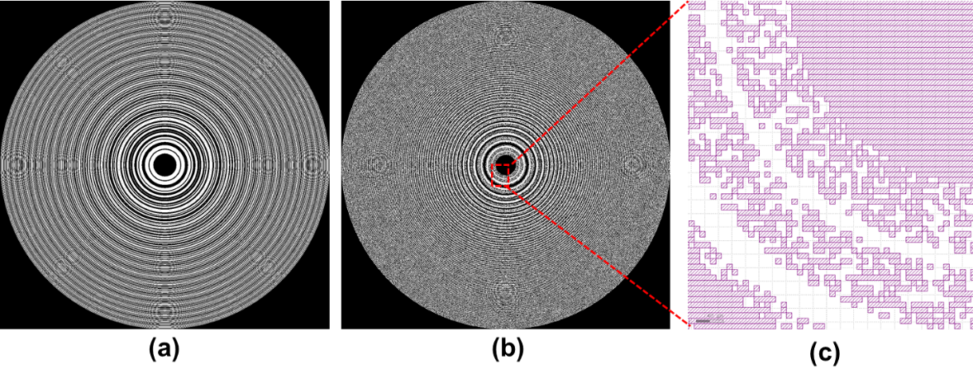
Figure S2. Binary phase mask for (a) spatial multiplexing with TAP-GSA and (b) random multiplexing for FINCH with reduced path difference. (c) CAD diagram of a section of the randomly multiplexed diffractive lens.
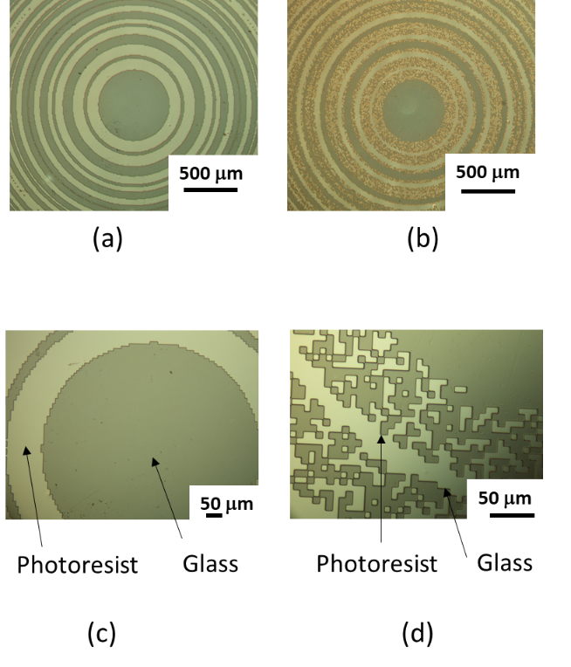
Figure S3. Optical microscope images of the central part of the binary phase mask for (a)(c) spatial multiplexing with TAP-GSA and (b)(d) random multiplexing for FINCH with reduced path difference.
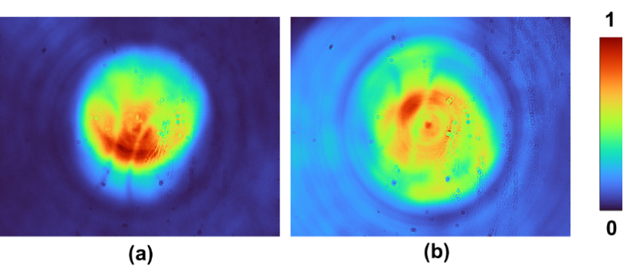
Figure S4. Holograms recorded for the pinhole with 100 μm using FINCH with reduced path difference with (a) spatial multiplexing with TAP GSA and (b) random multiplexing method.
The fabricated images were tested in the same optical setup shown in Figure 5. The beamsplitter before the SLM divides the beam into two. The fabricated devices were mounted perpendicular to the SLM, and the image sensor wave was moved to record the holograms. The hologram images for the 100 μm pinhole recorded using the image sensor are shown in Figures S4(a) for the TAP-GSA and S4(b) for the random multiplexing. From the experimental results, it is evident that spatial multiplexing with TAP-GSA has a better concentration of light than the randomly multiplexed case. Note that in this experiment, only a single camera shot hologram is created by one phase mask for each multiplexing method, and hence, a phase-shift-based reconstruction cannot be performed. Nevertheless, the similarity of Fig. S4(a) with TAP-GSA multiplexing to the holograms of a pinhole shown in Fig. 7(g)-7(i) is higher than the similarity of Fig. S4(b) with random multiplexing to the holograms of a pinhole shown in Fig. 7(a)-7(c).
Reference
[S1] A. Vijayakumar and S. Bhattacharya, Design and Fabrication of Diffractive Optical Elements with MATLAB (SPIE, 2017).

