Biography of Authors:

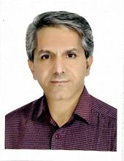
Mohammad Reza Ghaderi received the B.S. degree in electric engineering from Khajeh Nasir Toosi University of Technology, Tehran, Iran, in 1992 and M.S. degree in communication engineering form Tehran University, Tehran, Iran in 2014 and Ph.D. degree in communication engineering from Islamic Azad University South Tehran Branch, Tehran, Iran in 2019. He has been the reviewer of international journals such as Wireless Personal Communications, Supper Computing, Scientific Reports, Journal of Communications, and Medical & Biological Engineering & Computing in recent years. His research interests include wireless sensor networks, intelligent systems, blockchain, and E- helth. Email: ghaderi_mo@mapnagroup.com, st_mr_ghaderi@azad.ac.ir
ORCID: 0000-0003-0033-4898

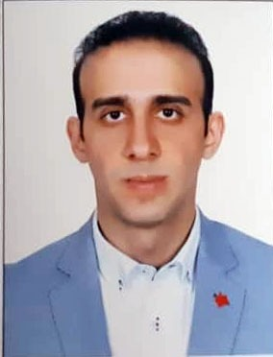

Ali Eghbali Ghahyazi received the B.S. degree in industrial engineering from Islamic Azad University south Tehran branch, Tehran, Iran, in 2012 and the M.S. degree in Information technology engineering-computer networks from Qazvin Azad University, Qazvin, Iran, in 2019. His research interests include computer networks, blockchain, and security. Email: aieghbali.edu@gmail.com

