Ferroelectric and negative piezoelectric properties in oxyhydroxide monolayers γ-XOOH (X = Al, Ga, and In)
Xuli Cheng¹, Shaowen Xu¹, Chao Liu^{1,3}, Yaning Cui¹, Wenbin Ouyang¹, Fanhao Jia^{2,1†}, Wei Wu¹, and Wei Ren^{1, 4*}
¹Physics Department, Shanghai Key Laboratory of High Temperature Superconductors, International Centre of Quantum and Molecular Structures, Shanghai University, Shanghai 200444, China
²State Key Laboratory of Advanced Special Steels, School of Materials Science and Engineering, Shanghai University, Shanghai 200444, China
³ Consiglio Nazionale delle Ricerche (CNR-SPIN), Unità di Ricerca presso Terzo di Chieti, c/o Università G. D'Annunzio, I-66100 Chieti, Italy
⁴ Zhejiang Laboratory, Hangzhou 311100, China
†fanhaojia@shu.edu.cn *renwei@shu.edu.cn
Table SⅠ. The structural parameters of XOOH bulks. The lattice constants (Å) along a, b and c directions at the optB86b-vdW level and from experiment, and the electronic energy band gap (eV) are listed here.
System |  | AlOOH | GaOOH | InOOH
Lattice constants DFT | a | 3.724 | 3.933 | 4.237
Lattice constants DFT | b | 2.880 | 3.012 | 3.304
Lattice constants DFT | c | 11.982 | 12.183 | 12.787
Lattice constants Exp. | a | 3.690
Lattice constants Exp. | b | 2.860
Lattice constants Exp. | c | 12.240
DFT Band gap |  | 5.428 | 3.121 | 1.948

Table SⅡ. The elastic constants (N/m) piezoelectric constant d_{ij} (pC/N) of XOOH monolayers.
System | C₁₁ | C₁₂ | C₂₂ | C₆₆ | d₁₁ | d₁₂
AlOOH | 170.745 | 46.036 | 199.054 | 75.158 | -1.241 | 0.252
GaOOH | 107.854 | 42.037 | 159.818 | 52.778 | -1.759 | 0.453
InOOH | 103.294 | 23.688 | 118.244 | 31.786 | -1.157 | 0.027

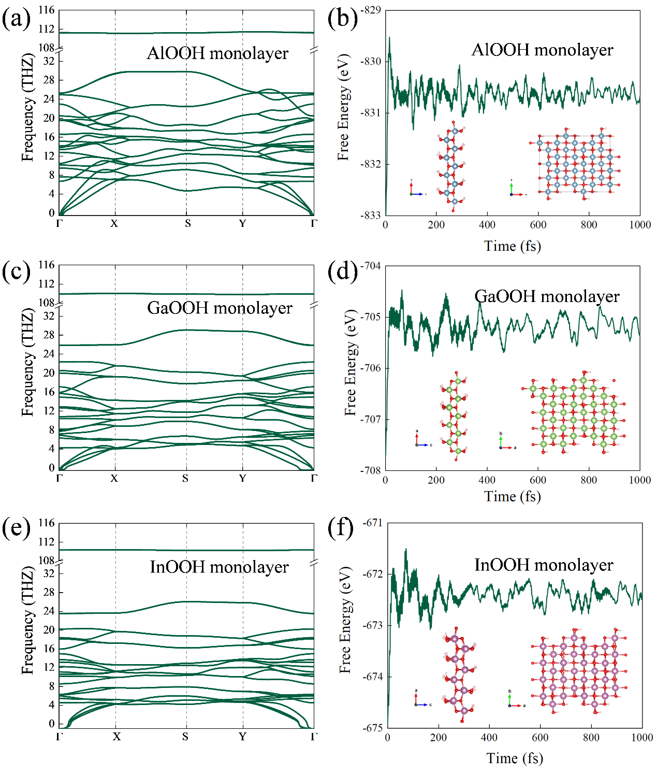
Figure S1. The phonon spectra and the evolution of energy over time at T = 300 K from molecular dynamics simulations of (a-b) AlOOH, (c-d) GaOOH and (e-f) InOOH monolayers.
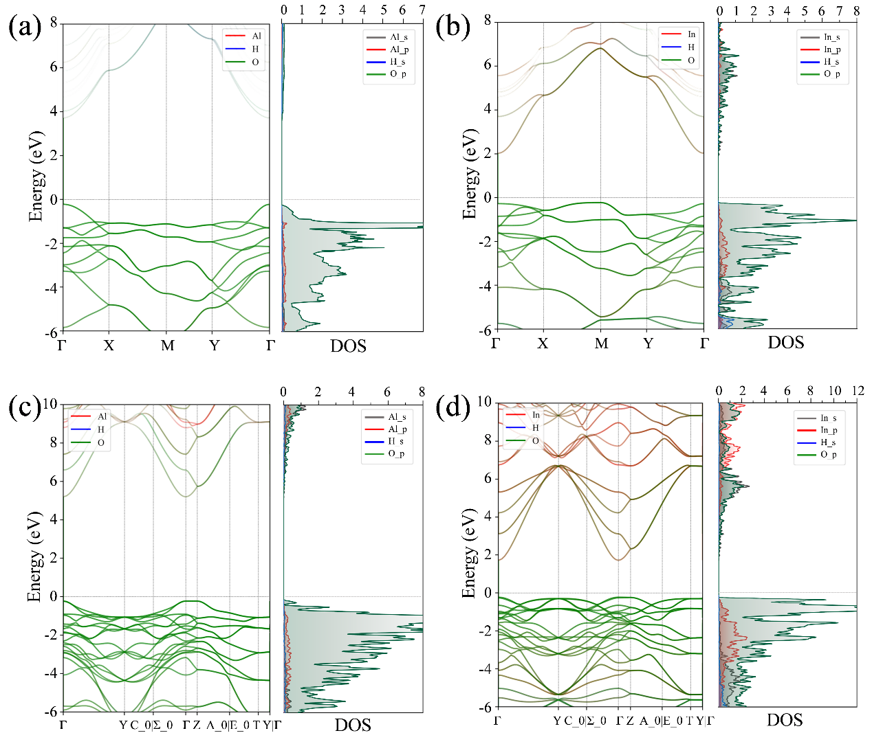
Figure S2. The electronic band structures and density of states of (a) AlOOH monolayer, InOOH monolayer, AlOOH bulk and InOOH bulk.

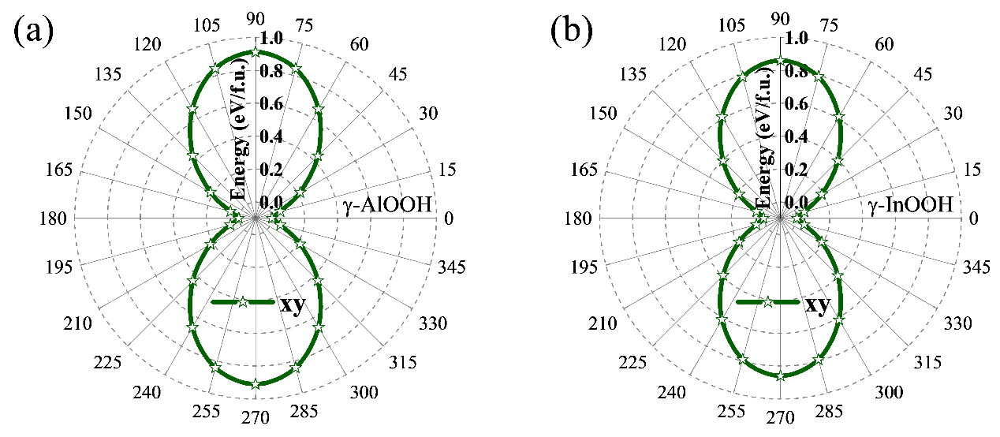
Figure S3. The energy (per formula unit) profile of the (a) AlOOH and (b) InOOH monolayers with the hydroxyl rotating around the [001] direction, while the energy minimum (along a direction) is set to 0 as a reference.
$$C_{ij}=\left[\begin{matrix}C_{11} & C_{12} & 0 & 0 & 0 & 0 \\ C_{12} & C_{22} & 0 & 0 & 0 & 0 \\ 0 & 0 & 0 & 0 & 0 & 0 \\ 0 & 0 & 0 & 0 & 0 & 0 \\ 0 & 0 & 0 & 0 & 0 & 0 \\ 0 & 0 & 0 & 0 & 0 & C_{66}\end{matrix}\right]$$

