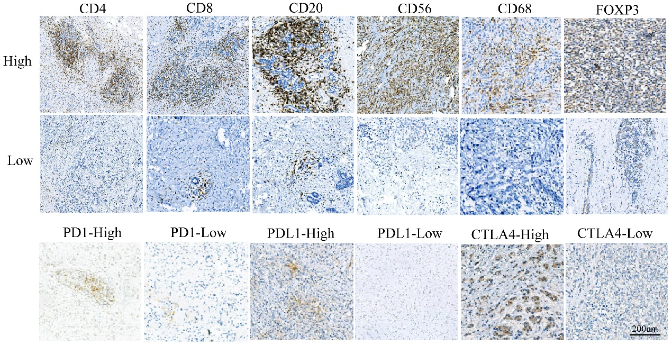
Figure S1 Representative images of tumor-associated immune cell markers and immune checkpoints from invasive lobular carcinoma determined by immunohistochemistry.

Figure S2 Kaplan-Meier curves for overall survival according to different immune markers density groups.
Plots show the Kaplan-Meier curves of CD4 (A), CD8 (B), CD20 (C), CD56 (D), CD68 (E), FOXP3 (F), CTLA-4 (G), PD-1 (H) and PD-L1 (I). Abbreviations: OS, overall survival.

Figure S3 Immune cell markers were screened by LASSO Cox regression
(A) LASSO coefficient profiles of 6 immune cell marker features; (B) ten-time cross-validation for tuning parameter selection in the LASSO model.
Figure S4 Distribution of immune markers in different IS and immune checkpoint subgroups
Plots show the distribution of immune markers according to IS (A), PD-L1(B), PD-1(C) and CTLA-4 subgroups (D).

Figure S5 Prognostic role of IS and immune checkpoints in ILC
Comparison of the prognostic effects of IS and immune checkpoints in overall DFS (A), 3-year DFS (B), 5-year DFS (C) and overall OS (D), 3-year OS (E), 5-year OS (F). Abbreviations: IS, immune score; DFS, disease-free survival; OS, overall survival.
Figure S6 Prognostic role of IS in different molecular subtypes
Comparison of the prognostic effects of IS in different molecular subtypes for overall DFS (A), 3-year DFS (B), 5-year DFS (C) and overall OS (D), 3-year OS (E), 5-year OS (F). Abbreviations: IS, immune score; DFS, disease-free survival; OS, overall survival.
Figure S7 The landscape of the tumor microenvironment in ILC and the characteristics of different subgroups.
(A) The IS grouping and proportions of TME cells for 139 patients in the METABRI cohort. Age, Menopausal state, ER, PR, HER2, Stage, OS time, and survival status are shown as patient annotations. (B) The proportions of TME cells in all samples. The proportions of TME cells in different HER2 (C), grade (D) and ISm (E) subgroups. The thick lines represent the median value. The bottom and top of the boxes are the 25th and 75th percentiles (interquartile range), respectively. The scattered dots represent the corresponding subgroups in the graph. Significant statistical differences between the two subgroups were assessed using the Mann–Whitney test (ns: not significant, *p < 0.05, ** p < 0.01, *** p < 0.001, **** p < 0.0001). Abbreviations: ISm, immune score; ER, Estrogen receptor; PR, Progesterone receptor; HER2, human epidermal growth factor receptor 2.

Figure S8 Prognostic role of ISm in the METABRIC cohort
Plots show univariate (A) and multivariate (B) analysis of OS; Receiver operating characteristics (ROC) curves for the prediction of 10-year OS (C) and overall OS (D).
Figure S9 Significantly related genes and functions in the low proportion group of CD68⁺ macrophages and FOXP3⁺ T cells
Plots show genes strongly associated with low proportion group of CD68 (A) and FOXP3 (C) (|R| > 0.3, p < 0.05); gene ontology (GO) analysis of strongly related genes in the low proportion group of CD68 (B) and FOXP3 (D).

Figure S10 Significantly related genes and functions in different subgroups of the CD68⁺ macrophages
Plots show genes strongly associated with low-CD68 (A) and high-CD68 (D) (|R| > 0.2, p < 0.05); gene ontology (GO) analysis of strongly related genes in the low-CD68 (B) and high-CD68 (E); kyoto encyclopedia of genes and genomes (KEGG) analysis of strongly related genes in the low-CD68 (C) and high-CD68 (F).

Figure S11 Significantly related genes and functions in different subgroups of the FOXP3⁺ T cells
Plots show genes strongly associated with low-FOXP3 (A) and high-FOXP3 (D) (|R| > 0.2, p < 0.05); gene ontology (GO) analysis of strongly related genes in the low-FOXP3 (B) and high-FOXP3 (E); kyoto encyclopedia of genes and genomes (KEGG) analysis of strongly related genes in the low-FOXP3 (C) and high-FOXP3 (F).

Figure S12 Significantly mutated genes in the different CD68⁺ macrophages subgroups
Plots show the mutated genes in the low-CD68 (A) and high-CD68 (B) groups. Mutated genes (rows, top 10) are ordered by mutation rate; samples (columns) are arranged to emphasize mutual exclusivity among mutations. The right shows mutation percentage, and the top shows the overall number of mutations. The color-coding indicates the mutation type.

Figure S13 Significantly mutated genes in the different FOXP3⁺ T cells subgroups
Plots show the mutated genes in the low-FOXP3 (A) and high-FOXP3 (B) groups. Mutated genes (rows, top 10) are ordered by mutation rate; samples (columns) are arranged to emphasize mutual exclusivity among mutations. The right shows mutation percentage, and the top shows the overall number of mutations. The color-coding indicates the mutation type.

