Supporting Information

Improving lightning nowcasting with aerosol-informed machine learning and satellite-enriched dataset

Number of pages: 11
Number of tables: 3
Number of figures: 5
Number of Texts: 2

Table S1. Summary of the descriptive variables.
Variable | Abbreviations | mean | min | max | Interquartile range
Day of year | DOY | 198.5 | 153 | 244 | 46
Hour of day | HH | 11.5 | 0 | 23 | 12
Flash density during the last hour (flash/km²/hour) | Flash | 0.002 | 0 | 3.73 | 0
Temperature at 500 hPa(K) | T500 | 265.00 | 243.45 | 272.89 | 3.07
Surface Pressure (Pa) | SP | 9.61×10⁴ | 7.04×10⁴ | 1.03×10⁵ | 4.35×10³
10 m U-component wind speed at 500 hPa (m/s) | UW | 6.72 | -28.47 | 40.61 | 9.70
10 m V-component wind speed at 500 hPa (m/s) | VW | -0.16 | -41.13 | 40.48 | 8.22
Specific Humidity  at 500 hPa (%) | SH | 0.0015 | 0.0000 | 0.0071 | 0.0017
Convective Available Potential Energy (J/kg) | CAPE | 474.78 | 0 | 11586 | 615.21
Black Carbon Aerosol Optical Depth at 550 nm | BC | 0.0103 | 0.0011 | 1.2347 | 0.0040
Sea Salt Aerosol Optical Depth at 550 nm | SS | 0.0133 | 0.0031 | 1.0800 | 0.0106
Sulfate Aerosol Optical Depth at 550 nm | SO4 | 0.0734 | 0.0059 | 1.0609 | 0.0606
Organic Carbon Aerosol Optical Depth at 550 nm | OC | 0.0519 | 0.0011 | 8.6720 | 0.0258
Dust Aerosol Optical Depth at 550 nm | Dust | 0.0273 | 0.0004 | 1.1136 | 0.0170
PM2.5 Concentration (μg/m³) | PM2.5 | 8 | 0 | 634 | 4

Table S2. Prediction skill of warning severe storm lightning occurrence in the state of Georgia.
Severe event day | POD | FAR | CSI | HSS
2020/07/25 | 81.1% | 10.1% | 0.741 | 0.767
2020/08/08 | 77.1% | 11.2% | 0.698 | 0.735
2020/08/10 | 82.4% | 12.9% | 0.727 | 0.691
2020/08/14 | 90.3% | 9.67% | 0.823 | 0.824
2020/08/19 | 84.8% | 7.41% | 0.794 | 0.810

Table S3. Location of centers of each station in LMA
LMA station name | Center Latitude | Center Longitude
COLMA | 40.446 | -104.637
DCLMA | 38.889 | -77.169
KSCLMA | 28.586 | -80.651
NALMA | 34.725 | -86.645
OKLMA | 35.279 | -97.918
SOLMA | 43.666 | -79.606
WTXLMA | 33.607 | -101.823

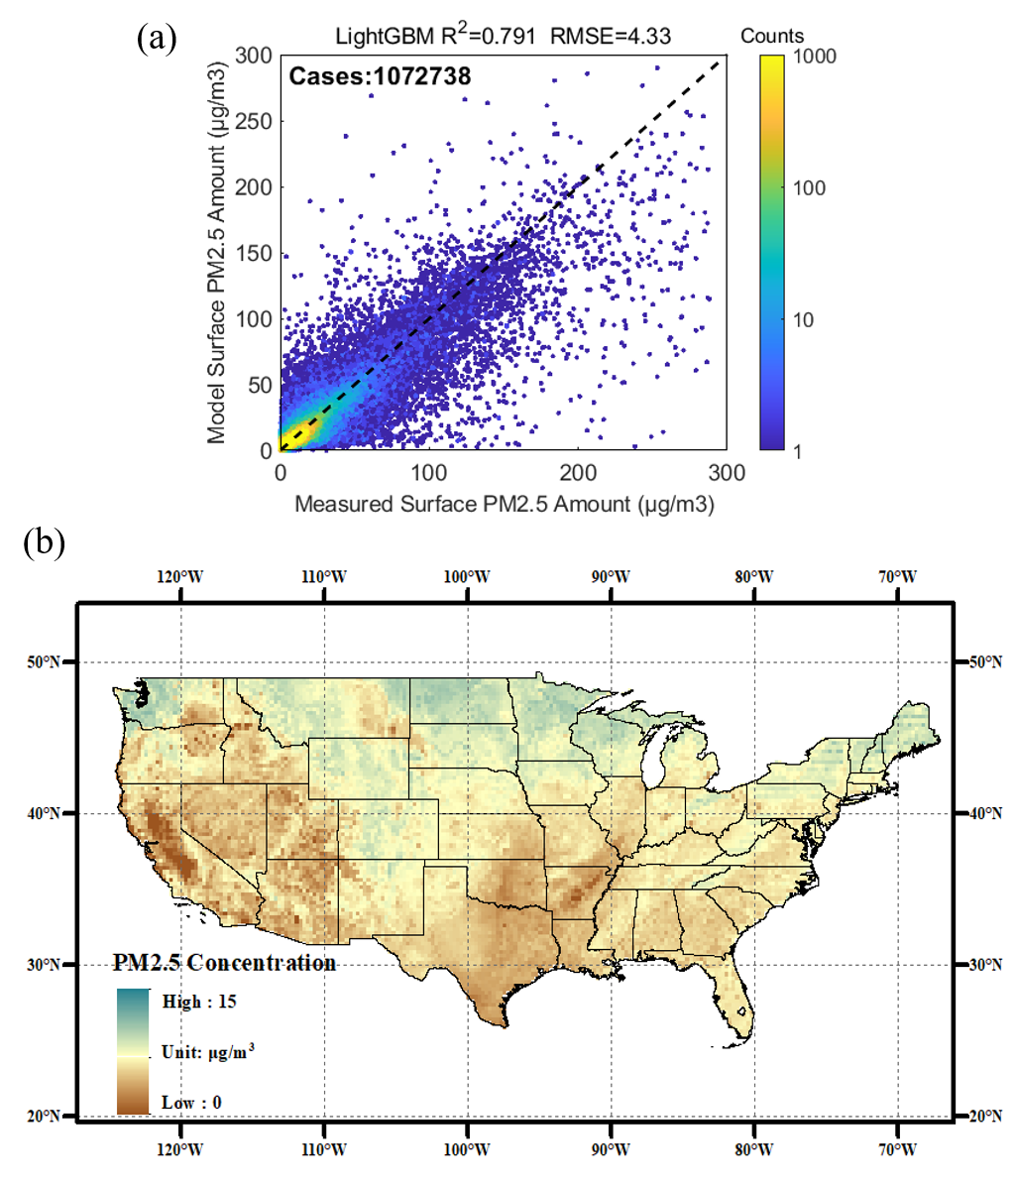
Fig.S1 (a) The scatterplot of hourly-level spatially continuous PM2.5 by the estimation model; (b) Average PM2.5 concentration distribution in summertime CONUS

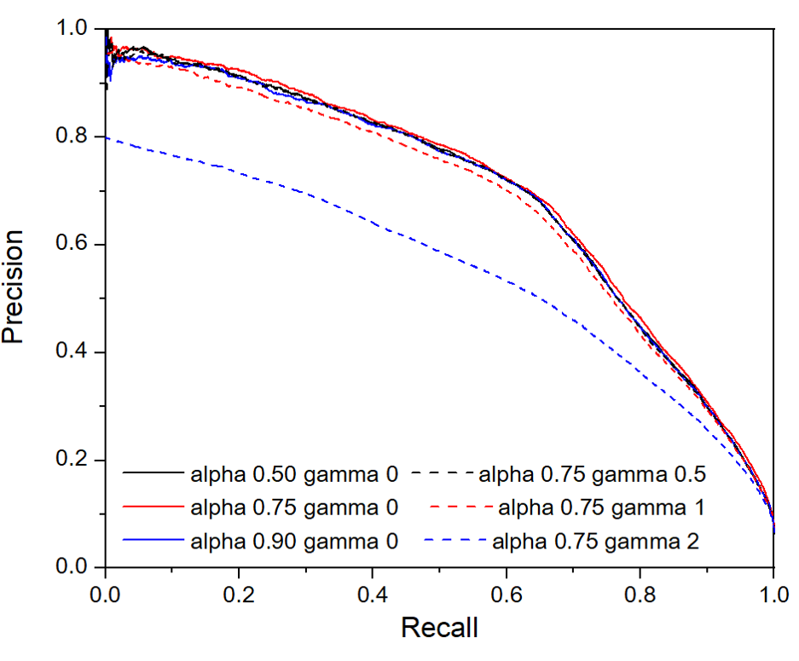
Figure S2. Comparison of precision-recall curves of Focal Loss method with different parameters α and γ settings.

Figure S3 Statistical analysis on the (a) diurnal variability of meteorological conditions, (b) diurnal variability of aerosol and (c) diurnal variability of lightning activity.

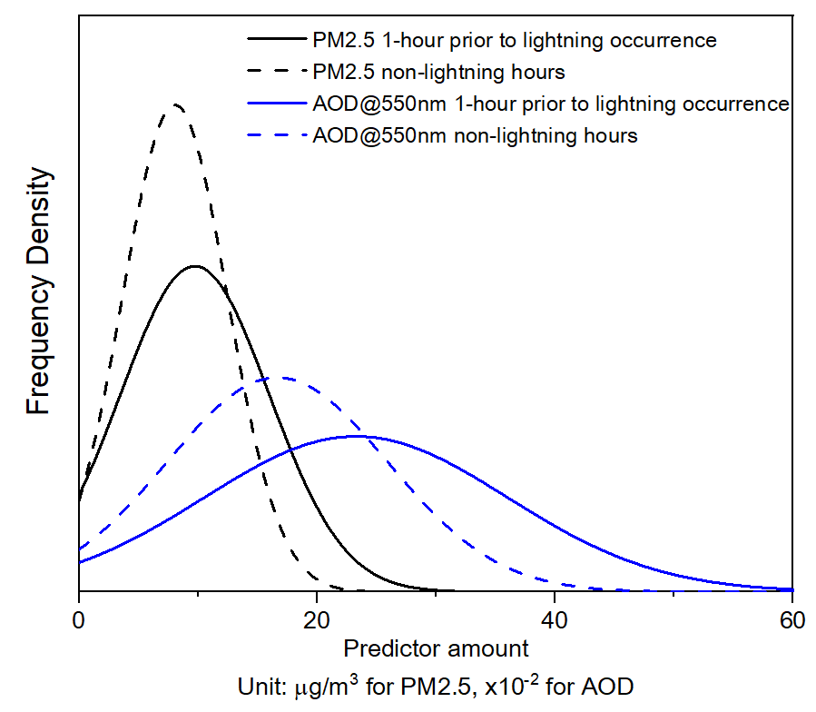
Figure S4 Distribution of predictor amount before lightning occurrence and during non-lightning hours under all meteorological conditions.

Figure S5 Diurnal variability of lightning prediction models with and without aerosol observations

Text S1:
To compare this model with other commonly used baseline models of lightning prediction, the Persistence model and the CAPE model are adopted. The Persistence model stands on the view that the lightning occurrence shows continuity, that the occurrence within the next hour would be the same as the current hour. The CAPE model distinguishes the lightning occurrence by the parameter CAPE. Once CAPE value exceeds a certain threshold, the model will predict the lightning occurrence in the next hour. The threshold of CAPE value in this study in determined by an optimized value in a way that provides the highest CSI. Considering the common comparison metrics of lightning occurrence models in previous studies, the model intercomparison is based on POD, FAR, CSI and HSS.
${LN}_{T+1}= {LN}_{T}$ (SE2)
$\left\{\begin{aligned}{LN}_{T+1}= 1, CAPE>C{APE}_{max} \\ {LN}_{T+1}= 0,CAPE≤CA{APE}_{max}\end{aligned}\right.$ (SE3)
Where:
$C{APE}_{max}$ represents the CAPE threshold that maximizes CSI of prediction

Text S2:
Date enrichment by GLM strongly enhances the model performance. To demonstrate the role of enriched samples, we simulated the traditional methods based on single-point observations of lightning occurrence. A lightning mapping array (LMA) is a network of time-of-arrival sensors that passively receive VHF impulses from electrical breakdown within thunderstorms. The system is able to determine the location and time of lightning discharge based on the time it takes the very high frequency (VHF) signal radiated by the discharge to arrive at the various antenna stations. These antennas can detect hundreds of sources per lightning flash over a domain extending around 200 km from the central point of the antenna network.
We simulated the observation of lightning occurrence from LMA by extracting the GLM observations at the detection range of LMA stations. The performance of the prediction model is then examined by the reduced samples within the LMA detection range. The list of LMA locations are shown in the Table S3.

