Original figures of Western blot

Original figures of Western blot for beta-actin
Original figures of Western blot for ATP S

Original figures of Western blot for bax
Original figures of Western blot for bcl2

Original figures of Western blot for Cyto C

Original figures of Western blot for CS

Original figures of Western blot for DRP1
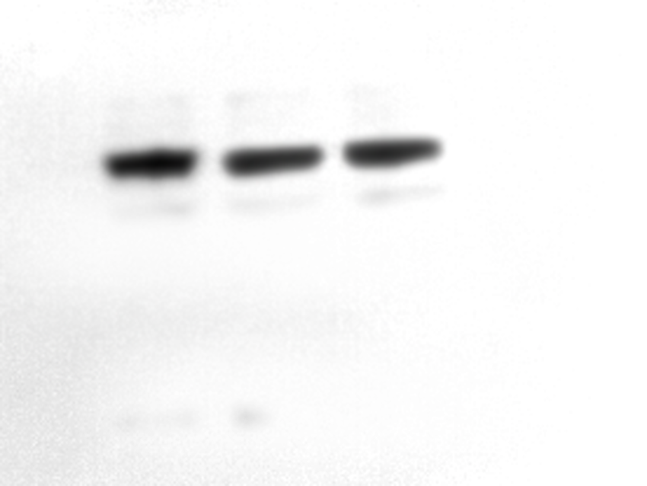
Original figures of Western blot for FIS1
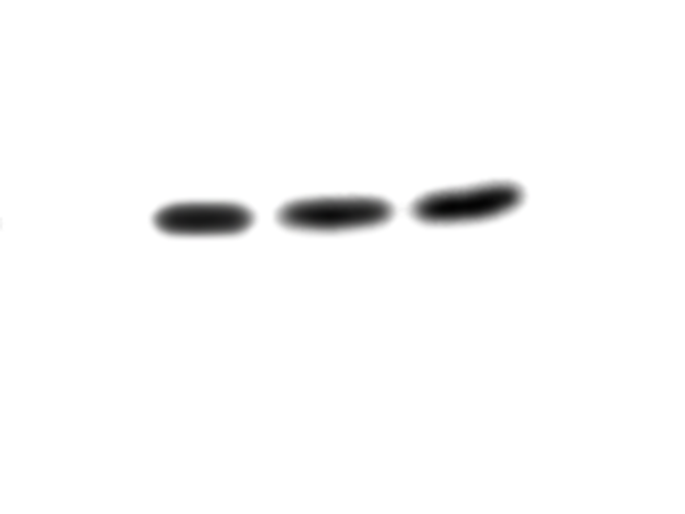
Original figures of Western blot for LC3

Original figures of Western blot for MFF
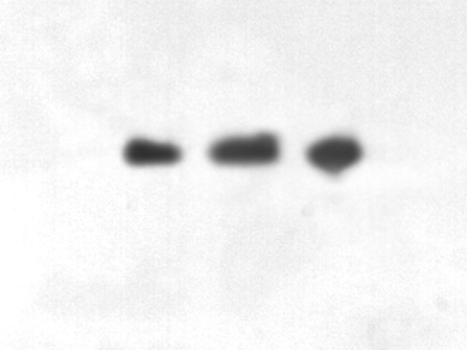
Original figures of Western blot for P62

